

2024.1 Version

Insurance Requirements in Contracts
A Procedure Manual

This manual was originally developed and placed in public domain to benefit public agencies. Sections of this current edition have been updated by Alliant Insurance Services, Inc. The manual is intended to provide general guidelines. Alliant does not warrant or guarantee the legal effect or the appropriate use of the contents. Alliant recommends that users consult with their legal counsel when considering contractual language.
Forms from the Insurance Services Office (ISO) are reproduced and included with permission of the ISO.

IRIC VERSION 2024.1

TABLE OF CONTENTS

TABLE OF CONTENTS ii
Foreword 1
Emerging Trends 3
Frequently Asked Questions 5
Introduction - Why Bother? 15
Chapter One: Contractual Risk Transfer – The Basics 16
Step 1: Analyze the Risks and Relationships 17
Step 2: Use a Hold Harmless 17
Step 3: Select the Appropriate Insurance Specifications 18
Step 4: Verify Coverage 22
Step 5: Report Claims Promptly 22
Exhibit A: Insurance Requirements for most Contracts 25
Chapter Two: Insurance Specifications for Most Contracts 28
Evaluate the Risk 28
Use the Appropriate Contract Template 28
Insurance Requirements 29
Be as Specific as Possible in Describing Types of Insurance Required 29
Describe Maximum Deductibles or Self-Insured Retentions that the Other Party may Maintain 29
How to Evaluate a SIR 30
Require the Addition of your Entity, its Officials, Employees and Volunteers as Additional Insureds to all Required Liability Coverage 31
Require that the Other Party’s Insurance be Primary 31
Require that Your Entity be Given at least Thirty (30) Days’ Notice of Cancellation of Insurance Coverage, with Ten Days’ Notice for Non-Payment 32
Specify that the Insurance is to be Placed with Insurers that Meet a Certain Minimum Rating, Unless Otherwise Acceptable to Your Entity 32
Fit the Insurance Limits to the Situation 33
How Much is Enough? 34
Professional Liability 34
Aggregate Limits 35
The Myth of “Following Form” Excess Insurance Policies for Higher Limits 35
Specify how Long the Insurance Must Remain in Effect for the Project or Lease 38
For Construction Projects or Claims-Made Policies 38
Professional Services Contracts 38
Professional Liability Insurance 39
Additional Insured Status 39
Claims-Made Coverage 40
Auto Insurance 42
Additional Insured Status 42
Workers’ Compensation 42
Independent Consultant Status 42
Indemnity Limitations 43
Property Insurance 44
Tenant’s Improvements and Betterments 44
Fire Legal Liability 44
Insurance Requirements for Lessees Exceptions for the Civic Center Act 45
Insurance Specifications for Common Situations 46
Sample Instructions for the Contractor, to be included as an attachment with the applicable Insurance Requirements 51
Sample Notice to Bidders regarding Indemnity and Insurance Requirements (may also be used with Purchase Orders) 52
Exhibit 1: Insurance Requirements for Most Contracts 55
Exhibit 2: Insurance Requirements for Professional Services 59
Exhibit 3: Insurance Requirements for Lessees 62
Exhibit 4: Insurance Requirements for Vendors 65
Chapter Three: Construction & Environmental Services 68
Construction Contracts 68
What is a “Construction Contract”? 68
Unique Construction Contract Provisions 69
Surety Bonds 69
Bid Bond 70
Performance Bond 70
Payment Bond 70
Subdivision or Completion Bond 70
Builder’s Risk Insurance (Course of Construction) 71
Installation Floater 72
Consolidated Insurance Programs (Wrap-Ups) 72
Discussion of the New Updated ISO Wrap Up Exclusion: 74
Environmental Contractors and Consultants 77
Transporters of Hazardous Materials and Wastes 79
Owners and Contractors Protective (OCP) Coverage 80
Railroad Protective Liability 80
Exhibit 5: Insurance Requirements for Construction Contracts 83
Exhibit 6: Insurance Requirements for Environmental Contractors and/or Consultants 87
Performance Bond 91
Payment (Labor & Materials) Bond 92
Chapter Four: Agreements Including Cyber Risks 94
Cyber Risks & Electronic Data Processing (EDP) 94
Exhibit 7: Insurance Requirements for Agreements Involving Information Technology 101
Chapter Five: Aviation Related Risks 106
Aviation Risks 106
Classes of Aviation Liability Exposures 106
Aviation Airport Liability / Fixed Based Operator’s Liability 107
Unmanned Aerial Systems – aka “Drones” 108
Exhibit 8: Sample Insurance Requirements for Airport, Airport Operations and FBOs 111
Exhibit 9: Sample Insurance Requirements for the Use of UAS 115
Charter Aircraft Services 117
Exhibit 10: Sample Insurance Requirements for Chartering for Aircraft 119
Chapter Six: Marine Related Risks 121
Marine Risks 121
Exhibit 11: Sample Insurance Requirements for Marine Risk Exposures 125
Chapter Seven: Special Situations 130
Teaching, Coaching, and Childcare 130
Contracts with Private Parties 130
Instructors 131
Special Events & Short-Term Rentals 132
Carnival Rides 133
Food Trucks/Farmers Markets 133
Contracts Involving Cash/Receipts Handling – Fidelity Bonds & Crime Insurance 134
California State University (CSU) Special Events Resource Guide (SERG) 134
Other Specialized Professional Liability Insurance 135
Investment Bankers Errors and Omissions Insurance 135
Garagekeeper’s Legal Liability Insurance 135
Exhibit 12: Insurance Requirements for Rental of Facilities 136
Exhibit 13: Insurance Requirements for Instructors 138
Chapter Eight: Schools and Other Youth-Serving Organizations 141
Use of Facilities 141
Third Party Instructors 142
Special Events 142
Student Placement Agreements 143
Sexual Abuse and Molestation (SAM) Liability 143
Transportation Risks 144
Exhibit 14: Insurance Requirements for Bus and Transportation Contracts 145
Chapter Nine: Verify Coverages 148
Typical Contractors Insurance Program 148
Verification of Coverage Process and Service Providers 149
Certificates of Insurance Guidelines 150
Additional Insured Endorsements 153
Other Endorsements 161
Primary Insurance 161
Waiver of Subrogation 162
Notice of Cancellation 162
Customized Endorsements 162
Appendix A: Risk Assessment 165
Severity-Related Questions for the Contract Risk Analyst 166
Checklist for Evidence of Insurance 168
Appendix B: Common Insurance Industry Forms 171
Appendix C: Sample Hold Harmless Agreements 231
Appendix D: Sample Checklists 239
Appendix E: Resources 246

Foreword
The purpose of this manual is to serve as a guide in developing proper insurance requirements in contracts. This manual explains how to establish insurance requirements for most contracts, including those with contractors, professional service providers, tenants, vendors, and users of public property, and how to verify their compliance with those requirements during the term of the contract.
It should be noted, however, that risk management is more of an art than a science, and therefore, although this manual will provide guidance in 90% of the cases encountered by the user, there will also be exceptions to the rules contained herein. If the user encounters situations that fall outside of the manual’s recommendations, the user should contact its insurance and legal advisors.
Recent editions have undergone extensive revisions to eliminate older insurance forms and to condense the material to make it easier for those without an insurance background to access and implement the recommendations. This includes a “basics” section that describes each element of the insurance requirements and provides a single set of specifications that can be used for most contracts. Instructions for the contractor and insurance agent or broker have also been included to make it easier for the contract administrator to request and receive the required coverage.
Another major change from years past is the elimination of most of the customized forms for public agencies. One of the proposed techniques of earlier editions was to request that insurers execute certificates and endorsement forms provided by the public entity. The obvious benefit of this approach is that the public entity knows that it is receiving the coverage it is looking for if the exact endorsement is provided. However, because many insurance forms require prior approval by state regulators, many insurers refused to use custom entity-designed endorsements, and it is no longer practical to obtain them. Also, most of the terms of the insurance requirements have been incorporated within standard insurance forms, lessening the need to spell out specific requirements. Finally, the reality of the emerging cyber and aviation risks has led the editors to create separate chapters on each.
The editors recommend that you use the specifications that spell out the form numbers and key terms described in this manual. Some insurers use custom policy documents, and we suggest that you compare the language in those documents to the specifications to verify that you are receiving the recommended coverage.
This manual contains sample standard Insurance Service Office (ISO) industry forms for reference. Occasionally, new editions of these forms are released. These new editions may broaden coverage, but they may also restrict coverage from the previous edition. An attempt is made in each successive version of this manual to include any updated forms, as well as comments on the changes made to old editions, and recommendations on which forms to use. Though a new edition is released, insurance companies may continue to use older editions of these forms. It is, therefore, important that the user check the edition date of the form supplied by contractors, tenants, vendors, and users of public property, and/or their agents and brokers. The edition date can usually be found in the lower left-hand corner of the form, following the form number.
This edition contains a review of significant updates to the ISO Commercial General Liability form and related Additional Insured endorsement forms, released December 2019. The impacts of some of these changes are significant and wide ranging. While every attempt is made to present these changes in a concise manner, we strongly encourage you to review with your Legal and Risk Management staff the implications of these changes to your Agency and update your Contracts to “trigger” coverage under these new forms. Otherwise, you may have reduced or even no coverage at claim time! Non-insurance sections of the contract are also very important to the risk management process. Normally, the “Indemnification” and “Scope of Work” sections should be reviewed for unusual language or risky activities. If the contractor’s insurance does not meet the requirements under the contract, it is the contractor’s responsibility to obtain the necessary coverage to satisfy its agreement with your Entity.
Insurance is only one way that the contractor can fulfill its financial responsibilities to your Entity. A section in the contract should state that the lack of insurance does not negate the contractor’s obligations under the contract, such as “These Indemnification provisions are independent of and shall not in any way be limited by the Insurance requirements of this agreement. Entity approval of the Insurance contracts required by this Agreement does not in any way relieve the Contractor from liability under this section.”
As Alliant is not a law firm, we recommend that users of this manual consult with their own insurance professionals or legal counsel for specific language for this section’s wording. Make sure your indemnity language is strong, and if the contractor does not carry sufficient or correct insurance to cover its obligations to your Entity, make certain it does have the assets to indemnify the Entity for those uninsured or underinsured areas of risk.
Finally, a section is included containing the most commonly asked questions from manual users over the years. We have included this section as a resource for the user, to illustrate that risk management is not always a simple process, and to encourage the user to contact their insurance advisor when encountering an “outside the box” situation.

Disclaimer: Wheresoever gendered pronouns appear in this document; it is intended that these terms will serve as placeholders for pronouns that accurately reflect the preferred gender identity of the individual to whom the pronouns refer. This is the intent for all such gender pronouns whether they be possessive (ie. “his” or “her”), objective (ie. “him” or “her”), or subjective (ie. “he”, “she”, or “he or she”).
ACKNOWLEDGEMENTS
This manual originates from work performed in the late 1970’s by public entity risk managers and consultants, a time when the field of public entity risk management was beginning to come into its own. The editors acknowledge the work of Erin Oberly, a risk management consultant working with Frank James of the Redwood Empire Municipal Insurance Fund (REMIF), for the earliest versions of this manual. Many changes have occurred in the fields of risk management and insurance since its inception, and this manual has kept up with those changes due to the continued support and dedication of public entity risk managers and consultants, including David Born, David Clovis, Joe Risser, Marcus Beverly, and Marjorie Segale. Over the past several years, the updates have been prepared with the support of PRISM (Public Risk Innovation, Solutions, and Management) including the expertise of Robert Marshburn of CertifiedRiskManagers.com. Mr. Marshburn is a recognized leader in the field of risk management, insurance policy language and public agency contracting as well as the founder of AutomatedInsuranceVerification.com.
Most importantly, this manual reflects the issues encountered by its users, and their feedback continues to be vital in keeping the material up-to-date and useful. We encourage you to contact your insurance or risk management consultant for advice as needed and send questions and suggestions for future editions of this manual to Marcus Beverly at marcus.beverly@alliant.com, or to Daniel Howell at dhowell@alliant.com.

Emerging Trends
The industry is rapidly changing, and the dynamic nature of these emerging risks has created an even greater need for creative risk management solutions. Here is some of what we are seeing:

- Cyber continues to be a hot topic
  - Ransomware attacks, increased reliance upon remote working, increased sanctions & penalties (OFAC), State & Local level protections, GDPR, etc.
- Wildfire Risks
- Hurricane & Storm Severity
- Flood
- Temporary housing solutions for homelessness
- COVID-19 Pandemic
  - Communicable disease exclusions and unintended impact – some exclusions may negate coverage for foodborne illness, especially important for contracts involving any foodservice
- Telework and Telehealth
  - Employees moving out of State impacts on WC coverage
- Parametric Products
  - Contingent Income, Earthquake, Flood, etc.
- Market consolidation of insurance companies and brokers
- Micro-mobility
  - Policies and procedures for safe deployment of scooters, bikes, etc.
- Parklets
- Increase in litigation and settlements
  - Directors & officers, employer liability, fiduciary plans (excessive fee litigation), privacy law, etc.
- Law Enforcement liability
  - Accepting contracted help
  - Response during Civil Unrest
  - Increased scrutiny on Officer involved shootings
  - Changing community expectations of use of force by police
- Security, including armed guards and school safety officers

Litigation Financing
The authors of this manual have performed a calculation of how a $1 million/$2 million per occurrence/annual aggregate limit compares to today’s environment. Using the Consumer Price Index (CPI), the value of $1 million in 1986 (when the new CGL initiated) would be over $5 million in today’s dollars. But using an inflation factor impacted by tort litigation inflation aka “social inflation” we estimate that the value of $1 million in 1986 is over $10 million for tort liability claims in today’s dollars (see resources at the Insurance Information Institute at iii.org and other industry references). Beyond the direct impact of increased medical costs and higher attorney’s fees, a key change has been the introduction of third-party litigation funding for plaintiff litigation costs. Much information has been published on how third-party litigation funding has changed the duration and cost trajectory of claims. Plaintiffs now have the financial ability to resist pressures for early settlement at lower value. As a result, when the impacts of social inflation are combined with the availability of third-party litigation financing, the cost of liability claims has increased at a faster rate than the CPI. Appropriate minimum limits will vary based on state jurisdiction and availability of governmental immunities and tort claims caps. Keep in mind that claims brought under federal causes of action or in other state jurisdictions may have very different potential cost.

As the world of risk continues to change at an accelerated rate, we can use what we’ve learned in the past to help us mitigate the risks of the future and present. Readers should consult with their risk advisors and legal counsel when contemplating how to manage these emerging risks

Frequently Asked Questions
The following questions represent those most often asked by users of this manual. If you have questions that are not answered by this section, please do not hesitate to contact your Alliant Account Administrator. As you can see by reviewing the following section, we all learn through the process of thoughtfully examining the risk management process.
- If a lessee or contractor is a large one, do I still need to insist on the insurance requirements?
Yes; you normally have no way of verifying that their assets are sufficient for losses that might occur, whereas you could be confident in an insurance carrier with a quality A.M. Best Rating.
- Is it all right if the contractor alters the indemnification language?
This is not advised. Indemnification language is carefully worded to afford your Entity as much protection as legally possible, and usually the exact language has been tested in court. Altering the language could weaken your Entity’s protection and should only be undertaken on advice of your legal counsel.
- Can we require an A.M. Best rating for a company that is “admitted” in California, or is this against the law?
Yes; unless the company is providing a surety bond. State law requires owners to accept surety bonds from any surety company, in an effort to improve small firm contractors’ chances in successfully bidding a job. If it is a federally approved surety company, you are obligated to accept the surety company. This can be reviewed on the web at:
https://www.fiscal.treasury.gov/
Remember, just because an insurance company is “admitted” does not ensure that they have the financial strength designation required by your contract. Also, we have removed the requirement for “admitted” insurers because so much insurance is now written by Surplus Lines insurers. We now suggest that insurers be “authorized” to write business in the state and rated by A. M. Best. These companies can offer advanced forms that can be tailored to specific needs. However, carefully verify that they do not take away needed standard coverages!
- Why should we ask for property insurance on tenants’ improvements and betterments, instead of just adding them to our property insurance policy?
Unless the lease specifically states that your Entity gains ownership of these improvements as soon as they are installed, your Entity has no insurable interest in them; and, therefore, you usually cannot insure them under your policy. We recommend that you require tenants to insure their TIB’s and personal property. If your entity does have an insurable interest, you may want to add the TIB’s to your entity’s property insurance.
- If the contractor’s insurance does not meet the criteria in our insurance requirement specifications, should we alter the requirements to fit the contractor’s insurance?
No; the insurance requirements language has been carefully worded to afford your Entity as much protection as possible, and it has been tested in court. Altering the language would usually weaken your Entity’s protection. It is not the responsibility of your Entity to tailor your requirements to what the contractor has; rather, the contractor should procure insurance to meet your specifications and truly, you are doing the contractor a favor in showing it the proper coverage needed in order to protect its business. We have worked very hard to recommend insurance requirement specifications that not only protect the Entity but are also realistic and available in the marketplace for the Contractor.
- Does the “edition date” on the suggested ISO endorsements matter?
Yes; there have been significant reductions in the coverage afforded to additional insureds by “updated” versions of these endorsements. A further discussion regarding these changes is contained in the section of this manual describing these endorsements.
- If the agent or broker changes the word “endeavor” to “will provide” in the notification of cancellation section of the certificate of insurance, or says we don’t need an endorsement because of language on the certificate, are we okay?
No; Certificates of insurance DO NOT alter the insurance coverage, and any changes that are necessary need to be endorsed onto the policy with a copy of the endorsement provided to your Entity. Agents and brokers will sometimes try to convince you that endorsements are unnecessary when the certificate has its standard wording changed; if so, you need to point out the boxes across the top of the certificate, one which states that it confers no rights on the holder and DOES NOT amend or alter the insurance and the other that endorsements are needed for additional insured status and may be needed for waiver of subrogation.
To ensure that the burden is on the insurance company to notify you of a change in status of coverage, you must receive an endorsement to this effect. Some carriers will provide such an endorsement, especially for larger projects, but most do not. Being named as an “additional insured” does NOT obligate the insurer to inform you of any status change in the policy since most policies require only the First Named Insured be notified.
Prior editions of this manual have suggested requiring notice of cancellation or coverage changes with 30 days’ notice by USPS registered mail with a return receipt. This approach does not seem feasible in the current environment of electronic communications and express mail services. Moreover, some insurers refuse to take on this obligation and, in some states, the cancellation requirements are stronger.
Many risk managers are now requiring that the contractor take on this responsibility. While this may be allowing the “fox to guard the henhouse”, mid-term cancellations and reductions of coverage are so rare as to make the value of this term less important. If a contract involves a risk so substantial that the risk of cancellation or coverage reduction is heightened, a project specific policy with the Entity as an Additional Insured may be warranted.
NOTE: The latest edition of the standard certificate of insurance form now reads that “notice of cancellation will be provided in accordance with policy terms and conditions.” This does not confer special rights on additional insureds and you must ask for an endorsement to the policy if your entity truly desires advance notice of cancellation.
- Can lower limits be permitted when we are dealing with small contractors or artisans, and we are only using them for small jobs?
Yes; there are some very small vendors or artisans that may provide a service to your Entity and the cost of obtaining standard limits may not be possible. You should always evaluate the potential of loss, potential benefit to the organization for the service provided and finally, the vendor’s financial capacity to purchase coverage at reasonable rates. The dollar amount of an agreement should never be the sole determining factor on the insurance, however. Even in a small-dollar contract, determine if it involves any exposures that could result in significant loss such as kids, large crowds, high voltage, water, heights, ladders, scaffolding, pyrotechnics, flammable products, alcohol, etc. Please see Appendix A “Risk Assessment” for criteria.
- The contractor’s agent says that we cannot get the endorsements as required by the Insurance Requirements in Contracts specifications; what can we do?
In many instances, the agent or broker has not approached the insurance company with your request – the agent or broker is merely trying to discourage you from asking so that it will not have to bother. We recommend contacting the broker or agent directly. By informing the agent or broker of the needs and requirements of your Entity, he or she will typically provide you with the necessary endorsements required by your Entity. If this tactic does not work, please call an insurance advisor for confirmation of the unavailability of endorsements from the contractor’s company.
Note that some states, California among them, now require prior approval of all insurance policy and endorsement forms by the Department of Insurance for “admitted” carriers. Therefore, use of custom endorsements may not be practical. However, many construction projects now use non-admitted carriers that are A. M. Best rated and on the LASLI surplus line list. In 2011, the List of Eligible Surplus Line Insurers, ("LESLI"), was replaced by the List of Approved Surplus Line Insurers, ("LASLI"). The LASLI is a voluntary list of non-admitted insurers that the California Department of Insurance ("CDI") has approved for use by surplus line brokers. Often these are part of large insurance groups with the group rating, backing, and resources of the larger, often admitted, insurance group and this allows for customized endorsements. In these situations, we recommend that the Entity work with its insurance advisor and the contractor to determine what forms are available to obtain the desired coverage.
- Do we need an additional insured endorsement on an automobile liability policy?
An additional insured endorsement is usually not required on most business auto policies because the standard ISO forms include coverage for “Anyone liable for the conduct of an insured”. Be careful with non-ISO policies since many, but not all, may contain this provision. It may be wise to require the additional insured coverage by using contract requirement language for the auto policy such as “the policy shall contain, or be endorsed to contain, Additional Insured coverage for the Entity.” Also, there are times when general and auto liability coverage are issued on a package policy and the additional insured endorsement can apply to all coverages.
- How do we determine the proper limits of liability for any given job?
Ask yourself how much damage the contractor could cause if it completely mismanaged its work causing bodily injury and property damage to others. Include in your estimate, lost time, wages, extra expense incurred for repairing or replacing the work, and any future impacts. If this amount is more than the suggested amounts shown in the specifications in this manual, use the greater amount.
Keep in mind that the $1 million per occurrence/$2 million annual aggregate limits of the CGL were implemented in 1986. If simple cost of living adjustments are applied, that $1 million rises to over $4 million in present value of today’s dollars. And some research has shown that tort costs have increased an average of 8.7% annually since 1951 which would take that 1986 $1 million dollars to over $9 million in present value. A settlement including 24-hour care for just one severely injured claimant can reach over $10 million in present value alone.
The editors have increased the standard requested limits of General Liability to $5 million for contracts with construction risks and to $2 million for other contracts. The Risk Manager will need to evaluate whether contracts require the suggested limits or a different amount. A major capital outlay project may require even higher limits. And some smaller contracts such as facilities use agreements may not merit $2 million, and a lesser amount may suffice. We have not increased the amount of auto liability limits because the business auto policy does not have an annual aggregate which means that the Entity need not be concerned about depletion of limits by other additional insureds, however, a catastrophic loss may prove $1 million of limits inadequate. A contract involving charter transportation could very well merit a $5 million limit or higher. Also, see the answer to question #8 above.
- Can we accept an insurer with less than an A.M. Best Rating A: VII or Standard & Poor’s BBB?
Yes; but keep in mind that the rating gives your Entity some confidence in that insurer’s ability to cover all of its claim liabilities, including your potential claim. By accepting lower A.M. Best or Standard & Poor’s ratings, you are exposing your Entity to the possibility that the insurer will be unable to pay any claim you or a third party may present. As an aside, major insurance brokers and agents also insist on placing clients in companies with high A.M. Best and Standard & Poor’s ratings, as a way of protecting themselves against potential E&O claims from their clients.
- How do we discover what the rating of an insurer is?
A.M. Best ratings can be accessed over the internet for no cost at www.ambest.com. Go to the “Member Center” of the website to register for access to the ratings.
You also can go to the Standard & Poor’s website to obtain the rating of a specific insurance company. You must register for access, although this is free of charge. Go to www.standardandpoors.com and look for a “Find a Rating” link in the margin or header.
- What do the A.M. Best or Standard & Poor’s Ratings mean?
See Chapter Two for a discussion of this question. Simply, the Standard & Poor’s or A.M. Best ratings give your Entity a sense of the financial strength of the insurance company that is insuring the contractor.
- Does a contractor need professional liability coverage?
A contractor needs professional liability coverage if expected under contract to provide “professional” services. The simplest way to decide is to determine whether the nature of the services provided entail “brain work” or “physical work”. If it is only physical work, then a liability policy, general and/or automobile will most likely cover all your exposures to loss. However, if the work or a portion of the work is expected to involve the use of professional knowledge, professional liability insurance is required.
As an example, if a contractor is merely following blueprints in constructing a building, it would involve only physical work and a general liability policy will suffice. However, if the contractor is a “design-build” firm, or decides that it knows of a better way to construct part of the building, and it alters the blueprints accordingly, then it has crossed the line over into providing “professional” service and would then need professional liability coverage to cover a subsequent loss.
- How long of a period of time do we require the claims-made professional liability insurance to be carried after completion of the project?
A “claims-made” coverage will only respond to a claim that is presented while the policy is in force or during an extended reporting provision. Therefore, it is imperative that your Entity be protected as long as possible after the completion of the project, so that any claims caused by faulty design or other professional services (see Question 15) will be covered by the responsible party. Keep in mind your regular general liability policy will not cover professional liability losses, and therefore your contractor may be bare in the event of a claim arising out of professional services rendered on the project. Normally, professional liability policies can be purchased with a three year “tail” (reporting period), which will allow claims to be presented up to three years after the professional liability policy expires. If you can get a longer tail in your contract, do so.
- Does a contractor need proof of automobile liability when hired to work on the premises?
Yes; for the simple reason that the contractor has to use some means of transportation to reach your premises, and to transport tools, supplies, and materials. If the contractor is determined to be engaged in business on your Entity’s behalf when it is involved in an automobile accident, then your Entity may be held liable. Further, since owners of vehicles are required to carry insurance anyway, this requirement carries little burden to the contractor.
- Should we ask to be named as an additional insured on the contractor’s professional liability policy?
No; the contractor’s professional liability insurer will not comply with such a request. The reason is that the insurer does not want to pick up your Entity’s professional liability hazards, which it would do if you were an additional insured. Professional liability policies are specifically underwritten based on the professional history of the contractor. A contractor’s insurer is not interested in underwriting your Entity’s professional risk, and therefore will not add your Entity as an additional insured on the contractor’s policy.
- What can be done if we don’t have the proof of insurance when it is time to start the work?
There is very little that can be done at this point in the process, which is why we strongly recommend that the indemnity and insurance specifications be sent out with the pre-bid package. There are no good choices when this situation occurs; either you must delay the work while you wait for the proof, or you must take some risk until the proof is received, and hope that the contractor’s insurance meets your specifications.
- Why can’t we accept a certificate of insurance as proof of the Entity being named as an additional insured?
Across the top of the current ACORD Certificate of Insurance are the following words:
IMPORTANT: If the certificate holder is an ADDITIONAL INSURED, the policy(ies) must be endorsed. If SUBROGATION IS WAIVED, subject to the terms and conditions of the policy, certain policies may require an endorsement. A statement on this certificate does not confer rights to the certificate holder in lieu of such endorsement(s).
If any agent or broker tries to convince you that the certificate truly does confer rights or coverages, and that you therefore do not need the endorsements you are requesting (and some will) you can direct their attention to this statement.
- Why do we need an indemnity clause in our contract when we are added as an additional insured on the liability policy?
Insurance is only one way that the contractor can financially guarantee its liabilities. If you have an indemnity provision in your contract with the contractor, that contractor is obligated to indemnify your Entity whether or not its insurance covers the loss. This puts the burden on the contractor rather than your Entity to make certain that its coverage is sufficient and current. Therefore, make sure your indemnity language is strong, and that if the contractor does not carry sufficient or correct insurance to cover their obligations to your Entity, it does have the assets to indemnify those uninsured or underinsured exposures.
In fact, the written indemnity clause in the contract is the real trigger for coverage as your contract, under normal circumstances, is an “Insured Contract” as defined under the Commercial General Liability policy (CGL). The CGL confers automatic coverage for “Insured Contracts,” (unless endorsements provide otherwise) but the Entity must have a written contract containing indemnity language in your favor prior to the loss in order to trigger coverage. As a result, the indemnity clause is crucial to trigger coverage and may even cover items not covered by the Additional Insured Endorsement.
- Should we ask for a waiver of subrogation from the contractor and/or insurer?
YES, always include in your contract terms; if your Entity does not do so, the contractor’s insurance company can look for reimbursement of any claim payments they have made when they believe your Entity’s negligence contributed to the loss. “Subrogation” is the transfer to the insurance company of the contractor’s right to collect for damages from another party, in this case, your Entity. If the contractor waives rights of subrogation in the contract their insurers have no rights to pursue your Entity for reimbursement, regardless of whether or not an endorsement is issued, because the insurer’s rights are no greater than their insured’s.
Some insurers require their insureds to report and pay for waivers of subrogation, and all policies prohibit waivers of subrogation after a loss has occurred. However, any recourse the insurer may have is with their insured and will not create subrogation rights versus your Entity.
In addition, if your Entity is named as an “additional insured” on the contractor’s liability policy, current case law holds that it is against public policy to allow an insurer to subrogate against its own insured, even an “additional insured.”
Editor’s note: the phrase “waiver of subrogation” is no longer used in the ISO Commercial General Liability form; rather the phrase “Transfer of Rights of Recovery against Others to Us” is now used. While the editors normally favor using the current industry language rather than historical legal terms, in this case we believe “waiver of subrogation” remains the best way to communicate to contractors and the legal community the intent of the agreement.
- If a hold harmless agreement does not absolve us of liability, why do we need to include it?
While a hold harmless agreement does not relieve you of legal liability for your Entity’s sole negligence, it should obligate the contractor and his insurer to pay for legal defense and damages due to your Entity’s vicarious liability arising from the contractor’s activities.
Each word in the phrase “hold harmless, defend and indemnify” conveys a different duty to be performed by the indemnitor. Even if the indemnity agreement is not fully enforced, or the indemnified party has separate negligence not included in the indemnity, the written agreement to indemnify is essential to triggering contractual liability coverage under the “insured contract” definition in the ISO CGL policy of your contractor. Without any agreement to indemnify your Entity is bare as respects the contractor’s insurance.
- Should we require bonds in contracts that are not construction related?
Yes; there are a number of situations when your Entity may want to require bonds. You may want to consider bonds when dealing with certain types of vendors, including those providing personalized products such as customized information systems, equipment, or other specific services for your Entity. Although bonds may not be required on all vendor agreements, it is important to understand how they may save your Entity in the event that the vendor fails to deliver or lacks the funding to finish its project.
- Should we require that contractors provide proof of terrorism coverage in their insurance programs?
Maybe; the Federal Government has mandated that all insurers offer coverage for “terrorist acts” for an additional premium. Though this coverage is currently available, many insureds are declining it due to the additional cost. It is unclear to what extent a contractor could be responsible for any act of terrorism that occurs while performing tasks for your Entity. You may consider the coverage on construction projects which may be impacted as a result of a terrorist attack. As with any exposure, you must identify the potential for risk. If the project is politically sensitive or considered highly visible, the inclusion of terrorism coverage may be necessary.
- What do I do if my contractor states that they are self-insured for liability, auto, and workers’ compensation, and they cannot provide a certificate of insurance?
In the State of California, organizations that are self-insured for workers’ compensation must have a Certificate of Consent to Self-Insure issued by the State of California Department of Industrial Relations. They must also have authorization from the State to self-insure their auto exposure, but this is not the case for general liability. First, obtain copies of their documents granting them the authority to self-insure for worker’s compensation and automobile liability. Second, obtain a letter from the contractor that clearly states all of the requirements in your agreement apply to their self-insurance. Next, you will need to confirm that the contractor has assets available to cover any losses in the event they occur. This would normally include the review of their independently audited financial statements. Finally, you may require the contractor to issue a bond or a letter of credit to your Entity in an amount necessary to cover any losses. Note that the manual requires special treatment of self-insured retentions to protect the entity.
- The contractor states that they are a sole proprietor and does not carry workers’ compensation insurance as they have no employees, is this acceptable?
Yes; many contractors are either sole proprietors or partnerships. You should receive a letter from the contractor stating they are either the owner of the organization or a partner, and are exempt from the State’s workers’ compensation requirements because they have no employees and agree to hold the Entity harmless from loss or liability for such.
- Should I require wet signatures on endorsements to policies?
It depends. If an endorsement is issued and delivered as a part of the policy, it does not need a signature as the complete policy was signed off by an authorized representative when it was issued. Usually there is a schedule of endorsements attached to the signed Declarations page and if your endorsement is listed on that schedule then it was a part of the policy at issuance and does not need a signature. Mid-term endorsements should be signed to confirm that an authorized representative has agreed to the policy change. A copy of the updated Policy Declarations and Endorsements page can be your best tool to verify the added endorsement. Keep in mind that all of this effort is intended to raise your confidence that the insurer has agreed to provide the required coverage, rather than an unauthorized intermediary. Indeed, you could next require that the signatory prove that he or she is authorized – which you might do if the signatory is a retail broker or agent, rather than a company underwriter or delegated managing general underwriter. At some point, it is reasonable to assume that the people who are issuing documents to you have the authority to do so.
- The ISO released an update to the CGL form in April of 2013, CG 00 01 04 13, and a number of Additional Insured endorsements. What are the important changes and what impact do they have?
There are significant changes in all of the 2013 Additional Insured endorsements section, the most relevant of which for the purpose of this manual are forms CG 20 10, CG 20 37, CG 20 33, and CG 20 38. Included is language that states:
- The coverage available shall not be broader than coverage that is required by the written contract or agreement
- The limits available to the Additional Insured shall not exceed what is required by the written contract or agreement
- The insurance afforded to the Additional Insured only applies to the extent permitted by law
Also noteworthy is the 2013 CG 20 01 endorsement that provides primary and non-contributory coverage. A more thorough discussion of the new CGL Additional Insured Endorsements is found in a separate section. Copies of the new forms are in the Exhibit section of this manual.
- What is the purpose of the 2013 Additional Insured endorsement, CG 20 38?
CG 20 38 is an Additional Insured endorsement that provides coverage for “upstream” parties such as property owners who may not have a direct contractual relationship (privity) with the insured. For example, if a Sub Contractor is required by a General Contractor to add the Owner (Entity) as AI, then coverage is available to the Owner (Entity) even though no contract exists between the Owner and the Sub.
The key element here is to make sure your contracts require that anyone performing work for your Entity must add upstream parties as additional insureds using CG 20 38, or broader coverage.
- I’m confused by the all the different versions of the additional insured endorsements. Is there a short answer?
Yes, at the risk of oversimplification. Since it is rare to be able to get the ISO 20 10 11 85 version, you can settle for a more recent 20 10 form combined with 20 37 form. It isn’t as desirable but may be the best you can do.
The table below provides a summary of the AI endorsements to be used for the situations as described above. Note there is no AI endorsement currently providing Completed Operations coverage to a party with no privity and no work being performed for them.

Insured Relationship to AI for Coverage | Doing Work For AI with a Contract requirement regardless of Privity |  | Doing Work For AI, with Privity, but no Subs | No Contract “With You” (No Privity) & No Work For Additional Insured
Type of Endorsement | Scheduled | Automatic* | Automatic** | Automatic* | Designated
Ongoing Ops Form # | 20 10 | 20 38 | 20 33 | 20 43 | 20 42 & 20 26
Completed Ops Form # | 20 37 | 20 40 | 20 39 | NONE from ISO | NONE from ISO
* Only if required in a written contract or agreement **Only if required in a written contract “with You” (Privity) **Use form 20 33 and 20 39 ONLY when you are SURE there are NO Subs being used that have NO Contract “with You”
For Automatic Status, Form Numbers 20 38 and 20 40 should be required rather than the 20 33 and 20 39

More details on this complex area may be found in Chapter 9 of the manual.

- How can my entity make sure that we have access to (1) the full coverage and (2) the full limits of insurance carried by our contractors?
The insurance requirements in this manual have long recommended language that states that the required limits are a minimum. We are reinforcing this language throughout the manual with the addition of the following shown in bold and italics here:
“The Insurance obligations under this agreement shall be: 1—all the Insurance coverage and/or limits carried by or available to the Contractor; or 2—the minimum Insurance coverage requirements and/or limits shown in this agreement; whichever is greater. Any insurance proceeds in excess of or broader than the minimum required coverage and/or minimum required limits, which are applicable to a given loss, shall be available to the Entity. No representation is made that the minimum Insurance requirements of this agreement are sufficient to cover the obligations of the Contractor under this agreement.”

- With the passage of California Civil Code §2782.9 effective January 1, 2018, do I have to adjust my current indemnification language as it relates to design professionals?
Yes. The new language states that design professionals shall be indemnified and held harmless from all liabilities and claims that arise out of negligence, recklessness or other misconduct on behalf of the principal. For a more complete analysis, please refer to Appendix C.
Non-California users should consult their general counsel for state-specific language and analysis of any “anti-indemnity” statutes or case law applicable to their contracts.
- How can we ensure Additional Insured coverage for completed operations?
ISO has three AI endorsements providing completed operations coverage: the CG 20 37 for Scheduled Persons and Operations, and the new CG 20 40 and CG 20 39 endorsements for Automatic Status when required in contract.
More details on this complex area may be found in Chapter 8 of the manual.
- Is my independent contractor really an independent contractor?
Some states are tightening the rules via legislation or judicial decisions defining when a contractor is truly and independent contractor. California has enacted AB 5 effective January 1, 2020. The evaluation of whether a contractor is truly an independent contractor is beyond the scope of this manual and should be reviewed by the user with your counsel. Suffice it to say that agreements should be reviewed with counsel to ensure the agreements have appropriate and strong independent contractor language. The independent contractor’s agreement to indemnify, defend and hold harmless the entity will then be supported by the insurance requirements described in this manual.
- How to dispel the myth of “following form” excess insurance coverage?
Most following form excess policies do not truly follow form. Many of these excess policies do provide higher limits, but they often have contradictory differences in terms of how and why the excess policy is triggered. There are often conflicts with the primary policies, and the excess policy may have additional provisions not included or even referenced in the underlying. A quick check for whether the excess policy is truly following form is the length of the excess policy – this should be no more than two to four pages. Our discussion in Chapter 2 includes a checklist for potential conflicts between the primary and excess policy, as well as sample endorsement language and examples of following form policy language.
- How does my agency transfer risks related to housing the homeless, including grant programs to purchase properties to convert to housing?
Most social service grant programs are administered by and through state or county agencies, though in the case of housing the homeless local agencies may be given the task of purchasing and managing the properties. Ideally, the agency is able to contract with a responsible nonprofit to take on the management responsibilities, though some agencies choose to manage themselves and ultimately liability will rest with the agency as the property owner. If contracting with a nonprofit we recommend thorough vetting, a minimum $3 million general liability limit, and regular management oversight.

Introduction - Why Bother?
Let’s face it, dealing with indemnity and insurance requirements can be tedious. No one likes to haggle about the terms of a contract or worry about whether a contractor has provided the correct insurance. Requesting, obtaining, and verifying insurance for contracted goods and services takes time, can be aggravating, and most often doesn’t seem to make any difference, since most contracts are completed without incident. However, when an incident occurs, all of those efforts become worth it. Public entities and businesses have saved millions of dollars by successfully tendering claims or suits arising from contracted goods or services, from the largest public works projects to the smallest service contracts.
The reasons for including a strong indemnification clause in your contracts and requiring insurance coverage include:
- Your entity can be held liable for damages caused by your contractors
- You should be able to rely on the contractor’s expertise to do the job safely, and if it doesn’t, it should pay for the consequences
- Responsibility encourages safety on the part of the contractor
- Risk is placed upon those best able to control the work
- You have a source for payment of claims against your entity
- Maintaining your own project or entity budget
- Maintaining your own good loss history and lower insurance costs
And remember, it is never a good thing to be the one responsible for costing your agency the significant expense of a large claim that could have been tendered to your contractor and paid by its insurance company. So, while it may be tempting to ignore the indemnity and insurance requirements in your contracts and accept whatever the contractor sends you as proof of insurance, consider it a required measure of due diligence that could result in significant savings for your entity.

Chapter One:
Contractual Risk Transfer – The Basics

SUMMARY

This chapter describes the basic steps in administering insurance clauses in contracts where the other party is required to provide insurance to protect your Entity, its officials, employees and volunteers. The five basic steps are:

- Analyze the Risks and Relationships
- Use a Hold Harmless (Indemnity) Agreement
- Select the Appropriate Insurance Specifications
- Verify Insurance Coverage
- Report Claims Promptly

In the practice of good risk management, your Entity should attempt to transfer the risk of accidental loss accruing through its contractual relationships. Usually, your Entity will require the other party to a contract (contractor) to assume your Entity’s liability arising out of the contractor’s negligent delivery of products, services, or activities. This transfer generally is appropriate, as the contractor is most often the party in the best position to control loss.
This intended transfer of risk is achieved by requiring suppliers, contractors, tenants, and users of public facilities (i.e. the other party to most Entity contracts) to hold your entity harmless in an indemnification agreement arising from their products, activities, or use of your facilities. The best way to assure that the transfer actually takes place (i.e. that a loss will be paid by someone other than your Entity) is to require a strong indemnity agreement and insurance appropriate in the contract for goods or services. In addition to protecting the contractor, the insurance should also protect the Entity, its officers, officials, employees, and volunteers.
This section is intended to give users a brief overview of the contractual risk transfer process and a set of insurance specifications that will apply to most situations. Many users will find that this section provides all the tools they need. Each step of the process is discussed in more detail in the following sections, including additional specifications for certain types of contracts, sample insurance forms, checklists, and references for additional resources.
Contractual Risk Transfer - The Steps
  - Analyze the Risks & Relationships
  - Use a Hold Harmless (Indemnity) Agreement
  - Select the Proper Insurance Requirements
  - Verify Coverage
  - Report Claims Promptly

Step 1: Analyze the Risks and Relationships
Review the scope of work, persons capable of completing it successfully, and the relationship that person will have with your entity. Pay special attention to the scope of work. Is it sufficient to describe the work to be performed, especially in case of a dispute as to who was responsible for certain duties, such as maintenance? Make sure you understand what is to be accomplished based on what is written in the scope.
Step back and think about the objectives to be accomplished and ask “What could go wrong?” What are the critical steps in completing your objectives? Is the contractor qualified? Focus on the risks and remember each situation is unique. The risks and your options for managing them will vary. It’s worth the time to learn as much as you can about the work, the contractor, and the risks involved to develop the best ways to protect your entity and avoid wasting your efforts on requirements that aren’t needed or won’t be effective.
It’s a mistake to think that a contract for a small job or service carries with it a small risk of loss, but contract managers often don’t pay as much attention to the risks inherent in smaller contracts. Some contracted services do carry more risks; even the smallest job has the potential for catastrophe. For this section, we are assuming the typical kinds of risks for most contracted services, such as professional services, maintenance agreements, and other contracted work performed for your entity, with the exception of construction contracts. Please see Chapter 3 for more details regarding construction projects and Chapter 4 for a discussion of other special types of situations.
Appendix A, “Risk Assessment”, has more information about identifying and prioritizing risks, including common questions to ask and references for conducting risk assessments, the first step in the risk management process.

Step 2: Use a Hold Harmless
Your contracts should contain a Hold Harmless (Indemnity) agreement that includes an obligation to defend your entity (including employees, officials, agents, etc.) and is meant to be interpreted as broadly as possible in your favor. Hold Harmless agreements are language that shifts responsibility for loss or damage arising from the activities of a contract from one party (your entity) to the other (the contractor). Your contractor acts as your representative while performing services for you, provided they are within the scope of your agreement. Any damages caused in such performance on your behalf can be collected against you. “Hold Harmless” language allows you to tender the claim of the damaged third party to the contractor for defense and indemnity by the contractor or their insurer.
Good Hold Harmless language for most contracts (with the key terms in bold) reads as follows:
Hold harmless: to the fullest extent permitted by law, Contractor shall hold harmless, defend at its own expense, and indemnify Entity its officers, employees, agents, and volunteers, against any and all liability, claims, losses, damages, or expenses, including reasonable attorney’s fees, arising from all acts or omissions of contractor or its officers, agents, or employees in rendering services under this contract; excluding, however, such liability, claims, losses, damages, or expenses arising from Entity’s sole negligence or willful acts.
It is preferable to use your own contract form with language that has been drafted by your attorney, but at times you may have to accept someone else’s form or negotiate the terms of your Hold Harmless with the prospective contractor. If you do have to make changes or accept another form, always have your attorney review and approve any language before you sign.
Sometimes your options are limited, and some service providers work very hard to limit their obligations. There are limits to the extent to which you may be held harmless, and there are two special restrictions for public entities, for construction and design professional contracts, that are discussed in more detail in Appendix C. That section also contains a good waiver for participants in sporting or volunteer activities.

Step 3: Select the Appropriate Insurance Specifications
A Hold Harmless is the Contractor’s promise to pay for claims caused, in whole or in part, from its activities. Requiring insurance helps to ensure the contractor will have the money to deliver on that promise. Therefore, it’s important to require insurance of the proper type and in sufficient amounts to protect your entity.
It’s also important to inform contractors of the insurance requirements early in the contract or bid process. This accomplishes two goals. First, it eliminates any questions that the bidder may have about the nature of the required insurance. Second, the bidder has the opportunity to forward the forms to its insurer or agent for approval before the bid is submitted, thus eliminating delay or the submission of unacceptable insurance documents after the contract or bid is awarded.
To make this process easier, we suggest including the insurance specifications as an appendix or attachment to the contract, with a reference to them in contract itself. In Chapter Two we have also provided a sample set of instructions for the contractor and agent, including a description of the contracted work or service, the applicable dates coverage is required, and space for any special instructions.
Sample Contract Language for Insurance Requirements:
INSURANCE REQUIREMENTS. Contractor agrees to have and maintain the policies set forth in Exhibit A entitled “INSURANCE REQUIREMENTS,” which is attached hereto and incorporated herein. All policies, endorsements, certificates, and/or binders shall be subject to approval by the Entity as to form and content. These requirements are subject to amendment or waiver only if so approved in writing by the Entity. A lapse in any required insurance coverage during this Agreement shall be a breach of this Agreement.
Basic Insurance Specifications: the end of this Chapter contains a set of Insurance Requirements for Most Contracts that can be used for most contracts. The professional liability (E&O) insurance can be waived or deleted if the contract does not involve professional services. The specifications (specs) contain a note for the contract administrator’s reference to help decide if professional liability insurance is needed.
For construction and environmental services contracts, please see Chapter Three for a complete set of specs and explanation. Chapter Four contains specifications for other types of special situations, including contracts with private individuals, cyber risks, instructors and special events. The rest of this section provides an explanation of the requirements for most contracts. Links are provided to the language in the requirements for key terms so you can review them along with the explanation.
For commercial contracts, the types of insurance regularly required are:
- Commercial General Liability (ISO CGL CG 00 01) – fundamental coverage for bodily injury, property damage, products & completed operations, and personal injury arising from the contractor’s activities.
- Business Auto Coverage Form (CA 00 01) – important for any work or service involving the use of motor vehicles, and a legal requirement for all vehicle owners.
- Workers’ Compensation (WC) & Employers Liability (EL) – all employers must provide this insurance or be registered as a Self-Insured entity with the State. This is not required for sole proprietors or companies that have no employees, typically professional partnerships that use contracted administrative support.
For technology and professional services contracts, particularly with licensed professionals such as architects, engineers, attorneys, accountants, and insurance brokers, you should also require:
- Professional Liability (or E&O - Errors and Omissions) – this provides coverage for errors in professional judgment that lead to damages to your entity or others.
Limit of Insurance: the minimum limit recommended is $2,000,000 per occurrence, accident, or claim, for CGL, CAL, and E&O, respectively. If you accept $1,000,000 per occurrence and an aggregate limit applies (a limit on the amount the insurer will pay for all claims in one policy period, typically one year) it should be no less than $2,000,000.
For Workers’ Compensation Insurance, you should require “Statutory Limits”. This coverage that is as high as the statute provides (essentially unlimited), with Employers Liability limits of $1,000,000 per accident or disease.
Keep in mind, these are recommended minimum limits that should be increased for a number of activities that are considered higher risk, including construction contracts. Because of the stricter language imposed in the 2013 version of CGL additional insured endorsements, it is important to carefully review the coverages and limits you require in your contracts, as those specifications can have a significant impact on what is available to you from your vendor’s insurance coverage in the event of a claim. Please refer to subsequent chapters and Appendix D for more information and a reference table for situations in which higher limits are recommended.
Other Recommended Insurance Requirements
In addition to the basic coverage outlined above, your entity should also request the following protection:
Additional Insured: an endorsement to the Commercial General Liability (CGL) policy will name your entity as an additional insured under the contractor’s policy for covered claims arising from their work or activities on your behalf. This status gives you direct rights under the Contractor’s insurance and greatly increases your chances of recovery, especially for your legal defense. This is not required under the Workers’ Compensation policy and is not available under Errors & Omission policies.
Primary Coverage: for all the insurance policies, you want to require the Contractor’s insurance to be the first to cover any claim, with your coverage applicable only if the Contractor’s is exhausted. An endorsement is generally not required for the standard Business Auto policy as primary insurance language is written into the standard policy form but is recommended for the CGL policy (ISO form CG 20 01 04 13), especially for high risk activities.
Waiver of Subrogation: if an insurer pays a claim, any rights their insured may have to recover all or part of the payment from someone else are transferred to the insurer. That process and the insurer’s attempts at reimbursement are called subrogation. Your insurance requirements should contain a waiver of the Contractor’s rights to recover such payments such as ISO CG 24 04 for CGL, and we recommend an endorsement to the Workers’ Compensation policy in most cases.
Notice of Cancellation: you want to be notified immediately if the policy is cancelled. You should be notified of cancellation by the Contractor’s agent or broker if he or she sent you a Certificate of Insurance verifying coverage, but unless you request an endorsement to the policies, failure to notify on the agent or broker’s part does not prevent cancellation without proper notice.
General Insurance Recommendations
Deductibles and Self-Insured Retentions: you want to make sure any amounts a Contractor must pay before its insurance applies are known and the contractor is capable of paying those amounts if needed. Remember, the carrier has the same liability obligation to defend and pay for damages under the policy whether the deductible is paid or not. However, if a self-insured retention (SIR) is not paid, in most cases the carrier has no obligation to defend or pay damages unless and until the SIR is paid! For this reason, you need to be especially careful of SIRs!
Verification of Coverage: proof of the Contractor’s insurance coverage is usually provided by its agent or broker with a Certificate of Insurance listing the types of coverage, insurers providing the coverage, policy period, and limits. Your entity will be listed as the Certificate Holder. For ongoing contracts, you should receive a new Certificate when the policies expire, but if not, you will need to follow up for proof of ongoing coverage. Make sure the agent is aware of the length of the contract when requesting the initial certificate and your entity should be notified automatically when their coverage renews.
A Certificate of Insurance is NOT enough proof of coverage when your entity wants to be named as an additional insured on the contractor’s CGL policy; you MUST also have an endorsement in order to be so. The standard CGL contains “contractual liability” coverage which affords the insured coverage for liability they assume in most contracts. Some policies may automatically name your entity as an additional insured if required in a written contract, or they may issue a “blanket” endorsement to that effect. You will want to obtain proof of your status, either through the endorsement or a copy of the applicable policy language.
We strongly recommend obtaining a copy of the policy declarations and endorsement page (make this a requirement in your Contract) to facilitate verification of coverages and spot any undesirable policy limitations or exclusions. For example, the endorsements page could show a Prior Work Exclusion. Certificates of Insurance will NOT show Prior Work Exclusions, These are deadly exclusions that exclude coverage and can be known by other names including: Montrose exclusions, Continuous Injury Coverage Exclusions, Modification of Occurrence Definition, Continuous and Progressive, Pre-existing Damage Endorsements, or other names.
These endorsements can have the effect of deleting Completed Operations Coverage, including Construction Defect coverage for both (1) Additional Insured Endorsements and (2) Contractual Liability Indemnity coverage—the 2 principal methods of covering the Named Insured Contractor and the Entity!
This is yet another reason to require in your Contract a copy of the Declarations & Endorsements pages with your Certificate of Insurance and copies of the Primary & Non-Contributory and Additional Insured endorsements so you can see and obtain copies of these endorsements for verification of Compliance (or non-Compliance) with Contract Insurance requirements.
A number of organizations have attempted to streamline online coverage verification. Robert Marshburn has helped develop one of those tools which can be found at www.AutomatedInsuranceVerification.com.
Acceptability of Insurers: the specifications list a minimum A.M. Best rating of A:VII. You can look up an insurer’s rating by going to www.ambest.com. At times you may run into an insurer that does not have the minimum rating or that is not rated by A.M. Best, particularly if your contractor is covered by a captive, Self-Insured Group (SIG), risk pool, or other “alternative” risk transfer mechanism. In such cases, you will need to research the company by referring to the Internet or requesting documentation from the agent. Also, enlist the advice of your insurance broker or risk management consultant. We are no longer suggesting that coverage must be written with “admitted” markets. In recent years an increasing percentage of coverage has moved to surplus lines markets that are “licensed” to conduct business, but not “admitted.” These non-admitted markets may offer customized forms and better coverage and better pricing than admitted markets. But, a non-admitted market may not be supported by a state’s insolvency fund. As a result, you may consider asking for a higher financial size rating as an indication of a non-admitted insurer’s financial capacity. In the manual we now use the term “authorized” insurers to include both admitted and non-admitted surplus lines insurers. However, note that non-admitted insurers may use custom policy forms, so use careful verification that these forms do not take away needed standard coverages!
Claims-Made Policies: most Professional Liability insurance policies, and other specialized policies such as Environmental Impairment (Pollution) or Educators Legal Liability, are written on what is known as a “claims-made” basis. This means the policy in force on the date a claim is made against the Contractor is the one that covers the loss, not necessarily the one that happens to be in force on the date the work begins or, as with an “occurrence” policy, the date when an accident that causes damage occurs.
For the work of Architects and Engineers, it may be many years after the design work is completed and the structure put to use before errors or defects in the design become apparent and a claim is filed. For this reason, it is recommended that you require proof of ongoing coverage for design work, at least three years, and often up to as long as ten years after a job is complete.
This section of the requirements can often be deleted if the contract does not involve professional or environmental services.
Special Risks or Circumstances: each situation is unique, and you may encounter a type of risk or coverage that requires more limits, acceptance of a lower A.M. Best rating, or a waiver of one of the recommended requirements. You should always reserve the right to modify your requirements to meet such demands, especially when conducting a bid process that could lock you in to rejecting an otherwise acceptable proposal.

Step 4: Verify Coverage
Review the Completed forms promptly.
You should receive at least two documents verifying coverage, a Certificate of Insurance and an Additional Insured (AI) Endorsement (or a copy of the applicable policy language confirming your AI status by written contract). Review the forms to be sure they are completed fully, that they have been signed by an appropriate party, and that no items have been crossed out or altered. Note the expiration date of the policies. If any policies expire during the term of the contract or project, you should set up a suspense file for forty-five (45) days before the expiration of the insurance. At that time, if you have not received proof of renewal or replacement of coverage, you should send a letter (including the current forms) to the other party stating that your Entity requires receipt of a new set of forms before expiration of the existing coverage. As noted above, we strongly recommend obtaining a copy of the policy declarations and endorsement page (make this a requirement in your Contract) to facilitate verification of coverages and spot any undesirable policy limitations or exclusions.
This manual provides a one-page checklist that can be completed for each contract (see Appendix D for examples). This checklist is used to compare the Entity’s specific requirements to the certificate(s) and endorsements provided. If something is missing, contact the contractor’s broker or agent to obtain the necessary certificates and endorsements. You can also enlist the assistance of your Risk Manager to contact insurance brokers/carriers to obtain all documents required to comply with your contract provisions. Please refer to Chapter Five for more guidance and details on verifying compliance.
Save the signed forms.
Save the forms with the rest of your contract documents. Contracts and insurance documentation for construction projects should be saved indefinitely, as claims may be presented many years after work is completed. The forms may be your Entity’s only proof of coverage. For other types of contracted work, follow your own record retention policies, but be aware that certain types of contracts, particularly for environmental services or other work that has the potential to generate claims far into the future should also be kept indefinitely.

Step 5: Report Claims Promptly
Inform the other party’s insurer immediately, in writing, of any incidents or claims arising out of the work. Send a copy to the Contractor and its agent as well.
Some liability insurance policies require reporting of accidents or other covered losses as soon as it is practical to do so and do not impose any specific deadline. Others require reporting of accidents immediately, but again leave that term undefined. Some policies written on “claims-made” forms impose strict deadlines on claim reporting. The sample forms provided in this manual include sample correspondence for reporting claims. As you may not have immediate access to the policy’s notice-of-claim requirement clause, you should assume the worst-case version and report incidents or claims to the other party’s insurer immediately. If you have a copy of the policy, follow the reporting procedures explicitly.
Most insurance policies require reporting of incidents or claims to the insurer. However, it is customary with most insurance buyers to report such events to the insurance agent, and to allow the agent to pass the information along to the insurer. While convenient, this practice does not fulfill the insured’s contractual responsibility to report events to the insurer. Therefore, the safest practice is to report the event to the insurer, with secondary notification to the agent. If you report by telephone, make a note of it, including the date and person spoken to. Follow up in writing as soon as possible.
You should also notify your own insurance company, claims administrator (TPA), agent or broker of the claim in order to protect your rights under your policy. If the Contractor’s insurer delays or disputes acceptance of the claim, you may need to rely on your own resources to protect your interests while the issue is resolved. Your insurer or TPA should continue the negotiations with the Contractor’s insurer on your behalf to successfully tender the claim to them, but at times these issues are not resolved until the claim is ready to settle. It may even be necessary to file a suit against the Contractor and/or insurer to enforce your rights, something that your insurer should do on your behalf.
Notes For Exhibit A: Insurance Requirements for Most Contracts
Excess & Umbrella Coverage: Please see the section on The Myth of “Following Form” Excess Limits Insurance Policies in chapter 2 for additional explanatory information on this very common Excess policy problem that needs to be verified and corrected.
Self-Insured Retentions: fill in the amount for your comfort level for the specific Contractor and job – it could be much higher, or in the case of a very small Contractor, you might want it lower. See below for additional language if needed:
The CGL and any policies, including Excess liability policies, may not be subject to a self-insured retention (SIR) or deductible that exceeds $25,000 unless approved in writing by Entity. Any and all deductibles and SIRs shall be the sole responsibility of Contractor or subcontractor who procured such insurance and shall not apply to the Indemnified Additional Insured Parties. Entity may deduct from any amounts otherwise due Contractor to fund the SIR/deductible. Policies shall NOT contain any self-insured retention (SIR) provision that limits the satisfaction of the SIR to the Named Insured. The policy must also provide that Defense costs, including the Allocated Loss Adjustment Expenses, will satisfy the SIR or deductible. Entity reserves the right to obtain a copy of any policies and endorsements for verification.
NOTE: If the SIR is not paid, there is NO COVERAGE for the Insured or you as the Additional Insured or Indemnified Party. Since there is usually a requirement in the SIR provisions on the Contractor’s policy that the Named Insured Contractor (not the Agency as an Additional Insured) is the only party allowed to make the payment of the SIR in order to trigger coverage, it is necessary to include the Contract provision requirement above.

A number of organizations have attempted to streamline online coverage verification. Robert Marshburn has helped develop one of those tools which can be found at www.AutomatedInsuranceVerification.com.

Exhibit A:
Insurance Requirements for most Contracts
(Not for Construction Contracts)
Contractor shall procure and maintain for the duration of the contract insurance against claims for injuries to persons or damages to property which may arise from or in connection with the performance of the work hereunder and the results of that work by the Contractor, his agents, representatives, employees, or subcontractors.
MINIMUM SCOPE OF INSURANCE
Coverage shall be at least as broad as:
- Commercial General Liability (CGL): Insurance Services Office Form CG 00 01 covering CGL on an “occurrence” basis, including products and completed operations, property damage, bodily injury and personal & advertising injury with limits no less than $2,000,000 per occurrence. If a general aggregate limit applies, either the general aggregate limit shall apply separately to this project/location (ISO CG 25 03 05 09 or 25 04 05 09) or the general aggregate limit shall be twice the required occurrence limit.
- Automobile Liability: ISO Form Number CA 00 01 covering any auto (Code 1), or if Contractor has no owned autos, covering hired, (Code 8) and non-owned autos (Code 9), with limit no less than $1,000,000 per accident for bodily injury and property damage.
- Workers’ Compensation: as required by the State of California, with Statutory Limits, and Employer’s Liability Insurance with limit of no less than $1,000,000 per accident for bodily injury or disease.
- Professional Liability (Errors and Omissions): Insurance appropriate to the Contractor’s profession, with limit no less than $1,000,000 per occurrence or claim, $2,000,000 aggregate. (If applicable – see footnote next page)
If the contractor maintains broader coverage and/or higher limits than the minimums shown above, the Entity requires and shall be entitled to the broader coverage and/or higher limits maintained by the contractor.
Other Insurance Provisions
The insurance policies are to contain, or be endorsed to contain, the following provisions:
Additional Insured Status
The Entity, its officers, officials, employees, and volunteers are to be covered as additional insureds on the CGL policy with respect to liability arising out of work or operations performed by or on behalf of the Contractor including materials, parts, or equipment furnished in connection with such work or operations. General liability coverage can be provided in the form of an endorsement to the Contractor’s insurance (at least as broad as ISO Form CG 20 10 11 85 or if not available, through the addition of both CG 20 10, CG 20 26, CG 20 33, or CG 20 38; and CG 20 37 if a later edition is used).
Primary Coverage
For any claims related to this contract, the Contractor’s insurance coverage shall be primary and non-contributory and at least as broad as ISO CG 20 01 04 13 as respects the Entity, its officers, officials, employees, and volunteers. Any insurance or self-insurance maintained by the Entity, its officers, officials, employees, or volunteers shall be excess of the Contractor’s insurance and shall not contribute with it. This also applies to any Excess or Umbrella liability policies.
Umbrella or Excess Policy
The Contractor may use Umbrella or Excess Policies to provide the liability limits as required in this agreement. The Umbrella or Excess policies shall be provided on a true “following form” or broader coverage basis, with coverage at least as broad as provided on the underlying Commercial General Liability insurance.
Notice of Cancellation
Each insurance policy required above shall provide that coverage shall not be canceled, except with notice to the Entity.
Waiver of Subrogation
Contractor hereby grants to Entity a waiver of any right to subrogation which any insurer of said Contractor may acquire against the Entity by virtue of the payment of any loss under such insurance. Contractor agrees to obtain any endorsement that may be necessary to affect this waiver of subrogation, but this provision applies regardless of whether or not the Entity has received a waiver of subrogation endorsement from the insurer.
Self-Insured Retentions
Self-insured retentions must be declared to and approved by the Entity. The Entity may require the Contractor to purchase coverage with a lower retention or provide proof of ability to pay losses and related investigations, claim administration, and defense expenses within the retention. The policy language shall provide, or be endorsed to provide, that the self-insured retention may be satisfied by either the named insured or Entity.
Acceptability of Insurers
Insurance is to be placed with insurers authorized to conduct business in the state with a current A.M. Best’s rating of no less than A:VII, unless otherwise acceptable to the Entity.
Claims Made Policies (note – should be applicable only to professional liability, see below)
If any of the required policies provide claims-made coverage:
- The Retroactive Date must be shown and must be before the date of the contract or the beginning of contract work.
- Insurance must be maintained, and evidence of insurance must be provided for at least five (5) years after completion of the contract of work.
- If coverage is canceled or non-renewed, and not replaced with another claims-made policy form with a Retroactive Date prior to the contract effective date, the Contractor must purchase “extended reporting” coverage for a minimum of five (5) years after completion of work.
Verification of Coverage
Contractor shall furnish the Entity with original certificates and amendatory endorsements, or copies of the applicable policy language effecting coverage required by this clause All certificates and endorsements and copies of the Declarations & Endorsements pages are to be received and approved by the Entity before work commences. However, failure to obtain the required documents prior to the work beginning shall not waive the Contractor’s obligation to provide them. The Entity reserves the right to require complete, certified copies of all required insurance policies, including endorsements required by these specifications, at any time.
Special Risks or Circumstances
Entity reserves the right to modify these requirements, including limits, based on the nature of the risk, prior experience, insurer, coverage, or other special circumstances.

Note: Professional liability insurance coverage is normally required if the Contractor is providing a professional service regulated by the state. (Examples of service providers regulated by the state are insurance agents, professional architects and engineers, doctors, certified public accountants, lawyers, etc.). However, other professional Contractors, such as computer or software designers, technology services, and services providers such as claims administrators, should also have professional liability. If in doubt, consult with your risk management or insurance advisor.

Chapter Two:
Insurance Specifications for Most Contracts
SUMMARY

This chapter describes considerations for drafting insurance specifications for most contracts. Sample specifications are included as exhibits in this chapter and for more complex or specialized contracts in the next two chapters.

The following section provides more detail to explain a number of the issues that need to be considered in drafting insurance requirements, as well as providing specifications for the most common types of contracts for public entities.

Evaluate the Risk
Before determining the types of insurance to be required, you must have some idea of the types of harm that could arise from the activities contemplated under the contract. Review the scope of work and talk to the contract manager and/or contractor to be sure you understand the work or service to be performed and that it is adequately described in the Scope. Refer to Appendix A for more information on Risk Assessment.

Use the Appropriate Contract Template
Every organization should implement a system that establishes procedures for developing and approving contracts. We recommend that your Entity create templates for the types of contracts typically used by departments within your Entity. This makes the process of selecting and reviewing the contract terms much easier, since the language has already been reviewed and approved by your attorney. Any changes to the template should be approved by legal counsel prior to signing.
Common contract templates should include:
- General Services: for most contracts, including routine maintenance of facilities or grounds
- Construction: for public works projects or major remodeling of facilities
- Design Professional Services: for the services of architects, engineers, and land surveyors
- Professional Services: for all other professional service providers, such as attorneys, accountants, technology services, medical professionals, and insurance brokers
- Leases and Rentals: for long and short-term use of your real property and/or personal property/equipment
One important reason for having a separate template for design professionals is a limitation on the type of Hold Harmless agreement you may require for their services. There is also a limitation on the Hold Harmless you can use for construction contracts. Refer to California Civil Code §2782 and see Appendix C for a full discussion of these limitations and recommended language.

Insurance Requirements
Insurance requirements in a contract ensure that the organization you are contracting with will have adequate assets available in the event of a loss arising out of the work performed for your Entity. The use of insurance is not the only means of guaranteeing that an organization will have adequate resources. Some very large organizations may choose to self-insure their liabilities. In that event, you may need to examine the organization’s financial statements or receive a letter of credit from a banking institution to guarantee the adequacy of assets. For the rest of this chapter, we will focus on insurance as the means for effective risk transfer.

Be as Specific as Possible in Describing Types of Insurance Required
Avoid using phrases which do not have a specific meaning. For example, the term “public liability” does not have a definite meaning in common usage or in the insurance industry. If you use an ambiguous term, your Entity may intend that a relatively broad coverage be purchased, yet a limited coverage form would still comply with the written requirement. This ambiguity is reduced by stating the titles or exact types of coverage forms to be maintained. The insurance specifications provided in this manual refer to specific Insurance Services Office (ISO) coverage forms wherever possible. While overwhelmingly industry standard, not all insurers use ISO forms, but they should have similar forms or policy language they can provide. Avoid the use of language such as “or its equivalent” since this is ambiguous and use the phrase “with coverage at least as broad as” the ISO forms. However, use of non-standard ISO language is a reason to review the forms and endorsements carefully, including a review of the policy language if in doubt.
In particular, your Entity should require that liability insurance be written on an “occurrence basis”. “Claims-made” coverage should be accepted only as an exception after verifying that occurrence-based coverage is not available. Professional liability insurance is usually available only on a claims-made basis and will be discussed later in this chapter.

Describe Maximum Deductibles or Self-Insured Retentions that the Other Party may Maintain
The manual no longer discusses disclosure of deductibles because it is the responsibility of the insurer, not the additional insured or loss payee, to recover deductibles from the insured. If the other party maintains self-insured retentions (SIRs), your Entity must seek reimbursement directly from the other party in accordance with the indemnity or hold-harmless clause of the contract. If the other party is financially unable to reimburse your Entity, or if the indemnification clause in the contract is set aside by a court, your Entity would bear the amount of the SIR or perhaps be left with no coverage at all from the contractor’s policy if the SIR was not paid. As of this writing, at least one court has held that an additional insured to a policy has no right to satisfy the SIR if the first named insured is unable to do so, based on policy language that unambiguously allowed only the named insured to satisfy the SIR. This situation can also occur when the subcontractor is not named in a suit and therefore is not required to respond and spend money that would count toward the SIR. In such cases, your entity may have to file a cross-complaint to force the subcontractor to respond and satisfy the SIR.
If SIRs are substantial, you can request the other party post a bond guaranteeing payment of losses and defense costs within the retained layer. As an alternative, the other party’s insurer may be willing to reduce or eliminate the retention as respects your Entity’s interests, most likely for an additional premium from the Contractor. You can include language that allows your Entity to withhold payment up to the amount of the SIR and act as the contractor’s agent in satisfying the policy SIR.
Also, some policies with SIRs do not require the insurer to provide legal defense. In such cases, your Entity might have to pay its own defense or seek reimbursement from the contractor. Moreover, a recent decision in California held the insurer did not have to pay claims where a bankrupt insured was not able to personally satisfy the SIR. Therefore, you should require disclosure and approval of SIRs and discuss them with your risk management advisor as necessary. Include language in your Contract requiring that the policy language shall provide, or be endorsed to provide, that the SIR may be satisfied by either the named insured or Entity.

How to Evaluate a SIR
As described in Chapter 1, a Self-Insured Retention (SIR) is different than a deductible. Under a policy with a deductible, the insurer adjusts (and controls) the claim and is reimbursed by the insured for the amount of the deductible. Under a policy with an SIR (SIR Policy), the insured controls the claim through the SIR, such as selection of counsel and right to settle. Unlike a policy with a deductible, under an SIR Policy, the insurer has no duty to defend or pay damages until the SIR has been paid. There has been litigation involving a bankrupt insured where the court found that the additional insured had no right to pay the deductible and trigger the coverage above the SIR. As a result, it is necessary to pay special attention when an SIR Policy is providing required liability coverage.

It is not necessarily appropriate to simply disallow a vendor/contractor to utilize an SIR Policy. Keep in mind that nearly all large public entities and pooling organizations utilize SIRs for the same reason your contractors may use them – they want to control their claims and avoid the frictional costs of trading dollars with their insurers/re-insurers. There are numerous organizations with well-funded and well-managed self-insurance programs. But, how do you determine if a bidder or existing vendor/contractor has a well-funded and well-managed self-insurance program? Here are some factors we recommend be considered in evaluating an SIR:

- Financial Size of Organization – Larger organizations tend to have the financial wherewithal and desire to have an SIR policy. If you see a smaller organization with an SIR, you should wonder why they have gone to an SIR policy. Does this organization have a high frequency of losses?
- Amount of SIR – An SIR Policy may include a retention into the millions of dollars for very large organizations. How can you tell if the organization can fund their SIR? We recommend reviewing the financial statement to see whether it appears the organization has the revenues and assets to pay for its SIR. If the organization is private, we recommend asking for the most recent audited financial statement (noting that you may be required to sign a non-disclosure agreement). For a construction contract, we recommend very careful examination of an SIR larger than $250,000.00 and that large an SIR should only be proposed on a very large capital project. Other vendors such as major utilities or Fortune 500 companies may have an appropriate SIR running in the millions of dollars.
- Funding of SIR – A well-funded self-insurance program should be able to demonstrate funding of the SIR at a reasonable level. For a smaller SIR, it may not be necessary to ask for a copy of a recent actuarial study (and they may not have one, say for a $100,000.00 SIR). For a larger SIR, you should obtain more information, and at least a certification by a risk professional (such as the organization’s Risk Manager) that the program has been funded at a 70% confidence level or more as calculated by an independent actuary. You may find information on funding in an audited financial statement.
- Program Management – A self-insurance program requires that the insured is responsible for administration of the claims within the SIR. This may be performed in-house or by a third-party-administrator (TPA). You should evaluate whether the contractor has the resources and personnel to administer claims, or whether their TPA is reputable.
- Excess/Reinsurer Review – The number of insurers offering SIR Policies is relatively small. SIR Policies are considered “specialty” contracts and are carefully underwritten by “specialty” underwriters. As a result, you would normally expect to see an SIR policy issued by a larger “A” rated carrier – a minimum of size X in our opinion for the lead (first excess layer) underwriter.

As you can see, there is not an exact science to evaluating an SIR. We recommend engaging your insurance broker or other risk management advisor to assist in your evaluation of an SIR for the first few times you encounter an SIR. And, if you encounter an SIR that doesn’t seem to make sense, we recommend engaging your insurance broker or other risk management advisor to assist.

Finally, as described in the first paragraph of this discussion topic, if an insured cannot pay their SIR, the excess insurance may not be available to your entity as an additional insured. But, there is a solution! As described in Chapter 2, there are workarounds to make an SIR Policy acceptable.

Require the Addition of your Entity, its Officials, Employees and Volunteers as Additional Insureds to all Required Liability Coverage
Standard contract conditions should specify that your Entity, its officials, employees, and volunteers be added by endorsement as additional insureds to all liability policies, except workers’ compensation or professional liability (errors & omissions) policies.
When the contractor will be employing subcontractors, request that they be required to maintain at least the same types of insurance as required of the general contractor. A lesser amount of general liability limits may be acceptable for a subcontractor performing a part of the project. You may require the contractor to provide your Entity with the required endorsements or insurance policies from each subcontractor which names the Entity, its officials, employees, and volunteers as additional insureds. It is common practice for an owner to require a contractor to furnish these endorsements, particularly for construction projects.
For large construction projects with consolidated insurance programs (“wrap-ups” aka OCIP’s), the insurer will include all subcontractors as additional insureds under the insureds (contractor’s) policies.

Require that the Other Party’s Insurance be Primary
To simplify loss adjustment and to eliminate the possibility that the other party’s insurer will seek contribution from your Entity, your Entity’s standard requirements should state that the other party’s insurance is to provide primary coverage, and that your Entity’s insurance or self-insurance program will not be called upon to contribute to a loss that should otherwise be paid by the other party’s insurer. You should require coverage at least as broad as ISO CG 20 01 04 13. If the agreement on primary insurance is merely stated in your contract with the other party and is not included in the policy, the condition is not binding on the insurer.

Require that Your Entity be Given at least Thirty (30) Days’ Notice of Cancellation of Insurance Coverage, with Ten Days’ Notice for Non-Payment
Your Entity’s standard insurance requirements should state that the insurer will provide at least thirty (30) days written notice of cancellation. Sixty (60) days’ notice is better and is required by law in many states. However, in CA the requirement is only ten (10) days for notice of cancellation due to non-payment. The standard certificate of insurance language has recently changed noting that notice of cancellation will only be given “in accordance with policy provisions”, which now clarifies what was always the intent. For this reason, if notice is required, it needs to be endorsed on to the policy like the additional insured status.
Prior editions of this manual have recommended requiring an endorsement necessitating notice of cancellation or coverage changes with 30 days’ notice by USPS registered mail with a return receipt. This approach does not seem feasible in the current environment of electronic communications and express mail services. Moreover, some insurers refuse to take on this obligation and, in some states, the cancellation requirements are stronger.
Most often you will not receive an endorsement regarding notice of cancellation even when your specifications require it. This is an area to use your judgment regarding what is reasonable and obtainable in light of the risks involved.
If a contract involves a risk so substantial that the risk of cancellation or coverage reduction is heightened, you should require an endorsement or consider a project specific policy with the Entity as an Additional Insured may be warranted. For example, the insurance requirements for construction and environmental risks (Exhibits 5 & 6) require an endorsement to the policies for notice of cancellation.
Statements made on a certificate regarding cancellation notice do not have the same effect as the same statement made in an insurance policy or endorsement. Insurance industry-supplied certificates usually only state that the insurer or its agent will “endeavor to” provide the required number of days’ notice of cancellation. Sometimes the words “endeavor to” may be crossed out on the certificate form. However, this change has no practical effect on the insurer but could lead to an E&O on the part of the agent, since generally, if notice is not sent, the coverage still terminates. You should presume that the certificate does not grant any conditions not contained in the policy. NOTE: The latest edition of the standard certificate of insurance form now reads that “notice of cancellation will be provided in accordance with policy terms and conditions”.

Specify that the Insurance is to be Placed with Insurers that Meet a Certain Minimum Rating, Unless Otherwise Acceptable to Your Entity
The ratings given by A.M. Best and Standard & Poor’s are widely used as standards for measurement of insurer acceptability. Insurer ratings are available on-line from each company at http://www.ambest.com and www.standardandpoors.com/ratings/insurance.
The A.M. Best rating is a two-part rating, separated by a colon. The first portion is the assessment of the quality of assets held. The second, given as a Roman numeral ranging up to XV, indicates financial size by policyholders’ surplus. Standard & Poor’s uses a single rating scheme measuring the company’s overall financial strength.
The management ratings currently used by A.M. Best and the overall ratings used by Standard & Poor’s are:
A.M. Best Ratings |  | Standard & Poor’s Ratings
A++, A+ | Superior | AAA | Superior
A, A– | Excellent | AA +/– | Excellent
B++, B+ | Good | A +/– | Good
B, B– | Fair | BBB +/– | Fair
C++, C+ | Marginal | BB +/– | Needs Improvement
C, C– | Weak | B +/– | Barely Acceptable
D | Poor | CCC +/– | Poor
 |  | CC +/– | Exceptionally Poor
 |  | C | Failing
+,– These signs following the letter rating indicate the relative position
within the class
The above analogy between .0202A.M. Best and Standard & Poor’s ratings is not exact. Each rating system has its differences, and the ratings are based on slightly different criteria and/or weighting. The use of both rating systems provides a better understanding of the strength or weakness of the company.
A.M. Best also rates insurance companies by their policyholders’ surplus. Class I is the lowest Financial Size category, indicating a policyholders’ surplus of under $1,000,000. Class XV indicates policyholders’ surplus of over $2,000,000,000. In the middle, Class VII surplus ranges from $50,000,000 to $100,000,000.
Your Entity should require that insurance be placed with companies that have a minimum A.M. Best rating of A:VII or a Standard & Poor’s Rating (if rated) of at least BBB unless specific approval for a lower rating has been granted by your Entity. This requirement does not guarantee that the insurer will be solvent when called upon to pay a loss, but it does reduce the possibility of coverage being placed with a clearly unqualified insurer.
Your Entity should only accept a lower-rated insurer if no other insurer will provide the coverage. Be aware, however, that there may be a significant risk that the insurer will not be able to pay a claim for which your Entity may then become responsible. If in doubt, contact your insurance advisor prior to approving the forms. Special consideration and evaluation should be undertaken when coverage is provided by Self-Insured Groups (SIGs), captives and risk pools. Many governmental agencies purchase coverage through pooling arrangements, so you should not be surprised when contracting with another governmental agency if their coverage is provided by a pool. Pool financials are public information, and it is easy to discover the strength of any particular pool. SIG financial information may or may not be accessible but should be requested if there is a concern. Contract documents should specifically address alternative risk transfer programs where possible.

Fit the Insurance Limits to the Situation
This is the most difficult principle of all to apply effectively. Judgment and experience are required to set required insurance limits. Precedent also plays a significant role. It becomes difficult to require $5,000,000 limits from one contractor if the Entity has previously required only $1,000,000 for similar projects. Nevertheless, if most contractors carry limits less than you think are appropriate, it is possible they are underinsuring their risks and you should not hesitate to ask for more.
In our view, the $2,000,000 limit stipulated in the sample insurance requirements is the minimum limit to require. Higher limits should be required for any hazardous activity, such as blasting, or where the activity has a severe loss potential, such as construction close to highways, utility lines, or high-valued property. You should consider the loss exposure, not the value of the contract, in determining appropriate limits. Some jobs, such as spraying of pesticides or backhoe operation near utilities, involve substantial potential liabilities even though the contract may involve only a small expense. Checklists at the end of this manual will help identify hazardous exposures, including a chart in Appendix D that lists recommended limits for different types of activities.
Amendments in 2013 limit coverage to the amount required in the agreement. As a result, the entity will be covered only to the amount requested and identification of minimum limits should be carefully considered.

How Much is Enough?
The saying, “A million dollars just ain’t what it used to be,” rings truer with the years. This manual required a $1 million general liability limit as the basic limit since the early 1980’s. The editors are now recommending limits of $2 million for basic commercial contracts (without construction) and $5 million for contracts with construction risks. Please keep in mind that because of annual limitations on policy payments (“aggregates”, see below) in standard policies unless a contract specific policy is written, your entity is sharing the contractors policy limits with all of the contractor’s other customers.
Note that increasing jury verdicts and recent changes to coverage forms make higher limits advisable. Studies have shown that jury verdicts against public entities have risen more than 50% in recent years (see www.iii.org and search for “jury verdicts” or see www.jvra.com and look for “Government Liability”). Also, recent changes to the CGL insured contract definition may bring defense costs within the limit of insurance, eroding the coverage available. The changes place defense costs within the limits of liability if there is a conflict, or your Entity selects separate defense counsel. Moreover, some policies and endorsements now limit coverage to the amounts of limits requested in the additional insured’s written agreement.
The editors understand that smaller vendors, sole proprietors, and individuals may not have $2 million of limits. This is where the art of risk management plays a role. Your entity must determine when to allow lesser limits. We suggest that standard tests be applied. For example, you might decide that any contract that does not includes a products or completed operations exposure, is low enough risk to allow a lesser limit such as $1 million. Note that these other agreements may not always be low risk, so the risk manager’s best weapon – common sense – must carry the day.

Professional Liability
Professional Liability coverage presents a difficult question as to how much limits should be required. An error by a professional can result in a significant loss to your entity even where the professional service fees are not significant. The authors believe that it is time for most entities to consider increasing the amount professional liability limit required. It would not be out of line to require a limit of $5 million of professional liability in most professional service agreements. The amount required can be adjusted up or down as exposure merits. Also, keep in mind that professional liability limits usually apply per claim and with an annual aggregate of the same amount.

Aggregate Limits
Many liability insurance forms used today impose aggregate (total of all claims) limits on all losses paid by the policy for the policy period (usually one year). There are usually three types of aggregates: a products and completed operations aggregate; a personal injury and advertising injury liability aggregate; and a general aggregate for all other types of losses. If the contractor purchases a Commercial General Liability policy, any losses arising out of projects for that contractor’s other clients would also reduce the aggregate limit available for losses arising out of its work for your Entity. Therefore, you may wish to require:
- A higher aggregate limit which is a multiple of the occurrence limit; for example, a $1,000,000 per occurrence limit with a $2,000,000 aggregate, or
- A separate aggregate limit for your project or lease, or
- A policy dedicated to your project.
None of these solutions is a perfect answer. Even a higher aggregate limit may be insufficient if the contractor experiences a large number of substantial claims during the coverage period. A possible solution is to require that the contractor provide higher limits through a combination of excess and primary policies. In this case, evidence of excess coverage should be provided on the same certificate form. On large projects, this approach may be the most feasible.
The insurer may decline to provide a separate or higher limit for your Entity’s project. If the insurer is willing to provide a higher limit, the contractor will be asked to pay additional premium. The cost of this premium may be passed along to your Entity if the contractor must obtain this coverage in order to receive the contract award.
The discussion above applies to coverage under the current ISO Commercial General Liability policy form. Other variations of endorsements adding aggregate limits exist. You should review these forms carefully when evaluating aggregate limits on your contractor’s liability policies and seek assistance from your insurance advisor as needed.

The Myth of “Following Form” Excess Insurance Policies for Higher Limits

Most so-called “Following Form” Excess Insurance policies that provide additional higher limits after exhaustion of the underlying policies are not true following form. It is not true that “covered on the underlying means covered on the excess”!

Since there is no “standard” Excess or Umbrella policy recognized in the industry, even those that claim to be a "Following Form" policy, you need to work through the entire policy to determine the extent to which it follows the underlying policy, any differences, and how those differences affect the desired coverages to comply with your Contract requirements.

- Most Excess policies have additional provisions that apply instead of the underlying policy in case of a conflict! Carefully check if the following are the same as the Underlying Policy:

  - General Provisions – the correct underlying policy, limits, and effective dates are the same as listed in the Excess Policy
  - Defense provisions – inside or outside limits
  - Is defense an obligation; or the “right, but not the duty” to defend
  - Are Additional Insureds on the primary covered on the Excess
  - Must Additional Insureds be advised or endorsed on to the Excess
  - What about Automatic Additional Insureds when required by Contract
  - Is the Excess Policy Primary & Non-Contributory for an Additional Insured
  - Is there the same coverage for Indemnity
  - Are the Contractual liability provisions that cover Indemnity the same
  - Is the “Insured Contract” Definition the same or is it modified
  - Has the definition of “Occurrence” been modified
  - Is there a “Prior Work” limitation or exclusion
  - Are there any other exclusions or limitations that are part of, or have been added to, the Excess Policy
  - Does the primary/underlying policy have a Self-Insured Retention (SIR) that can only be satisfied by the named insured and that, if not paid, would prevent triggering the Excess Policy and Defense obligations?

- It is much easier to spot these changes on the ISO CGL policy since the policy is standardized and any changes from the unmodified policy must be made by endorsement. Although ISO has an Excess & Umbrella liability policy, there is no generally recognized Excess “standard” policy in the industry. As such, limitations or exclusions can be in the text of the policy itself as well as because of endorsements!

- True “following form” Excess policies will generally be only 2 or 3 pages! If more, you must carefully wade through all of the pages to analyze and understand the differences! Some are twice as many pages as the entire standard ISO CGL.

If a "Following Form" Excess Policy is not a true "Following Form", it can sometimes be endorsed back to be such with language similar to the following from an actual excess policy:

FOLLOW FORM ENDORSEMENT
It is agreed that this policy will follow the exact warranties, terms, conditions, exclusions and limitations contained in the Followed Policy listed in the Declarations

Some following form endorsements will say something similar to the above and then add “...except for any other endorsement added to this policy” or other similar policy language.

If the Excess Policy is not 4 pages or less, or does not have a “clean” following form endorsement, it will no doubt read similar to the following actual examples:

EXAMPLE of not being true following form, and other exclusions or limitations that are part of or have been added to the Excess Policy:

The following was on an Excess Policy with an additional Exclusion for PD liability.
The Excess Policy is NOT a TRUE Following Form:

On Page 5 of the excess policy it states:

“If an inconsistency or contradiction exists between an Exclusion of this policy and an Exclusion of the "controlling underlying insurance" the Exclusion of this policy will apply.”

Exclusions

The EXCLUSIONS sections of the "controlling underlying insurance" are made part of this policy. If an inconsistency or contradiction exists between an Exclusion of this policy and an
Exclusion of the "controlling underlying insurance" the Exclusion of this policy will apply.
However, in no case will coverage be excluded by the "controlling underlying insurance" and not excluded by this policy.

Translation: The broader exclusion of either policy is what will apply!

EXAMPLE:

Except to the extent any terms, definitions, limits of insurance, conditions or exclusions of the "controlling underlying insurance" are different from any terms, definitions, limits of insurance, conditions or exclusions of this policy, this policy will provide the same coverage for "ultimate net loss" as provided by the "controlling underlying insurance". If any terms, definitions, limits of insurance, conditions or exclusions of this policy are more restrictive than those of the "controlling underlying insurance", then this policy's terms, definitions, limits of insurance, conditions or exclusions will apply. However, under no circumstance will this policy provide broader coverage than that provided by the "underlying insurance".

The red in the middle sounds pretty good, and the “Except...” at the beginning of this statement is almost incomprehensible, but what it really says is ‘if there are not any differences between the underlying policy and this excess policy, this policy will provide the same coverage for "ultimate net loss" as provided by the "controlling underlying insurance". But after that, it explains that ". If this policy is more restrictive, then this policy's terms, definitions, limits of insurance, conditions, or exclusions will apply.

Translation, once again: The broader exclusion of either policy is what will apply!

EXAMPLE:

This policy will follow the warranties, terms, conditions, exclusions and limitations that are contained in the Followed Policy listed in Item 6. of the Declarations unless a warranty, term, condition, exclusion or limitation contained in this policy:
1. Differs from a warranty, term, condition, exclusion or limitation of the Followed Policy; or
2. Is not contained in the Followed Policy;
In which case, such warranty, term, condition, exclusion or limitation of this policy will apply, to the extent that it provides less coverage than the Followed Policy.

The above statement was contained in a "Following Form" Excess Policy that said at the top of the policy “FOLLOWING FORM EXCESS LIABILITY INSURANCE POLICY”

Many other examples could be given, but you get the idea – You must verify all of the coverage provisions of any so-called "Following Form" Excess Policy!

Sample Contract language:

EXCESS/UMBRELLA LIABILITY INSURANCE – If any Excess or Umbrella Liability policies are used to meet the limits of liability required by this agreement, then said policies shall be “following form” of the underlying policy coverage, terms, conditions, and provisions and shall meet all of the insurance requirements stated in this document, including, but not limited to, the additional insured, contractual liability & “insured contract” definition for indemnity, occurrence, no limitation of prior work coverage, and primary & non-contributory insurance requirements stated therein. No insurance policies maintained by the Additional Insureds, whether primary or excess, and which also apply to a loss covered hereunder, shall be called upon to contribute to a loss until the Contractor’s primary and excess liability policies are exhausted.

Specify how Long the Insurance Must Remain in Effect for the Project or Lease
You should state in the contract that the required insurance must be in effect prior to awarding the contract and that it or a successor policy must be in effect for the duration of the project or lease. A clause in the contract should state that maintenance of proper insurance coverage is a material element of the contract and that failure to maintain or renew coverage or to provide evidence of renewal may be treated by your Entity as a material breach of contract. For large, ongoing projects you may want to include a provision allowing your Entity to withhold payment to purchase insurance to replace any expired coverage.

For Construction Projects or Claims-Made Policies
You will want coverage to extend a number of years past the end of the project to cover completed operations liability claims, often in the form of Construction Defect liability. See the discussion in Chapter Three on Construction and Professional Services contracts for more detail.

Professional Services Contracts
Professional service providers (consultants) include those who are licensed by the state, including architects, engineers, attorneys, medical service providers, accountants, and insurance agents, brokers, and claims administrators. However, there are a wide variety of professional services that fall outside state licensing, including computer system designers and programmers, technology consultants, safety professionals, and risk management consultants. They key is whether you are relying on a consultant’s professional judgment and if an error in judgment could lead to damages to your Entity or a third party. California has enacted new language to amend Civil Code section 2782 regarding contracted professional’s liability in 2007 and again recently effective January 1, 2018. For a more in-depth analysis, please refer to Appendix C.
A consultant is guilty of professional negligence when damages result from a failure to exercise the same standard of care that another consultant in the same practice and geographic area would use. Examples of such claims include design errors of architects or engineers and malpractice of doctors or lawyers. An expert in the subject field is almost always necessary to establish the duty of care and render an opinion on whether or not it was met when attempting to prove a claim for damages.
Claims arising from professional services performed for your Entity will name the consultant, your Entity and any other connected party as defendants. Even though the consultant may be the party liable under the law, your Entity, in the event of even the slightest joint liability, could still be required to pay for all or part of a loss caused by the consultant. In addition, your Entity may have its own claims against the consultant for improper design or other professional negligence that results in damage to your property.
When contracting for professional services, your Entity should ensure that the other party to the contract (consultant) carries sufficient professional and general liability insurance to protect against losses that may result from its negligent acts or omissions. The following discussion addresses a number of issues when dealing with professional services contracts, including:
  - Professional Liability (E&O) Insurance
  - Additional Insured Status
  - Claims-Made Coverage
  - Auto Insurance
  - Workers’ Compensation
  - Independent Consultant Status
  - Indemnity Limitations

Professional Liability Insurance
Professional liability insurance provides protection against covered claims for damages by reason of any act, error or omission committed or alleged to have been committed by the insured. It is also referred to as “Errors and Omissions” or “E&O” insurance. Coverage provided by professional liability insurance policies differs from coverage provided by general liability insurance. General liability policies exclude professional liability exposures such as design errors. General liability policies are also limited to claims for bodily injury, property damage, advertising injury, and personal injury. Professional liability policies cover a broader range of financial and economic loss from an error or omission even if no bodily injury or property damage happened. This type of coverage is for consultants, attorneys, architects, engineers, and others who give advice, specifications, plans, or other professional services.
Exhibit 2 (at the end of this chapter) provides a sample set of specifications for consultant insurance requirements. Limits required by these sample specifications are $2,000,000. On large projects, or those with significant potential for loss such as bridges or dams, higher limits are appropriate.
You must also exercise judgment on the subject of minimum acceptable insurer requirements. For some professions, limited insurance markets exist for professional liability coverage. There may be no insurers meeting your Entity’s standard insurer requirements that are willing to write the particular kind of coverage required. In such cases, you must sometimes be willing to relax standard insurer rating requirements. When doing so, you should attempt to evaluate the financial condition of the consultant and its insurer, determine how long the consultant has been in business, how long it has maintained insurance coverage, and how long its insurer has been writing the kind of professional liability in question. For assistance in evaluating professional liability insurers, contact your risk management advisor.

Additional Insured Status
Because of the highly personal nature of professional liability insurance (the insurer covers the professional’s competence); insurers generally will not add additional insureds to the policy unless they are employees or subsidiaries of the insured. The specifications in this manual do not request additional insured status for professional liability.

Claims-Made Coverage
Most professional liability coverage is written on a “claims-made” basis, rather than the “occurrence” or “accident” coverage for general and auto liability. This means the policy in force on the date a claim is made against the consultant is the policy that responds to the loss, not the policy in force on the date damages occur. For architects and engineers especially, the date of a claim may be many years after the design and construction of a structure and months after any defects caused damage. For this reason, this manual recommends requesting continuation of professional liability coverage for at least three to five years after completion of the subject of the design work. For large projects you may want to require an even longer time period and/or require a policy with a built in “tail” for reporting claims in the future.
Because professional liability insurance is almost always written on a claims-made basis, Entities that hire architects or engineers should have concern about coverage for latent defects or design errors that may result in future claims after the current coverage has expired. One solution to this problem is to require the design professional to agree to maintain coverage for a specified period after the project has been completed (extended reporting period, or tail, coverage). However, this requirement may be very difficult to enforce. If the project is large enough, the architect’s or engineer’s insurer may provide a policy specific to the project or “project policy” in the name of the Entity, with a built-in tail. The policy may cover all design professionals on a project. This arrangement affords greater protection for the Entity’s interests but will require an additional premium for the separate policy. Therefore, this is only cost effective on large projects (generally when architects and engineering fees exceed $1 million).
The “trigger” of coverage differs for Claims-Made policies rather than the more typical Occurrence policy. The trigger of coverage for an occurrence policy is the date of the loss, regardless of when the claim is made. And as many public entities have seen, claims for certain long-tail exposures can be reported many years after the initial incident that caused the loss.
For Claims-Made policies the trigger of coverage is the date the claim is made against the insured. The loss also must have occurred after any applicable Retroactive Date and reported to the insurer within the policy period or any applicable extended reporting period. Typically, the insured has 30-60 days after policy expiration to report the claim, and extended reporting periods of a year are more are generally offered for an additional premium.
The illustration below provides an overview of how Occurrence and Claims-Made policies may be triggered by the same loss that occurs in one policy period but is reported in another.
Because professional liability insurance is almost always written on a claims-made basis, Entities
that hire architects or engineers should have concern about coverage for latent defects or design
errors that may result in future claims after the current coverage has expired. The date of a claim may be many years after the design and construction of a structure and months after any defects caused damage. For this reason, this manual recommends requesting continuation of professional liability coverage for at least three to five years after completion of the subject of the design work. However, this requirement may be very difficult to enforce.
If the project is large enough, the architect’s or engineer’s insurer may provide a policy specific to the project or “project policy” in the name of the Entity, with a built-in tail. The policy may cover all design professionals on a project. This arrangement affords greater protection for the Entity’s interests but will require an additional premium for the separate policy. Therefore, this is only cost effective on large projects (generally when architects and engineering fees exceed $1 million).
Other types of professionals may also have claims that are not reported until many months or even years after the incident that caused the loss, including attorneys, medical practitioners, and risk management professionals. Consider the exposure, including the consultant’s history of maintaining coverage and ability to continue, and how best to enforce any continued coverage requirements you may have.

ISO Professional Liability Policy
Professional Liability policies have not been standardized since ISO had never published one that became the standard for the industry such as the ISO Commercial General Liability (CGL) and Business Auto (BAP) forms. ISO has finally published a Professional Liability policy in 2017. Since the carriers writing this type of insurance have already developed and used their own proprietary manuscript forms for years, we have not noticed any rush to adopt the ISO form. If in the future, it begins to come into common use we will do an analysis of the ISO form.

Auto Insurance
If the consultant will use an automobile in any phase of the work performed for your Entity you should also require evidence of automobile liability insurance. In some cases, the consulting firm will not own automobiles and therefore may not purchase full automobile liability coverage. Regardless of whether or not a firm owns any autos of their own, they should carry coverage for their non-owned and hired automobile exposure. Non-owned and hired automobile liability insurance covers vehicles owned by consultants’ employees and protects your entity from claims arising out of the use of personal or rented vehicles used in the course of business. To verify coverage, request a certificate of insurance listing the carrier, coverage terms and covered auto symbols – hired is symbol 8 and non-owned is symbol 9. If you are dealing with a sole proprietor, proof of personal auto coverage should be required, though you may have to accept less than a $1 million limit.

Additional Insured Status
The omnibus clause afforded in automobile liability policies grants coverage to any person or organization held responsible for operation of the vehicle and for the covered autos of a contractor’s policy. This means that there is no need to request and review additional insured status and endorsements.

Workers’ Compensation
Your Entity should require evidence of Workers’ Compensation insurance. However, if the other party has no employees, for example a sole practitioner or a partner in a consulting firm with only contracted support staff, then Workers’ Compensation is not required. Many persons in that position will purchase Short and/or Long-Term Disability to cover their own exposure.
States may have requirements to provide Workers’ Compensation for certain types of activities or occupations that otherwise would be exempt and may require filing a declaration that the person qualifies for the exemption that can be requested to satisfy your insurance requirements. Regardless, you should request written confirmation from the other party before agreeing to waive this important coverage. The confirmation should include an agreement to obtain Workers’ Compensation and notify you if any employee is hired, to verify proof of coverage for any subcontractors, and to hold harmless and defend you in case of claims arising from failure to provide benefits.
If a contractor advises that it does not have any employees subject to workers compensation, we recommend that the entity require a declaration of this status in lieu of providing a certificate of WC coverage. A search of the internet will provide examples and we found that the County of Santa Barbara had a good example and that the City of Los Angeles had a good process form to obtain the risk manager’s approval for a waiver.

Independent Consultant Status
Even though the contract with the consultant may make clear that the consultant is hired as a contractor and not as an employee, the courts may find a way to provide workers’ compensation coverage or other benefits through Entity resources in the event that a consultant or employee is injured or claims that he or she should be entitled to health, pension, or overtime benefits due to the nature of the contractual relationship.
This is an area to involve legal counsel specializing in employment issues to review the work assignments and performance standards and draft appropriate protections in the contract. The Internal Revenue Service may ultimately make a determination whether or not a consultant should be considered an employee. You can review its criteria on its website at http://www.irs.gov. The key factor is the amount of control you exercise over the work, especially whether you have the right to control only the result of the work, not the means and methods. However, there are other factors and other types of benefits to be considered. Your agency should carefully review all consultant agreements to avoid a ruling that you are responsible for benefits, payroll taxes, social security, pension, and Medicare payments as a result of the consultant’s function.

Indemnity Limitations
Special care is needed in drafting indemnification requirements for contracts with consultants. Appendix C explains special restrictions on indemnity agreements with design professionals. In addition, most professional liability insurers exclude liability assumed under contract by their insureds. However, most general liability policies in use today provide an exception to the contract exclusion to provide coverage for bodily injury and property damage liability assumed under an “insured contract”. Therefore, the indemnity agreement should be carefully worded so that the consultant agrees to defend and indemnify your Entity for bodily injury or property damage arising out of the consultant’s negligent acts or omissions in performance of the work. This assumption of liability is insurable under general liability policies.
Professional liability policies generally do not contain an “insured contract” exception in their contract exclusions. The exclusion applies unless the liability arises from an error, omission, or negligent act of the insured and would have attached in the absence of such agreement. While the insurer will protect the consultant, it may not honor certain provisions of the hold harmless, such as a duty to defend or pay costs as incurred. For this reason, many consultants attempt to negotiate away such provisions.
In such cases, you may have to rely on the consultant’s or another contractor’s general liability coverage for defense and ongoing reimbursement of costs, and you may have to file a cross-complaint to assure that the consultant and insurer pay for their share of any loss.
Note, however, that your Entity would seldom be liable for any share of a true E&O loss, as the concept of professional liability applies to a practitioner of that profession. The most common ways your Entity could be directly liable for a professional error include negligently choosing the consultant or negligently approving a design or work product. On any large construction loss there will be allegations of professional negligence as well as construction defects attributed to the contractor or various subcontractors, so the goal is to make sure the consultant or insurer pays for its share of the damage.
Another tactic often tried with professional services agreements is to limit the indemnity to the amount of the contract or some other relatively low dollar amount. This should be avoided but if not possible, as noted above, separate out the obligations for damages covered by general liability or other insurance and, if necessary, limit only certain obligations related to delays or other hard to prove damages, typically in a liquidated damages provision.
The area of professional liability insurance does not lend itself to the application of hard-and-fast rules. Flexibility and discretion are needed to protect your Entity. Although there are no absolute guarantees to assure that your Entity will not be forced to pay a loss due to errors or omissions of its consultants, the practices described above can help provide a reasonable measure of protection.

Property Insurance
Responsibility for damage to property owned by one of the parties to a contract, irrespective of cause, is normally not addressed in the insurance requirements. But there are two situations where responsibility for property loss should be clearly spelled out - buildings in the course of construction and leases involving tenant improvements and betterments. Course of construction risks are addressed in the next chapter, while leases are addressed below and in Exhibit 3 at the end of this chapter.

Tenant’s Improvements and Betterments
Property insurance should be required where your Entity has a continuing interest in improvements or betterments installed by a tenant in one of your properties. Many leases require that such improvements revert to the property owner at the completion of the lease. In such cases, you should require the tenant to provide sufficient insurance to cover the full replacement value of the improvements and to name your Entity as loss payee on the policy. In addition, you should require a copy of the policy for your review.

Fire Legal Liability
Another insurance requirement for property leases is “Fire Legal Liability” for damage the tenant causes to the property. While that term is often used, it’s in quotes because technically it doesn’t exist anymore – it’s now called Damage to Premises Rented to You. And the coverage has the same limitation in that it only applies to the tenant’s liability for fire damage and the limit shown in the liability declarations is usually $100,000. You can ask for more but better to ask for coverage under the tenant’s property insurance with Legal Liability Coverage (ISO Form CP 00 40). This will provide coverage for the tenant’s legal liability for any cause that is covered by their property policy and with a limit to cover the value of the rented space.
Typically, the Landlord will also require a Waiver of Subrogation for any claims paid by the tenant’s insurance. While it is not recommended, at times it may make sense to forego the insurance and agree to a mutual Waiver of Subrogation. The major benefits of a Mutual Waiver of Subrogation clause are:
- No need to purchase separate fire legal liability
- No dispute over cause of loss between tenant and landlord
- Existing property policy has built-in language that allows you to waive subrogation in writing as either a tenant or landlord before a loss occurs
- You are not relying on another entity’s policy nor do you have to verify the adequacy of its coverage as respects to your property
An example of language for a waiver is as follows:
Tenant and Landlord agree to a waiver of any right to subrogation which any insurer of either party may acquire against the other by virtue of the payment of any loss under such insurance. Tenant and Landlord agree to obtain any endorsement that may be necessary to affect this waiver of subrogation, but this provision applies regardless of whether or not a waiver of subrogation endorsement has been issued by the insurer, and each party shall indemnify the other against any loss or expense, including reasonable attorneys’ fees, resulting from the failure to obtain such waiver.

Insurance Requirements for Lessees Exceptions for the Civic Center Act
In California, “The Civic Center Act,” CA Education Code Section §38130, specifies which groups are entitled to the use of school district facilities free of charge, and those groups which the district can elect to charge a fee for use of a school facility.
With respect to the insurance requirements and indemnification language, there are differences in what the district can require depending upon whether the user is a free of charge user or a paying user.
Free of Charge Users – Groups entitled to use school facilities free of charge under Education Code Section §38130 must be able to demonstrate the following:
- There is no other suitable meeting place available;
- The group is a nonprofit organization;
- The group is organized to promote youth and/or school activities.
For Free of Charge Users, the school district is liable for any injuries resulting from the negligence of the district and the maintenance of those facilities and grounds. This cannot be transferred. The user shall be liable for any injuries resulting from the negligence of that group during the use of those facilities or grounds.

The Other Insurance Provisions – Clause 1 in Exhibit 3 needs to be amended to state that:
“1. The District, its officers, officials, employees and volunteers are to be covered as additional insureds with respect to liability arising out of negligence of the user during the use of the facilities or grounds.”
Clauses 2 and 3 should remain unchanged.
This exception applies only to Free of Charge Users.

Insurance Specifications for Common Situations
The sets of insurance specifications at the end of this chapter have been developed for the most common situations your Entity staff will encounter. If you want to rely on just one set of specifications in this manual, use Exhibit 2. If the contract does not involve professional services, you can delete the required insurance and the section on claims-made coverages. Exhibit 2 is the same set of specifications used in Chapter 1, Exhibit A, but without the notes to provide guidance on when to require professional liability coverage.
Exhibits 5 and 6 are found at the end of Chapter Three: Construction & Environmental Services, and Exhibit 7 is found at the end of Chapter Four: Agreements including Cyber Risks. These exhibits are:
- Exhibit 1 Insurance Requirements for Most Contracts (not for professional services or construction risks)
- Exhibit 2 Insurance Requirements for Professional Services
- Exhibit 3 Insurance Requirements for Lessees (Not for Daily or Short Term Rentals)
- Exhibit 4 Insurance Requirements for Vendors
- Exhibit 5 Insurance Requirements for Construction Contracts
- Exhibit 6 Insurance Requirements for Environmental Contractors and/or Consultants
- Exhibit 7 Insurance Requirements for Agreements Involving Information Technology
- Exhibit 8 Insurance Requirements for Airport, Airport Operations and FBOs
- Exhibit 9 Insurance Requirements for the Use of UASs
- Exhibit 10 Insurance Requirements for Chartering of Aircraft
- Exhibit 11 Insurance Requirements for Marine Risks
- Exhibit 12 Insurance Requirements for Rental of Facilities
- Exhibit 13 Insurance Requirements for Instructors
- Exhibit 14 Insurance Requirements for Bus and Transporation Contracts

Exhibits 1 and 2 are the broadest requirements. While Exhibit 1 can be used for tenant or supplier contracts, its requirements are broader than usually needed for such agreements. For example, the exhibit requires automobile insurance. Automobile insurance is not required in most tenant situations.
Exhibit 3 is identical to Exhibit 1 but deletes the automobile insurance requirement. It should be used for most tenant situations, provided the tenant does not use or commercially park vehicles on the leased premises.
Exhibit 4 is intended for contracts that involve only the purchase of equipment or supplies which do not require installation or maintenance by the vendor. It is identical to the first exhibit, except that both the auto insurance requirement and the workers’ compensation insurance requirement are deleted.
If the activity or subject of the contract fits into more than one category, use the broadest applicable language. For example, if a vendor will also install or maintain the product or perform other services for your Entity, the vendor should be considered as a contractor for the purpose of insurance requirements. Instead of using Exhibit 4, the broader language of Exhibit 1 or 2 should be used.
Following are some guidelines for determining which set of specifications to use or if special language is needed.
TYPE OF ACTIVITY | SPECIFICATIONS AND LIMITS
Maintenance and services contracts, including most routine maintenance, janitorial service, movers, on-site equipment maintenance agreements, tow service, tree maintenance, fireworks exhibits, and other general services. | Use Exhibit 1, with a minimum limit of $2 million. If $1 million is used, request at least a $2 million aggregate limit. Remember to base the required limits on the amount of damage that may occur, not on the contract price.
Construction projects | Use Exhibit 5. Construction projects will usually require course of construction (builder’s risk) property insurance. Major construction projects, especially those which involve many subcontractors, may call for special insurance requirements. See Chapter Three for a more complete discussion.
Professional services, including architects, engineers, consultants, counselors, medical professionals, hospitals, clinics, attorneys, and accountants. | Use Exhibit 2. Your Entity should require proof of professional liability insurance.
Environmental risks, including asbestos, hazardous chemicals or waste, and nuclear risks.  [Reminder: Your Entity is unlikely to have pollution coverage through its primary liability insurance or risk pool. If you don’t transfer the risk, your Entity could be totally responsible for a loss.] | Use Exhibit 6. However, coverage specifications and limits should be developed to fit the circumstances of the situation. Generally, limits should be no less than $2 million. Special insurance is available for hazardous activities, including nuclear risks, asbestos removal/containment or waste handling.
Aircraft, watercraft and airports operated under contract, including charter of aircraft or watercraft by your Entity or by another party in performance of work for your Entity.  [Reminder: Your entity’s primary liability insurance or risk pool program probably does not cover aircraft or airports. If you don’t transfer the risk, your Entity could be totally responsible for a loss.] | See Exhibit 9 for Aviation exposures and Exhibit 11 for Marine exposures.
Leases for tenants and concessionaires including food and beverage concessions, gift shops, office space tenants, childcare centers, senior centers, and other space rental to lessees who have full-time or part-time employees. | Exhibit 3 can be used if no autos are used or commercially parked on the premises. If autos are used or parked, Exhibit 1 should be used. If the tenant’s activities include valet parking, with or without a fee, or servicing of automobiles, Exhibit 1 may need to be supplemented by additional coverage called garagekeeper’s legal liability. The required limit for this coverage should be equal to the value of the maximum number of automobiles that may be in the tenant’s custody.
Vendors, including vendors who supply equipment or other products to your Entity and who do not perform other functions, such as installation or maintenance. | Exhibit 4 may be used.
Space rental, including short-term space rental for special occasions to groups who have no employees, such as club functions, weddings, dances, picnics or social dinners, crafts exhibitions or classes, animal shows and recreational activities, including baseball and football. | Exhibit 12 may be used.  [Reminder: A special events policy is available to public entities. Contact your risk management department for details.]
Transportation of Hazardous Materials | Exhibit 6 may be used.
PLEASE NOTE:
Non-insurance sections of the contract are also very important to the risk management process. At a minimum, always review the “scope of work” and “indemnification” sections of a contract. If the contractor’s insurance does not cover all of their indemnity exposures under the contract, it is its responsibility to obtain the necessary coverages to satisfy its agreement with your Entity.
Always remember that insurance is only one way that the contractor can indemnify your Entity. There should always be a section in the contract that states that the lack of insurance does not negate the contractor’s obligations under the contract. We recommend that the manual user consult with their Entity’s attorney for specific language for this section’s wording. Make sure your indemnity language is strong, and if the contractor does not carry sufficient or correct insurance to cover its obligations to your Entity, make certain it has assets to indemnify those uninsured or underinsured areas.

Sample Instructions for the Contractor, to be included as an attachment with the applicable Insurance Requirements

INSURANCE REQUIREMENTS INSTRUCTION FORM

Contractor shall provide its insurance broker(s)/agent(s) with a copy of the attached insurance requirements and request that they provide Certificates of Insurance complete with copies of all required endorsements and/or applicable policy language to:

Entity Information (Certificate Holder and/or Additional Insured):

Name:

Address:

Contact person:

Phone number:

Email:

Description of Operations/Location(s)/Vehicles: _____________________________
_______________________________________________________________________

Dates of required coverage: ______________________________________________

Special Instructions: ____________________________________________________
_______________________________________________________________________
_______________________________________________________________________

Sample Notice to Bidders regarding Indemnity and Insurance Requirements (may also be used with Purchase Orders)

SUMMARY OF INDEMNITY AND INSURANCE REQUIREMENTS
1. These are the Indemnity and Insurance Requirements for Contractors providing services or supplies to Name of Entity (Entity). By agreeing to perform the work or submitting a proposal, you verify that you comply with and agree to be bound by these requirements. If any additional Contract documents are executed, the actual Indemnity language and Insurance Requirements may include additional provisions as deemed appropriate by Entity, and if a conflict occurs, the broader requirements shall prevail.

2. You should check with your Insurance advisors to verify compliance and determine if additional coverage or limits may be needed to adequately insure your obligations under this agreement. These are the minimum required and do not in any way represent or imply that such coverage is sufficient to adequately cover the Contractor’s liability under this agreement. The full coverage and limits of Insurance carried by or available to the Contractor shall be available to Entity and these Insurance Requirements shall not in any way act to reduce coverage that is broader or includes higher limits than those required. The Insurance obligations under this agreement shall be either: 1—all the Insurance coverage and limits carried by or available to the Contractor; or 2—the minimum Insurance requirements shown in this agreement; whichever is greater. Any Insurance proceeds in excess of the specified minimum limits and coverage required, which are applicable to a given loss, shall be available to Entity.

3. Self-insured retentions (SIRs) of the CGL and any policy, including Excess liability policies, must be disclosed to and approved in writing by the Entity and shall not reduce the limits of liability. Policies shall NOT contain any self-insured retention (SIR) provision that limits the satisfaction of the SIR to the Named Insured and shall provide, or be endorsed to provide, that the SIR may be satisfied by either the Named Insured or the Entity. Any and all deductibles and SIRs shall be the sole responsibility of Contractor or Subcontractor(s) who procured such Insurance and shall not apply to the Indemnified or Additional Insured Parties. Entity may deduct from any amounts otherwise due Contractor to fund the SIR/deductible. All policies, including Excess policies, must also provide that Defense costs, including the Allocated Loss Adjustment Expenses, will satisfy the SIR or deductible.

4. If any Excess or Umbrella Liability policies are used to meet the limits of liability required by this agreement, then said policies shall be true “following form” of the underlying policy coverage, terms, conditions, and provisions and shall meet all of the Insurance requirements stated in this document, including but not limited to the additional insured, SIR, and primary Insurance requirements stated therein. No Insurance policies maintained by the Indemnified parties or Additional Insureds, whether primary or excess, and which also apply to a loss covered hereunder, shall be called upon to contribute to a loss until all the Primary and Excess liability policies carried by or available to the Contractor are exhausted.

5. Contractor shall furnish the Entity with original Certificates of Insurance including all required amendatory and Additional Insured endorsements (or copies of the applicable policy language affecting coverage required by this clause) and a copy of the Declarations and Endorsements Pages of the policies listing all policy endorsements shown below under “ADDITIONAL ENDORSEMENTS REQUIRED” to Entity before work begins. Entity reserves the right to require full-certified copies of all Insurance policy coverage and endorsements.

6. The Contactor shall contractually require and verify that all Subcontractors maintain the same types and limits of insurance required of Contractor under this contract and meeting all the Indemnity and Insurance requirements applicable to their scope of work stated herein and provide proof of such upon request to the Entity. In connection with the subcontractors’ commercial general liability insurance policies, Contractor shall also require its subcontractors provide endorsements (i) Naming Project owner as an additional insured (ii) Agreeing that the subcontractor’s coverage shall be primary and shall not require contribution from Project owner’s insurance or self-insurance program (iii) Waiver of subrogation rights in favor of Project owner.

I. INDEMNIFICATION:

COPY YOUR INDEMNITY REQUIREMENTS HERE – California Type 1, 2, 3, or Design Professional

II. INSURANCE COVERAGE AND LIMITS:

Liability coverage shall be at least as broad as Insurance Services Office (ISO) CGL Policy CG 00 01. No modifications or endorsements are allowed that would reduce, limit, restrict, or exclude coverage under the standard unmodified ISO CGL policy coverages. Minimum Coverage Requirements are:
COPY YOUR INSURANCE REQUIREMENTS HERE, including all Coverages and Limits required for your specific Contract as required based on the scope of work i.e., CGL, Professional Liability, perhaps Environmental Pollution Liability, as well as the usual Auto & Workers' Compensation coverage and liability and any Specialty Coverages necessary to cover the risks involved for the scope of work.
ADDITIONAL ENDORSEMENTS REQUIRED:
1. Waiver of Subrogation (Rights of Recovery) endorsement for Workers' Compensation.
2. Additional Insured Endorsement for “ongoing operations” at least as broad as ISO CG 2010 Scheduled form, or Automatic form CG 2038.
3. Additional Insured Endorsement for “completed operations” at least as broad as ISO CG 2037 Scheduled form, or Automatic form CG 2040.
4. Primary & non-contributory coverage (at least as broad as ISO CG 20 01)
5. ALSO: A copy of the Declarations & Policy Endorsements pages for the CGL policy.
6. ALSO: A complete copy of all Excess or other Liability policies with all endorsements.
Failure to comply with these requirements shall be considered a material breach of contract.
I have read and understand the above requirements and agree to be bound by them for any work performed for the Entity.

Authorized Signature: ______________________________ Date: ___________________

Printed Name: ____________________________________

Exhibit 1:
Insurance Requirements for Most Contracts
(Not for Construction Contracts)
Contractor shall procure and maintain for the duration of the contract insurance against claims for injuries to persons or damages to property which may arise from or in connection with the performance of the work hereunder and the results of that work by the Contractor, his agents, representatives, employees or subcontractors.
Minimum Scope and limit of Insurance
Coverage shall be at least as broad as:
- Commercial General Liability (CGL): Insurance Services Office Form CG 00 01 covering CGL on an “occurrence” basis, including products and completed operations, property damage, bodily injury and personal & advertising injury with limits no less than $2,000,000 per occurrence. If a general aggregate limit applies, either the general aggregate limit shall apply separately to this project/location (ISO CG 25 03 or 25 04) or the general aggregate limit shall be twice the required occurrence limit.
- Automobile Liability: ISO Form Number CA 00 01 covering any auto (Code 1), or if Contractor has no owned autos, hired, (Code 8) and non-owned autos (Code 9), with limit no less than $1,000,000 per accident for bodily injury and property damage.
- Workers’ Compensation: as required by the State of California, with Statutory Limits, and Employer’s Liability Insurance with limit of no less than $1,000,000 per accident for bodily injury or disease.
- Professional Liability (Errors and Omissions): Insurance appropriates to the Contractor’s profession, with limit no less than $2,000,000 per occurrence or claim, $2,000,000 aggregate. (If applicable – see footnote next page)
If the Contractor maintains broader coverage and/or higher limits than the minimums shown above, the Entity requires and shall be entitled to the broader coverage and/or the higher limits maintained by the contractor. Any available insurance proceeds in excess of the specified minimum limits of insurance and coverage shall be available to the Entity.
Other Insurance Provisions
The insurance policies are to contain, or be endorsed to contain, the following provisions:
Additional Insured Status
The Entity, its officers, officials, employees, and volunteers are to be covered as additional insureds on the CGL policy with respect to liability arising out of work or operations performed by or on behalf of the Contractor including materials, parts, or equipment furnished in connection with such work or operations. General liability coverage can be provided in the form of an endorsement to the Contractor’s insurance (at least as broad as ISO Form CG 20 10 11 85 or if not available, through the addition of both CG 20 10, CG 20 26, CG 20 33, or CG 20 38; and CG 20 37 if a later edition is used).
Primary Coverage
For any claims related to this contract, the Contractor’s insurance coverage shall be primary and non-contributory and at least as broad as ISO CG 20 01 04 13 as respects the Entity, its officers, officials, employees, and volunteers. Any insurance or self-insurance maintained by the Entity, its officers, officials, employees, or volunteers shall be excess of the Contractor’s insurance and shall not contribute with it. This requirement shall also apply to any Excess or Umbrella liability policies.
Umbrella or Excess Policy
The Contractor may use Umbrella or Excess Policies to provide the liability limits as required in this agreement. This form of insurance will be acceptable provided that all of the Primary and Umbrella or Excess Policies shall provide all of the insurance coverages herein required, including, but not limited to, primary and non-contributory, additional insured, Self-Insured Retentions (SIRs), indemnity, and defense requirements. The Umbrella or Excess policies shall be provided on a true “following form” or broader coverage basis, with coverage at least as broad as provided on the underlying Commercial General Liability insurance. No insurance policies maintained by the Additional Insureds, whether primary or excess, and which also apply to a loss covered hereunder, shall be called upon to contribute to a loss until the Contractor’s primary and excess liability policies are exhausted.
NOTE to Agencies: Please see the section on The Myth of “Following Form” Excess Limits Insurance Policies in chapter 2 for additional explanatory information on this very common Excess policy problem that needs to be verified and corrected.
Notice of Cancellation
Each insurance policy required above shall provide that coverage shall not be canceled, except with notice to the Entity.
Waiver of Subrogation
Contractor hereby grants to Entity a waiver of any right to subrogation which any insurer of said Contractor may acquire against the Entity by virtue of the payment of any loss under such insurance. Contractor agrees to obtain any endorsement that may be necessary to affect this waiver of subrogation, but this provision applies regardless of whether or not the Entity has received a waiver of subrogation endorsement from the insurer.
Self-Insured Retentions
Self-insured retentions must be declared to and approved by the Entity. The Entity may require the Contractor to purchase coverage with a lower retention or provide proof of ability to pay losses and related investigations, claim administration, and defense expenses within the retention. The policy language shall provide, or be endorsed to provide, that the self-insured retention may be satisfied by either the named insured or Entity. The CGL and any policies, including Excess liability policies, may not be subject to a self-insured retention (SIR) or deductible that exceeds $25,000 [fill in the amount for your comfort level for the specific Contractor and job – it could be much higher, or in the case of a very small Contractor, you might want it lower] unless approved in writing by Entity. Any and all deductibles and SIRs shall be the sole responsibility of Contractor or subcontractor who procured such insurance and shall not apply to the Indemnified Additional Insured Parties. Entity may deduct from any amounts otherwise due Contractor to fund the SIR/deductible. Policies shall NOT contain any self-insured retention (SIR) provision that limits the satisfaction of the SIR to the Named. The policy must also provide that Defense costs, including the Allocated Loss Adjustment Expenses, will satisfy the SIR or deductible. Entity reserves the right to obtain a copy of any policies and endorsements for verification.
NOTE to Agencies: If the SIR is not paid, there is NO COVERAGE for the Insured or you as the Additional Insured or Indemnified Party. Since there is usually a requirement in the SIR provisions on the Contractor’s policy that the Named Insured Contractor (not the Agency as an Additional Insured) is the only party allowed to make the payment of the SIR in order to trigger coverage, it is necessary to include the Contract provision requirement above
Acceptability of Insurers
Insurance is to be placed with insurers authorized to conduct business in the state with a current A.M. Best’s rating of no less than A:VII, unless otherwise acceptable to the Entity.
Claims Made Policies (note – should be applicable only to professional liability, see below)
If any of the required policies provide claims-made coverage:
- The Retroactive Date must be shown, and must be before the date of the contract or the beginning of contract work.
- Insurance must be maintained, and evidence of insurance must be provided for at least five (5) years after completion of the contract of work.
- If coverage is canceled or non-renewed, and not replaced with another claims-made policy form with a Retroactive Date prior to the contract effective date, the Contractor must purchase “extended reporting” coverage for a minimum of five (5) years after completion of work.
Verification of Coverage
Contractor shall furnish the Entity with original certificates and amendatory endorsements or copies of the applicable policy language effecting coverage required by this clause and a copy of the Declarations and Endorsements Pages of the CGL and any Excess policies listing all policy endorsements. All certificates and endorsements and copies of the Declarations & Endorsements pages are to be received and approved by the Entity before work commences. However, failure to obtain the required documents prior to the work beginning shall not waive the Contractor’s obligation to provide them. The Entity reserves the right to require complete, certified copies of all required insurance policies, including endorsements required by these specifications, at any time. Entity reserves the right to modify these requirements, including limits, based on the nature of the risk, prior experience, insurer, coverage, or other special circumstances.
Special Risks or Circumstances
Entity reserves the right to modify these requirements, including limits, based on the nature of the risk, prior experience, insurer, coverage, or other special circumstances.

Note 1: Professional liability insurance coverage is normally required if the Contractor is providing a professional service regulated by the state. (Examples of service providers regulated by the state are insurance agents, professional architects and engineers, doctors, certified public accountants, lawyers, etc.). However, other professional Contractors, such as computer or software designers, and services providers such as claims administrators, should also have professional liability. If in doubt, consult with your risk management or insurance advisors.
Note 2: We strongly recommend obtaining a copy of the policy declarations and endorsement page (make this a requirement in your Contract) to facilitate verification of coverages and spot any undesirable policy limitations or exclusions.
A number of organizations have attempted to streamline online coverage verification. Robert Marshburn has helped develop one of those tools which can be found at www.AutomatedInsuranceVerification.com.

Exhibit 2:
Insurance Requirements for Professional Services
Consultant shall procure and maintain for the duration of the contract insurance against claims for injuries to persons or damages to property which may arise from or in connection with the performance of the work hereunder by the Consultant, its agents, representatives, or employees.
Minimum Scope and limit of Insurance
Coverage shall be at least as broad as:
- Commercial General Liability (CGL): Insurance Services Office Form CG 00 01 covering CGL on an “occurrence” basis, including products and completed operations, property damage, bodily injury and personal & advertising injury with limits no less than $2,000,000 per occurrence. If a general aggregate limit applies, either the general aggregate limit shall apply separately to this project/location (ISO CG 25 03 or 25 04) or the general aggregate limit shall be twice the required occurrence limit.
- Automobile Liability: Insurance Services Office Form Number CA 0001 covering, Code 1 (any auto), or if Consultant has no owned autos, Code 8 (hired) and 9 (non-owned), with limit no less than $1,000,000 per accident for bodily injury and property damage.
- Workers’ Compensation insurance as required by the State of California, with Statutory Limits, and Employer’s Liability Insurance with limit of no less than $1,000,000 per accident for bodily injury or disease.
(Not required if consultant provides written verification it has no employees)
- Professional Liability (Errors and Omissions) Insurance appropriates to the Consultant’s profession, with limit no less than $2,000,000 per occurrence or claim, $2,000,000 aggregate.
If the Consultant maintains broader coverage and/or higher limits than the minimums shown above, the Entity requires and shall be entitled to the broader coverage and/or the higher limits maintained by the contractor. Any available insurance proceeds in excess of the specified minimum limits of insurance and coverage shall be available to the Entity.
Other Insurance Provisions
The insurance policies are to contain, or be endorsed to contain, the following provisions:
Additional Insured Status
The Entity, its officers, officials, employees, and volunteers are to be covered as additional insureds on the CGL policy with respect to liability arising out of work or operations performed by or on behalf of the Contractor including materials, parts, or equipment furnished in connection with such work or operations. General liability coverage can be provided in the form of an endorsement to the Contractor’s insurance (at least as broad as ISO Form CG 20 10 11 85 or if not available, through the addition of both CG 20 10, CG 20 26, CG 20 33, or CG 20 38; and CG 20 37 if a later edition is used).
Primary Coverage
For any claims related to this contract, the Contractor’s insurance coverage shall be primary and non-contributory and at least as broad as ISO CG 20 01 04 13 as respects the Entity, its officers, officials, employees, and volunteers. Any insurance or self-insurance maintained by the Entity, its officers, officials, employees, or volunteers shall be excess of the Contractor’s insurance and shall not contribute with it. This requirement shall also apply to any Excess or Umbrella liability policies.
Umbrella or Excess Policy
The Contractor may use Umbrella or Excess Policies to provide the liability limits as required in this agreement. This form of insurance will be acceptable provided that all of the Primary and Umbrella or Excess Policies shall provide all of the insurance coverages herein required, including, but not limited to, primary and non-contributory, additional insured, Self-Insured Retentions (SIRs), indemnity, and defense requirements. The Umbrella or Excess policies shall be provided on a true “following form” or broader coverage basis, with coverage at least as broad as provided on the underlying Commercial General Liability insurance. No insurance policies maintained by the Additional Insureds, whether primary or excess, and which also apply to a loss covered hereunder, shall be called upon to contribute to a loss until the Contractor’s primary and excess liability policies are exhausted.
NOTE to Agencies: Please see the section on The Myth of “Following Form” Excess Limits Insurance Policies in chapter 2 for additional explanatory information on this very common Excess policy problem that needs to be verified and corrected.
Notice of Cancellation
Each insurance policy required above shall provide that coverage shall not be canceled, except with notice to the Entity.
Waiver of Subrogation
Contractor hereby grants to Entity a waiver of any right to subrogation which any insurer of said Contractor may acquire against the Entity by virtue of the payment of any loss under such insurance. Contractor agrees to obtain any endorsement that may be necessary to affect this waiver of subrogation, but this provision applies regardless of whether or not the Entity has received a waiver of subrogation endorsement from the insurer.
Self-Insured Retentions
Self-insured retentions must be declared to and approved by the Entity. The Entity may require the Contractor to purchase coverage with a lower retention or provide proof of ability to pay losses and related investigations, claim administration, and defense expenses within the retention. The policy language shall provide, or be endorsed to provide, that the self-insured retention may be satisfied by either the named insured or Entity. The CGL and any policies, including Excess liability policies, may not be subject to a self-insured retention (SIR) or deductible that exceeds $25,000 [fill in the amount for your comfort level for the specific Contractor and job – it could be much higher, or in the case of a very small Contractor, you might want it lower] unless approved in writing by Entity. Any and all deductibles and SIRs shall be the sole responsibility of Contractor or subcontractor who procured such insurance and shall not apply to the Indemnified Additional Insured Parties. Entity may deduct from any amounts otherwise due Contractor to fund the SIR/deductible. Policies shall NOT contain any self-insured retention (SIR) provision that limits the satisfaction of the SIR to the Named. The policy must also provide that Defense costs, including the Allocated Loss Adjustment Expenses, will satisfy the SIR or deductible. Entity reserves the right to obtain a copy of any policies and endorsements for verification.
NOTE to Agencies: If the SIR is not paid, there is NO COVERAGE for the Insured or you as the Additional Insured or Indemnified Party. Since there is usually a requirement in the SIR provisions on the Contractor’s policy that the Named Insured Contractor (not the Agency as an Additional Insured) is the only party allowed to make the payment of the SIR in order to trigger coverage, it is necessary to include the Contract provision requirement above
Acceptability of Insurers
Insurance is to be placed with insurers authorized to conduct business in the state with a current A.M. Best’s rating of no less than A:VII, unless otherwise acceptable to the Entity.
Claims Made Policies (note – should be applicable only to professional liability, see below)
If any of the required policies provide claims-made coverage:
- The Retroactive Date must be shown, and must be before the date of the contract or the beginning of contract work.
- Insurance must be maintained and evidence of insurance must be provided for at least five (5) years after completion of the contract of work.
- If coverage is canceled or non-renewed, and not replaced with another claims-made policy form with a Retroactive Date prior to the contract effective date, the Contractor must purchase “extended reporting” coverage for a minimum of five (5) years after completion of work.
Verification of Coverage
Contractor shall furnish the Entity with original certificates and amendatory endorsements or copies of the applicable policy language effecting coverage required by this clause and a copy of the Declarations and Endorsements Pages of the CGL and any Excess policies listing all policy endorsements. All certificates and endorsements and copies of the Declarations & Endorsements pages are to be received and approved by the Entity before work commences. However, failure to obtain the required documents prior to the work beginning shall not waive the Contractor’s obligation to provide them. The Entity reserves the right to require complete, certified copies of all required insurance policies, including endorsements required by these specifications, at any time. Entity reserves the right to modify these requirements, including limits, based on the nature of the risk, prior experience, insurer, coverage, or other special circumstances.
Subcontractors
Consultant shall require and verify that all subcontractors maintain insurance meeting all the requirements stated herein, and Contractor shall ensure that Entity is an additional insured on insurance required from subcontractors.
Duration of Coverage
CGL & Excess liability policies for any construction related work, including, but not limited to, maintenance, service, or repair work, shall continue coverage for a minimum of 5 years for Completed Operations liability coverage. Such Insurance must be maintained and evidence of insurance must be provided for at least five (5) years after completion of the contract of work.
Special Risks or Circumstances
Entity reserves the right to modify these requirements, including limits, based on the nature of the risk, prior experience, insurer, coverage, or other special circumstances.

Exhibit 3:
Insurance Requirements for Lessees
(Not For Daily or Short Term Rentals)
Lessee shall procure and maintain for the duration of the contract insurance against claims for injuries to persons or damages to property which may arise from or in connection with the Lessee’s operation and use of the leased premises. The cost of such insurance shall be borne by the Lessee.
Minimum Scope and limit of Insurance
Coverage shall be at least as broad as:
- Commercial General Liability (CGL): Insurance Services Office Form CG 00 01 covering CGL on an “occurrence” basis, including products and completed operations, property damage, bodily injury and personal & advertising injury with limits no less than $2,000,000 per occurrence. If a general aggregate limit applies, either the general aggregate limit shall apply separately to this project/location (ISO CG 25 03 or 25 04) or the general aggregate limit shall be twice the required occurrence limit.
- Workers’ Compensation insurance as required by the State of California, with Statutory Limits, and Employer’s Liability Insurance with limits of no less than $1,000,000 per accident for bodily injury or disease. (This applies to lessees with employees).
- Property insurance against all risks of loss to any tenant improvements or betterments, at full replacement cost with no coinsurance penalty provision.
If the Lessee maintains broader coverage and/or higher limits than the minimums shown above, the Entity requires and shall be entitled to the broader coverage and/or the higher limits maintained by the Lessee. Any available insurance proceeds in excess of the specified minimum limits of insurance and coverage shall be available to the Entity.
Other Insurance Provisions
The insurance policies are to contain, or be endorsed to contain, the following provisions:
Additional Insured Status
The Entity, its officers, officials, employees, and volunteers are to be covered as additional insureds on the CGL policy with respect to liability arising out of work or operations performed by or on behalf of the Contractor including materials, parts, or equipment furnished in connection with such work or operations. General liability coverage can be provided in the form of an endorsement to the Contractor’s insurance (at least as broad as ISO Form CG 20 10 11 85 or if not available, through the addition of both CG 20 10, CG 20 26, CG 20 33, or CG 20 38; and CG 20 37 if a later edition is used).
Primary Coverage
For any claims related to this contract, the Lessee’s insurance coverage shall be primary and non-contributory and at least as broad as ISO CG 20 01 04 13 as respects the Entity, its officers, officials, employees, and volunteers. Any insurance or self-insurance maintained by the Entity, its officers, officials, employees, or volunteers shall be excess of the Lessee’s insurance and shall not contribute with it. This requirement shall also apply to any Excess or Umbrella liability policies.

Umbrella or Excess Policy
The Lessee may use Umbrella or Excess Policies to provide the liability limits as required in this agreement. This form of insurance will be acceptable provided that all of the Primary and Umbrella or Excess Policies shall provide all of the insurance coverages herein required, including, but not limited to, primary and non-contributory, additional insured, Self-Insured Retentions (SIRs), indemnity, and defense requirements. The Umbrella or Excess policies shall be provided on a true “following form” or broader coverage basis, with coverage at least as broad as provided on the underlying Commercial General Liability insurance. No insurance policies maintained by the Additional Insureds, whether primary or excess, and which also apply to a loss covered hereunder, shall be called upon to contribute to a loss until the Contractor’s primary and excess liability policies are exhausted.
NOTE to Agencies: Please see the section on The Myth of “Following Form” Excess Limits Insurance Policies in chapter 2 for additional explanatory information on this very common Excess policy problem that needs to be verified and corrected.
Legal Liability Coverage
The property insurance is to be endorsed to include Legal Liability Coverage (ISO Form CP 00 40 04 02 or equivalent) with a limit equal to the replacement cost of the leased property.
Notice of Cancellation
Each insurance policy required above shall provide that coverage shall not be canceled, except with notice to the Entity.
Waiver of Subrogation
Lessee hereby grants to Entity a waiver of any right to subrogation which any insurer of said Lessee may acquire against the Entity by virtue of the payment of any loss under such insurance. Lessee agrees to obtain any endorsement that may be necessary to affect this waiver of subrogation, but this provision applies regardless of whether or not the Entity has received a waiver of subrogation endorsement from the insurer.
Self-Insured Retentions
Self-insured retentions must be declared to and approved by the Entity. The Entity may require the Lessee to purchase coverage with a lower retention or provide proof of ability to pay losses and related investigations, claim administration, and defense expenses within the retention. The policy language shall provide, or be endorsed to provide, that the self-insured retention may be satisfied by either the named insured or Entity. The CGL and any policies, including Excess liability policies, may not be subject to a self-insured retention (SIR) or deductible that exceeds $25,000 [fill in the amount for your comfort level for the specific Lessee and job – it could be much higher, or in the case of a very small Lessee, you might want it lower] unless approved in writing by Entity. Any and all deductibles and SIRs shall be the sole responsibility of Lessee who procured such insurance and shall not apply to the Indemnified Additional Insured Parties. Entity may deduct from any amounts otherwise due Lessee to fund the SIR/deductible. Policies shall NOT contain any self-insured retention (SIR) provision that limits the satisfaction of the SIR to the Named. The policy must also provide that Defense costs, including the Allocated Loss Adjustment Expenses, will satisfy the SIR or deductible. Entity reserves the right to obtain a copy of any policies and endorsements for verification.
NOTE to Agencies: If the SIR is not paid, there is NO COVERAGE for the Insured or you as the Additional Insured or Indemnified Party. Since there is usually a requirement in the SIR provisions on the Lessee’s policy that the Named Insured (not the Agency as an Additional Insured) is the only party allowed to make the payment of the SIR in order to trigger coverage, it is necessary to include the Contract provision requirement above
Acceptability of Insurers
Insurance is to be placed with insurers authorized to conduct business in the state with a current A.M. Best’s rating of no less than A:VII, unless otherwise acceptable to the Entity.
Verification of Coverage
Lessee shall furnish the Entity with original certificates and amendatory endorsements or copies of the applicable policy language effecting coverage required by this clause and a copy of the Declarations and Endorsements Pages of the CGL and any Excess policies listing all policy endorsements. All certificates and endorsements and copies of the Declarations & Endorsements pages are to be received and approved by the Entity before work commences. However, failure to obtain the required documents prior to the work beginning shall not waive the Lessee’s obligation to provide them. The Entity reserves the right to require complete, certified copies of all required insurance policies, including endorsements required by these specifications, at any time. Entity reserves the right to modify these requirements, including limits, based on the nature of the risk, prior experience, insurer, coverage, or other special circumstances.
Special Risks or Circumstances
Entity reserves the right to modify these requirements, including limits, based on the nature of the risk, prior experience, insurer, coverage, or other special circumstances.

Exhibit 4:
Insurance Requirements for Vendors
Vendor shall procure and maintain for the duration of the contract insurance against claims for injuries to persons or damages to property which may arise from or in connection with products and materials supplied to the Entity. The cost of such insurance shall be borne by the Vendor.
Minimum Scope and limit of Insurance
Coverage shall be at least as broad as Insurance Services Office Commercial General Liability coverage (occurrence Form CG 00 01) and include products coverage.
Minimum Limits of Insurance
Coverage shall be at least as broad as Insurance Services Form CG 00 01 covering CGL on an “occurrence” basis, including products and completed operations, property damage, bodily injury and personal & advertising injury with limits no less than $2,000,000 per occurrence. If a general aggregate limit applies, either the general aggregate limit shall apply separately to this project/location (ISO CG 25 03 or 25 04) or the general aggregate limit shall be twice the required occurrence limit.
If the Vendor maintains broader coverage and/or higher limits than the minimums shown above, the Entity requires and shall be entitled to the broader coverage and/or the higher limits maintained by the contractor. Any available insurance proceeds in excess of the specified minimum limits of insurance and coverage shall be available to the Entity.
Self-Insured Retentions
Self-insured retentions must be declared to and approved by the Entity. The Entity may require the Vendor to purchase coverage with a lower retention or provide proof of ability to pay losses and related investigations, claim administration, and defense expenses within the retention. The policy language shall provide, or be endorsed to provide, that the self-insured retention may be satisfied by either the named insured or Entity.
Other Insurance Provisions
The insurance policies are to contain, or be endorsed to contain, the following provisions:
Additional Insured Status
The Entity, its officers, officials, employees, and volunteers are to be covered as additional insureds on the CGL policy with respect to liability arising out of work or operations performed by or on behalf of the Vendor including materials, parts, or equipment furnished in connection with such work or operations. General liability coverage can be provided in the form of an endorsement to the Vendor’s insurance at least as broad as ISO Form CG 20 10 11 85 or if not available, through the addition of both CG 20 10, CG 20 26, CG 20 33, or CG 20 38; and CG 20 37 if a later edition is used).
Primary Coverage
For any claims related to this contract, the Vendor’s insurance coverage shall be primary and non-contributory and at least as broad as ISO CG 20 01 04 13 as respects the Entity, its officers, officials, employees, and volunteers. Any insurance or self-insurance maintained by the Entity, its officers, officials, employees, or volunteers shall be excess of the Vendor’s insurance and shall not contribute with it. This requirement shall also apply to any Excess or Umbrella liability policies.
Umbrella or Excess Policy
The Vendor may use Umbrella or Excess Policies to provide the liability limits as required in this agreement. This form of insurance will be acceptable provided that all of the Primary and Umbrella or Excess Policies shall provide all of the insurance coverages herein required, including, but not limited to, primary and non-contributory, additional insured, Self-Insured Retentions (SIRs), indemnity, and defense requirements. The Umbrella or Excess policies shall be provided on a true “following form” or broader coverage basis, with coverage at least as broad as provided on the underlying Commercial General Liability insurance. No insurance policies maintained by the Additional Insureds, whether primary or excess, and which also apply to a loss covered hereunder, shall be called upon to contribute to a loss until the Vendor’s primary and excess liability policies are exhausted.
NOTE to Agencies: Please see the section on The Myth of “Following Form” Excess Limits Insurance Policies in chapter 2 for additional explanatory information on this very common Excess policy problem that needs to be verified and corrected.
Notice of Cancellation
Each insurance policy required above shall provide that coverage shall not be canceled, except with notice to the Entity.
Acceptability of Insurers
Insurance is to be placed with insurers authorized to conduct business in the state with a current A.M. Best’s rating of no less than A:VII, unless otherwise acceptable to the Entity.
Verification of Coverage
Vendor shall furnish the Entity with original certificates and amendatory endorsements or copies of the applicable policy language effecting coverage required by this clause and a copy of the Declarations and Endorsements Pages of the CGL and any Excess policies listing all policy endorsements. All certificates and endorsements and copies of the Declarations & Endorsements pages are to be received and approved by the Entity before work commences. However, failure to obtain the required documents prior to the work beginning shall not waive the Vendor’s obligation to provide them. The Entity reserves the right to require complete, certified copies of all required insurance policies, including endorsements required by these specifications, at any time. Entity reserves the right to modify these requirements, including limits, based on the nature of the risk, prior experience, insurer, coverage, or other special circumstances.
Waiver of Subrogation
Vendor hereby grants to Entity a waiver of any right to subrogation which any insurer of said Vendor may acquire against the Entity by virtue of the payment of any loss under such insurance. Vendor agrees to obtain any endorsement that may be necessary to affect this waiver of subrogation, but this provision applies regardless of whether or not the Entity has received a waiver of subrogation endorsement from the insurer
Special Risks or Circumstances
Entity reserves the right to modify these requirements at any time, including limits, based on the nature of the risk, prior experience, insurer, coverage, or other special circumstances.

Note: Vendor Exceptions
There are a number of organizations/companies that provide services to your agencies that will not have formal contracts in place. These include but are not limited to, United Parcel Service, Federal Express, United States Postal Service, and for hire interstate truck lines as examples. Although each of these companies may provide vendor services to you, you typically will not require formal contracts and will not require evidence of insurance. All of the companies listed above are required to be licensed under the Department of Transportation rules and regulations which also require specific limits of insurance.

Chapter Three:
Construction & Environmental Services
SUMMARY

This chapter provides guidance for drafting insurance requirements for construction projects and environmental services.

Construction Contracts
Construction contracts are often the largest and most complex agreements that your organization will create, usually involving a formal and complex bidding process preceding the agreement. The potential for loss in construction related events can be devastating. The size and nature of most construction agreements give you a significant advantage in the negotiation process for requiring insurance. You need to carefully examine all of the exposures to risk in the construction agreement and then must require specific insurance for each exposure.
The discussion on construction agreements provides a baseline for the majority of agreements that will be created for your organization. Discussion on the specifics of the project should occur early on in the design process. This will better position your Entity to develop your insurance requirements and provide the bidding contractors with all of the requirements before the bids are submitted. It should be made clear during the pre-bid meetings that your Entity has exact insurance requirements and contractors should be encouraged to contact their brokers/carriers as they are developing their bids. Your Entity should precisely advise bidding contractors that you will not accept change orders that are based on insurance costs that were not appropriately considered.
Indemnification provisions within construction contracts are unique and should be reviewed carefully. Please see Appendix C for a more robust discussion on the scope of indemnity clauses within construction contracts.

What is a “Construction Contract”?
The reader needs to be aware that the term “construction contract” has specific meaning as it relates to public entities, and there are a number of requirements and restrictions that relate to risk transfer and management of such contracts. One significant restriction is the extent to which a public entity may be held harmless for damages arising from construction contracts, as more fully explained in Appendix C. For purposes of this section, we refer you to the following California Civil Code section defining these contracts as they relate to the indemnity restrictions:
Civil Code §2783: As used in Sections 2782 and 2782.5, "construction contract" is defined as any agreement or understanding, written or oral, respecting the construction, surveying, design, specifications, alteration, repair, improvement, maintenance, removal of or demolition of any building, highway, road, parking facility, bridge, railroad, airport, pier or dock, excavation or other structure, development or other improvement to real or personal property, or an agreement to perform any portion thereof or any act collateral thereto, or to perform any service reasonably related thereto, including, but not limited to, the erection of all structures or performance of work in connection therewith, the rental of all equipment, all incidental transportation, crane and rigging service and other goods and services furnished in connection therewith.
Public Contract Codes
A discussion of various State Public Contract Codes is beyond the scope of this manual. However, the editors want to make the reader aware of certain common provisions, such as bonding requirements and written acknowledgement by the contractor of the requirement to provide workers’ compensation or approved self-insurance, that impact the insurance requirements for construction projects. The reader who is regularly involved in managing the risks and/or insurance requirements for construction contracts should be familiar with their Code’s terms and conditions related to their type of entity and their typical public contracts.
The IRIC manual editors recommend that capital project agreements include specific language direction that any claims or change orders under the agreement shall be presented in writing, subject to a mediation process that includes requirements to “meet and confer” as well as mediation.

Unique Construction Contract Provisions
For purposes of this manual, we will provide an overview of insurance requirements that are generally unique to construction contracts, including issues you are likely to encounter in providing risk management oversight for them. These include:
- Surety Bonds;
- Builder’s Risk or course of construction insurance;
- Consolidated insurance programs or wrap-ups;
- Higher Limits; and
- Extended Coverage/AI Status.
We conclude this section with a discussion of environmental services contracts and hazards, including remediation and waste hauling, with sample insurance specifications and forms for reference.

Surety Bonds
“Surety” is a three-party contract wherein a person or entity agrees to be responsible for the contractual obligations of another should those obligations not be met.
A surety bond is a contractual agreement under which the surety company guarantees the performance of certain obligations of the principal (contractor) for the benefit of another (entity). In public works contracts, for example, the surety company guarantees the completion of the construction project by the contractor for the benefit of the public entity.
The surety company stands behind the bonded contractor and guarantees the completion of the bonded work. In this way, the surety bond is a risk transfer technique similar to but different than insurance. A bond differs from insurance in two fundamental ways: (1) the number of parties to the contract, and (2) the surety’s right of indemnity from the contractor, if they fail.
Insurance has two parties to the insuring contract: the insurer and the insured (policyholder). A bond, however, has three parties to the surety contract: the bonding company (surety aka obligor), the entity being bonded (principal), and the entity who benefits in the event of a bonded default (obligee).
A surety company also has the right of indemnity from the principal. If a surety is called upon to make a payment on a bond because the principal failed to meet a bonded obligation to the obligee, the surety may recover the amount of loss from the principal (also referred to as the obligor).
Surety bonds are designed to help the obligee ensure that the contractor will complete the job in accordance with the contract. If a bonded contractor defaulted on any obligation of a bonded job, the surety may seek to recover any amounts it paid to the obligee (the Entity) from the principal (the bonded contractor). Thus, the bonded contractor has a punitive incentive through the legal constraints of the bond to complete the work expected by the obligee.
Further, surety companies carefully underwrite applicants for bonds by examining the contractor’s managerial and financial ability to undertake and complete a job. Thus, the requirement for surety bonds also serves to eliminate truly unqualified contractors from the bid process.
All public works contracts should include a requirement that the contractor furnish contract bonds, but you may choose to exercise discretion for certain types of jobs that have inconsequential cost or risk of other harm should a contractor fail to complete the work.
The surety bonds related to public work contracts include: Bid Bond, Performance Bond and Payment Bonds and Completion Bonds. Collectively, they are referred to as Contract Bonds.

Bid Bond
A Bid Bond is a guarantee by the surety that the bidder for a public works contract will undertake the job at the quoted price and replace the bid bond with a performance bond.

Performance Bond
A Performance Bond is a guarantee that if the bonded contractor fails to complete the bonded job as quoted, the surety will assume the contractor’s financial responsibility to have the work completed.

Payment Bond
A Payment Bond, or Labor and Material Bond, is a guarantee that the contractor will pay all the bills incurred on the work, as provided in the lien laws (subcontractors, suppliers, laborers).

Subdivision or Completion Bond
A Subdivision or Completion Bond is a type of performance bond that includes all the improvements to be made in a subdivision. The key difference is that the developer must pay the cost of building the improvements if the contractor fails to complete them, not the public agency. The owner/developer purchases the bond and serves as the principal, rather than the contractor, and is ultimately responsible if the contractor fails to complete the work.
The contractor should obtain Performance and Payment Bonds with penalties equal to one hundred percent (100%) of the contract price as determined from the prices in the bid form. The bond amount may be periodically adjusted as necessary to cover and satisfy all payment obligations arising from the contract.
The contractor should file the required bond with the public entity prior to or simultaneous with the execution of the contract.
Although bonds are most commonly used in construction agreements, there are other specific agreements where performance bonds may be used by your Entity. Purchase agreements for specific items such as software development or other products specifically engineered by the vendor may incorporate language requiring a performance/material bond.
Performance and Payments Bonds should be submitted on forms provided by the public entity. The surety should possess a minimum rating from A. M. Best Company of A:VII. Also, the surety or co-sureties should be listed as an acceptable surety on federal bonds by the United States Department of the Treasury, https://www.fiscal.treasury.gov/, subject to the maximum amount shown in the listing. If co-sureties are used, their bonds should be on a joint and several basis. In California, the only requirement by law is that the surety needs to be an admitted carrier with a valid surety license.

Builder’s Risk Insurance (Course of Construction)
Insurance for property under construction is called “Builder’s Risk” or “Course of Construction” insurance. This protects the interests of both the owner and contractor by covering property under construction as well as equipment and materials to be installed. Pricing takes into account changing values as construction nears completion.
Often, the contractor provides builder’s risk insurance on construction projects as a part of their construction services. The recommended default position in the insurance specifications require the contractor to provide it to protect both their and your interest in property while in the course of construction. However, many public entities have Builder’s Risk coverage as part of their own property policy, and many larger agencies, or those in large programs, may be able to obtain broader or less expensive coverage from their own insurer. For large projects it’s worth having a conversation with your broker about this and perhaps having the contractor provide a bid with and without the Builder’s Risk cover in order to compare terms and pricing.
Items to consider include:
- Perils
Coverage should be written on an “all risk” (aka “Special” policy form) basis, and the perils of earthquake and flood should be considered for inclusion, but can be problematic due to pricing considerations. In an “all risk” form, earthquake and flood are the major exclusions. Earthquake and flood coverage are normally optional based on the needs and location of the project. For example, earthquake and/or flood coverage must be included if a grant funding the project or financing arrangements (i.e., bonds) require it. In California, Public Contract Code §7105 limits the amount of coverage that can be required for an “Act of God” defined as earthquake or tsunami, so this code may need to be considered if earthquake or tsunami coverage is to be required.
- Deductibles
Deductibles should be reasonable in relation to the financial ability of the parties and the size of the project. If your entity purchases the Builder’s Risk Coverage, then you need to make clear who will be paying the deductible. Note that contractors typically purchase Builder’s Risk coverage with relatively low deductibles, $5,000 to $25,000. If your entity decides to purchase the Builder’s Risk coverage, then you need to clearly state who is responsible for all or part of the deductible. The editors recommend that the contractor remain responsible for primary losses up to a specified amount so that contractor has an incentive to control and protect the job site.
- Property Covered
At a minimum, the insurance should cover the full insurable value of the improvements. It may, at your Entity’s option, also include consequential loss insurance, if your Entity could be harmed financially because of delay due to an insured loss. Coverage is available for both loss of revenue (rents or earnings) and for additional interest costs or expenses.
- Loss Payee Status
Your Entity should be named in the policy as a Loss Payee, to protect your interests with respect to the repair or replacement of any damaged property or other amounts payable under the policy. Any payment will have to include your Entity as a payee or otherwise have your written authority to make payment to someone else. Since both your entity and the contractor have an interest in the property while it’s being constructed, payment might also include the contractor and/or other party making repairs.
- Valuation Basis
Coverage can be written based on the completed value of the project or by reporting changes in value on a monthly basis. Usually, the former method is preferred as it is less complex, and there is less of a chance of error resulting in inadequate insurance.
The editors recommend that the Entity request and retain a complete copy of the Builder’s Risk policy. It is not necessary to provide sample endorsement or certificate forms in your specifications, but requirements for the coverage should be clearly stated in the bid documents.

Installation Floater
Insurance coverage for property (usually equipment) being installed by a contractor is called an “Installation Floater”. Essentially, it is a specialized type of builder’s risk coverage that is often written on the same form used to provide builders risk coverage, but for projects where no real property construction is taking place.

Consolidated Insurance Programs (Wrap-Ups)
Construction contracts may vary widely in scope and in degree of risk involved. Simple remodeling projects or building repairs can be addressed through the appropriate specifications as presented in Exhibits 1 or 5. Larger projects may require more sophisticated insurance techniques.
Large-scale construction projects involve numerous contractors, subcontractors, consultants, and other parties, all subject to a variety of risks arising out of the work. Because of the numerous parties involved, assuring adequate insurance protection for all concerned poses certain technical and logistical problems. An approach often advocated to deal with these complexities is called the Consolidated Insurance Program (CIP).
A CIP (often referred to as a “wrap up”) usually involves procurement by the project owner (OCIP) or general contractor (CCIP) of certain insurance policies which protect both the project owner and various contractors and subcontractors involved in the construction. These coverages may include general liability, professional liability, workers’ compensation, umbrella liability, and builder’s risk. The owner or general contractor arranges for safety and loss control services, if any, beyond those provided by the insurer. A CIP works best on large projects where there are a number of contractors, where the project is labor intensive, where construction takes place in a limited geographical area, and where the owner or general contractor is committed to safety and loss control, including top quality claims management.
While entire books can be written on the advantages and disadvantages of CIP’s, theoretically, the CIP concept should provide for cost savings to the owner due to purchasing economies of scale, cash flow advantages from controlling premium payments, potential for dividend returns and potential for savings due to coordinated loss control. In practice however, a number of factors can reduce or eliminate these potential savings. Some of these factors may include:
- Insufficient contractor motivation to control losses.
Many contractors do not realize that workers’ compensation losses on a CIP project will affect the contractor’s experience modifier. The contractor may therefore be more highly motivated to complete the project ahead of schedule or under budget than to pay attention to safety.
- Inclusion of contractor insurance charges.
Depending on the competitive environment, contractors may include the cost of insurance in its bid pricing. Additionally, the contractor may feel compelled to charge for difference in conditions coverage to fill any gaps in the owner’s insurance program as it applies to the contractor.
- Inclusion of non-project-related claims.
If a contractor has employees assigned to the project who also work on other projects for the contractor, it is possible that workers’ compensation claims not related to the project may show up on the owner’s loss runs.
- Increased administrative costs.
In order to obtain the cost-saving benefits, the owner of a CIP project must provide superior loss control services either through staff or contractors. Keeping track of various workers’ compensation insurance policies and other paperwork adds administrative expense to the project.
To a certain extent, all of the above factors can be controlled. If properly administered, the CIP concept should generate cost savings, some of which may be realized by the project owner. Because of the variables cited above and other factors, precision in estimating savings usually is not possible.
Other than possible savings, a major incentive for using a CIP is to avoid the reduction in coverage for the Entity as an additional insured under the recent editions of the CG 20 10 and CG 20 37 endorsements. Additional reasons for using a CIP include better control of claims involving potential multiple defendants, and the comfort of knowing that adequate insurance is in place. Because there is a single policy for liability insurance, limits and breadth of coverage under a CIP are known and uniform, rather than a patchwork quilt of different insurance that might be purchased by the various contractors. A CIP eliminates much of the need for establishing insurance specifications in each contract with each contractor, as the owner provides the insurance. Also, the paperwork burden of keeping up with certificates is greatly reduced.

Discussion of the New Updated ISO Wrap Up Exclusion:

ISO issued a new more limited Wrap Exclusion, CG 21 31 12 19, that provides a narrower exclusion, and therefore broader coverage, than the 25 year old CG 21 54 1 96 for the ISO CGL policy.
The older version that has been used for years had ambiguous language that has been interpreted by some as very broad in excluding any coverage under the Contractor’s ISO CGL policy for any Wrap program “in which you are involved”, which could be mean you are involved in that Wrap program even if you are not enrolled in it, as is sometimes the case.
The newer exclusion applies “only if you are enrolled in a "controlled (wrap-up) insurance program“...
Furthermore, the Wrap exclusion does not apply if the wrap-up program “in which you are enrolled... has been cancelled, nonrenewed or otherwise no longer applies for reasons other than the exhaustion of all available limits, whether such limits are available on a primary, excess or on any other basis. You must advise us of such cancellation, nonrenewal or termination as soon as practicable.”
This more limited Wrap up exclusion would therefore seem to allow the CGL coverage from the Contractor’s own insurance to apply in all Wrap projects except when the issues providing the need for coverage was other than the exhaustion of limits under the Wrap up policy – and even then the exclusion will apply only if the Contractor was actually enrolled in the Wrap up Insurance program.
It would therefore be prudent and we are recommending that all Entities that provide a Wrap up policy for a particular project require that any participating contractors have a CGL policy that contains the following requirement:
“If any Wrap up exclusion is contained in the Contractor’s CGL policy, such exclusion shall be no broader than ISO form CG 21 31 12 19.”
Of course it would be preferred to not have any Wrap up exclusion on their CGL policy as a requirement, or a custom negotiated Wrap up exclusion that is Excess of any liabilities not covered by the Wrap up project policy, but this has become very difficult to negotiate due to the nearly universal application of Wrap up exclusions..
Future revisions and case law litigation will clarify if this revised wording of the Exclusion for the Contractor’s Wrap Up provides coverage for some of the gap coverage issues involved with Wrap Ups (other than the exhaustion of limits; or when not actually enrolled), such as...

- Property Damage liability coverage for the Sub to the work of other Contractors?
- Completed Operations coverage after the Wrap is cancelled, expired, or non-renewed?
- Coverage for Construction Defects as well as Warranty, Maintenance, or Repair work done on a Wrap project in the future after the time period covered by the Wrap?
- The Contractor’s CGL coverage for Contractual liability for indemnification of the Owner/GC, including “Action over” litigation from a Contractor’s employee when the Owner/GC is not considered to be the Employer who has protection from the “sole remedy” doctrine of Workers' Compensation and Employer's Liability?
- “Off-site” Coverage, including Additional Insured Endorsements for the Project Owner?

- Other Provisions of the Construction Contract Insurance Requirements.
Limits: the recommended minimum limit for general liability is $5 million per occurrence. The higher limit is appropriate for general contractors on any new construction or major remodel projects. Subcontractors in areas of higher risk, such as electric, roofing, or plumbing work, should have limits above the standard minimum of $1 million (or $2 million as recommended in this IRIC). Please refer to the chart in Appendix D, for a reference to suggested minimum limits for a variety of construction and other risks.
  - Extended Coverage and Additional Insured Status
For many types of construction projects, the reader is advised to consider requiring that the contractor maintain general liability coverage and maintain your entity’s status as an additional insured for a period of time after completion. This is due to the fact that defects in construction may not become evident or cause damage for many years after completion, and you want to be certain the contractor has coverage naming you as an additional insured when that damage first occurs.
For example, your entity hires a contractor to replace a sewer line. Four years later, neighboring homeowners file a claim alleging negligent construction of the line has caused their patios to shift and crack. The contractor’s policy at the time the damages first began, say three years after construction and a heavy rain, is the first policy to respond to the loss. While your entity may be able to rely on the hold harmless agreement, and the contractor may have insurance at that time, you will not have the added protection of additional insured status.
Note: For new and larger construction projects, requesting coverage for up to 5 to 7 years, or even longer, is recommended. The Instruction Form to be used for the insurance specifications has space for requesting coverage beyond the construction completion. As a minimum, and for smaller projects, your entity should request additional insured status until the expiration of the policy in force when the project is completed.
- Design/Build Contracts
- For contracts with construction risk, we have added coverage requirements for professional liability. The professional liability coverage is necessary for “design/build” contracts where the contractor is expected to provide engineering and architectural services. Effective January 1, 2018, California Civil Code §2782.9 was amended to protect design professionals from defense and indemnity obligations, except for claims caused by negligence, recklessness or willful misconduct by the design professional. For a more in-depth analysis, please refer to Appendix C.

Environmental Contractors and Consultants
Environmental issues are a concern and responsibility for municipal risk managers both as the owner of potentially contaminated property and as the jurisdiction responsible for the permit process. Entities are progressively recognizing their exposure as generators and transporters of hazardous materials and pollutants. Entities are involved in issuing easement permits for access to their property involving both groundwater and soil contamination testing and potential cleanup of pollution generators within their communities.
Exhibit 6 (at the end of the chapter) addresses the availability of coverage for the unique risks associated with environmental issues in today’s insurance market. When testing and cleanup are either mandated or desired, a common public goal must be met. There are very few insurance companies underwriting these unusual risks, and they are reluctant to amend the policy conditions. Careful research and compromise on the part of the risk manager is recommended.
Many times the standard insurance requirements as set forth in other sections of this manual may not be achievable for environmental contractors and/or consultants. An example is the issuance of encroachment permits relating to environmental work. Frequently contractors and consultants are not made aware of the Entity’s requirements when responding to the private sector, and many times the contractor’s insurance companies will not comply with standard requirements. Therefore, these standards must be flexible to allow for compliance by the few professional firms experienced in environmental testing and cleanup, since they will not typically be aware of your Entity’s specific requirements until they have been hired by the private sector firm to conduct testing. Without preventing the needed testing or cleanup, the Entity must recognize how to transfer risk with the best protection for the Entity while still reaching the common goal.
Exhibit 6 contains insurance requirements appropriate for environmental contractors and/or consultants. If you cannot verify the A.M. Best rating of the insurance company, or if the coverage is written by a Risk Retention Group or captive insurance company, you may want to check with your insurance advisor for further information about the market.
It is fairly obvious that environmental remediation, asbestos abatement, and other hazardous material operations involve exposures that require pollution legal liability coverage, but some contracts have pollution exposures that are not in the primary scope of work. For example, materials recovery/recycling facilities are rife with hazardous materials exposures, as are landfill operations. Road construction can also include risks of contamination to waterways from runoff or accidents involving hazardous substances.
Note that pollution policies now come in many formats such as:
- First party clean-up of the insured’s property
- Third party clean up and bodily injury if the insured’s pollutants impact other properties
- Cost Cap coverage to protect the insured from cost overruns or surprises for cleanup of properties with known pollutants
- Landfill closure coverage – to comply with Federal financial responsibility requirements
The areas of coverage are as varied as the exposures and the pollution liability and clean up insurance market is now well developed to respond to the insured’s needs – but for a price!
Note: Automobile, Contractors Pollution Liability, Asbestos Pollution, and/or Errors & Omissions insurance carriers may not name the Entity as additional insured. If the Entity cannot be named as additional insured, you should request a letter from the insurance company confirming their position.

Transporters of Hazardous Materials and Wastes
Entities are increasingly recognizing their exposure as generator and transporter of hazardous materials and pollutants. It is important to know that all motor carriers and drivers involved in transportation of hazardous materials must comply with requirements contained in federal and state regulations and must apply for and obtain a hazardous materials transportation license. Additionally, transporters of hazardous wastes are required to carry the MCS-90.
The MCS-90 is a required endorsement to a business automobile policy for hazardous material/waste transporters. It originated in response to the Motor Carrier Act of 1980. Its purpose is to ensure that funds are available for damages arising from a trucking accident that involves hazardous materials. However, it only applies to vehicles subject to financial assurance requirements of the Act; that is, which are subject to Federal jurisdiction. It may not provide coverage in situations where substances are transported that do not specifically fall within the definitions contained in the Act.
The MCS-90 endorsement is limited coverage for transport and hauling and doesn’t cover true pollution risks from operations involving the handling and disposal of hazardous materials. The editors of this manual recommend analysis of whether broader coverage is needed based on the contracted exposure.
What is a Hazardous Material?
The Clean Water Act (Federal) defines hazardous material as “any material that, because of its quantity, concentration, or physical or chemical characteristics, poses a significant presence or potential hazard to human health and safety, or to the environment.” Hazardous materials include, but are not limited to, hazardous substances and hazardous wastes. The Porter-Cologne Water Quality Control Act, is the California version of the Clean Water Act and predates it.
A hazardous waste is a waste or combination of wastes that because of its quantity, concentration, or physical, chemical, or infectious characteristics may do either of the following:
- Cause or significantly contribute to an increase in serious irreversible illness or death; or
- Pose a substantial hazard to human health or the environment when improperly treated, stored, transported or disposed of.
A hazardous substance is any substance or chemical product for which any of the following applies:
- The substance is listed as hazardous by the US Department of Transportation;
- The substance is listed on the “Director’s List of Hazardous Substances,” which is maintained by Cal/OSHA;
- The substance is listed as radioactive by the Nuclear Regulatory Commission; or
- The manufacturer or producer is required to prepare a Safety Data Sheet (SDS) for the substance.
Even if a contract does not involve hauling waste which is statutorily defined as hazardous, the Entity may consider the waste a hazard and should be requiring ISO Form CA 99 48 03 06 – Pollution Liability – Broadened Coverage for Covered Autos. This form should be required of municipal solid waste haulers, construction debris roll off services and haulers of other items which may be caustic but not defined as falling within the statute.
Exhibit 6 contains insurance requirements appropriate for environmental contractors and/or consultants. These same insurance requirements are appropriate for transporters of hazardous wastes.

Owners and Contractors Protective (OCP) Coverage
An Owners and Contractors Protective (OCP) policy covers the vicarious liability of the named insured (the Owner or Contractor) for the designated contractor’s operations and the named insured’s general supervision of those operations.
Although Project Owners and Contractors have some liability coverage for these acts within their CGL policies, the goal of this policy is to transfer the risk to the Contractor performing the operations. This is usually done by means of the indemnity agreement in the contract, as well as an Additional Insured Endorsement with the downstream Contractor. These are discussed in detail elsewhere in this manual.
The OCP policy is purchased by the contractor as an alternate method to the Additional Insured Endorsement by providing direct coverage for the benefit of the upstream party that requires it.
There are two significant exclusions in the OCP policy—the completed operations exclusion and the “acts or omissions of the insured” exclusion for anything other than the “general supervision” of the designated contractor’s work. “General supervision” examples are negligent failure to provide the independent contractor’s employee with a safe work place; to make “reasonable inspection” of the work site; to take “reasonable precautions” and safeguards to protect contractors’ employees; and requiring work to be done on equipment so situated that a great risk of injury existed. “General supervision” is usually understood to include coverage for an “action over” lawsuit alleging an unsafe workplace from the Contractor’s employee.
The primary advantages of OCP coverage over additional insured status are a separate set of limits; guaranteed notice of cancellation; and the avoidance of conflicting “other insurance” provisions due to its specific application as a primary policy.
The primary disadvantages of OCP coverage are the exclusions stated above, especially in construction where there is a significant Completed Operations exposure.
With the common usage of Additional Insured Endorsements, the use of OCP policies has become relatively rare.

Railroad Protective Liability
Railroad protective liability (RPL) is coverage protecting a railroad company from liability it may incur because of work done on or near the railroad’s right-of-way by hired contractors and/or third parties. Commonly, the proximity of the RPL applies to premises and operations coverage within 50 feet of the railroad’s owned property and otherwise on railroad worksites. Coverage for work within 50 feet of the railroad’s property is excluded in a normal general liability policy and therefore requires Railroad Protective Liability coverage be purchased. Importantly, contractors should note that this coverage does not protect their work or employees, but rather only shield the railroad from liability and thus, often includes various hold-harmless and indemnity language. Because RPL policies are premises-operations based, they are often required by owners of projects associated with railroads. RPL policies are project specific, and apply to bodily injury and property damage.
- Coverages
RPL’s are similar to previously discussed OCP policies, but are broadened to cover the railroad’s acts or omissions resulting in damages, as opposed to the OCP which limits coverage to vicarious liability of those as named insureds. Another key difference is the RPL policy covers bodily injury or property damage caused by or due to the railroad. However, the policy only covers those damages that resulted from work related to or in connection with the work performed by contractors or subcontractors within the scope of the policy. It is important that your Entity makes certain the job location and description of work or services tendered is specifically documented – brevity is strongly discouraged. See CG 34 17.
In addition to railyards and tracks, which are obvious, railroad property coverage commonly includes buildings and signs, equipment breakdowns, loss of income, and post-accident cleanup.
- Physical Damage
The RPL applies to physical damage to property owned, leased or otherwise in possession of the insured per a contractual agreement. This language is broader than standard ISO forms. The most important difference pertaining to railway operations is the clearly-applied legal difference between buildings and structures. Case law holds that structures are defined broader than buildings. Simply put, all buildings are structures, but not all structures are buildings. Thus, any physical damage to a structure that is not defined as a building would not be covered until standard RPL policies. For more complete reference, see Katsoff v. Lucertini, 103 A.2d 812 (CT 1954).
Other risks include physical damage to tools, property, equipment, and items lost in transit.
- Limits
The Railroad will determine the limit required; however, low risk jobs’ RPL policies commonly require coverage limits of $2 million per occurrence and $2 million aggregate. Low risk jobs do not pose inherent risks nor the potential for interference to railway operations or tracks. High hazard jobs are typically excluded in CGL policies – so your RPL is designed to fill this void. Despite the fear or apprehension contained within the name, high risk jobs are those pertaining to work along rail corridors or otherwise within 50 feet of railroad property. These jobs typically require limits of $10 million per occurrence and $10 million aggregate.

- Who Should Buy RPL
RPL coverage should be required for those contracted to perform any work for or around railroad owned property. Additionally, those engaged as lessors and lessees of railcars, as well as suppliers, short-line and/or regional railway operators, rail service companies, tourist and excursion railway operations, manufacturers, track owners, light-rail and urban transit services, and those engaged in rail freight.
Contractor’s looking for a Railroad Protective Liability market can quickly and easily access one at www.railroadprotectivesolutions.com by clicking on “click here” if you are a contractor.
Agents or Brokers looking for a Railroad Protective Liability market quickly and easily access one at the link above and clicking on “click here” if you are an agent or broker.
Limits up to $25,000,000 can be purchased through this program.

- ISO Forms
There are four primary ISO forms that apply to railroad liability: CG 00 35, CG 22 27 CG 24 17 and CG 24 27.
  - CG 00 35 – Railroad Protective Liability Coverage Form
Much of this form has been discussed above, but it is certainly worth referencing, along with your insurance broker, prior to signing off on any railroad related projects.
  - CG 22 27 – Exclusion – Bodily Injury to Railroad Passengers
Depending on the scope of services sought and/or offered, this form can have significant impacts on liability coverage should any passenger-related accident occur.
  - CG 24 17 – Contractual Liability – Railroads
This GL endorsement was referenced above. Your Entity will want to be as thorough as possible when describing the scheduled railroad project and designated job site, because default interpretation will rely solely on your policy’s declarations page.
  - CG 24 27 – Limited Contractual Liability - Railroads
This covers not only the railroad’s own negligent acts or omissions, but the updated version limits injury or damages caused by the contractor or its agents.

Exhibit 5:
Insurance Requirements for Construction Contracts
Contractor shall procure and maintain for the duration of the contract, and for x years thereafter, insurance against claims for injuries to persons or damages to property which may arise from or in connection with the performance of the work hereunder by the Contractor, his agents, representatives, employees, or subcontractors.
Minimum Scope and limit of Insurance
Coverage shall be at least as broad as:
- Commercial General Liability (CGL): Insurance Services Office (ISO) Form CG 00 01 covering CGL on an “occurrence” basis, including products and completed operations, property damage, bodily injury and personal & advertising injury with limits no less than $5,000,000 per occurrence. If a general aggregate limit applies, either the general aggregate limit shall apply separately to this project/location (ISO CG 25 03 or 25 04) or the general aggregate limit shall be twice the required occurrence limit.
- Automobile Liability: Insurance Services Office Form CA 0001 covering Code 1 (any auto), with limits no less than $5,000,000 per accident for bodily injury and property damage.
- Workers’ Compensation insurance as required by the State of California, with Statutory Limits, and Employers’ Liability insurance with a limit of no less than $1,000,000 per accident for bodily injury or disease.
- Builder’s Risk (Course of Construction) insurance utilizing an “All Risk” (Special Perils) coverage form, with limits equal to the completed value of the project and no coinsurance penalty provisions.
- Surety Bonds as described below.
- Professional Liability (if Design/Build), with limits no less than $2,000,000 per occurrence or claim, and $2,000,000 policy aggregate.
- Contractors’ Pollution Legal Liability and/or Asbestos Legal Liability and/or Errors and Omissions (if project involves environmental hazards) with limits no less than $1,000,000 per occurrence or claim, and $2,000,000 policy aggregate.
If the contractor maintains broader coverage and/or higher limits than the minimums shown above, the Entity requires and shall be entitled to the broader coverage and/or the higher limits maintained by the contractor. Any available insurance proceeds in excess of the specified minimum limits of insurance and coverage shall be available to the Entity.
Self-Insured Retentions
Self-insured retentions must be declared to and approved by the Entity. The Entity may require the Contractor to purchase coverage with a lower retention or provide proof of ability to pay losses and related investigations, claim administration, and defense expenses within the retention. The policy language shall provide, or be endorsed to provide, that the self-insured retention may be satisfied by either the named insured or Entity. The CGL and any policies, including Excess liability policies, may not be subject to a self-insured retention (SIR) or deductible that exceeds $25,000 [fill in the amount for your comfort level for the specific Contractor and job – it could be much higher, or in the case of a very small Contractor, you might want it lower] unless approved in writing by Entity. Any and all deductibles and SIRs shall be the sole responsibility of Contractor or subcontractor who procured such insurance and shall not apply to the Indemnified Additional Insured Parties. Entity may deduct from any amounts otherwise due Contractor to fund the SIR/deductible. Policies shall NOT contain any self-insured retention (SIR) provision that limits the satisfaction of the SIR to the Named Insured. The policy must also provide that Defense costs, including the Allocated Loss Adjustment Expenses, will satisfy the SIR or deductible. Entity reserves the right to obtain a copy of any policies and endorsements for verification.
NOTE to Agencies: If the SIR is not paid, there is NO COVERAGE for the Insured or you as the Additional Insured or Indemnified Party. Since there is usually a requirement in the SIR provisions on the Contractor’s policy that the Named Insured Contractor (not the Agency as an Additional Insured) is the only party allowed to make the payment of the SIR
Other Insurance Provisions
The insurance policies are to contain, or be endorsed to contain, the following provisions:
- The Entity, its officers, officials, employees, and volunteers are to be covered as additional insureds on the CGL policy with respect to liability arising out of work or operations performed by or on behalf of the Contractor including materials, parts, or equipment furnished in connection with such work or operations and automobiles owned, leased, hired, or borrowed by or on behalf of the Contractor. General liability coverage can be provided in the form of an endorsement to the Contractor’s insurance (at least as broad as ISO Form CG 20 10, CG 11 85 or both CG 20 10, CG 20 26, CG 20 33, or CG 20 38; and CG 20 37 forms if later revisions used).
- For any claims related to this project, the Contractor’s insurance coverage shall be primary and non-contributory insurance coverage at least as broad as ISO CG 20 01 04 13 as respects the Entity, its officers, officials, employees, and volunteers. Any insurance or self-insurance maintained by the Entity, its officers, officials, employees, or volunteers shall be excess of the Contractor’s insurance and shall not contribute with it. This requirement shall also apply to any Excess or Umbrella liability policies.
- Each insurance policy required by this clause shall provide that coverage shall not be canceled, except with notice to the Entity.
Builder’s Risk (Course of Construction) Insurance
Contractor may submit evidence of Builder’s Risk insurance in the form of Course of Construction coverage. Such coverage shall name the Entity as a loss payee as their interest may appear.
If the project does not involve new or major reconstruction, at the option of the Entity, an Installation Floater may be acceptable. For such projects, a Property Installation Floater shall be obtained that provides for the improvement, remodel, modification, alteration, conversion or adjustment to existing buildings, structures, processes, machinery and equipment. The Property Installation Floater shall provide property damage coverage for any building, structure, machinery or equipment damaged, impaired, broken, or destroyed during the performance of the Work, including during transit, installation, and testing at the Entity’s site.
Claims Made Policies – (If at all possible avoid and require occurrence type CGL policies)
If any coverage required is written on a claims-made coverage form:
- The retroactive date must be shown, and this date must be before the execution date of the contract or the beginning of contract work.
- Insurance must be maintained and evidence of insurance must be provided for at least five (5) years after completion of contract work.
- If coverage is cancelled or non-renewed, and not replaced with another claims-made policy form with a retroactive date prior to the contract effective, or start of work date, the Contractor must purchase extended reporting period coverage for a minimum of five (5) years after completion of contract work.
- A copy of the claims reporting requirements must be submitted to the Entity for review.
- If the services involve lead-based paint or asbestos identification/remediation, the Contractors Pollution Liability policy shall not contain lead-based paint or asbestos exclusions. If the services involve mold identification/remediation, the Contractors Pollution Liability policy shall not contain a mold exclusion, and the definition of Pollution shall include microbial matter, including mold.
Umbrella or Excess Policies
The Contractor may use Umbrella or Excess Policies to provide the liability limits as required in this agreement. This form of insurance will be acceptable provided that all of the Primary and Umbrella or Excess Policies shall provide all of the insurance coverages herein required, including, but not limited to, primary and non-contributory, additional insured, Self-Insured Retentions (SIRs), indemnity, and defense requirements. The Umbrella or Excess policies shall be provided on a true “following form” or broader coverage basis, with coverage at least as broad as provided on the underlying Commercial General Liability insurance. No insurance policies maintained by the Additional Insureds, whether primary or excess, and which also apply to a loss covered hereunder, shall be called upon to contribute to a loss until the Contractor’s primary and excess liability policies are exhausted.
NOTE to Agencies: Please see the section on The Myth of “Following Form” Excess Limits Insurance Policies in chapter 2 for additional explanatory information on this very common Excess policy problem that needs to be verified and corrected.
Acceptability of Insurers
Insurance is to be placed with insurers authorized to conduct business in the state with a current A.M. Best rating of no less than A: VII, unless otherwise acceptable to the Entity.
Waiver of Subrogation
Contractor hereby agrees to waive rights of subrogation which any insurer of Contractor may acquire from Contractor by virtue of the payment of any loss. Contractor agrees to obtain any endorsement that may be necessary to affect this waiver of subrogation. The Workers’ Compensation policy shall be endorsed with a waiver of subrogation in favor of the Entity for all work performed by the Contractor, its employees, agents and subcontractors.
Verification of Coverage
Contractor shall furnish the Entity with original certificates and amendatory endorsements or copies of the applicable policy language effecting coverage required by this clause and a copy of the Declarations and Endorsements Pages of the CGL and any Excess policies listing all policy endorsements. All certificates and endorsements and copies of the Declarations & Endorsements pages are to be received and approved by the Entity before work commences. However, failure to obtain the required documents prior to the work beginning shall not waive the Contractor’s obligation to provide them. The Entity reserves the right to require complete, certified copies of all required insurance policies, including endorsements required by these specifications, at any time. Entity reserves the right to modify these requirements, including limits, based on the nature of the risk, prior experience, insurer, coverage, or other special circumstances.
Subcontractors
Contractor shall require and verify that all subcontractors maintain insurance meeting all requirements stated herein, and Contractor shall ensure that Entity is an additional insured on insurance required from subcontractors. For CGL coverage, subcontractors shall provide coverage with a form at least as broad as CG 20 38 04 13.
Duration of Coverage
CGL & Excess liability policies for any construction related work, including, but not limited to, maintenance, service, or repair work, shall continue coverage for a minimum of 5 years for Completed Operations liability coverage. Such Insurance must be maintained and evidence of insurance must be provided for at least five (5) years after completion of the contract of work.
Surety Bonds
Contractor shall provide the following Surety Bonds:
- Bid Bond
- Performance Bond
- Payment Bond
- Maintenance Bond
The Payment Bond and the Performance Bond shall be in a sum equal to the contract price. If the Performance Bond provides for a one-year warranty a separate Maintenance Bond is not necessary. If the warranty period specified in the contract is for longer than one year a Maintenance Bond equal to 10% of the contract price is required. Bonds shall be duly executed by a responsible corporate surety, authorized to issue such bonds in the State of California and secured through an authorized agent with an office in California.
Special Risks or Circumstances
Entity reserves the right to modify these requirements, including limits, based on the nature of the risk, prior experience, insurer, coverage, or other circumstances.

Exhibit 6:
Insurance Requirements for Environmental Contractors and/or Consultants
Contractor shall procure and maintain for the duration of the contract insurance against claims for injuries to persons or damage to property which may arise from or in connection with the performance of the work hereunder and the results of that work by the Contractor, his agents, representatives, employees, or subcontractors. With respect to General Liability, Errors & Omissions, Contractors Pollution Liability, and/or Asbestos Pollution Liability, coverage should be maintained for a minimum of five (5) years after contract completion.
Minimum Scope and limit of Insurance
Coverage shall be at least as broad as:
- Commercial General Liability (CGL): Insurance Services Office Form CG 00 01 covering CGL on an “occurrence” basis, including products and completed operations, property damage, bodily injury and personal & advertising injury with limits no less than $2,000,000 per occurrence. If a general aggregate limit applies, either the general aggregate limit shall apply separately to this project/location (ISO CG 25 03 or 25 04) or the general aggregate limit shall be twice the required occurrence limit.
- Automobile Liability: Insurance Services Office Form Number CA 0001 covering any auto (Code 1), or if Contractor has no owned autos, hired (Code 8) and non-owned (Code 9) autos, with limit no less than $1,000,000 per accident for bodily injury and property damage.
- Workers’ Compensation insurance as required by the State of California, with Statutory Limits, and Employer’s Liability Insurance with limit of no less than $1,000,000 per accident for bodily injury or disease.
- Contractors Pollution Liability and/or Asbestos Pollution Liability and/or Errors & Omissions applicable to the work being performed, with a limit no less than $2,000,000 per claim or occurrence and $2,000,000 aggregate per policy period of one year.
If the contractor maintains broader coverage and/or higher limits than the minimums shown above, the Entity requires and shall be entitled to the broader coverage and/or the higher limits maintained by the contractor. Any available insurance proceeds in excess of the specified minimum limits of insurance and coverage shall be available to the Entity.
Self-Insured Retentions
Self-insured retentions must be declared to and approved by the Entity. The Entity may require the Contractor to purchase coverage with a lower retention or provide proof of ability to pay losses and related investigations, claim administration, and defense expenses within the retention. The policy language shall provide, or be endorsed to provide, that the self-insured retention may be satisfied by either the named insured or Entity. The CGL and any policies, including Excess liability policies, may not be subject to a self-insured retention (SIR) or deductible that exceeds $25,000 [fill in the amount for your comfort level for the specific Contractor and job – it could be much higher, or in the case of a very small Contractor, you might want it lower] unless approved in writing by Entity. Any and all deductibles and SIRs shall be the sole responsibility of Contractor or subcontractor who procured such insurance and shall not apply to the Indemnified Additional Insured Parties. Entity may deduct from any amounts otherwise due Contractor to fund the SIR/deductible. Policies shall NOT contain any self-insured retention (SIR) provision that limits the satisfaction of the SIR to the Named Insured. The policy must also provide that Defense costs, including the Allocated Loss Adjustment Expenses, will satisfy the SIR or deductible. Entity reserves the right to obtain a copy of any policies and endorsements for verification.
NOTE to Agencies: If the SIR is not paid, there is NO COVERAGE for the Insured or you as the Additional Insured or Indemnified Party. Since there is usually a requirement in the SIR provisions on the Contractor’s policy that the Named Insured Contractor (not the Agency as an Additional Insured) is the only party allowed to make the payment of the SIR
Other Insurance Provisions
- The General Liability, Automobile Liability, Contractors Pollution Liability, and/or Asbestos Pollution policies are to contain, or be endorsed to contain, the following provisions:
- The Entity, its officers, officials, employees, and volunteers are to be covered as additional insureds with respect to liability arising out of work or operations performed by or on behalf of the Contractor including materials, parts or equipment furnished in connection with such work or operations. General liability coverage can be provided in the form of an endorsement to the Contractor’s insurance (at least as broad as ISO Form CG 20 10, CG 11 85 or both CG 20 10, CG 20 26, CG 20 33, or CG 20 38; and CG 20 37 forms if later revisions used).
- For any claims related to this project, the Contractor’s insurance coverage shall be primary and non-contributory insurance coverage at least as broad as ISO CG 20 01 04 13 as respects the Entity, its officers, officials, employees, agents, and volunteers. Any insurance or self-insurance maintained by the Entity, its officers, officials, employees, agents, or volunteers shall be excess of the Contractor’s insurance and shall not contribute with it. This requirement shall also apply to any Excess or Umbrella liability policies.
- Each insurance policy required above shall provide that coverage shall not be canceled, except with notice to the Entity.
- The Automobile Liability policy shall be endorsed to include Transportation Pollution Liability insurance, covering materials to be transported by Contractor pursuant to the contract. This coverage may also be provided on the Contractors Pollution Liability policy.
- If General Liability, Contractors Pollution Liability and/or Asbestos Pollution Liability and/or Errors & Omissions coverages are written on a claims-made form:
- The retroactive date must be shown and must be before the date of the contract or the beginning of contract work.
- Insurance must be maintained and evidence of insurance must be provided for at least five (5) years after completion of the contract of work.
- If coverage is canceled or non-renewed, and not replaced with another claims-made policy form with a retroactive date prior to the contract effective date, the Contractor must purchase an extended period coverage for a minimum of five (5) years after completion of contract work.
- A copy of the claims reporting requirements must be submitted to the Entity for review.
- If the services involve lead-based paint or asbestos identification / remediation, the Contractors Pollution Liability shall not contain lead-based paint or asbestos exclusions. If the services involve mold identification / remediation, the Contractors Pollution Liability shall not contain a mold exclusion and the definition of “Pollution” shall include microbial matter including mold.
Umbrella or Excess Policy
The Contractor may use Umbrella or Excess Policies to provide the liability limits as required in this agreement. This form of insurance will be acceptable provided that all of the Primary and Umbrella or Excess Policies shall provide all of the insurance coverages herein required, including, but not limited to, primary and non-contributory, additional insured, Self-Insured Retentions (SIRs), indemnity, and defense requirements. The Umbrella or Excess policies shall be provided on a true “following form” or broader coverage basis, with coverage at least as broad as provided on the underlying Commercial General Liability insurance. No insurance policies maintained by the Additional Insureds, whether primary or excess, and which also apply to a loss covered hereunder, shall be called upon to contribute to a loss until the Contractor’s primary and excess liability policies are exhausted.
NOTE to Agencies: Please see the section on The Myth of “Following Form” Excess Limits Insurance Policies in chapter 2 for additional explanatory information on this very common Excess policy problem that needs to be verified and corrected.
Acceptability of Insurers
Insurance is to be placed with insurers authorized to conduct business in the state with a current A.M. Best rating of no less than A:VII if admitted in the State of California.
Verification of Coverage
Contractor shall furnish the Entity with original certificates and amendatory endorsements or copies of the applicable policy language effecting coverage required by this clause and a copy of the Declarations and Endorsements Pages of the CGL and any Excess policies listing all policy endorsements. All certificates and endorsements and copies of the Declarations & Endorsements pages are to be received and approved by the Entity before work commences. However, failure to obtain the required documents prior to the work beginning shall not waive the Contractor’s obligation to provide them. The Entity reserves the right to require complete, certified copies of all required insurance policies, including endorsements required by these specifications, at any time. Entity reserves the right to modify these requirements, including limits, based on the nature of the risk, prior experience, insurer, coverage, or other special circumstances.
Waiver of Subrogation
Contractor hereby grants to Entity a waiver of subrogation which any insurer may acquire against Entity, its officers, officials, employees, and volunteers, from Contractor by virtue of the payment of any loss. Contractor agrees to obtain any endorsement that may be necessary to affect this waiver of subrogation but this provision applies regardless of whether or not the Entity has received a waiver of subrogation endorsement from the insurer.
The Workers’ Compensation policy shall be endorsed with a waiver of subrogation in favor of the Entity for all work performed by the Contractor, its employees, agents, and subcontractors.
Subcontractors
Contractor shall require and verify that all subcontractors maintain insurance meeting all the requirements stated herein, and Contractor shall ensure that Entity is an additional insured on insurance required from subcontractors. For CGL coverage subcontractors shall provide coverage with a format least as broad as CG 20 38 04 13.
Duration of Coverage
CGL & Excess liability policies for any construction related work, including, but not limited to, maintenance, service, or repair work, shall continue coverage for a minimum of 5 years for Completed Operations liability coverage. Such Insurance must be maintained and evidence of insurance must be provided for at least five (5) years after completion of the contract of work.
Special Risks or Circumstances
Entity reserves the right to modify these requirements, including limits, based on the nature of the risk, prior experience, insurer, coverage, or other special circumstances.

Sample Forms: Surety Bonds

Performance Bond
BOND NO. ____________
PREMIUM: ____________

WHEREAS, The ____________________________________, (hereinafter designated as “Obligee”) and ___________________________ (hereinafter designated as “Principal”) have entered into an agreement whereby principal agrees to install and complete certain designated public improvements, which said agreement, dated __________________________ , and identified as project _________________________ is hereby referred to and made a part hereof; and
WHEREAS, Said principal is required under the terms of said agreement to furnish a bond for the faithful performance of said agreement;
NOW, THEREFORE, We, the principal and ______________________ as surety, are held and firmly bound unto the hereinafter called “The Obligee,” in the penal sum of ______________________________ dollars ($ _________________) lawful money of the United States for the payment of which sum well and truly to be made, we bind ourselves, our heirs, successors, executors and administrators, jointly and severally firmly by these presents.
SAMPLE
The condition of this obligation is such that if the above bound principal, his or its heirs, executors, administrators, successors or assigns, shall in all things stand to and abide by, and well and truly keep and perform the covenants, conditions and provisions in the said agreement and any alteration thereof made as therein provided, on his or their part, to be kept and perform and at the time and in the manner therein specified, and in all respects according to their true intent and meaning, and shall indemnify and save harmless the Obligee, its officers, agents and employees, as therein stipulated, then this obligation shall become null and void; otherwise it shall be and remain in full force and effect.
As part of the obligation secured hereby and in addition to the face amount specified therefore, there shall be included costs and reasonable expenses and fees, including reasonable attorney’s fees, incurred by county in successfully enforcing such obligation, all to be taxed as costs and included in any judgment rendered.
The surety hereby stipulates and agrees that no change, extension of time, alteration or addition to the terms of the agreement or to the work to be performed thereunder or the specification accompanying the same shall in any wise affect its obligations on this bond, and it does hereby waive notice of any such change, extension of time, alteration or addition to the terms of the agreement or to the work or to the specifications.
IN WITNESS WHEREOF, this instrument has been duly executed by the principal and surety above named, on

By ____________________________________________
PRINCIPAL
By: ____________________________________________
PRINCIPAL
By: _____________________________________________
Attorney-In-Fact

Payment (Labor & Materials) Bond

BOND NO.__________________

KNOW ALL MEN/WOMEN BY THESE PRESENT that we,_______________________ as Principal (also referred to herein as “CONTRACTOR”), and __________________________ as Surety, are held and firmly bound unto ____________, hereinafter called "OWNER," in the sum of _______________________________________________Dollars ($___________), for the payment of which sum, well and truly to be made, we bind ourselves, our heirs, executors, administrators, successors, and assigns, jointly and severally, firmly by these present.
The condition of the above obligation is such that, whereas said Principal has been awarded and is about to enter into the annexed Contract for the __________________________ [NAME OF PROJECT], in accordance with OWNER’s Call for Bids documents and Principal’s Bid Dated _____________, and to which reference is hereby made for all particulars, and is required by said “OWNER” to give this bond in connection with the execution of said Contract;
NOW, THEREFORE, if said CONTRACTOR, its Subcontractors, its heirs, executors, administrators, successors, or assigns, shall fail to pay (a) for any materials, provisions, equipment, or other supplies used in, upon, for or about the performance of the WORK contracted to be done under the Contract, or (b) for any work or labor thereon of any kind contracted to be done under the Contract, or (c) for amounts due under the Unemployment Insurance Code with respect to work or labor performed pursuant to the Contract, or (d) for any amounts required to be deducted, withheld, and paid over to the Employment Development Department from the wages of employees of the CONTRACTOR and its Subcontractors under Section 13020 of the Unemployment Insurance Code with respect to such work and labor, in each case, as required by the provisions of Sections 9550-9566 inclusive, of the Civil Code of the State of California and acts amendatory thereof, and sections of other codes of the State of California referred to therein and acts amendatory thereof, and provided that the persons, companies, corporations or other entities so furnishing said materials, provisions, provender, equipment, or other supplies, appliances, or power used in, upon, for, or about performance of the Work contracted to be executed or performed, or any person, company, corporation or entity renting or hiring implements or machinery or power for or contributing to said Work to be done, or any person who performs work or labor upon the same, or any person, company, corporation or entity who supplies both work and materials therefor, shall have complied with the provisions of said laws, then said Surety will pay in full the same in an amount not exceeding the sum hereinabove set forth and also will pay, in case suit is brought upon this bond, a reasonable attorney's fee, as shall be fixed by the Court. This bond shall inure to the benefit of any and all persons named in Section 9100 of the Civil Code of the State of California so as to give a right of action to them or their assigns in any suit brought upon this bond.
SAMPLE
PROVIDED, that any alterations in the WORK to be done or the materials to be furnished, or changes in the time of completion, which may be made pursuant to the terms of said Contract Documents, shall not in any way release said CONTRACTOR or said Surety thereunder, nor shall any extensions of time granted under the provisions of said Contract Documents release either said CONTRACTOR or said Surety, and notice of such alterations or extensions of the Agreement is hereby waived by said Surety.
IN WITNESS WHEREOF, the Principal and the Surety have executed this instrument in duplicate this ________________ day of ________________, 20_____.

_________________________________ __________________________________
Surety Principal

By: ______________________________ By: _______________________________
SAMPLE

_________________________________ ___________________________________
Print Name/Title Print Name/Title

_________________________________ ___________________________________
Address Address

(______)__________________________ (_____)______________________________
Telephone Number Telephone Number

__________________________________ ____________________________________
Email Address Email Address

NOTARIAL CERTIFICATE OF ATTORNEY IN FACT AND SEAL OF SURETY MUST BE ATTACHED.

Chapter Four:
Agreements Including Cyber Risks
SUMMARY

Collectively called “Cyber Risk” these exposures are rapidly expanding and changing as we become more reliant upon technology and insurers respond to emerging statutes, regulations and case law. In an era of accelerated mass digitization there is no longer a question of “will” my Entity be breached, rather, “when” and what can we do now to prepare? In the following section, we will address some of the implications of privacy laws and what your Entity can do to mitigate risk from both a contract and internal policy & procedure perspective.

Cyber Risks & Electronic Data Processing (EDP)
The risks associated with IT products and services is ever-evolving and increasing which means serious attention needs to be paid to the contract wording along with the insurance requirements. The ability to transfer these risks to traditional insurance or look to typical contractual indemnity is severely limited due to the complexity of these risks.
Cyber risks and the related management techniques can be broken down into first party risks, related to damages directly to an entity’s own systems or data, and third-party risks related to liability to others for breaches of security that may lead to loss of privacy or potential for identity theft for which the Entity may be responsible. There is no approved standard for cyber liability policies and the coverage and terms vary significantly between policies. It’s important to review the coverage you have in place closely with your broker and legal counsel to ensure the coverage will respond the way you expect it to.
Many vendor’s services require access your data, and contracts oftentimes do not clearly define the responsibilities and obligations of the vendor when doing so. With clearly defined privacy and data security provisions in vendor contracts, your organization can ensure that vendors have a responsibility to protect your data and there is an adequate remedy if they fail to honor that duty. Also, discussing these provisions during contract negotiations may provide valuable insight on the maturity of a vendor’s information security posture.
To include or not to include Technology Professional Liability (Tech E&O)? Third party vendors, services, consultants, and advisors may perform a wide variety of services for the entity. Organizations that provide technology services or technology products for compensation may have professional liability known as “Technology (or IT) Professional Liability”. The agency may have vicarious liability for the work performed by the vendor/consultant. In other words, when any technology services or technology products for compensation is provided as a service for the entity by a vendor, the exposure is referred to as “Technology Professional Liability.” See following Exhibit 7 for sample contract language relating to Tech E&O. Unfortunately, it is difficult, if not impossible, to apply the same privacy and data security provisions to every contract. It is important for your organization to determine the types of data to be accessed by the vendor, and what they will be doing with it. The answers to those questions will determine what provisions are necessary and how far you can “bend” before looking elsewhere. This guide will discuss certain privacy and data security provisions for your organization to consider when negotiating contracts with vendors that access or process your data.
For purposes of drafting hold harmless language and insurance requirements for contracts with third parties who may provide cyber and tech services, including data processing services to your entity, the reader is advised to work closely with his or her legal, technical, and insurance advisors to ensure the broadest possible indemnity, not limited to bodily injury or property damage but should specifically include wording that encompasses cyber-related risks that include theft, loss or misuse of data, release of private information and responsibility for costs, fines and penalties that the entity might incur. Beyond that, questions should be asked about the contractor’s data security procedures, including whether or not they have been audited to industry standards regarding their controls over information technology and related processes. In drafting the agreement, it is suggested that the following points be taken into consideration:
- Essential Privacy and Security Terms
Every contract with privacy and data security implications should contain certain defined terms. Organizations should push for definitions that align with the business objectives of the contract and encompass all data accessed or processed by the vendor.
- Personal Information – Properly defining this term will ensure the vendor’s duties align with the organization’s obligation to protect personal information under state, federal and international law.
  - If a vendor accesses, stores or processes any personal information, such as personally identifiable information (“PII”), protected health information (“PHI”), or payment card information (“PCI”), include these items in the definition to ensure it is specifically protected.
- Confidentiality
Standard contract language is often too narrow or omits provisions of confidentiality for information that is protected under state and federal law, which can result in disputes if it is unclear whether information that has been breached falls under the contract. Specifically, we recommend that you think through the following:
- Make sure that the definition of Confidential Information is broad and applies to the relevant data or intellectual property the vendor collects, stores, or processes on your behalf. If the vendor collects any personal information, protected health information (“PHI”), or payment card information (PCI), include these items in the definition of confidential information to ensure confidential treatment of the same.
- If your organization is providing credentials to the vendor to access your network or systems, make sure that such credentials are deemed confidential information.
- Require access to confidential information only on a “need to know” basis.
- Require vendor to enter into similar confidentiality agreements with staff, third parties, and subcontractors who may have access to confidential information.

- Data Protection Provisions
Clear and specific data protection provisions will allow your organization to limit its exposure due to a vendor’s failure to employ standard security practices. The data protection provisions should apply to all vendor personnel, including contractors and subcontractors with access to data. Depending on the relationship, you may want to require that all vendor personnel agree to the data protection provisions in writing.
- Standard of Care – It is important to establish a baseline standard of care for vendors to employ when accessing or processing your organization’s information. Minimally, vendors should be expected to use the same degree of care, but no less than a reasonable degree of care, to prevent the unauthorized use, dissemination, or publication of your information as it uses to protects its own, including standard anti-virus/malware deployment.
- Information Security Program – Consider requiring your vendor to have a written information security program in place.
- Entities that store or maintain PII, PCI, or PHI are required to implement reasonable security to safeguard information in their care. Vendors that do not have a written information security program or resists a contractual agreement requiring one, should be viewed sceptically.
- Consider requiring vendors of all sizes to conduct periodic penetration testing and/or risk assessments. Although not a requirement, periodic testing and risk assessment is a sign of information security maturity.
- Notification of an Information Security Incident – It is important that the contract require prompt notification in the event of an information security incident involving your data. However, consider the timing and how quickly you will want to be notified.
  - Faster is not always better. Forensic investigations take time to understand the full scope of the incident and identify potentially affected individuals. Most legal notification deadlines start from when you are notified by the vendor. If the vendor notifies you immediately, the clock will start running before the vendor has completed their investigation, further reducing the amount of time you have to notify affected individuals. Consider discussing these timing considerations with your legal counsel to find what works best for your organization.
  - Consider requiring the vendor to notify your organization of actual or suspected use, disclosure, or acquisition of your data by an unauthorized actor.
  - The vendor may attempt to limit notice obligation only to “actual” incidents instead of encompassing “alleged” incidents – make sure you include language requiring notification for alleged as well
- Incident-Related Costs – In the event that an incident occurred due to a failure of the vendor to secure your organization’s data, consider shifting your costs associated with investigating, addressing, and responding to an incident to the vendor. The threat of exposure to these costs may provide the vendor additional incentive to keep your data secure.
- Compliance with Privacy Laws
It may be helpful to set out the privacy laws that your organization expects its vendors to comply with. Here are some laws to consider depending on your industry and states where your data subjects reside:
- GLBA (financial), FCRA (consumer reports / HR data), CAN-SPAM (marketing)
- PCI DSS – if handling payment card data
- GDPR
- HIPAA – if handling medical records or health information
- FERPA – if handling student data
- CCPA/CCPR or its equivalent
- DSL (Data Security Law) and PIPL (Personal Information Protection Law) for entities whose operations touch China
- Certain states impose minimum security requirements (e.g. California, Illinois, Massachusetts, and New York)
- Access to Systems
The principle of least privilege – only permitting a user to access data or systems that is necessary to perform their duties – is an important data risk management tool for organizations of all sizes. This principle can also be applied to vendors to help limit your exposure in the event of a data security incident. Your organization should consider defining where your data can be stored and what happens after the vendor no longer needs access.
- Restrictions – Depending on the scope of engagement, you may consider the following restrictions for vendors who access or process your data:
- Domestic Operations: No access or transfer of data to/from outside of the United States (domestic operations); international operations should be subject to the appropriate legal instrument(s) governing access or transfer.
- No modifications to company data.
- No unauthorized access.
- Restrict access to those who “need to know” in order to perform services under the agreement.
- Require vendors to terminate credentials of an employee who no longer needs access to your systems to perform their duties. Credential management is a best practice to help limit activity by disgruntled individuals or malicious actors.
- Data Storage – Limiting the data that can be stored outside on your enterprise is an important data loss prevention tool. Consider the following:
- Limit the data that can be stored outside of your environment to that necessary for a vendor to perform services and authorized by your organization.
- Do not permit the storage of company data on vendor mobile/removable devices (e.g. laptops, USB drives, or removable) except for limited purpose and duration.
- Data Destruction – Consider requiring that vendors to destroy or securely return your data upon termination or expiration of the engagement.
- Audit Rights
Trust, but verify. Depending on the size and nature of your contract, consider requiring vendors to submit to information security audits or questionnaires to ensure compliance with the requirements of the agreement. Below are a few audit considerations for your organization when negotiating vendor contracts.
- Determine who will conduct the audit – vendor, third-party, or resources at your organization.
- Decide on the scope and frequency of the audit as determined by the size and information accessed by the vendor.
- The less onerous the audit measure, the more frequently it can be requested.
- Penetration testing – monthly
- Risk Assessments – quarterly
- Full SOC 2, Type II, or ISO 27001 certification – yearly
- Indemnification and Limitation of Liability
Standard limitations on liability are most likely too low to cover the costs related to a breach as breaches often expose companies to significantly high costs for remediation and legal fees. If the vendor had more control over the factors giving rise to a particular risk, the vendor should bear more responsibility in the event that such risk materializes and results in damages to your company.
- Security breaches – Where the vendor is likely responsible, include indemnity language for liability for security breaches and failure to timely notify thereof to vendor; indemnity should cover any breach of confidentiality and security obligations. Depending on who the laws see as the original data owner, you may still have liability and may need to file suit against the vendor to draw upon their insurance policy, should the contractual language not indemnify you to the fullest extent. You should not only require that the vendor indemnify you, but also that the vendor cooperate with any pending litigation or investigation in connection with security incident.
- Carve-outs:
- Insist on exceptions to a limitation of liability cap in instances of gross negligence, wilful misconduct, or fraud and in cases of third-party claims.
- Limitation of liability provisions should not disclaim the costs of termination and any additional costs you may incur to obtain alternative functionality as promised in the original contract that vendor failed to deliver.
- Exclude breach of confidentiality, data security, notification and data privacy obligations from the limitation of liability provision to the greatest extent possible. If vendor will not exclude such claims, attempt to negotiate a separate liability cap.
- Remedies – Limitation of liability provisions should address specific remedies in the event of a breach, including liquidated damages, the right to seek injunctive relief, the right to terminate, credit for not meeting service levels, the release of materials from escrow, breach notification reimbursement, special damages for epidemic failure, etc.
- Impact on Insurance – If you agree to indemnify vendor against third-party claims, consult with your insurance broker to make sure your policy covers the claims and to understand the potential impact of such indemnification language on coverage in general.
- Warranties
Generally, vendors tend to disclaim all warranties unless specifically stated otherwise. It is therefore crucial to include affirmative, express warranties regarding security. Warranties should be tailored to match the specific services rendered.
- Require vendor to provide warranties of adequate internal security standards and any such standard that specifically relate to the product acquired or services rendered.
- Require vendor to give ample prior notice of any material changes to the deliverables that could adversely affect security and/or data integrity.
- Vendor should represent that any work product should be free and clear of viruses.
- Vendor should provide proper documentation and/or user manuals describing the deliverable and technical specifications. Work product and all related equipment, software and systems should substantially conform with such documentation.
- Termination
The ability to terminate an agreement with a vendor who did not adhere to certain security standards or suffered a breach is essential to the protection of your data. Even if a breach was not involved, the termination of a contract may present additional risk to your company because the vendor may no longer be under any duty to protect your confidential information. Consider the following to award your data maximum protection and to transition the engagement to another provider swiftly and effectively:
- Termination due to a security failure – If termination for convenience cannot be agreed upon, reserve the right to terminate if vendor fails to comply with its security representations and obligations under the agreement (those do not have to amount to a full-blown breach).
- Return of materials upon termination – Vendor should return or destroy all data and materials provided to vendor or created by vendor in the course of the engagement. Sever access to any systems post-termination should be provided for.
- Transition Assistance – Require assistance if data or materials need to be transferred to a subsequent service provider.
- No data “Lockout” – Vendor should return data and materials regardless of any other open items and payment obligations; data should not be held “hostage.”

- Subcontractors and liability for third parties
When engaging a vendor who may use subcontractors to provide the contracted services, your main objective is to hold the vendor to the same performance standards and liabilities regardless of who performs the work. Therefore, the vendor should require any subcontractors to meet the same security standards as vendor is required to meet. Key considerations include the following:
- Vendor should be accountable and liable for any acts or omissions by third parties (such as failure to employ adequate security measures) in accordance with any limitation of liabilities/indemnification provisions in the contract.
- Permission to Subcontract – Vendor should seek prior authorization to subcontract in writing. If vendor will not agree to prior written consent, vendor should at a minimum promptly notify you of any subcontracting. Vendor should not be permitted to subcontract services that access or process sensitive company information.
- Access - Make sure that third-party access rights are spelled out conspicuously to help control who has access to the data and how it can be used when multiple participants are involved.
- Preservation Notices and E-Discovery
Records, documents, and communications with the vendor may become relevant if litigation is brought against your company due to a security incident. Consider adding language along the lines of the following to ensure in advance that the vendor complies with discovery requests to help avoid friction over this issue in the future.
- It is beneficial to add language ensuring vendor’s compliance with a third-party legal hold notice in the event of litigation, any preservation notices and document requests.
- In instances where the vendor provides software/platform, vendor should allow you to retain an archival copy of the most recently used version of the software and all documentation in the event that discovery requests call for electronically stored information in native format.
- Insurance
Review section above for sample language and common exposures to address in contract. See following Exhibit 7 for sample Cyber and Tech E&O limits. Make sure that your company is an additional insured and request a certificate of insurance annually from all vendors.

Exhibit 7:
Insurance Requirements for Agreements Involving Information Technology
Vendor/Consultant shall procure and maintain for the duration of the contract insurance against claims for security breaches, system failures, injuries to persons, damages to software, or damages to property (including computer equipment) which may arise from or in connection with the performance of the work hereunder by the Vendor, its agents, representatives, or employees. Vendor shall procure and maintain for the duration of the contract insurance claims arising out of their services and including, but not limited to loss, damage, theft or other misuse of data, infringement of intellectual property, invasion of privacy and breach of data.
Please consult the full text ahead of this exhibit in Chapter 4 for a more thorough analysis of the special terms and conditions related to cyber contacts.
Minimum Scope and limit of Insurance
Coverage shall be at least as broad as:
- Commercial General Liability (CGL): Insurance Services Office Form CG 00 01 covering CGL on an “occurrence” basis, including products and completed operations, property damage, bodily injury and personal & advertising injury with limits no less than $2,000,000 per occurrence. If a general aggregate limit applies, either the general aggregate limit shall apply separately to this project/location (ISO CG 25 03 or 25 04) or the general aggregate limit shall be twice the required occurrence limit.
- Automobile Liability: Insurance Services Office Form Number CA 0001 covering, Code 1 (any auto), or if Consultant has no owned autos, Code 8 (hired) and 9 (non-owned), with limit no less than $1,000,000 per accident for bodily injury and property damage.
- Workers’ Compensation insurance as required by the State of California, with Statutory Limits, and Employer’s Liability Insurance with limit of no less than $1,000,000 per accident for bodily injury or disease.
(Not required if consultant provides written verification it has no employees)
- Cyber Liability Insurance, with limits not less than $2,000,000 per occurrence or claim, $2,000,000 aggregate. Coverage shall be sufficiently broad to respond to the duties and obligations as is undertaken by Vendor in this agreement and shall include, but not be limited to, claims involving security breach, system failure, data recovery, business interruption, cyber extortion, social engineering, infringement of intellectual property, including but not limited to infringement of copyright, trademark, trade dress, invasion of privacy violations, information theft, damage to or destruction of electronic information, release of private information, and alteration of electronic information. The policy shall provide coverage for breach response costs, regulatory fines and penalties as well as credit monitoring expenses.
- Technology Professional Liability Errors & Omissions
(Include this section only if vendor is providing a technology service (data storage, website designers, etc.,) or product (software providers)
Technology Professional Liability Errors and Omissions Insurance appropriate to the Consultant’s profession and work hereunder, with limits not less than $2,000,000 per occurrence. Coverage shall be sufficiently broad to respond to the duties and obligations as is undertaken by the Vendor in this agreement and shall include, but not be limited to, claims involving security breach, system failure, data recovery, business interruption, cyber extortion, social engineering, infringement of intellectual property, including but not limited to infringement of copyright, trademark, trade dress, invasion of privacy violations, information theft, damage to or destruction of electronic information, release of private information, and alteration of electronic information. The policy shall provide coverage for breach response costs, regulatory fines and penalties as well as credit monitoring expenses.
  - The Policy shall include, or be endorsed to include, property damage liability coverage for damage to, alteration of, loss of, or destruction of electronic data and/or information “property” of the Agency in the care, custody, or control of the Vendor.
If the Vendor maintains broader coverage and/or higher limits than the minimums shown above, the Entity requires and shall be entitled to the broader coverage and/or the higher limits maintained by the contractor. Any available insurance proceeds in excess of the specified minimum limits of insurance and coverage shall be available to the Entity.
Other Insurance Provisions
The insurance policies are to contain, or be endorsed to contain, the following provisions:
Additional Insured Status
The Entity, its officers, officials, employees, and volunteers are to be covered as additional insureds on the CGL policy with respect to liability arising out of work or operations performed by or on behalf of the Vendor including materials, parts, or equipment furnished in connection with such work or operations. General liability coverage can be provided in the form of an endorsement to the Consultant’s insurance (at least as broad as ISO Form CG 20 10 11 85 or both CG 20 10, CG 20 26, CG 20 33, or CG 20 38; and CG 20 37 forms if later revisions used).
Please note, if there is an insured vs. insured exclusion on the vendor’s policy, carefully review with the vendor and their insurance carrier on whether being added as an additional insured onto the vendor’s policy removes your organization’s ability to file suit against the vendor and draw upon the policy should final adjudication in a lawsuit state that the vendor shall pay damages to your organization.
Please also note, while you can and should request Additional Insured Status from any Vendors/Consultants who have access to your Entity’s sensitive data, in the event of a breach you should consult with your insurance advisor on whether to trigger the vendors policy or your own. Your data is ultimately your responsibility and even if you can tap into a Vendors policy through Additional Insured status, that may not be the best way to respond to a breach. Your entity’s own cyber liability policy could have broader terms and higher limits for certain coverages, like dependent business interruption coverage.
If a Vendor/Consultant is requesting Additional Insured Status on YOUR entities Cyber policy, be wary! If you can’t push back on the requirement there are alternative solutions in place. In some cases, it may make more sense to place a separate standalone cyber policy which carves out the specific service and or contract that is requiring AI status.
Primary Coverage
For any claims related to this contract, the Vendor’s insurance coverage shall be primary and non-contributory. Coverage for commercial liability shall be at least as broad as ISO CG 20 01 04 13 as respects the Entity, its officers, officials, employees, and volunteers. Any insurance or self-insurance maintained by the Entity, its officers, officials, employees, or volunteers shall be excess of the Vendor’s insurance and shall not contribute with it. This requirement shall also apply to any Excess policies.

Umbrella or Excess Policy
The Vendor may use Umbrella or Excess Policies to provide the liability limits as required in this agreement. This form of insurance will be acceptable provided that all of the Primary and Umbrella or Excess Policies shall provide all of the insurance coverages herein required, including, but not limited to, primary and non-contributory, additional insured, Self-Insured Retentions (SIRs), indemnity, and defense requirements. The Umbrella or Excess policies shall be provided on a true “following form” or broader coverage basis, with coverage at least as broad as provided on the underlying Commercial General Liability insurance. No insurance policies maintained by the Additional Insureds, whether primary or excess, and which also apply to a loss covered hereunder, shall be called upon to contribute to a loss until the Vendor’s primary and excess liability policies are exhausted.
NOTE to Agencies: Please see the section on The Myth of “Following Form” Excess Limits Insurance Policies in chapter 2 for additional explanatory information on this very common Excess policy problem that needs to be verified and corrected.
Notice of Cancellation
Each insurance policy required above shall state that coverage shall not be canceled, except with notice to the Entity.
Waiver of Subrogation
Requesting a waiver of subrogation on a Vendor's cyber liability policy is not typical, but it can be done in certain situations. An Entity can request a waiver if the Vendor’s actions or negligence could impact your Entity’s ability to operate, however, most cyber policies simply won’t grant this coverage extension so expectations should be managed. If it is granted, we would recommend the following:
Vendor hereby grants to Entity a waiver of any right to subrogation which any insurer of said Vendor may acquire against the Entity by virtue of the payment of any loss under such insurance. Vendor agrees to obtain any endorsement that may be necessary to affect this waiver of subrogation, but this provision applies regardless of whether or not the Entity has received a waiver of subrogation endorsement from the insurer.
Self-Insured Retentions
Self-insured retentions must be declared to and approved by the Entity. The Entity may require the Vendor to purchase coverage with a lower retention or provide proof of ability to pay losses and related investigations, claim administration, and defense expenses within the retention. The policy language shall provide, or be endorsed to provide, that the self-insured retention may be satisfied by either the named insured or Entity. The CGL and any policies, including Excess liability policies, may not be subject to a self-insured retention (SIR) or deductible that exceeds $25,000 [fill in the amount for your comfort level for the specific Vendor and job – it could be much higher, or in the case of a very small Vendor, you might want it lower] unless approved in writing by Entity. Any and all deductibles and SIRs shall be the sole responsibility of Vendor or subcontractor who procured such insurance and shall not apply to the Indemnified Additional Insured Parties. Entity may deduct from any amounts otherwise due Vendor to fund the SIR/deductible. Policies shall NOT contain any self-insured retention (SIR) provision that limits the satisfaction of the SIR to the Named Insured. The policy must also provide that Defense costs, including the Allocated Loss Adjustment Expenses, will satisfy the SIR or deductible. Entity reserves the right to obtain a copy of any policies and endorsements for verification.
NOTE to Agencies: If the SIR is not paid, there is NO COVERAGE for the Insured or you as the Additional Insured or Indemnified Party. Since there is usually a requirement in the SIR provisions on the Vendor’s policy that the Named Insured Contractor (not the Agency as an Additional Insured) is the only party allowed to make the payment of the SIR in order to trigger coverage, it is necessary to include the Contract provision requirement above
Acceptability of Insurers
Insurance is to be placed with insurers authorized to conduct business in the state with a current A.M. Best’s rating of no less than A-:VII, unless otherwise acceptable to the Entity.
Claims Made Policies
If any of the required policies provide coverage on a claims-made basis:
- The Retroactive Date must be shown and must be before the date of the contract or the beginning of contract work.
- Insurance must be maintained and evidence of insurance must be provided for at least five (5) years after completion of the contract of work.
- If coverage is canceled or non-renewed, and not replaced with another claims-made policy form with a Retroactive Date prior to the contract effective date, the Vendor must purchase “extended reporting” coverage for a minimum of five (5) years after completion of contract work.
Verification of Coverage
Vendor shall furnish the Entity with original certificates and amendatory endorsements or copies of the applicable policy language effecting coverage required by this clause and a copy of the Declarations and Endorsements Pages of the CGL and any Excess policies listing all policy endorsements. All certificates and endorsements and copies of the Declarations & Endorsements pages are to be received and approved by the Entity before work commences. However, failure to obtain the required documents prior to the work beginning shall not waive the Vendor’s obligation to provide them. The Entity reserves the right to require complete, certified copies of all required insurance policies, including endorsements required by these specifications, at any time. Entity reserves the right to modify these requirements, including limits, based on the nature of the risk, prior experience, insurer, coverage, or other special circumstances.
Subcontractors
Vendor shall require and verify that all subcontractors maintain insurance meeting all the requirements stated herein, and Vendor shall ensure that Entity is an additional insured on insurance required from subcontractors.
Special Risks or Circumstances
Entity reserves the right to modify these requirements, including limits, based on the nature of the risk, prior experience, insurer, coverage, or other special circumstances.

Chapter Five:
Aviation Related Risks
SUMMARY

This chapter covers considerations related to Aviation Risks including risks involving operation of airports, aircraft, unmanned aerial systems and charter aircraft

Aviation Risks
Whether a commercial, municipal or general aviation airport, the operation of airports inherently include risks of loss that are identified in almost every section of this manual.
- Injury or damage to the general public on the airport premises or operations.
- Environmental damage, including third party injury or damage arising out of the various fuels, lubricants, metals and other pollutants that are found at airports.
- Construction operations that can involve repair, renovation or maintenance of the grounds, the facility or ancillary buildings.
- Mechanic operations and work.
- Cyber Liability from data transmissions and identify theft of third-party information.
- Vendors providing services at the airport.
Some airports (or the Entity owner of the airport) may grant rights to a Fixed Base Operator (FBO), a commercial entity, that takes over the obligations to provide some or all of needed aeronautic support services, such as aircraft maintenance or repair, hangaring, tie-down, aircraft parking, fueling services, air taxi, air charter or aircraft rental, crop dusting or other aerial applicators, aircraft sales, aircraft parts sales, flight instruction, pilot training, services for pilots, flight crews, passengers that can include food service, ground transportation, flight planning and concierge services.
Classes of Aviation Liability Exposures:
- Entities utilizing aircraft
- Commercial and Regional airlines
- Charter and cargo operations
- Corporate Business and aviation exposures
- Private pilots
- Aerial applicators
- Corporate non-owned aircraft liability
- Variety of light aircraft risks, including non-owned coverage for renter and instructor pilots
It is important to remember that when entering into contracts with this wide variety of service or construction providers, the Entity must review those indemnity agreements and required insurance programs. See other sections of this Manual for guidance.

Aviation Airport Liability / Fixed Based Operator’s Liability
Because the risks of airport owners are essentially the same as FBOs the insurance requirements are often similar or even identical.
Aviation airport liability coverages fit the needs for owners and/or operators of private, commercial, or municipal airports as well as fixed based operators (FBO’s), against claims resulting from injuries to persons of the general public or physical damage to persons of the general public, provided that these individuals are on the premises of the airport or its related facilities.
The policy may include any or all of the following coverages:
- Premises and Operations Liability Insurance
- Personal Injury
- Premises Medical payments
- Contractual
Sample Indemnity
The Contractor shall indemnify, defend, and hold harmless the CLIENT, its officers, agents, and employees for any claim, liability, loss, injury or damage arising out of, or in connection with, performance of this agreement by contractor and/or its agents, employees or sub-contractors, excepting only loss, injury or damage caused by the sole negligence or willful misconduct of personnel employed by the CLIENT. It is the intent of the parties to this agreement to provide the broadest possible coverage for the CLIENT. The Contractor shall reimburse the CLIENT for all costs, attorney’s fees, expenses and liabilities incurred with respect to any litigation in which the Contractor is obligated to indemnify, defend and hold harmless the CLIENT under this agreement.
Glossary of Terms
Aviation (Aircraft) Liability: Aviation Liability Insurance is an insurance contract which insures the owner of an aircraft against loss sustained on account of having to pay damages for injuries to persons or property inflicted by or in the operation of such aircraft.
Aviation (Aircraft) Liability Requirements: Minimum requirements vary by state however most states do not have a statutory or regulatory requirements.
Summary of Aviation (Aircraft) Liability Insurance coverages policies to be considered:
- Bodily Injury Liability: Protection for the insured against any bodily injury or death claims brought by members of the public other than passengers in the aircraft.
- Passenger bodily liability: Protection for claims for bodily injury or death to any passenger in the aircraft at the time of the accident
- Property damage liability: Protection against claims from others for damage to property, including the loss of use of such property.
- Medical Payments: Coverage for the reasonable expenses of necessary medical, surgical, ambulance, hospital and professional nursing services resulting from bodily injuries to passengers in the aircraft, and reasonable expenses resulting from death. It is paid regardless of whether the owner is legally liable for such bodily injury.
- Guest Voluntary Settlement: Most insurers offer this coverage, as part of passenger bodily injury liability and is an offer of settlement to passengers who suffer certain injury, without admitting liability, and in return for a release from further liability.

Unmanned Aerial Systems – aka “Drones”
The Federal Aviation Administration (FAA) has determined that drones are “currently the most dynamic growth sector within aviation.” By 2020 it is estimated that about 300,000 small unmanned aerial vehicles will be used for all types of business purposes. Currently, the FAA has allocated $64 Billion for the modernization of the country’s air traffic control systems as well as an expansion of airspace to accommodate the commercial use of drones.
If the Entity has purchased a drone for commercial use, FAA regulations should be followed (note that FAA regulations are subject to change):
- The owner/operator must obtain (as necessary):
1. A Section 333 grant of exemption,
2. A Certificate of Waiver or Authorization (COA),
3. An aircraft registration with the FAA, and/or
4. A pilot with an FAA airman certificate.
The FAA’s final rule for small, unmanned aircraft (Part 107) went into effect on August 29, 2016. It provides specific safety regulations for unmanned aircraft drones weighing less than 55 pounds that are conducting non-hobbyist operations (business users).
California law prohibits entering the airspace of an individual in order to capture an image or recording of that individual engaging in a private, personal, or familial activity without permission.
In addition to regulatory and legal challenges, there are a myriad of complex liability and coverage issues related to insuring the use of commercial drones.
Currently, there are no mandated insurance requirements however operators should assume that their customers and partners will require them to certify that they are insured.
Insurance Requirements and/or Considerations will be needed for the use of UAS’s. An operator should consider legal liability insurance as a “minimum”. This covers the cost to property repair or injury to persons. Additional coverage may include personal injury (invasion of privacy), non-owned (if you crash someone else’s drone), medical expenses, premises liability and war perils such as damage sustained from a malicious act.
Further, coverage is available against physical damage to the drone system itself. This covers the cost to repair equipment, or cover the total loss of either the platform, payload or ground equipment.
For the manufacturer or service provider (training facility, dealer, consultant, software designer), product liability is available. This would provide coverage in the event the insured product is considered to have caused or contributed to a loss. It is important to note that even if a UAS operation is just getting started and is not yet commercially viable as a business, it still risks exposure in the event of an incident and should have the appropriate insurance coverage.
Safety Management-additional considerations:
- Choice of platform
- Experience of the operator(s)
- Intended use
- Interaction between the operator and observer
- Weather and environmental issues
- Maintaining a safe distance from the UAS
- Ensuring the airworthiness of the drone
- Pre-flight/post-flight checks
- Maintenance of the drone
Procuring the coverage
Currently there are more than 15 insurance companies that provide coverage for the use of UAS’s in commercial activities. Before contacting an insurance company, be sure to have information needed in order to procure the coverage including:
- UAS/Drone Data: model/year built
- Manufacturer
- Value
- How the UAS is launched: Airport runway, catapult, roads, field, vertical takeoff
- How is aircraft controlled- no pilot/ground based pilot
- Proposed USE of aircraft: business, commercial, or pleasure
- Area of proposed operations
- Amount of insurance needed: typically, liability limits may be purchased on a combined single limit basis at $500,000, $1,000,000, and $2,000,000 and higher depending on the insurance company and/or requirement. Coverage for the hull (value) and any detachable cameras are also available.
What limits to ask for related to Airport Operations
Airport operations range from small general aviation airports to large commercial airports. A leading airport liability underwriter has suggested the following limits in airport operation related agreements:

Standard Limits of Insurance for Airport tenants, vendors and users
The following recommended limits of insurance are provided for informational purposes only and are offered as a resource to be used together with your professional insurance advisors.

- NON-AIR SIDE
TYPE OF  USER | TYPE OF  COVERAGE | LIMITS PER OCCURRENCE | LIMITS GENERAL AGGREGATE
Floor cleaning/ Janitorial | CGL | $5,000,000 | $5,000,000
Skycaps/baggage | CGL | $5,000,000 | $5,000,000
Taxi-cabs | Automobile | $5,000,000 | $Not applicable
Taxi-cabs | CGL | $1,000,000 | $1,000,000
Rent-a-Car | Automobile | $5,000,000 | $Not applicable
Rent-a-Car | CGL | $5,000,000 | $5,000,000
Shuttle bus | Automobile | $10,000,000 | $Not applicable
Shuttle bus | CGL | $10,000,000 | $10,000,000
Contractors  construction/ demolition | CGL | $5,000,000 | $5,000,000
Small Concessionaires | CGL | $1,000,000 | $1,000,000

- AIR SIDE
General Aviation
Fixed Base Operators  (FBO’s) | Premises | $1,000,000 | $None
Fixed Base Operators  (FBO’s) | Products | $5,000,000 | $Aggregate products
Fixed Base Operators  (FBO’s) | Hangarkeepers | $1,000,000 | $None (note 1)
Fixed Base Operators  (FBO’s) | Refueling | $10,000,000 | $Aggregate products
Vehicles | Automobile | $10,000,000 | $Not applicable
Airline refueling | Premises | $50,000,000 | $None
Airline refueling | Products | $50,000,000 | $Aggregate products
Airline refueling | Hangarkeepers | $50,000,000 | $None (note 1)
Ground handlers/ Ramp service | Premises | $10,000,000 | $None
Ground handlers/ Ramp service | Products | $10,000,000 | $Aggregate products
Ground handlers/ Ramp service | Hangarkeepers | $10,000,000 | $None (note 1)

Exhibit 8:
Sample Insurance Requirements for Airport, Airport Operations and FBOs
Insurance
Vendor/Contractor/Operator shall procure and maintain for the duration of the contract insurance against claims for injuries to persons or damage to property which may arise from or in connection with the performance of the work or in connection with products, materials or services supplied to the Entity and shall include their agents, representatives, employees or subcontractors. With respect to General Liability, Errors & Omissions, Pollution Legal Liability and Remediation, coverage should be maintained for a minimum of five (5) years after contract completion.
MINIMUM SCOPE AND LIMIT OF INSURANCE
Coverage shall be at least as broad as:
A. For fixed-based operators (FBO’s), flight schools, and/or flying clubs located at the airport:
- Airport Liability Insurance: On an “occurrence” basis, including products and completed operations, property damage, bodily injury with limits no less than $1/2/3/4/5,000,000 per occurrence, including owned and non-owned aircraft coverage.
B. For aero-nautical and non-aeronautical businesses located at the airport:
- Commercial General Liability (CGL): Insurance Services Office Form CG 00 01 covering CGL on an “occurrence” basis, including products and completed operations, property damage, bodily injury and personal & advertising injury with limits no less than $2,000,000 per occurrence. If a general aggregate limit applies, either the general aggregate limit shall apply separately to this project/location (ISO CG 25 03 or 25 04) or the general aggregate limit shall be twice the required occurrence limit.
- Automobile Liability: Insurance Services Office Form Number CA 0001 covering any auto (Code 1), or if Vendor/Contractor/Operator has no owned autos, hired (Code 8) and non-owned (Code 9) autos, with limit no less than $1,000,000 per accident for bodily injury and property damage.
- Workers’ Compensation insurance as required by the State of California, with Statutory Limits, and Employer’s Liability Insurance with limit of no less than $1,000,000 per accident for bodily injury or disease.
- Pollution Legal Liability and Remediation and/or Errors & Omissions applicable to underground or above ground fuel storage tanks, fueling or refueling operations with a limit no less than $2,000,000 per claim or occurrence and $2,000,000 aggregate per policy period of one year. This policy shall include coverage for bodily injury, property damage personal injury and environmental site restoration, including fines and penalties in accordance with applicable EPA or state regulations.
- Hangerkeepers Liability: with a limit not less than $1,000,000 combined single limit per occurrence and $1,000,000 aggregate.
C. If the contract is with any Vendor/Contractor/Operator that may provide IT services or software or that might involve the retention of private, non-public information about third parties then add:
- Cyber Liability Insurance, with limits not less than $2,000,000 per occurrence or claim, $2,000,000 aggregate. Coverage shall be sufficiently broad to respond to the duties and obligations as is undertaken by Vendor/Contractor/Operator in this agreement and shall include, but not be limited to, claims involving infringement of intellectual property, including but not limited to infringement of copyright, trademark, trade dress, invasion of privacy violations, information theft, damage to or destruction of electronic information, release of private information, alteration of electronic information, extortion and network security. The policy shall provide coverage for breach response costs as well as regulatory fines and penalties as well as credit monitoring expenses with limits sufficient to respond to these obligations.
D. If the contract is with a Tenant or General Lessee, then add:
- Property Insurance: Tenant/Lessee shall maintain not less than $1,000,000 Legal Liability Coverage (ISO Form CP 00 40 or equivalent) on all real property being leased, including improvements and betterments owned by the Entity, and shall name the Entity as a loss payee. Tenant/Lessee shall also provide property insurance on all personal property and betterments and improvements contained within or on the leased premises. The policy must be written on an “all risks” replacement cost basis, excluding earthquake and flood, with no more than a ninety (90) percent co-insurance requirement, and Tenant/Lessee shall name Entity as a loss payee for its interest in the property.
- Interruption of Business Insurance: Lessee shall, at its sole cost and expense, maintain business interruption insurance by which the minimum monthly rent will be paid to Lessor for a period of up to one (1) year if the premises are destroyed or rendered inaccessible by a risk insured against by a policy of standard fire and extended coverage insurance, with vandalism and malicious mischief endorsements.
If the Vendor/Contractor/Operator maintains broader coverage and/or higher limits than the minimums shown above, the Entity requires and shall be entitled to the broader coverage and/or the higher limits maintained by the Vendor/Contractor/Operator. Any available insurance proceeds in excess of the specified minimum limits of insurance and coverage shall be available to the Entity.
Self-Insured Retentions
Self-insured retentions must be declared to and approved by the Entity. The Entity may require the Vendor/Contractor/Operator to purchase coverage with a lower retention or provide proof of ability to pay losses and related investigations, claim administration, and defense expenses within the retention. The policy language shall provide, or be endorsed to provide, that the self-insured retention may be satisfied by either the named insured or Entity.
Other Insurance Provisions
The General Liability, Automobile Liability, Pollution Legal Liability and Remediation, policies are to contain, or be endorsed to contain, the following provisions:
  - The Entity, its officers, officials, employees, and volunteers are to be covered as additional insureds with respect to liability arising out of work or operations performed by or on behalf of the Vendor/Contractor/Operator including materials, parts or equipment furnished in connection with such work or operations. General liability coverage can be provided in the form of an endorsement to the Contractor’s insurance (at least as broad as ISO Form CG 20 10, CG 11 85 or both CG 20 10, CG 20 26, CG 20 33, or CG 20 38; and CG 20 37 forms if later revisions used).
  - For any claims related to this project or use of facilities, the (Contractor / Vendor / Operator’s) insurance coverage shall be primary and non-contributory insurance coverage at least as broad as ISO CG 20 01 04 13 as respects the Entity, its officers, officials, employees, agents, and volunteers. Any insurance or self-insurance maintained by the Entity, its officers, officials, employees, agents, or volunteers shall be excess of the Vendor/Contractor/Operator insurance and shall not contribute with it. This requirement shall also apply to any Excess or Umbrella liability policies.
  - Each insurance policy required shall provide that coverage shall not be canceled, except with notice to the Entity.
The Automobile Liability policy shall be endorsed to include Transportation Pollution Liability insurance, covering materials to be transported by Vendor/Contractor/Operator pursuant to the contract. This coverage may also be provided as part of the Pollution Legal Liability and Remediation policy.
If the Airport Liability, General Liability, Pollution Legal Liability and Remediation policy and/or Errors & Omissions coverages are written on a claims-made form:
- The retroactive date must be shown and must be before the date of the contract or the beginning of contract work.
- Insurance must be maintained, and evidence of insurance must be provided for at least five (5) years after completion of the contract of work.
- If coverage is canceled or non-renewed, and not replaced with another claims-made policy form with a retroactive date prior to the contract effective date, the Contractor must purchase an extended period coverage for a minimum of five (5) years after completion of contract work.
- A copy of the claims reporting requirements must be submitted to the Entity for review.
Umbrella or Excess Policy
The Vendor/Contractor/Operator may use Umbrella or Excess Policies to provide the liability limits as required in this agreement. This form of insurance will be acceptable provided that all of the Primary and Umbrella or Excess Policies shall provide all of the insurance coverages herein required, including, but not limited to, primary and non-contributory, additional insured, Self-Insured Retentions (SIRs), indemnity, and defense requirements. The Umbrella or Excess policies shall be provided on a true “following form” or broader coverage basis, with coverage at least as broad as provided on the underlying Commercial General Liability insurance. No insurance policies maintained by the Additional Insureds, whether primary or excess, and which also apply to a loss covered hereunder, shall be called upon to contribute to a loss until the Vendor/Contractor/Operator’s primary and excess liability policies are exhausted.
NOTE to Agencies: Please see the section on The Myth of “Following Form” Excess Limits Insurance Policies in chapter 2 for additional explanatory information on this very common Excess policy problem that needs to be verified and corrected.

Acceptability of Insurers
Insurance is to be placed with insurers authorized to conduct business in the state with a current A.M. Best rating of no less than A:VII.
Verification of Coverage
Vendor/Contractor/Operator shall furnish the Entity with original certificates and amendatory endorsements, or copies of the applicable policy language effecting coverage required by this clause and a copy of the Declarations and Endorsements Pages of the CGL and any Excess policies listing all policy endorsements. All certificates and endorsements and copies of the Declarations & Endorsements pages are to be received and approved by the Entity before work commences. However, failure to obtain the required documents prior to the work beginning shall not waive the Vendor/Contractor/Operator obligation to provide them. The Entity reserves the right to require complete, certified copies of all required insurance policies, including endorsements required by these specifications, at any time. Entity reserves the right to modify these requirements, including limits, based on the nature of the risk, prior experience, insurer, coverage, or other special circumstances.
Waiver of Subrogation
Vendor/Contractor/Operator hereby grants to Entity a waiver of subrogation which any insurer may acquire against Entity, its officers, officials, employees, and volunteers, from Vendor/Contractor/Operator by virtue of the payment of any loss. Vendor/Contractor/Operator agrees to obtain any endorsement that may be necessary to affect this waiver of subrogation, but this provision applies regardless of whether or not the Entity has received a waiver of subrogation endorsement from the insurer.
The Workers’ Compensation policy shall be endorsed with a waiver of subrogation in favor of the Entity for all work performed by the Vendor/Contractor/Operator, its employees, agents, and subcontractors.
Subcontractors
Vendor/Contractor/Operator shall require and verify that all subcontractors maintain insurance meeting all the requirements stated herein, and Vendor/Contractor/Operator shall ensure that Entity is an additional insured on insurance required from subcontractors. For CGL coverage subcontractors shall provide coverage with a format least as broad as CG 20 38 04 13.
Special Risks or Circumstances
Entity reserves the right to modify these requirements, including limits, based on the nature of the risk, prior experience, insurer, coverage, or other special circumstances.

Exhibit 9:
Sample Insurance Requirements for the Use of UAS
Insurance
Owner/Operator shall procure and maintain for the duration of the contract insurance against claims for injuries to persons or damage to property which may arise from or in connection with the ownership, maintenance or use of the Unmanned Aerial System.
Minimum Scope and limit of Insurance
Coverage shall be at least as broad as:
Aviation Liability Insurance: On an “occurrence” basis, including products and completed operations, property damage, bodily injury with limits no less than $1,000,000 per occurrence, and $2,000,000 in the aggregate. This coverage may also be provided by endorsement to a Commercial General Liability policy. In that event then:
- Commercial General Liability (CGL): Insurance Services Office Form CG 00 01 covering CGL on an “occurrence” basis, including products and completed operations, property damage, bodily injury and personal & advertising injury with limits no less than $2,000,000 per occurrence. If a general aggregate limit applies, either the general aggregate limit shall apply separately to this project/location (ISO CG 25 03 or 25 04) or the general aggregate limit shall be twice the required occurrence limit.
- Workers’ Compensation insurance as required by the State of California, with Statutory Limits, and Employer’s Liability Insurance with limit of no less than $1,000,000 per accident for bodily injury or disease.
If the Owner/Operator maintains broader coverage and/or higher limits than the minimums shown above, the Entity requires and shall be entitled to the broader coverage and/or the higher limits maintained by the Owner/Operator. Any available insurance proceeds in excess of the specified minimum limits of insurance and coverage shall be available to the Entity.
Self-Insured Retentions
Self-insured retentions must be declared to and approved by the Entity. The Entity may require the Owner/Operator to purchase coverage with a lower retention or provide proof of ability to pay losses and related investigations, claim administration, and defense expenses within the retention. The policy language shall provide, or be endorsed to provide, that the self-insured retention may be satisfied by either the named insured or Entity.

Other Insurance Provisions
- The Aviation Liability or General Liability policy is to contain, or be endorsed to contain, the following provisions:
- The Entity, its officers, officials, employees, and volunteers are to be covered as additional insureds with respect to liability arising out of work or operations
- For any claims related to this project, the Owner’s/Operator’s insurance coverage shall be primary and non-contributory insurance coverage at least as broad as ISO CG 20 01 04 13 as respects the Entity, its officers, officials, employees, agents, and volunteers. Any insurance or self-insurance maintained by the Entity, its officers, officials, employees, agents, or volunteers shall be excess of the Owner’s/Operator’s insurance and shall not contribute with it. This requirement shall also apply to any Excess or Umbrella liability policies.
- Each insurance policy required above shall provide that coverage shall not be canceled, except with notice to the Entity.
Umbrella or Excess Policy
The Owner/Operator may use Umbrella or Excess Policies to provide the liability limits as required in this agreement. This form of insurance will be acceptable provided that all of the Primary and Umbrella or Excess Policies shall provide all of the insurance coverages herein required, including, but not limited to, primary and non-contributory, additional insured, Self-Insured Retentions (SIRs), indemnity, and defense requirements. The Umbrella or Excess policies shall be provided on a true “following form” or broader coverage basis, with coverage at least as broad as provided on the underlying Commercial General Liability insurance. No insurance policies maintained by the Additional Insureds, whether primary or excess, and which also apply to a loss covered hereunder, shall be called upon to contribute to a loss until the Owner/Operator’s primary and excess liability policies are exhausted.

NOTE to Agencies: Please see the section on The Myth of “Following Form” Excess Limits Insurance Policies in chapter 2 for additional explanatory information on this very common Excess policy problem that needs to be verified and corrected.
Acceptability of Insurers
Insurance is to be placed with insurers authorized to conduct business in the state with a current A.M. Best rating of no less than A:VII.
Verification of Coverage
Owner/Operator shall furnish the Entity with original certificates and amendatory endorsements, or copies of the applicable policy language effecting coverage required by this clause and a copy of the Declarations and Endorsements Pages of the CGL and any Excess policies listing all policy endorsements. All certificates and endorsements and copies of the Declarations & Endorsements pages are to be received and approved by the Entity before work commences. However, failure to obtain the required documents prior to the work beginning shall not waive the Owner/Operator’s obligation to provide them. The Entity reserves the right to require complete, certified copies of all required insurance policies, including endorsements required by these specifications, at any time. Entity reserves the right to modify these requirements, including limits, based on the nature of the risk, prior experience, insurer, coverage, or other special circumstances.
Waiver of Subrogation
Owner/Operator hereby grants to Entity a waiver of subrogation which any insurer may acquire against Entity, its officers, officials, employees, and volunteers, from Contractor/Vendor/Operator by virtue of the payment of any loss. Owner/Operator agrees to obtain any endorsement that may be necessary to affect this waiver of subrogation but this provision applies regardless of whether or not the Entity has received a waiver of subrogation endorsement from the insurer.
The Workers’ Compensation policy shall be endorsed with a waiver of subrogation in favor of the Entity for all work performed by the Owner/Operator, its employees, agents, and subcontractors.
Subcontractors
Owner/Operator shall require and verify that all subcontractors maintain insurance meeting all the requirements stated herein, and Owner/Operator shall ensure that Entity is an additional insured on insurance required from subcontractors. For CGL coverage subcontractors shall provide coverage with a format least as broad as CG 20 38 04 13.
Special Risks or Circumstances
Entity reserves the right to modify these requirements, including limits, based on the nature of the risk, prior experience, insurer, coverage, or other special circumstances.

Charter Aircraft Services
Air charter is the business of renting the entire aircraft on an on-demand basis for the purpose of controlling your personal schedule and providing considerable flexibility. With the ability to fly in and out of more than 5,000 public use airports in the US (more than 100 times that of the airlines), air charter provides safe, secure, and convenient travel to your destination.
Air charter companies focus on individual aircraft and itineraries, urgent on time sensitive cargo, air ambulance service and other forms of ad hoc air transportation.
Charter Jet Categories:
- Turbo prop
- Light jets
- Mid-size jets
- Super mid-size jets
- Heavy jets
- Airlines
Certification & Insurance:
Within the US, charter aircraft operators that provide services for-hire must be certified by the FAA. The FAA’s air carrier certification process helps the agency ensure that certified entities are able to “design, document, implement, and audit critical safety processes.” The type of certificate a flight operates under is dictated by how it’s being used and how many passengers. Certificates for larger planes and those being used for transport services have more stringent safety and compliance standards. Copies of the certificate, the FAA DO-86 (authorized aircraft document), and evidence of current hull and liability insurance for the tail numbers to be flown should all be requested in advance of a contract agreement.
Safety, Security, and Maintenance History:
The single most important risk mitigation step a potential charter user can take is to research and verify the audit history, ratings, pilot certifications, and accidents/incidents of any potential charter operator. The charter operator should be able to provide these requests including directing you to a third-party safety auditor: ARGUS (Aviation Research Group US), Wyvern, ACSF (Air Charter Safety Foundation), or IS-BAO (International Standard of Business Aircraft Operations) of which they should subscribe to one or more of these “rating” services.
Non-owned Aircraft Liability and Physical Damage insurance:
When chartering aircraft, you might be exposed to liability in the event of an accident/incident. Non-owned aircraft liability insurance provides coverage in the event a company becomes liable for injuries and/or property damage to third parties as a result of a loss involving a company or employees use of a non-owned aircraft. Liability coverage would be provided to the company as long as the aircraft is not partly or wholly owned or registered in the name of the company.

Exhibit 10:
Sample Insurance Requirements for Chartering for Aircraft
Insurance
Owner/Operator shall procure and maintain for the duration of the contract insurance against claims for injuries to persons or damage to property which may arise from or in connection with the ownership, maintenance or use of the chartered aircraft.
Coverage shall be at least as broad as:
- Aviation Liability Insurance: On an “occurrence” basis, including products and completed operations, property damage, bodily injury with limits no less than $50,000,000 per occurrence, and $50,000,000 in the aggregate. If the charter is an international flight, the limits shall be no less than $250,000,000 per occurrence and $250,000,000 in the aggregate.
- Workers’ Compensation insurance as required by the State of California, with Statutory Limits, and Employer’s Liability Insurance with limit of no less than $1,000,000 per accident for bodily injury or disease.
If the Owner/Operator maintains broader coverage and/or higher limits than the minimums shown above, the Entity requires and shall be entitled to the broader coverage and/or the higher limits maintained by the Owner/Operator. Any available insurance proceeds in excess of the specified minimum limits of insurance and coverage shall be available to the Entity.
Self-Insured Retentions
Self-insured retentions must be declared to and approved by the Entity. The Entity may require the Owner/Operator to purchase coverage with a lower retention or provide proof of ability to pay losses and related investigations, claim administration, and defense expenses within the retention. The policy language shall provide, or be endorsed to provide, that the self-insured retention may be satisfied by either the named insured or Entity.
Other Insurance Provisions
The Aviation Liability policy is to contain, or be endorsed to contain, the following provisions:
  - The Entity, its officers, officials, employees, and volunteers are to be covered as additional insureds with respect to liability arising out of the ownership, maintenance or use of the chartered aircraft.
  - For any claims related to this charter, the Owner/Operator’s insurance coverage shall be primary and non-contributory insurance coverage as respects the Entity, its officers, officials, employees, agents, and volunteers. Any insurance or self-insurance maintained by the Owner/Operator’s insurance and shall not contribute with it. This requirement shall also apply to any Excess or Umbrella liability policies.
  - Each insurance policy required above shall provide that coverage shall not be canceled, except with notice to the Entity.

Umbrella or Excess Policy
The Owner/Operator may use Umbrella or Excess Policies to provide the liability limits as required in this agreement. This form of insurance will be acceptable provided that all of the Primary and Umbrella or Excess Policies shall provide all of the insurance coverages herein required, including, but not limited to, primary and non-contributory, additional insured, Self-Insured Retentions (SIRs), indemnity, and defense requirements. The Umbrella or Excess policies shall be provided on a true “following form” or broader coverage basis, with coverage at least as broad as provided on the underlying Commercial General Liability insurance. No insurance policies maintained by the Additional Insureds, whether primary or excess, and which also apply to a loss covered hereunder, shall be called upon to contribute to a loss until the Owner/Operator’s primary and excess liability policies are exhausted.

NOTE to Agencies: Please see the section on The Myth of “Following Form” Excess Limits Insurance Policies in chapter 2 for additional explanatory information on this very common Excess policy problem that needs to be verified and corrected.
Acceptability of Insurers
Insurance is to be placed with insurers authorized to conduct business in the state with a current A.M. Best rating of no less than A:VII.
Verification of Coverage
Prior to the flight, Owner/Operator shall furnish the Entity with original Certificates of Insurance including all required amendatory endorsements (or copies of the applicable policy language effecting coverage required by this clause) and a copy of the Declarations and Endorsement Page of the policy listing all policy endorsements. All certificates and endorsements are to be received and approved by the Entity before the flight commences. However, failure to obtain the required documents prior to the work beginning shall not waive the Owner’s/Operator’s obligation to provide them. The Entity reserves the right to require complete, certified copies of all required insurance policies, including endorsements required by these specifications, at any time.
Waiver of Subrogation
Owner/Operator hereby grants to Entity a waiver of subrogation which any insurer may acquire against Entity, its officers, officials, employees, and volunteers, from Owner/Operator by virtue of the payment of any loss. Owner/Operator agrees to obtain any endorsement that may be necessary to affect this waiver of subrogation but this provision applies regardless of whether or not the Entity has received a waiver of subrogation endorsement from the insurer.
The Workers’ Compensation policy shall be endorsed with a waiver of subrogation in favor of the Entity for all work performed by the Owner/Operator, its employees, agents, and subcontractors.
Subcontractors
Owner/Operator shall require and verify that all subcontractors maintain insurance meeting all the requirements stated herein, and Owner/Operator shall ensure that Entity is an additional insured on insurance required from subcontractors.
Special Risks or Circumstances
Entity reserves the right to modify these requirements, including limits, based on the nature of the risk, prior experience, insurer, coverage, or other special circumstances.

Chapter Six:
Marine Related Risks
SUMMARY

This chapter covers considerations related to Marine Risks including risks involving operations on or around navigable waters, watercraft (vessels), piers, wharves, docks, marina operations and vendors or contractors performing operations for the Public Entity relating to these properties. The coverages required that respond to these risks are unique and specific to Marine Risks. Note that this chapter is directed at Marine Risks in general but is not intended to address the operations of a major seaport. Once a public entity’s Marine Risks are identified a specialist insurance professional or specialist legal counsel should be consulted for drafting appropriate insurance requirements.

Marine Risks
Public Entities with exposures on or around navigable water, usually will have marine risks that need to be addressed contractually with the appropriate insurance requirements. These exposures can include:
- Vessels (owned or non-owned)
- Piers, Docks and Wharves
- Marina Operations
- Vessel Charters (special events involving the public or business-related tours)
- Contractors providing services for water related locations
- Vendors providing services on vessels or over docks, piers, or on marinas
- Water sampling and inspection of underwater facilities
All of these types of operations can trigger the need for marine insurance coverage and contractual risk transfer. It is critical to require the appropriate marine insurance policies and endorsements because the standard property and casualty policies (CGL) usually have exclusions that will remove all coverage for the ‘wet’ marine risks. To address these risks, agreements need to request marine coverages with specific language. The following is a list of the most common coverages and a brief discussion of the coverage:
Marine General Liability (MGL)
A MGL is a Commercial General Liability (CGL) policy on steroids. Besides all of the common CGL shore-side coverages, it should also include a number of Marine components. This policy will cover both shore-side exposures as well as marine exposures. Unlike a CGL policy that will have a standard ISO policy number, the MGL is usually a manuscript form designed to meet the particular needs of the Insured. You must call out the specific Marine coverages that are needed for your project.
As a part of the contract provisions, you can require either a MGL policy or a CGL policy that has NO waterborne exclusions. Please note that you should require Additional Insured status, Waivers of Subrogation and Primary and Non-Contributory wording under a MGL policy the same way that you would under a CGL policy.
Appropriate MGL coverage can include the following:
- Bodily Injury and Property coverage
- Personal Injury Coverage
- Products and Completed Operations
- Contractual Liability
- Terminal Operators Liability
- Wharfingers Liability
- Charterers Liability
- Marina Operators’ Liability
- Stevedores Liability
- Sudden and Accidental Pollution Liability
- United States Longshore and Harbor Workers (USL&H) coverage on a contingent basis
- Maritime Employers Liability
Terminal Operators Liability
Coverage for property damage to goods or cargo in the care, custody and control of the operator. If the operation involves passengers such as a cruise line or a ferry operator, this coverage needs to be expanded to include bodily injury. The contract will need to specifically require Bodily Injury coverage.
Wharfingers Liability
Any public entity that owns a pier, dock or wharf where third parties can dock their vessels, needs this coverage. It provides coverage for the safe berth of vessels.
Charters Liability
This coverage addresses the vicarious liability of the entity chartering the vessel. This includes liability for physical damage to the watercraft including demurrage as well as defense costs. It will also respond to third party liability claims.
Marina Operators’ Liability (including Fueling Operations)
This coverage is for the legal liability of the Marina Operator for loss or damage to pleasure watercraft in the insured’s care, custody and control for operations including:
- Repair, alterations or maintenance
- Mooring at slips
- Hauling in or out of vessels
- Fueling
This policy also includes coverage for both bodily injury and property damage.
Sudden and Accidental Pollution Liability
It is not unusual for a MGL policy to provide coverage for Sudden and Accidental Pollution arising from the insured’s operations or this coverage can be provided by a stand-alone policy. This type of coverage has very strict reporting requirements and any potential claim should be reported as soon as an incident is known.
Stevedores Liability
This is coverage for damage to vessels, equipment or cargo during the course of loading, unloading or stowage of cargo.
Jones Act
The Jones Act is Federal legislation that protects workers injured at sea. This law allows qualifying sailors who have been involved in accidents or become sick while performing their duties to recover compensation from their employers.
United States Longshore and Harbor Workers (USL&H) Insurance
This is a type of Workers Compensation insurance mandated by the Federal Government for employees doing work on or over navigable water. It has an extremely broad definition and can apply for all work by or over a navigable waterway that are NOT exempted. Some exempted classes of workers include:
- Public Entity Employees;
- Individuals subject to Jones Act: Masters or members of crew;
- Individuals employed exclusively to perform office clerical, secretarial or security work;
- Individuals employed by a marina who are not engaged in construction at the marina except for routine maintenance;
- Employees of suppliers or vendors who are temporarily doing business on the premises and are not engaged in the normal work of the employees covered under this act, i.e. shipyard workers;
- Individuals employed to build recreational vessels under 65 feet in length.
This coverage is characterized by high benefits and high rates. The definitions of ‘who is NOT subject’ to this Act are general and often confusing. There is a large body of law surrounding the applicability of this complex Act.
The US Department of Labor, Division of Longshore and Harbor Workers’ Compensation authorizes insurance carriers and self-insured employers to write this coverage. A list of authorized insurers can be found at: https://www.dol.gov/owcp/dlhwc/lscarrier.htm.
Protection & Indemnity (P&I) Insurance
This is an extremely important coverage for vessels. It covers third party damages (both bodily injury and property damage) caused by a vessel. It is important to note that P&I (which includes Jones Act coverage) should apply to all Masters and Members of the crew as well as passengers on board the vessel. In addition to damages to third parties, P&I insurance will also provide coverage for wreck removal if the vessel sinks in a navigable waterway or when the removal is compulsory by law. There is also coverage for damage to fixed and floating objects such as docks, piers, bridges or buoys.
Tower’s Legal Liability
This coverage is typically added by an endorsement to the vessel’s P&I coverage and extend the liability coverage for operations involving towing of third-party vessels.
Maritime Employers Liability (MEL)
MEL can be written without the USL&H coverage. It functions as P&I for an employee not permanently assigned to a vessel. It is a particularly important coverage for Diving activities.
Hull & Machinery Coverage
Coverage for physical damage to a vessel. Hull & Machinery coverage can also include an important coverage for damage caused by collision of the vessel with another vessel (known as the “running down” clause).
Vessel Pollution Liability
Vessels carry all types of fuel, lube oil and/or solvents for the use of the vessel. Whenever P&I coverage is mandated, also required is Vessel Pollution Liability with limits equal to the P&I. It will also provide coverage for fines and penalties due to contamination caused by the vessel.
Excess Marine Liability
Provides excess limits of liability coverage that typically “follow” form over a “primary” scheduled marine liability policy. It does not provide broader coverage than is found in the primary policy.
Bumbershoot
Provides excess limits over both Marine and Non-Marine liability policies and is typically broader than the “primary” policies that are scheduled on the Bumbershoot. This policy can drop-down subject to a SIR/deductible if the “primary policy limit is exhausted in the payment of claims.
Marine Professional Liability
This coverage may be necessary, for example, if a Marine engineer is involved in a rebuilding project of a wharf, dock or pier or other circumstances where a professional is involved in marine-related trades.

Exhibit 11:
Sample Insurance Requirements for Marine Risk Exposures
Sample Insurance Requirements: Whenever an activity involves vessels, divers, piers, docks, wharves or work on a navigable waterway, simply using the standard Property and Casualty contract requirements will not be adequate. Appropriate marine insurance wording must be incorporated to secure the appropriate coverage. The following are examples of the types of activities that will require special wording:
Construction Projects: Construction projects on the water (with or without vessels) have unique exposures. Your Request for Proposals from Contractors should include a description of the types and limits of insurance likely to be required for the project. While the contractor will be responsible for determining the actual means and methods of the project, your insurance specifications should be broad enough to encompass the likely marine exposures.
The following is the type of project that would require marine liabilities:
The Public Entity owns a dock next to a restaurant. The restaurant leases the dock from the Public Entity so that its patrons can tie their vessels to it. The dock is in serious need of repair. The lease stipulates that the Public Entity will be responsible for keeping the dock in good repair. The Public Entity is going to request bids for a construction project to:
- Repair broken rails and replacement of the handrails;
- Since several vessels have hit the dock, the Public Entity’s Engineer wants all of the pilings to be inspected for damage and recommend which pilings should be repaired;
- Paint the entire dock;
- Upgrade the walkway to the restaurant and install new signage that will direct guests to the restaurant.
The total estimated cost for the project is $300,000. The work is clearly on and over a navigable waterway. Even if the Contractor chooses to try and perform all of the work from the shore/dock, there are several marine coverages that will be more clearly addressed by a MGL policy as well as the more standard coverage that the Public Entity would require for any type of construction project:

MINIMUM SCOPE AND LIMITS OF INSURANCE
Coverage shall be at least as broad as:
Marine General Liability (MGL) OR Commercial General Liability with no waterborne exclusions including coverage for:
- Contractual Liability
- Products and Completed Operations
- Bodily Injury and Property Damage
- Terminal Operators/Wharfingers Liability
- Sudden and Accidental Pollution
- USL&H (potentially)
- MEL (potentially)
In addition to the above coverage components, the Public Entity should be named as an Additional Insured, there should be a Waiver of Subrogation in the Public Entity’s favor as well as Primary and Non-Contributory wording.
Vessel Hull & Machinery, P&I, Vessel Pollution Liability
It is highly likely that the Contractor will need to use some type of barge or vessel to complete this project. Our recommendation is that if you are uncertain if the contractor will use vessels to perform the work, then call out the potential coverage necessary to address this exposure. It is better to waive the requirement than to not to have the appropriate coverage. The following types of insurance should be required:
- Protection & Indemnity Insurance (including crew): Liability for any third-party bodily injury or property damage caused by the vessel. This includes injury to the crew. Minimum limits acceptable are $1,000,000. For larger projects, higher limits would be recommended.
- Vessel Pollution Liability: For barges or vessels of any size, require Vessel Pollution Liability with limits equal to the required P&I limits.
- Hull & Machinery (H&M): Vessels, like automobiles, are insured for their Actual Cash Value. H&M, in addition to providing physical damage coverage for the vessel, will also provide Collision coverage for damage that could be caused to other vessels.
The Public Entity should be named as an Additional Insured on the P&I and Vessel Pollution Liability. There should be a Waiver of Subrogation in favor of the Public Entity as well as Primary and non-contributory wording.
USL&H: If the work being performed for the Public Entity will take place on or over a navigable waterway. In addition, these employees would not fall into one of the exempt classifications. Therefore, all of the Contractor’s employees as well as any subcontractor employees will need to be insured under USL&H and not State workers’ compensation acts. Limits should be statutory. Please note that many times smaller subcontractors, such as painters, will request that the requirement of USL&H coverage be waived for them. These types of injury cases have been litigated over the years and the courts have found that USL&H does apply to these types of operations.
Maritime Employers Liability (MEL): This coverage is particularly important for diving activities, such as to inspect pilings for docks, piers, wharves and bridges as well as underwater pipelines such as water treatment plant outflow pipelines. The standard limit is $1,000,000. Divers are a special class and this activity is classified as ultra-hazardous. Typically, the remedy for an injured diver is MEL. In addition to requiring MEL insurance, the Public Entity should insert a provision stipulating the divers employed for their project must be commercially certified. A recreational certification will not be sufficient.
Marine operations can be more expensive due to the usually higher exposure to injury and property damage. As a result, the required insurance tends to be more expensive than for projects on dry land; however, the insurance protections are important and should not be ignored. This chapter describes the types of coverage available and necessary.
Marina Operations Example: The Public Entity owns a Marina. They have hired an operator to run the facility. In addition to providing moorage slips, the marina has the following additional operations:
- Chartering of small watercraft;
- Fueling Operations: Marina personnel fuel vessels at a special fuel dock;
- A small grocery store that sells ice, beer, wine and food;
- Hauling and Launching of vessels;
- Wet and dry storage of vessels;
- A boat ramp for individuals to launch their own vessels;
- Parking areas for cars, trailer and other vehicles while people use the marina facilities.
The Public Entity is looking for a new operator for their facility. What types of insurance should be required?
Marine General Liability: This type of policy can incorporate all of the coverage necessary to adequately insure the operator and provide the Public Entity with Additional Insured status, Waiver of Subrogation and Primary and Non-Contributory wording. The types of coverage that should be included:
- Bodily Injury and Property Damage;
- Premises Liability;
- Contractual Liability;
- Products and Completed Operations;
- Liquor Liability for the sale of beer and wine;
- Marina Operators Legal Liability: This coverage can be provided as a part of the MGL or it can be addressed thru a stand-alone policy. This coverage will respond to damage caused to vessels while they are being launched or removed from the water. It will also respond to damaged non-owned vessels while they are moored at the marina;
- Sudden & Accidental Pollution: This is important coverage due to the fueling operations;
- Owned Vessels coverage: This coverage can also be endorsed onto a MGL policy OR it can be provided on a separate policy. It should include Protection and Indemnity (P&I) coverage at a minimum. Since marina patrol and maintenance vessels are small, it is likely that Vessel Pollution Liability will not be included in the policy. Hull & Machinery is optional, unless the Public Entity is requiring the operator to insure Entity owned vessels. In addition, the marina is chartering small vessels to others. These vessels will also require P&I coverage.
Since this is a Marina Operation, USL&H will not be required for the Operator’s employees or vendors coming onto the premises.
The Public Entity should be named as an Additional Insured, waivers of subrogation should be provided along with primary and non-contributory wording. Limits of liability: The minimum limits are $5,000,000 per occurrence/$5,000,000 aggregate. For this type of operation, a $5,000,000 per occurrence limit is more realistic due to the fueling operations, rental of vessels to others and the sale of liquor.
Watercraft Charter: The Public Entity is proud of their waterfront. They want to Charter a vessel to provide weekly tours through the summer months. The vessel will tie-up to a dock owned by the Entity. They will charter a vessel with a crew for this activity. What insurance does the Entity need? What insurance should the Owner of the vessel provide to the Entity?
- Insurance Coverage that Entity should have: The Public Entity owns the dock and is allowing the vessel to tie-up to it. Also, passengers will be using the Public Entity’s dock for loading and unloading of the vessel. The Public Entity should have:
  - Terminal Operators/Wharfingers Liability: The limit of liability should be $10,000,000 per claim/$10,000,000 aggregate.
  - Charterers Liability: This coverage will defend and indemnify the Public Entity if they are named in a claim by a third party for bodily injury or property damage arising from the Charter agreement.
It is highly likely that the owner of the vessel will require evidence of coverage for the above. They will also want to be named as an Additional Insured and have Waivers of Subrogation. These types of requests can be met.
- Vessel Owner/Operator’s Insurance: The Owner/Operator should have the following coverages. The Charter Owner/Operator is providing the vessel and the crew to operate it. They should provide the Public Entity with evidence of the following types of insurance:
  - Protection and Indemnity Insurance (including the crew and passengers): The limits for this type of operation are highly dependent on the number of passengers that will be carried on the vessel. The minimum limit is $1,000,000. However, if the vessel will carry greater than 25 passengers, then we would recommend limits of liability of at least $10,000,000 per claim. The Public Entity should be named as an Additional Insured and Waivers of Subrogation should be provided.
  - Vessel Pollution Liability: Evidence of this coverage should be provided. The limits required should be equal to the P&I limits required. The Public Entity should be named as an Additional Insured and a Waiver of Subrogation should be provided.
  - Hull & Machinery: The Hull & Machinery should be insured at the vessel’s market value.

Chapter Seven:
Special Situations
SUMMARY

This chapter covers a number of situations in which special commercial insurance should be required or when personal lines insurance may be acceptable.

Teaching, Coaching, and Childcare
An often-overlooked exposure for public entities that run day care, provide after school programs, or provide coaches for recreational activities is the potential for claims of abuse or molestation. Despite being a sad fact of life for those in the teaching professions, it is an exposure that is not covered by standard general liability policies. Sexual Abuse and Molestation (SAM) coverage may be endorsed to a standard liability policy, or it may be obtained on a specially purchased stand-alone policy. More information on this and other school youth exposures is found in Chapter 8.
For this exposure, use Exhibit 13, for Instructors, that includes requirement for SAM coverage. For professional liability exposures including teaching consider adding SAM coverage to Exhibit 2, for professional liability.

Contracts with Private Parties
Occasionally, your Entity will enter into contracts with private individuals. A common example may be rental of a facility for private usage, such as a park, meeting hall, or historic building for holding a wedding or other private gathering, or rental of a booth at a community fair. Recreational activity instructors may also be individuals working part-time or as a hobby. As private individuals (and some small nonprofit organizations) do not normally purchase commercial liability insurance, other forms of financial guarantee may be needed.
Most homeowner insurers will provide additional insured coverage to another party if requested. Thus an individual who purchases a homeowner’s policy or tenant’s package policy would be able to ask his or her insurance agent to provide the additional insured endorsement. See Exhibit 12 for a set of recommended insurance specifications that allow for homeowner’s insurance.
Be aware that most private individuals do not carry large amounts of liability insurance. Unless the homeowner purchases personal umbrella liability coverage, limits on the homeowner’s or tenant’s package policy are likely to be in the vicinity of $300,000 to $500,000. However, the risks involved in a private party event may be just as severe as those in a commercial contract. Crowd exposures and food poisoning are examples.
One possible alternative to endorsement on a homeowner’s policy is to require the purchase of Special Event coverage. For those Entities that frequently rent or lease facilities, Special Event coverage may be attractive. Coverage is negotiated by your Entity, and a master policy is issued to your Entity by the insurer. Each tenant applies for and pays the premium on coverage for the special event. The insurer issues a binder for that event only. Coverage applies to the event holder as well as the Entity. The advantage of Special Event coverage is that your Entity can determine coverage and limits. Contact your risk management advisor for information concerning the availability of a Special Events insurance program for your Entity. If a special event policy is utilized, then the limit of coverage is dedicated to that event and is the aggregate limit available. For low risk and smaller events, a limit of $1 million per occurrence and $1 million aggregate is likely acceptable.

Instructors
Many public entities offer a wide variety of recreational classes and programs, from creative writing to yoga, dance, tennis, and karate lessons. And while many of these activities are considered low risk, many are not. In spite of this, many entities do not practice the contract and insurance recommendations contained in this manual; indeed, many do not require a written contract with instructors. It is recommended that at very least the entity require a written contract containing a scope of work, with a hold harmless in favor of the entity and a waiver of claims against the entity. For high-risk activities and full-time instructors, it is recommended that the entity also require general liability coverage with additional insured protection. Note that coverage for instructors is available for specific classes, similar to special events coverage. See Exhibit 13 for recommended insurance specifications.
International Insurance Requirements
Insurance requirements with vendors and contractors outside the United States or involving your own entity’s incidental international operations, such as foreign travel, require special attention. Here we provide some broad concepts for your consideration.

- Contracting with International vendors and contractors coming to your location – We periodically see agreements involving contractors or consultants located outside the United States. Usually this involves a specialist consultant or perhaps technical contractor for installation of equipment. These contractors likely don’t have a domestic U.S. insurance program if they are not regularly working in the United States. You will need to review the contract with your insurance advisor or broker to determine whether the coverage is appropriate. Similar to your entity’s liability coverage that likely responds to claims from occurrences anywhere in the world but only for claims brought in the United States jurisdiction, your vendor/contractor may not have coverage for claims brought in the United States. Your advisor/broker can assist in sorting out the coverage nuances.
- Contracting with International vendors and contractors for operations outside the United States – Your entity may engage in an agreement that involves short or long term operations in a foreign jurisdiction. Note that some jurisdictions require the contracting entity to provide coverage similar to workers’ compensation even when you engage third parties. Special attention should be paid to the insurance requirements of that jurisdiction and your insurance advisor or broker can assist in sorting out the coverage nuances.
- Foreign Travel by your entity’s employees or officials – Many public entities have employees traveling abroad on entity related business. This might be public officials engaging in trade development, such as a “sister city” exchange, or be related to a procurement from a foreign supplier. Also, many schools engage in short or longer term school sponsored international travel. We recommend that your organization procure foreign travel insurance. For very limited travel, a travel assistance, accident and sickness coverage procured trip by trip may be sufficient. But a more comprehensive foreign travel package program is a better option. A package policy can combine coverages for traveler’s assistance, accident and sickness with general and non-owned auto liability, as well as foreign voluntary compensation and kidnap and extorsion coverages. A foreign package policy can serve as the first line of protection for your entity for matters taking place outside the U.S. and is of great value when situations arise.

It is important to engage with your insurance advisors and brokers to gain a better understanding of contracts involving international exposures. Insurance broker professionals should have access to resources with experience in the jurisdiction you are addressing and can help protect your entity from unintended risks.

Special Events & Short-Term Rentals
Public entities also sponsor a wide variety of special events or allow them to be held on their property. For each event not sponsored by the entity, a permit should be issued to a legitimate sponsoring organization that contains a hold harmless and a requirement for general liability insurance naming the entity as an additional insured. Where the sponsoring organization contracts with others to hold the event, the entity should also request proof of insurance and additional insured status from that party. Special event coverage is also available to protect the renter and your agency, including one program offered by Alliant. Ask your insurance advisor or search the Internet for Special Event Coverage for more details.
Where the special event will also entail closing off streets for parades, craft fairs, farmers markets, etc., the entity should also require a traffic safety plan approved by a qualified engineer delegated such authority by the public entity’s governing body. This will provide design immunity in the event of a claim alleging unsafe or ineffective traffic safety precautions. Please refer to the California Manual on Uniform Traffic Control Devices or other resources at http://www.dot.ca.gov/trafficops/tcd/workzones.html for more information.
Political protests, rallies, or signage are subject to permitting and insurance requirements with some restrictions. The government can’t prohibit marches on public sidewalks or rallies in most public parks or plazas and may not be able to restrict a small demonstration that does not present serious safety or competing use concerns. Check with your legal counsel and local ordinances for guidance on this issue and see ACLU reference: https://www.aclunc.org/our-work/know-your-rights/free-speech-protests-demonstrations.
Exhibit 12 may be used for both short-term rentals of facilities and for outdoor special events. Note that the specifications also address the issue of liquor liability insurance. As a general rule, any person who is in the business of manufacturing, distributing, or selling alcohol must have liquor liability coverage. This includes a caterer who is supplying alcohol or a non-profit selling beer or wine at a street fair to raise money. These entities should also have a permit issued by the local Alcohol Bureau of Control (ABC) board. Otherwise, if the renter is supplying alcohol for no charge, their coverage should include host liquor liability, and most general liability policies do provide such coverage.
The ISO form CG 20 10 Additional Insured form should be considered for short term facilities use agreements.

Carnival Rides
State Fairs are as American as apple pie, and a cornerstone of every fair are the carnival rides. What should be seamless fun for every guest, however, does not occur without proper planning and preparation. The California Division of Occupational Safety and Health (OSHA) has guidelines and requirements for carnival rides. State inspectors are required to inspect all portable amusement rides before they are initially put into operation for public use, and thereafter at least once a year. They must also be inspected upon every disassembly and reassembly. These inspectors are required to report every accident resulting in anything greater than ordinary first aid administration.

OSHA further sets specific, yet common, insurance requirements for administration of amusement park rides. However, this regulation applies to permanent rides, which shifts the focus from a pop-up carnival or fair to a formal amusement park, such as Six Flags. OSHA requires the entity to obtain coverage of at least $1,000,000 per occurrence.

In addition to coverage for the rides themselves, it’s crucial to remember other necessary coverages, including workers’ compensation, commercial auto for any transportation or rides or parts, and inland marine for the property while on site, to protect from fire, theft or vandalism.

Other related questions which should be addressed prior to opening the carnival include whether this event will generate income, parking responsibilities (your entity or left to the vendors), the desired number of participants and/or spectators, and the entrance fee.

For more information, review the OSHA website, www.dir.ca.gov/DOSH, as well as Chapter 3.2 of the California Code of Regulations. Also, for information regarding amusement parks and ride safety, visit saferparks.org.

Food Trucks/Farmers Markets
Food trucks and farmers markets pose similar challenges, as well. Both are short-term operations like carnivals. Food trucks involve inherent mobility, so in addition to strong general liability and workers’ compensation coverage, a sound auto liability and auto physical damage policies are key. There are also many items within the truck vital to food storage, preparation and presentation that should be covered as a loss to any main item, such as an oven or refrigerator, could cause unnecessary delays in that truck’s operations.

Farmers markets pose inherent risks, too. The entity hosting the farmers market and the vendors themselves require appropriate and comprehensive coverage. Understanding the agreement between the host entity and vendors is crucial, too, so that each party knows who is responsible for what. The booths need coverage as much as the workers. Most likely, injuries sustained at a farmers’ market will be high frequency but low severity, such as slip and falls, illness arising from food, or equipment theft or damage. The host entity may need to protect the vendors, farmers and food stands from third-party injury and/or claims arising from participation in the event.

If your entity is thinking about hosting food trucks or a farmers’ market, you should draft an appropriate hold harmless agreement. It would also be wise to review Exhibit 12, regarding a short-term facility rental.

Contracts Involving Cash/Receipts Handling – Fidelity Bonds & Crime Insurance
Separately in this manual, we have discussed use of surety bonds as they relate to construction projects (bid, performance and payment bonds). Historically, another form of surety bond involved “bonding” of certain employees or contractors who handle cash. Under these bonds, a loss of cash or securities would be paid to the entity by the surety company which would then seek to recover the funds from the person causing the loss. More recently, the insurance industry has offered “Crime Insurance Policies” which include employee dishonesty and theft, disappearance and destruction of money and securities. When an entity is contracting with a third party who will be handling of cash or other forms of receipts, such as credit card transactions, it is important that the entity require a crime insurance policy with limits suitable for amount at risk. For example, a vendor handing parking receipts or fine collections could be handling a significant amount of the entity’s funds over the duration of the contract. Suitable risk management controls should be in place to limit the amount of any one loss.

California State University (CSU) Special Events Resource Guide (SERG)
The California State University (CSU) system features 23 campuses and over 100 auxiliary non-profit organizations. Though these universities range from large to small, urban to rural, and span the entire state, they are no stranger to hosting an incredible variety of events designed for student and community enrichment. Despite their willingness to host competitions, speakers, performances and other celebrations, each event presents both common and unique challenges.
To address as many obstacles as possible from a broad perspective, CSU has published a Special Events Resource Guide to aid the event coordinators in planning and preparation to ensure their event runs smoothly. More information on how CSU and how it navigates special events can be found on the CSU Risk Management Authority website here: csurma.org.
Proper event management should be viewed for what it is – a cycle. The SERG addresses each component in detail: (1) Describe the event; (2) Identify the potential benefits and losses; (3) Evaluate those risks and benefits; (4) Develop appropriate risk management techniques; (5) Assess the residual risk and whether they are acceptable given the event as a whole; (6) Implement the necessary risk management techniques; and (7) Review the effectiveness of the applied risk management technique. Not only does the SERG provide the tools necessary for an isolated event, but it can guide all events your Entity hosts, regardless of their similarities or differences.
Viewing through perhaps the broadest lens, the SERG provides a comprehensive overview of a special event – from the initial planning stages, to the event itself, all the way through post-event analysis. As much as it is a guide to hosting events, it is a manual in management. The later chapter’s address this directly, focusing on policy and program management and systematic event management functions. The event operations chapter illustrates a top-down structure, detailing how to organize event coordinators into a hierarchical structure of divisions, groups, teams and individuals.
While the primary focus of the guide is aimed at the CSU, nearly all of it can be readily applied to other organizations. All events carry certain risks your Entity will want to be protected from, however great or minor they may seem. The SERG offers comprehensive analysis of each element of an event.

Other Specialized Professional Liability Insurance
There are a variety of specialized professional services that may require a unique type of professional liability coverage. The reader is advised to use Exhibit 2 for the insurance specifications but may need to customize the language based on the unique exposure presented. One such exposure is investment banking, and the following is provided as a sample of how to address it in the contract.

Investment Bankers Errors and Omissions Insurance
At all times during the term of this Agreement, Consultant agrees to maintain Investment Bankers Errors and Omissions Insurance coverage for claims arising from the negligent acts, errors, or omissions for services or operations performed by the Consultant under this Agreement. The Consultant shall ensure both that (1) any policy retroactive date is on or before the date of commencement of the Project; and (2) any policy has a reporting period of at least two years after the date of completion or termination of this Agreement. The Consultant agrees that, for the time period defined above, any changes that reduce coverage will be presented to Entity for review.

Garagekeeper’s Legal Liability Insurance
This protects parking lot operators who provide valet parking, car dealers, and garage owners against liability for damage to vehicles in their care, custody, or control. The garagekeeper who accepts another’s property for repair or keeping becomes a bailee. The law imposes certain legal responsibilities on a bailee. These responsibilities are normally excluded by general liability policies under the care, custody, or control exclusion. Therefore, this coverage is needed. In addition, if the service provider also tows cars to/from servicing locations the insurance should include “on-hook” coverage for accidents or damage occurring while a vehicle is in tow.

Security Guards – Armed & Unarmed
Security guards present a unique professional liability exposure based on their potential interaction with the public in preventing crime. Standard commercial liability coverage must be endorsed to provide extended coverage for this exposure, including claims of personal injury and violation of civil rights including wrongful detention and discrimination. More likely, a professional service will have a customized package policy for security guards to include these additional coverages. Given the unique nature of these polices we recommend obtaining a copy of the Declarations and confirmation of coverage to include violation of civil rights. We recommend a minimum limit of $3 million for unarmed and $5 million for armed guards. Schools and similar organizations that hire police officers to serve as School Resource Officers should do so through the officer’s agency and confirm the agency is providing coverage for their employee.

Exhibit 12:
Insurance Requirements for Rental of Facilities
Renter shall procure and maintain for the duration of the rental period insurance against claims for injuries to persons or damages to property which may arise from or in connection with the rental of the facilities and the activities of the renter, his guests, agents, representatives, employees, or subcontractors.
Minimum Scope and limit of Insurance
Coverage shall be at least as broad as Insurance Services Form CG 00 01 covering CGL on an “occurrence” basis, including property damage, bodily injury and personal & advertising injury with limits no less than $1,000,000 per occurrence. If a general aggregate limit applies, either the general aggregate limit shall apply separately to this project/location (ISO CG 25 03 or 25 04) or the general aggregate limit shall be twice the required occurrence limit.
If the use includes athletic activities, Renter shall provide evidence of that the CGL includes coverage for injuries to athletic participants and should also provide evidence of Participant Accident Insurance.
If the Renter maintains broader coverage and/or higher limits than the minimums shown above, the Entity requires and shall be entitled to the broader coverage and/or the higher limits maintained by the Renter. Any available insurance proceeds in excess of the specified minimum limits of insurance and coverage shall be available to the Entity.
Other Insurance Provisions
The insurance policies are to contain, or be endorsed to contain, the following provisions:
Additional Insured Status
The Entity, its officers, officials, employees, and volunteers are to be covered as additional insureds on the CGL policy with respect to liability arising out of the rental of the facility, work or operations performed by or on behalf of the Renter including materials, parts, or equipment furnished in connection with such work or operations. General liability coverage can be provided in the form of an endorsement to the Renter’s insurance (at least as broad as ISO Form CG 20 10 11 85 or if not available, through the addition of both CG 20 10, CG 20 26, CG 20 33, or CG 20 38; and CG 20 37 if a later edition is used).
Primary Coverage
For any claims related to this contract, the Renter’s insurance coverage shall be primary and non-contributory insurance coverage at least as broad as ISO CG 20 01 04 13 as respects the Entity, its officers, officials, employees, and volunteers. Any insurance or self-insurance maintained by the Entity, its officers, officials, employees, or volunteers shall be excess of the Renter’s insurance and shall not contribute with it. This requirement shall also apply to any Excess or Umbrella liability policies.
Umbrella or Excess Policy
The Renter may use Umbrella or Excess Policies to provide the liability limits as required in this agreement. This form of insurance will be acceptable provided that all of the Primary and Umbrella or Excess Policies shall provide all of the insurance coverages herein required, including, but not limited to, primary and non-contributory, additional insured, Self-Insured Retentions (SIRs), indemnity, and defense requirements. The Umbrella or Excess policies shall be provided on a true “following form” or broader coverage basis, with coverage at least as broad as provided on the underlying Commercial General Liability insurance. No insurance policies maintained by the Additional Insureds, whether primary or excess, and which also apply to a loss covered hereunder, shall be called upon to contribute to a loss until the Renter’s primary and excess liability policies are exhausted.
NOTE to Agencies: Please see the section on The Myth of “Following Form” Excess Limits Insurance Policies in chapter 2 for additional explanatory information on this very common Excess policy problem that needs to be verified and corrected.
Notice of Cancellation
Each insurance policy required above shall provide that coverage shall not be canceled, except with notice to the Entity.
Waiver of Subrogation
Renter hereby grants to Entity a waiver of any right to subrogation which any insurer of said Renter may acquire against the Entity by virtue of the payment of any loss under such insurance. Renter agrees to obtain any endorsement that may be necessary to affect this waiver of subrogation, but this provision applies regardless of whether or not the Entity has received a waiver of subrogation endorsement from the insurer.
Acceptability of Insurers
Insurance is to be placed with insurers authorized to conduct business in the state with a current A.M. Best’s rating of no less than A:VII, unless otherwise acceptable to the Entity.
Verification of Coverage
Renter shall furnish the Entity with original Certificates of Insurance including all required amendatory endorsements (or copies of the applicable policy language effecting coverage required by this clause) and a copy of the Declarations and Endorsement Page of the CGL policy listing all policy endorsements to Entity before work begins. All certificates and endorsements are to be received and approved by the Entity at least five days before Renter commences activities.
Liquor Liability
If Renter will be supplying alcoholic beverages, the general liability insurance shall include host liquor liability coverage. If Renter is using a caterer or other vendor to supply alcohol that vendor must have liquor liability coverage. If Renter intends to sell alcohol either the Renter or vendor providing the alcohol for sale must have a valid liquor sales license and liquor liability insurance covering the sale of alcohol.
Homeowners Insurance
In some cases, the Renter’s homeowner’s liability insurance may provide coverage sufficient to meet these requirements. Renter should provide these requirements to his or her agent to confirm and provide verification to the Entity.
Special Events Coverage
Special events coverage is available for an additional fee to provide the liability insurance required by this agreement. Renter can obtain additional information and cost from Entity.
Special Risks or Circumstances
Entity reserves the right to modify these requirements based on the nature of the risk, prior events, insurance coverage, or other special circumstances.

Exhibit 13:
Insurance Requirements for Instructors
Contractor shall procure and maintain for the duration of the contract insurance against claims for injuries to persons or damages to property which may arise from or in connection with the performance of the work hereunder and the results of that work by the Instructor, his agents, representatives, employees or subcontractors.
Minimum Scope and limit of Insurance
Coverage shall be at least as broad as:
- Commercial General Liability (CGL): Insurance Services Office Form CG 00 01 covering CGL on an “occurrence” basis, including property damage, bodily injury and personal & advertising injury with limits no less than $1,000,000 per occurrence. If a general aggregate limit applies, either the general aggregate limit shall apply separately to this project/location (ISO CG 25 03 or 25 04) or the general aggregate limit shall be twice the required occurrence limit.
- Automobile Liability: Insurance Services Office Form Number CA 0001 covering Code 1 (any auto), or if Instructor has no owned autos, Code 8 (hired) and 9 (non-owned), with limits no less than $1,000,000 per accident for bodily injury and property damage. (Note – required only if auto is used in performance of work).
- Workers’ Compensation insurance as required by the State of California, with Statutory Limits, and Employer’s Liability Insurance with limit of no less than $1,000,000 per accident for bodily injury or disease. (Note – required only if Instructor has employees).
- Sexual Abuse or Molestation (SAM) Liability: If the work will include contact with minors, and the CGL policy referenced above is not endorsed to include affirmative coverage for sexual abuse or molestation, Contractor shall obtain and maintain a policy covering Sexual Abuse and Molestation with a limit no less than $1,000,000 per occurrence or claim.

If the Contractor maintains broader coverage and/or higher limits than the minimums shown above, the Entity requires and shall be entitled to the broader coverage and/or the higher limits maintained by the Contractor. Any available insurance proceeds in excess of the specified minimum limits of insurance and coverage shall be available to the Entity.
Self-Insured Retentions
Self-insured retentions must be declared to and approved by the Entity. The Entity may require the Instructor to provide proof of ability to pay losses and related investigations, claim administration, and defense expenses within the retention. The policy language shall provide, or be endorsed to provide, that the self-insured retention may be satisfied by either the named insured or Entity.
Other Insurance Provisions
The general liability policy is to contain, or be endorsed to contain, the following provisions:
- The Entity, its officers, officials, employees, agents, and volunteers are to be covered as additional insureds with respect to liability arising out of work or operations performed by or on behalf of the Instructor including materials, parts or equipment furnished in connection with such work or operations.
- For any claims related to this contract, the Instructor’s insurance coverage shall be primary and non-contributory insurance coverage at least as broad as ISO CG 20 01 04 13 as respects the Entity, its officers, officials, employees, agents, and volunteers. This requirement shall also apply to any Excess or Umbrella liability policies.
- The Insurance Company agrees to waive all rights of subrogation against the Entity, its elected or appointed officers, officials, agents, and employees for losses paid under the terms of any policy which arise from work performed by the Instructor for the Entity. This provision also applies to the Instructor’s Workers’ Compensation policy.
- Each insurance policy required above shall provide that coverage shall not be canceled, except with notice to the Entity.
Umbrella or Excess Policy
The Instructor may use Umbrella or Excess Policies to provide the liability limits as required in this agreement. This form of insurance will be acceptable provided that all of the Primary and Umbrella or Excess Policies shall provide all of the insurance coverages herein required, including, but not limited to, primary and non-contributory, additional insured, Self-Insured Retentions (SIRs), indemnity, and defense requirements. The Umbrella or Excess policies shall be provided on a true “following form” or broader coverage basis, with coverage at least as broad as provided on the underlying Commercial General Liability insurance. No insurance policies maintained by the Additional Insureds, whether primary or excess, and which also apply to a loss covered hereunder, shall be called upon to contribute to a loss until the Instructor’s primary and excess liability policies are exhausted.
NOTE to Agencies: Please see the section on The Myth of “Following Form” Excess Limits Insurance Policies in chapter 2 for additional explanatory information on this very common Excess policy problem that needs to be verified and corrected.
Acceptability of Insurers
Insurance is to be placed with insurers authorized to conduct business in the state with a current A.M. Best’s rating of no less than A: VII, unless otherwise acceptable to the Entity.
Verification of Coverage
Instructor shall furnish the Entity with original Certificates of Insurance including all required amendatory endorsements (or copies of the applicable policy language effecting coverage required by this clause) and a copy of the Declarations and Endorsement Page of the CGL policy listing all policy endorsements to Entity before work begins. The Entity reserves the right to require complete, certified copies of all required insurance policies, including endorsements affecting the coverage required by these specifications, at any time.
Homeowner’s Insurance
In some cases, the Instructor’s homeowner’s liability insurance may provide coverage sufficient to meet these requirements. Instructor should provide these requirements to his or her agent to confirm and provide verification to the Entity.

Special Events Coverage for Instructors
Special events coverage is available for an additional fee to provide the liability insurance required by this agreement. Instructor can obtain additional information and cost from the Entity.
Special or Low Risk Activities
Entity reserves the right to modify these requirements, including limits, based on the nature of the risk, prior experience, insurer, coverage, or other special circumstances. The Entity reserves the right to modify or waive insurance requirements for certain low risk recreational activities.

Chapter Eight:
Schools and Other Youth-Serving Organizations
SUMMARY

This chapter covers considerations related to Education Risks including risks involving school operations, usage of campus facilities, extracurricular activities, off-campus coverage, and specialized programs custom to any education level or purpose.

Of all the types of public entities, entities with an education mission including schools, colleges and universities tend to encompass nearly every type of risk described in this manual. Education operations are so varied and can include a marine biology field trip (see the Marine chapter), use of a drone (see the Aviation chapter), and computer technology (see the Cyber chapter). Moreover, because in many cases, education risks involve interaction with minors, it is critical that educational organizations contract to protect both the organization and its assets but more importantly, the youth that involved. While the general principles described in this manual are equally applicable to educational organizations, this chapter highlights areas for special attention in these organizations’ contracting agreements.
We have included in Appendix D a sample minimum insurance requirements matrix suggested for use by schools.

Use of Facilities
Most school campuses are hubs of their communities and there are requirements in some jurisdictions that the facilities be open to use.
The usage of on-campus facilities at many educational institutions is about as wide-ranging as any other line of business. From athletic events to fine art exhibitions to book or bake sales, it is almost as common to have outsiders on campus as it is students. When hosting or sponsoring an event on campus, it is recommended that your client fills out a proper application and permit for use of facilities. This agreement should include the applicant’s name and purpose, what specific facilities will be used and how, the nature of the event, the date and time range, fees, and estimated attendance – among many other factors. For a more in-depth analysis of such evets, we recommend you read the Special Events Resource Guide, referenced in this Manual in Chapter 7.
One aspect of allowing third parties to use your facilities that should never be forgotten is the importance of a facilities use agreement that includes insurance requirements similar to the Exhibits in this manual and hold harmless and indemnification agreements, referenced in Appendix C. Additionally, your campus should make the user or other third parties aware of their obligations, both those under your own policies, as well as any mandated by law. Stress that the user is not allowed to make any permanent changes to the physical environment they are leasing, and that they are to exercise proper care at all times before, during and after the event.
An easy way to provide security to your organization is by having any third-party facilities user complete an application. This application can be brief – highlighting dates/hours of use, purpose, person(s) in charge, facility(ies) to be used, estimated attendance, and any other special needs this user may have. Further, on the same application, include an indemnification and hold harmless agreement, which is put into effect by the applicant’s signature on their application.
See Exhibit 12 for sample insurance requirements.

Third Party Instructors
(Note: this discussion follows from the discussion of the previous chapter and is intended for specific consideration in the school environment.)
Third Party Instructors are analogous to independent contractors. A common example found on school campuses are speech pathologists. They are often hired on a limited basis for a set wage or fee, and many work independently without a parent company. Though they are accredited through a certified organization, they often do not have their own liability coverage, and are typically excluded from standard school general liability policies. A speech pathologist, who often has one-on-one interactions with students behind closed doors to best facilitate a program to the student’s needs, is a prime example of a third-party instructor for which your organization needs to secure coverage.
A common issue raised against such coverage includes asking why the school should purchase a $10,000 policy when they are only paying the specialist $20,000. In addition to needing coverage since the specialist is likely excluded from the general liability policy, a tailored professional liability insurance policy will provide coverage for the instruction provided, including negligence, defense costs, personal injury, and others. The answer further parallels the secondary consequences raised in a sexual abuse incident. Such specialists should be reminded, too, that in any event of negligence or injury, they just as likely to be personally named in a suit as the school itself.
See Exhibit 13 for sample insurance requirements.

Special Events
School campuses naturally attract special events. Please refer to the Chapter 7 Special Situations and we also recommend searching online for the California State University’s Special Event Resource Guide (SERG). We provide here some basic information to help frame some of the issues.
Most schools, colleges and universities have a well-crafted and practiced risk management program for their core operations. Special events can bring in elements that stretch beyond the campuses risk management and insurance program. Some types of events to pay extra attention to:
- Carnivals – Carnivals bring in the outside public and may include amusement rides. These rides require specific permitting and distinct insurance. See Chapter 7 for further discussion.
- Helicopters and Drones – Events that include use of aircraft including “unmanned aerial vehicles” (UAV’s aka “drones”) will require special insurance described in Chapter 5. Also, keep in mind that campus fields are regularly used for emergency support, such as wildfire response bases. Mutual aid arrangements with other public entities should have a written agreement to indemnify the school as well as a hold harmless/additional insured endorsement from the aviation insurer.
- Concerts – Musical events can range from very low to very high risk. Some classifications of artists such as heavy metal and rap will incur very high premiums. Be sure to define security and traffic control responsibilities. See the CSU SERG manual for ideas.

Student Placement Agreements
The California Education Code section 51769 addresses students in programs being considered employees under the Labor Code. This section states that the school district or administrator, or student apprenticeship program itself, “shall be considered the employer . . . of persons receiving this training unless the persons during the training are being paid a cash wage or salary by a private employer.” There is an exception, however, for registered student apprentices when the school district, or any school administered by the State Department of Education, purchases and provides workers’ compensation insurance, or unless the person/firm under whom the students are garnering work experience or training provides such insurance. It is important that student placement agreements define whether the school or host has an obligation to cover liabilities arising from the placement, including workers’ compensation.

Sexual Abuse and Molestation (SAM) Liability
The majority of general liability policies do not include coverage for sexual abuse or molestation. Abuse protection must be added on as an endorsement. Despite the expense, such coverage is necessary anytime your employee or a hired third party may interact with children, regardless of how unlikely. If a school hires anyone – full time or contract work – they must be given proper child abuse mandated reporter training. The California Penal Code section 11165.7 defines who is a mandatory reporter with over 50 different types of persons, 9 of which directly relate to schools. Such examples include teachers, aides, administrators, school officers/officials, athletic coaches, arts and drama instructors, janitors, and even hired third parties such as transportation companies and their employees. This insurance manual is not intended to provide risk management programs for protection of youth.
As described above it is essential that contractors be required to have coverage for Sexual Abuse or Molestation (SAM) liability. SAM liability may be endorsed to a standard liability policy or it may be obtained on a specially purchased stand-alone policy. If a contractor attempts to confirm SAM liability coverage by showing their policy does not exclude the exposure (i.e. is silent rather than having an affirmative coverage grant), the authors recommend that the school require written confirmation of coverage from the contractor’s insurer or insurance agent/broker. The problem with relying on silence to trigger coverage is that most insurers will decline a claim alleging abuse or molestation based on the intentional acts exclusion and other exclusions for criminal activities. The level of diligence in confirming the coverage may depend on the nature and duration of the contract, but keep in mind that single claimant SAM litigations have cost schools more than $5 million in recent litigation matters.
Educators Legal Liability (ELL) is designed to cover a broad range of non-bodily injury/non-property damage liability claims made against the administrators, employees, and staff members of both schools and colleges. ELL, which is also known as "school board legal liability insurance," is a hybrid of traditional directors and officers and errors and omissions coverages. Typical claims covered by ELL include wrongful termination, wrongful dismissal, failure to grant tenure, and negligent counseling.

Transportation Risks
Schools typically have a substantial transportation exposure from busses. Even where a school does operate owned buses, it likely contracts for additional transportation needs, such as field trips and special events. We strongly recommend requiring all transportation contractors to provide a minimum auto liability limit of at least $5 million. If the school contracts for vehicle maintenance or repairs, Garage Liability coverage should be required at a $1 million limit and Garage Keepers Legal Liability should be required to at least $75,000.

Beyond contracted transportation, there are a number of exposures related to parental volunteers transporting students to athletic and other events. It is beyond the scope of this manual as these exposures are not contracted. Suffice it to say that a school should have a comprehensive program to screen and register volunteer drivers and ensure their personal auto insurance is in place.

See Exhibit 14 for sample insurance requirements.

Exhibit 14: Insurance Requirements for Bus and Transportation Contracts
Contractor shall procure and maintain for the duration of the contract insurance against claims for injuries to persons or damages to property which may arise from or in connection with the performance of the work hereunder and the results of that work by the Contractor, his agents, representatives, employees, or subcontractors.
Minimum Scope and limit of Insurance
Coverage shall be at least as broad as:
- Commercial General Liability (CGL): Insurance Services Office Form CG 00 01 covering CGL on an “occurrence” basis, including products and completed operations, property damage, bodily injury and personal & advertising injury with limits no less than $2,000,000 per occurrence. If a general aggregate limit applies, either the general aggregate limit shall apply separately to this project/location (ISO CG 25 03 or 25 04) or the general aggregate limit shall be twice the required occurrence limit.
- Automobile Liability: ISO Form Number CA 00 01 covering any auto (Code 1), or if Contractor has no owned autos, hired, (Code 8) and non-owned autos (Code 9), with limit no less than $5,000,000 per accident for bodily injury and property damage.
- Workers’ Compensation: as required by the State of California, with Statutory Limits, and Employer’s Liability Insurance with limit of no less than $1,000,000 per accident for bodily injury or disease.
- Sexual Abuse or Molestation (SAM) Liability: If the CGL policy referenced above is not endorsed to include affirmative coverage for sexual abuse or molestation, Contractor shall obtain and maintain a policy covering Sexual Abuse and Molestation with a limit no less than $1,000,000 per occurrence or claim.
If the Contractor maintains broader coverage and/or higher limits than the minimums shown above, the Entity requires and shall be entitled to the broader coverage and/or the higher limits maintained by the contractor. Any available insurance proceeds in excess of the specified minimum limits of insurance and coverage shall be available to the Entity.
Other Insurance Provisions
The insurance policies are to contain, or be endorsed to contain, the following provisions:
Additional Insured Status
The Entity, its officers, officials, employees, and volunteers are to be covered as additional insureds on the CGL and SAM policy with respect to liability arising out of work or operations performed by or on behalf of the Contractor including materials, parts, or equipment furnished in connection with such work or operations. General liability coverage can be provided in the form of an endorsement to the Contractor’s insurance (at least as broad as ISO Form CG 20 10 11 85 or if not available, through the addition of both CG 20 10, CG 20 26, CG 20 33, or CG 20 38; and CG 20 37 if a later edition is used).
Primary Coverage
For any claims related to this contract, the Contractor’s insurance coverage shall be primary and non-contributory and at least as broad as ISO CG 20 01 04 13 as respects the Entity, its officers, officials, employees, and volunteers. Any insurance or self-insurance maintained by the Entity, its officers, officials, employees, or volunteers shall be excess of the Contractor’s insurance and shall not contribute with it. This requirement shall also apply to any Excess or Umbrella liability policies.
Umbrella or Excess Policy
The Contractor may use Umbrella or Excess Policies to provide the liability limits as required in this agreement. This form of insurance will be acceptable provided that all of the Primary and Umbrella or Excess Policies shall provide all of the insurance coverages herein required, including, but not limited to, primary and non-contributory, additional insured, Self-Insured Retentions (SIRs), indemnity, and defense requirements. The Umbrella or Excess policies shall be provided on a true “following form” or broader coverage basis, with coverage at least as broad as provided on the underlying Commercial General Liability insurance. No insurance policies maintained by the Additional Insureds, whether primary or excess, and which also apply to a loss covered hereunder, shall be called upon to contribute to a loss until the Contractor’s primary and excess liability policies are exhausted.
NOTE to Agencies: Please see the section on The Myth of “Following Form” Excess Limits Insurance Policies in chapter 2 for additional explanatory information on this very common Excess policy problem that needs to be verified and corrected.
Notice of Cancellation
Each insurance policy required above shall provide that coverage shall not be canceled, except with notice to the Entity.
Waiver of Subrogation
Contractor hereby grants to Entity a waiver of any right to subrogation which any insurer of said Contractor may acquire against the Entity by virtue of the payment of any loss under such insurance. Contractor agrees to obtain any endorsement that may be necessary to affect this waiver of subrogation, but this provision applies regardless of whether or not the Entity has received a waiver of subrogation endorsement from the insurer.
Self-Insured Retentions
Self-insured retentions must be declared to and approved by the Entity. The Entity may require the Contractor to purchase coverage with a lower retention or provide proof of ability to pay losses and related investigations, claim administration, and defense expenses within the retention. The policy language shall provide, or be endorsed to provide, that the self-insured retention may be satisfied by either the named insured or Entity. The CGL and any policies, including Excess liability policies, may not be subject to a self-insured retention (SIR) or deductible that exceeds $25,000 [fill in the amount for your comfort level for the specific Contractor and job – it could be much higher, or in the case of a very small Contractor, you might want it lower] unless approved in writing by Entity. Any and all deductibles and SIRs shall be the sole responsibility of Contractor or subcontractor who procured such insurance and shall not apply to the Indemnified Additional Insured Parties. Entity may deduct from any amounts otherwise due Contractor to fund the SIR/deductible. Policies shall NOT contain any self-insured retention (SIR) provision that limits the satisfaction of the SIR to the Named Insured. The policy must also provide that Defense costs, including the Allocated Loss Adjustment Expenses, will satisfy the SIR or deductible. Entity reserves the right to obtain a copy of any policies and endorsements for verification.
NOTE to Agencies: If the SIR is not paid, there is NO COVERAGE for the Insured or you as the Additional Insured or Indemnified Party. Since there is usually a requirement in the SIR provisions on the Contractor’s policy that the Named Insured Contractor (not the Agency as an Additional Insured) is the only party allowed to make the payment of the SIR in order to trigger coverage, it is necessary to include the Contract provision requirement above
Acceptability of Insurers
Insurance is to be placed with insurers authorized to conduct business in the state with a current A.M. Best’s rating of no less than A:VII, unless otherwise acceptable to the Entity.
Claims Made Policies (note – should be applicable only to professional liability, see below)
If any of the required policies provide claims-made coverage:
- The Retroactive Date must be shown and must be before the date of the contract or the beginning of contract work.
- Insurance must be maintained and evidence of insurance must be provided for at least five (5) years after completion of the contract of work.
- If coverage is canceled or non-renewed, and not replaced with another claims-made policy form with a Retroactive Date prior to the contract effective date, the Contractor must purchase “extended reporting” coverage for a minimum of five (5) years after completion of work.
Verification of Coverage
Contractor shall furnish the Entity with original certificates and amendatory endorsements or copies of the applicable policy language effecting coverage required by this clause and a copy of the Declarations and Endorsements Pages of the CGL and any Excess policies listing all policy endorsements. All certificates and endorsements and copies of the Declarations & Endorsements pages are to be received and approved by the Entity before work commences. However, failure to obtain the required documents prior to the work beginning shall not waive the Contractor’s obligation to provide them. The Entity reserves the right to require complete, certified copies of all required insurance policies, including endorsements required by these specifications, at any time. Entity reserves the right to modify these requirements, including limits, based on the nature of the risk, prior experience, insurer, coverage, or other special circumstances.
Special Risks or Circumstances
Entity reserves the right to modify these requirements, including limits, based on the nature of the risk, prior experience, insurer, coverage, or other special circumstances.

Chapter Nine:
Verify Coverages
SUMMARY

Your Entity should require the responsible party to submit acceptable proof of insurance before work can begin or premises are occupied. As proof of coverage, most insurance agents are accustomed to preparing, signing, and submitting an insurance industry-designed certificate of insurance. In addition to the certificate(s), you should require endorsements to the policy for additional insured status on the general liability policy and other requested protection, such as a waiver of subrogation endorsement for Workers’ Compensation. For major projects, or to be as certain as possible about coverage and compliance with requirements, you should obtain a copy of the complete insurance policy and read it carefully.

A contractor’s insurance agent or broker will provide verification of compliance with your insurance specifications by issuing a Certificate of Insurance and any endorsements that may be needed to comply with other requested insurance provisions, including additional insured status for your entity. Because of their importance in verifying coverage and securing your entity’s rights as an additional insured on the Contractor’s policy, this Chapter will focus on these documents.

Typical Contractors Insurance Program

$5 million  Umbrella or Excess Liability |  |  |  | Unlimited Contract $ “Statutory” | REPLACEMENT COST
$1 MIL | BUSINESS  AUTO  POLICY | COMM’L  GENERAL  LIABILITY | EMPLOYERS  LIABILITY | WORKERS’  COMPENSATION | PROPERTY,  INCLUDING  BUILDER’S RISK (AKA COURSE OF CONSTRUCTION) | BONDS  BID  PERFORMANCE  PAYMENT
Deductible

Verification of Coverage Process and Service Providers
Now that your Entity has established appropriate indemnity and insurance requirements with precise “triggering” language in contracts, it’s important to verify that the documents provided by contractors meet the requirements of the agreement. We recommend that your entity:
- Have an established process to obtain and verify insurance documentation
- Include steps to follow-up as needed for additional or corrected documentation
- Include steps to evaluate risks and document waiver of non-compliance
- Treat the contractor insurance documentation as if it were an insurance policy of your own in your records retention policy.
- Follow the process
We have described that it is important to have more than certificates of insurance. Your entity needs documents that show the entity is an Additional Insured, Subrogation has been waived, it is Primary & Non Contributory, etc. This means you need to see the necessary documents, and that could include the declarations page and endorsements page with the schedule of forms, or even a complete copy of the policy, especially for Excess policies. While contracts for big projects certainly require detailed attention, there are many cases of small agreements, even purchase orders, resulting in losses of tens of millions of dollars, and some of these losses could have been transferred had thorough verification of coverage been applied.
The process of verification can be time consuming. Some organizations have engaged third parties to perform the verification process, including initial review, compliance follow-up, and verification of renewal documentation. These services can relieve your entity’s staffing but do come at a cost, which can add up depending on the level of service and number of agreements reviewed and tracked. The authors believe that advancing technology, use of machine learning and perhaps “artificial intelligence” will continue streamline the verification, compliance and tracking process. In fact, Automated Insurance Verification has been launched by one of the authors to facilitate this transition. Visit automatedinsuranceverification.com to learn more.

Certificates of Insurance Guidelines
You will be receiving certificates of insurance from various tenants, vendors, and contractors, such as those hired to perform tenant improvements, alterations, and additions. Consequently, it is essential that you be able to understand these certificates and compare the information provided to the applicable insurance requirements in a lease or other contract.
The following guidelines are designed to assist you with this process.
General Information
What is a certificate?
A certificate of insurance is a document that gives evidence of the insured’s financial ability (via an insurance policy) to respond to a claim. No coverage benefits are afforded to the certificate holder; the certificate merely confirms that the subject company carries insurance.
Why are certificates needed?
Certificates give evidence that the other party has appropriate insurance to cover the claims for which they are responsible.
When are certificates needed?
Certificates are needed when another party (such as a contractor janitorial service, security service, etc.) performs services on your behalf or has property in its care, custody, or control (e.g. leasing your premises or your equipment).
Who should provide the certificate?
The other party’s insurance agent, broker, or risk management department should provide the certificate to you, and it should be signed by an authorized representative of the issuer.
Certificates of Insurance
Section 384 of the California Insurance Code clarifies the role of certificates of insurance in relation to the insurance policies which they describe:
A certificate of insurance or verification of insurance provided as evidence of insurance in lieu of an actual copy of the insurance policy shall contain the following statements or words to the effect of:
This certificate or verification of insurance is not an insurance policy and does not amend, extend or alter the coverage afforded by the policies listed herein. Notwithstanding any requirement, term or condition of any contract or other document with respect to which this certificate or verification of insurance may be issued or may pertain, the insurance afforded by the policies described herein is subject to all the terms, exclusions and conditions of such policies.
This wording means that if the certificate is not accurate, the insurer is not required to conform to the certificate. Also, any statements made on the certificate, such as cancellation notice provisions or naming your Entity as an additional insured, do not affect the policy.
Occasionally, insurance agents or insurers may make errors when issuing certificates of insurance. The most common errors involve description of additional insureds and notice of cancellation. When these errors on the certificate conflict with terms found in the policy, the policy governs, according to California law. Customized endorsements used by public entities may no longer be accepted by insurers. As a result, asking for an entity’s custom endorsements will likely delay the verification of coverage process. The sample custom endorsement may best be used as a baseline to compare what is provided by the contractor rather than a mandatory form. Sample Certificates, including an annotated version describing the various provisions, are provided in the Appendix. Note the wording on the reverse side of the certificate.
LIABILITY INSURANCE CERTIFICATES
Certificate of General Liability Insurance
Basis - The certificate should indicate whether coverage is being provided on an occurrence basis or on a claims-made basis. Most general liability insurance policies are written on an occurrence basis.
Limits - The certificate should specify amounts of coverage conforming to the requirements of your contract.
Coverages - The certificate should specify whether coverage is provided by a Comprehensive General Liability policy or a Commercial General Liability policy. It should also indicate whether special coverages required by the contract have been included.
Certificate of Excess Liability Insurance
Limits - If the other party’s general liability, automobile, and employers’ liability, etc. policies provide less than the limits required by you, the certificate of insurance may (and should) give evidence of an excess policy to provide the additional limits.
Coverages - The certificate should indicate whether excess liability coverage is provided on an excess form or an umbrella form.
A number of organizations have attempted to streamline online coverage verification. Robert Marshburn has helped develop one of those tools which can be found at www.AutomatedInsuranceVerification.com.
Additional Insured (Liability Policies)
If you are named as an additional insured, the endorsement should clearly state that you are an additional insured and for what purpose. Contractors who work on numerous projects should issue endorsements for “Any and all work performed” also known as “blanket endorsements,” to ensure that documents are not missed on an individual contract. Typically, the language of a certificate of insurance provided by the other party does not control the terms of an insurance policy. In an appropriate case, it may be desirable to specify that the other party’s insurance policy is primary and non-contributing and that your policy is excess.
You should strongly consider being named as an additional insured on the other party’s policy when:
- It is a contractor or vendor working on your behalf.
- It is directing or controlling the work of any of your employees in a situation where injury might result.
- It is leasing space in a building or on property you own.
- It is conducting a special event, i.e. wedding, parade, etc., and utilizing your Entity’s facilities.
Indemnity is covered in your Vendor/Contractors Insurance under the definition of an “Insured Contract” in the CGL under which the named insured (the Vendor/Contractor you hired) assumes the tort liability of the Entity to pay for injury or damage to a third party.
Indemnification is not limited to the definitions of the Additional Insured endorsements.
However, the defense costs associated with enforcing an Indemnification clause are usually considered damages and are deducted from the available policy limits.
Include that these are insurable Indemnity items ONLY, and attorneys may want to include non-insurable items.
In contrast, the Additional Insured Endorsements provide direct access to the Insurance carrier of your Vendor/Contractor, and defense costs are paid in addition to, and do not deduct from, the policy limits.
The preferred method of recovery is through the insurance company as an additional insured. Problems could arise later if not reported to the insurance company in a timely manner.

Primary Language
All policies for general liability should state that the insurance is primary and that any insurance policy owned by your Entity will be considered as excess and non-contributory to the underlying policy such as coverage at least as broad as ISO CG 20 01 04 13.
PROPERTY INSURANCE CERTIFICATES
Certificate of Property Insurance
This certificate is needed when another party has been made responsible for providing insurance on property you own or for which you are responsible. This certificate also pertains to tenants, where it is specifically required by contract.
A certificate of property insurance should show:
Property Covered - The certificate should provide an appropriate description of all property for which insurance is required;
Limits - The certificate should evidence appropriate amounts of coverage for the property and applicable deductibles;
Coverages - The certificate should provide appropriate coverages for the risk of loss to which the property is subject. This is usually expressed as “all risks” or “special form;”
Interests - The certificate should indicate the nature of your interest, i.e. owner, lender, or landlord in the insured property and your status under the policy; and
Loss Payee - If you are named as a loss payee, the certificate should clearly state you are a loss payee and for what purpose. By being named as a loss payee, you will have the right under the policy to be reimbursed for a loss to your property directly by the insurance carrier. Usually, in the event of a covered loss, the carrier will issue a payment jointly to the loss payee and the insured.
WORKERS’ COMPENSATION INSURANCE CERTIFICATES
Most often, you should require evidence of workers’ compensation coverage from your vendors and subcontractors. Please note that you cannot be added as an additional insured to a workers’ compensation policy.
Limits - The certificate should specify that the policy provides the statutorily required benefits of workers’ compensation and the minimum amount of employers’ liability coverage required by your contract.
Waiver of Subrogation - The insurance policy should be endorsed with a waiver of subrogation in favor of your Entity. This language protects your Entity from claims for contribution resulting from injuries sustained by contractor employees.

Additional Insured Endorsements
Requiring your entity to be named as an Additional Insured under a contractor’s insurance policy provides an extra layer of protection by giving your entity direct rights of coverage under that policy. As illustrated below, the Hold Harmless clause gives you one avenue for protection, but you must go through the contractor’s obligation to you (defined as an “Insured Contract” in the liability policy) to obtain funds from the insurer.

The additional insured endorsement gives you a second contract, direct with the insurer, to pursue payment. This allows you to circumvent potential difficulties with the contractor and greatly improves your ability to obtain a legal defense for any potentially covered claims. In addition, under the pre-2004 endorsements discussed below, the coverage provided your entity may be broader than the contractor’s obligations under the Hold Harmless. This second avenue of coverage, and potentially broader indemnity, are what make Additional Insured status so desirable.

Public Entity

Contractor

Contractor’s Insurer
Coverage flows from Indemnity
Coverage flows direct via
Additional Insured Endorsement
Hold Harmless
“Insured Contract”

You should always require being named as an additional insured on the other party’s policy when:
- They are a contractor or vendor working on your behalf.
- They are directing or controlling the work of any of your employees in a situation where injury might result.
- They are leasing space in a building or on property you own.
- They are conducting a special event, i.e. wedding, parade, bounce house, etc., and utilizing your Entity’s facilities.
Additional Insured Endorsement Forms
If you are named as an Additional Insured, the endorsement should clearly declare your status and for what purpose. Contractors who work on numerous projects for your entity should provide endorsements for “any and all work performed” to ensure that documents are not missed on an individual contract.
The Additional Insured endorsement for contractors form has changed materially since the 11 85 version that is most recommended. The preferred ISO form numbers is CG 20 10 11 85 (the 11 85 in the number sequence is the “edition date,” November 1985). That form states:
WHO IS AN INSURED (Section II) is amended to include as an insured the person or organization shown in the Schedule, but only with respect to liability arising out of “your work” for the insured by or for you. (emphasis added)
The phrase “your work” encompasses coverage for both “ongoing operations” (damages that occur while the contractor is on the job) and the “products-completed operations hazard” (damages that arise from defects in the contractor’s product or work after the product is sold or the work is completed).
Beginning in October 1993, the CG 20 10 ISO form was changed to cover only “ongoing operations” and a new form, CG 20 37, was introduced to provide the products and completed operations coverage. Both forms were updated again in 1997, and 2001, with significant changes in 2004 and 2013. The most recent changes were made in 2019, along with the introduction of new endorsements that generally expand coverage to “upstream” parties, including those without a direct contractual relationship, or privity, with the contractor.
The 1993, 1997, and 2001 versions of the CG 20 10 form read:
WHO IS AN INSURED (Section II) is amended to include as an insured the person or organization shown in the Schedule, but only with respect to liability arising out of “your ongoing operations” performed for that insured. (emphasis added)
The 2001 version adds a specific exclusion for completed operations.
Since the CG 20 10 form excludes completed operations, it is recommended that for contractors your entity also request the CG 20 37 form (CG 20 37 10 01), which contains coverage for products and completed operations. The 10 01 version of this form reads:
WHO IS AN INSURED (Section II) is amended to include as an insured the person or organization shown in the Schedule, but only with respect to liability arising out of “your work” at the location designated and described in the schedule of this endorsement performed for that insured and included in the “products-completed operations hazard.” (emphasis added)
The term “arising out of” gives the additional insured the ability to directly access the contractor’s insurance coverage, even when solely negligent, due to numerous court decisions that have held as long as the claim “arose out of” the contractor’s work it was potentially covered, even if the contractor’s actions did not contribute to the damages.
As a result, ISO updated the language in the 07 04 editions of the endorsements to eliminate the “arising out of” language, replacing it with the following for the CG 20 37 07 04 form:
WHO IS AN INSURED is amended to include as an additional insured the person(s) or organization(s) shown in the Schedule, but only with respect to “bodily injury” or “property damage” caused, in whole or in part, by “your work” at the location designated and described in the schedule of this endorsement performed for that additional insured and included in the “products-completed operations hazard.” (emphasis added)
The 2004 form requires that damages be caused, in whole or in part, by the contractor in order for coverage to apply to the additional insured. This attempts to limit coverage to the vicarious liability of the additional insured arising from the contractor’s negligence and eliminate coverage for the additional insured’s sole negligence. The new form also restricts coverage to bodily injury or property damage and for the first time adds the qualifier “additional” insured in the Who Is An Insured definition in the policy.
The 2004 version of CG 20 10 maintains the exclusion for completed operations, but replaces “your ongoing operations” with a different definition, including:
A. Section II. Who Is An Insured is amended to include as an additional insured the person(s) or organization(s) shown in the Schedule, but only with respect to liability for "bodily injury", "property damage" or "personal and advertising injury" caused, in whole or in part, by:
1. Your acts or omissions; or
2. The acts or omissions of those acting on your behalf; in the performance of your ongoing operations for the additional insured(s) at the location(s) designated above.
The changes in 2013 further limited the coverage available to the additional insured, to coverage and limits required by contract, and to the extent permissible under state anti-indemnification laws. This means if the coverage and limits are not required in your contracts, there is no coverage even if the insurance would have otherwise provided it! It is imperative that you review your contracts with your legal and risk management teams to ensure they include appropriate insurance requirements.
In addition to restricting coverage in the existing endorsements, ISO introduced a new endorsement in 2013 to provide Automatic AI status for “upstream” parties who do not have privity with the contractor:
CG 20 38 04 13: Additional Insured – Owners, Lessees or Contractors – Automatic Status for Other Parties When Required in Written Construction Agreement (emphasis added).
While addressing a genuine concern this endorsement is limited to ongoing operations coverage for “upstream” parties who do not have privity with the insured contractor but for whom the contractor is conducting operations. The endorsement does not provide completed operations coverage or apply to operations not performed for the AI, including under a permit.
In 2019 ISO revised and introduced a number of Additional Insured Endorsements, several of which are designed to further address coverage for “upstream” parties to the contract, such as property owners, general contractors, and public entities, who do not have a direct contractual relationship with the contractor and/or for whom no work is being performed.
The 2019 revisions to the 2013 AI endorsements were slight, removing the phrase "shown in the Declarations" and instead refer to “applicable limits” in order to account for limits of insurance that may be applicable under an endorsement or other provision of the policy. Some endorsements include other minor editorial revisions. These changes result in no impact on coverage
The biggest and most positive change is the addition of a number of automatic status endorsements, including one that provides Completed Operations coverage. With these additions we now have more flexibility in obtaining appropriate AI coverage from contractors for more parties.

There are two major types of Additional Insured Endorsements for contractors under commercial general liability policies:

1 – Liability for “Ongoing Operations” while the work is being done; and
2 – Liability for “Completed Operations” after the work is completed

There are two basic ways to accomplish this:

1 – The Additional Insured and the location and description are “Scheduled”, or individually named, on the Additional Insured Endorsement, or
2 – The Endorsement applies on an “Automatic Status” basis, but only if it is required in a written contract or agreement “With You”.

Previously ISO provided “Automatic” coverage by use of the long-standing CG 2033 or the newer CG 2038 Additional Insured Endorsements. Coverage applies only if it is required in a written contract or agreement “With You” and only for Ongoing Operations liability.

However, two new Additional Insured Endorsement forms give “Automatic Status” for Additional Insureds for Completed Operations (emphasis added):

CG 20 39 12 19 Additional Insured – Owners, Lessees Or Contractors – Automatic Status When Required In Written Construction Agreement With You (Completed Operations)
Extends “Automatic” Completed Operations coverage, designed to work with the CG 2033 that extends “Automatic” Ongoing Operations coverage to Additional Insureds. As noted above, it must be required in a written Contract or agreement “with you” (not another Contractor or Sub) to trigger the AI coverage.

CG 20 40 12 19 Additional Insured – Owners, Lessees Or Contractors – Automatic Status For Other Parties When Required In Written Construction Agreement (Completed Operations)
Extends “Automatic” Completed Operations coverage, designed to work with the CG 2038 that extends “Automatic” Ongoing Operations coverage to Additional Insureds even if they have no Contract “with you”, but only if it is required to cover you in a written Contract or agreement by the Contractor hiring them.

Prior to this, the only way to obtain an Additional Insured Endorsement for Completed Operations was by means of the CG 2037 that covers liability for parties named individually on the endorsement, i.e., it could not be on an “Automatic” basis.

Another important issue to understand: the Contract “With You” Requirement:

For the CG 2033, the “Automatic” coverage is not effective unless the Contract that requires it is “with you” i.e., the Sub of a Contractor cannot cover you with the CG 2033 since the Sub’s Agreement is with the Contractor, not with you.

The CG 20 38 04 13 solved this problem. It also gives “Automatic” Ongoing Operations coverage from a Sub to cover you as an Additional Insured even if they have no Contract “with you”, as long as it is required to cover you in a Contract by the Contractor hiring them.

If the Sub of a Contractor you hire only has the CG 2033, and not the CG 2038, then you must be named individually on the CG 2010 in order to obtain “ongoing operations” coverage from that Sub since the Sub’s Contract is not “with you.”
In 2019 ISO also introduced two Automatic Status endorsements for general use, not tied to construction:
CG 20 42 12 19 Additional Insured - Automatic Status for Designated Operations
A. Section II - Who Is An Insured is amended to include as an additional insured any person(s) or organization(s) for whom you have agreed to add under any contract or agreement, but only with respect to liability for:
1. "Bodily injury" or "property damage" not included in the "products-completed operations hazard" or
2. "Personal and advertising injury"
caused by, in whole or in part, your acts or omissions or the acts or omissions of those acting on your behalf in the performance of your operations as described in the Schedule above.
CG 20 43 12 19: Additional Insured – Automatic Status When Required in Written Contract or Agreement
This new endorsement is similar to the one above but does not require listing the operations in the endorsement schedule. However, both of these new endorsements include an exclusion for professional services and list a number of examples, including but not limited to legal, engineering, law enforcement, firefighting, and body piercing services.
And lastly, ISO introduced an Automatic AI Endorsement for Vendors:
CG 20 44 12 19: Additional Insured – Vendors – Automatic Status When Required in Agreement; provides traditional vendor coverage per terms of contract and endorsement.
Summary – Additional insured endorsements for contractors, in order of preference:
- Best: CG 20 10 11 85 covers all bases (or CG 20 26 11 85). This edition date is now extremely difficult to obtain in most all except large public works projects.
- Very Good: Both CG 20 10, or CG 20 26, or CG 20 33, 10 01 Editions, or CG 20 38 04 13 (includes Subs coverage that the 20 33 may not); and CG 20 37; 10 01 Edition date
- Good: Both CG 20 10, or CG 20 26, or CG 20 33, 07 04 Editions, or CG 20 38 04 13 (includes Subs coverage that the 20 33 may not); and CG 20 37; 07 04 Edition date
- OK, but not Preferred: 04 13 or 12 19 Edition dates of Both CG 20 10, or CG 20 26, or CG 20 33, or CG 20 38 (includes Subs coverage that the 20 33 may not); and CG 20 37. The 2013 editions are becoming the “standard’ date in Additional Insured Endorsements and may be what is available.
For use of property (owners/lessees exposure), or other contracts where there is no risk of damage from completed construction or operations (such as a training instructor) Form CG 20 10 10 01, for ongoing operations, is sufficient by itself.
For Additional Insured protection of “upstream” owners, general contractors, etc., use the following guidelines:
- If you have privity of contract with the insured, AND the insured is performing work on your behalf, request both of the following:
CG 20 33 Additional Insured-Owners, Lessees or Contractors-Automatic Status When Required in a Written Construction Agreement With You – for ongoing operations; and
CG 20 39 Additional Insured – Owners, Lessees Or Contractors – Automatic Status When Required In Written Construction Agreement With You (Completed Operations)
- If you have no privity of contract with the insured performing the work AND they are performing work on your behalf you need Scheduled endorsements for both ongoing operations and completed operations:
CG 20 10 Additional Insured - Owners, Lessees Or Contractors – Scheduled Person or Organization; for ongoing operations, and
CG 20 37 Additional Insured – Owners, Lessees Or Contractors – Completed Operations
Or if you prefer the Automatic Status in Contract approach:
CG 20 38 Additional Insured – Owners, Lessees Or Contractors – Automatic Status For Other Parties When Required In Written Construction Agreement; for ongoing operations; and
CG 20 40 Additional Insured – Owners, Lessees Or Contractors – Automatic Status For Other Parties When Required In Written Construction Agreement (Completed Operations)
- If you have no privity of contract and no work performed on your behalf by the insured but want AI coverage for a designated operation ask for this endorsement:
CG 20 42 Additional Insured – Automatic Status For Designated Operations; provides ongoing operations coverage only
And lastly – this endorsement can be used with no privity, work or a designated operation, it only has to be required in a written contract:
CG 20 43 Additional Insured – Automatic Status When Required In Written Contract Or Agreement; provides ongoing operations coverage only
Both of these new Automatic AI endorsements contain professional liability exclusions for a long list of services, including legal, medical, law enforcement, and firefighting.
The table below provides a summary of the AI endorsements to be used for the situations as described above. Note there is no AI endorsement currently providing Completed Operations coverage to a party with no privity and no work being performed for them.

Insured Relationship to AI for Coverage | Doing Work For AI with a Contract requirement regardless of Privity |  | Doing Work For AI, with Privity, but no Subs | No Contract “With You” (No Privity) & No Work For Additional Insured
Type of Endorsement | Scheduled | Automatic* | Automatic** | Automatic* | Designated
Ongoing Ops Form # | 20 10 | 20 38 | 20 33 | 20 43 | 20 42 & 20 26
Completed Ops Form # | 20 37 | 20 40 | 20 39 | NONE from ISO | NONE from ISO

* ONLY if required in a written contract or agreement ** ONLY if required in a written contract “With You” (Privity)
For Automatic Status, Form Numbers 20 38 and 20 40 should be required rather than the 20 33 and 20 39
Use form 20 33 and 20 39 ONLY when you are SURE there are NO Subs being used that have NO Contract “With You”

*ALL Automatic forms must be required in a “written contract or agreement” or there is NO Additional Insured coverage!

Automatic or “Blanket” AI Endorsements
Many insurers will issue endorsements providing Automatic Status as an Additional Insured (often called “blanket” endorsements), meaning they will cover your entity as an additional insured as long as it is required in a written contract. The CG 20 33 and CG 20 38 Additional Insured Endorsements mentioned above are examples of automatic or blanket endorsements. This eliminates the need to customize the endorsement to name your entity and/or the project. Many insurers have this automatic language written into their policies and will not need to issue an endorsement. However, you should request a copy of that section of the policy for verification.
The policy language or endorsement may also agree to provide primary coverage and a waiver of subrogation, as long as it is required in the contract. The ISO CG 20 01 is an example of a primary coverage endorsement and you should require coverage “at least as broad as” this endorsement. This will satisfy the “as long as it is required in a written contract or agreement” provision to trigger the coverage. This is perfectly acceptable and may provide for broader coverage than you may receive from a standard endorsement as long as you use the specifications provided in this manual to comply with the “written contract or agreement” requirement. Be aware, however, that some insurers use customized “blanket” endorsements or policy language that may be more restrictive in terms of reporting requirement or use of independent legal counsel. Review the terms carefully and consult with your risk management advisor when faced with non-standard language.

Permits
Many times an agency will issue a permit allowing the permittee to conduct business within the agency’s jurisdiction. This permit may not be a traditional contract with a third-party vendor, but the permit may require that the permittee carry insurance and include the agency as an additional insured.
ISO provides two AI endorsements to address permits or authorizations, the CG 20 12 for general use and the CG 20 13 for permits related to specific hazards on the insured’s premises. Note the CG 20 12 endorsement excludes Completed Operations coverage and work performed for the agency (emphasis added):
CG 20 12 12 19: Additional Insured – State or Governmental Agency - Permits or Authorizations
2. This insurance does not apply to:
a. "Bodily injury", "property damage" or "personal and advertising injury" arising out of operations performed for the federal government, state or municipality; or
b. "Bodily injury" or "property damage" included within the "products-completed operations hazard".

And the CG 20 13 refers only to specific hazards on the insured’s premises:
CG 20 13 12 19: Additional Insured – State or Governmental Agency - Permits or Authorizations Relating to Premises
This insurance applies only with respect to the following hazards for which the state or governmental agency or subdivision or political subdivision has issued a permit or authorization in connection with premises you own, rent or control and to which this insurance applies:
1. The existence, maintenance, repair, construction, erection or removal of advertising signs, awnings, canopies, cellar entrances, coal holes, driveways, manholes, marquees, hoist away openings, sidewalk vaults, street banners or decorations and similar exposures; or
2. The construction, erection or removal of elevators; or
3. The ownership, maintenance or use of any elevators covered by this insurance.
At this time there is no AI endorsement for permits that provides Completed Operations coverage to the permit-issuing agency. The only avenue is through the indemnity agreement in the permit that would allow the agency to access coverage through the contractor’s obligation to hold the agency harmless from damages related to any defective work product.

More detailed information is available from Alliant or other industry references listed in Appendix E.

Other Endorsements
Along with the additional insured endorsement, other provisions in the recommended insurance specifications may require an endorsement to provide the required protection. The following is a brief discussion of these requirements, with sample endorsements after the descriptions.
Primary Insurance – The recommended ISO CG 00 01 commercial general liability form does not automatically provide primary coverage to your entity as an additional insured. However, ISO now provides an endorsement that provides such coverage, the ISO CG 20 01 04 13. Also, forms that contain “blanket” additional insured language often do provide primary coverage to the additional insured, as long as it is required under contract. The reader is advised to include the recommended primary language in their insurance specifications with language such as “coverage at least as broad as ISO CG 20 01 04 13” and confirm their status via endorsement or policy language.
The recommended policy form for auto liability typically provides primary coverage to your entity, as long as it is required by contract. In addition, State Insurance Code provisions provide that the policy that most specifically describes the subject auto is primary and that should be the policy of the vehicle’s owner. Taken together, the general rule in California and most other states is that “the insurance follows the car”, and therefore, there is no need for a separate endorsement. One major exception is for vehicle owners who are in the business of renting, leasing, selling or servicing automobiles. For rental vehicles, the driver’s insurance is primary, and unless required by written contract, most garagekeeper’s insurance will also be excess over any other insurance available to the driver.
As with the additional insured endorsement, the reader is advised to include the primary requirement in their contract specifications and verify the status with an endorsement, policy language, or other written confirmation from the insurer or agent.
Waiver of Subrogation – In cases where your entity is an additional insured on the auto and general liability policies and your contract contains a waiver of subrogation, you should not need an endorsement. Most policies, including property insurance, allow their insured to waive subrogation prior to a loss.
A waiver of subrogation should also prevent the contractor’s Workers’ Compensation insurer from pursuing your entity. However, the standard Workers’ Compensation policy form does not allow the insured to waive subrogation. Most insurers will agree to waive subrogation if requested, but many will charge the contractor and additional premium to do so. Contractors should notify their insurer of the requested waiver of subrogation and obtain their consent. The reader is advised to make sure such notice has been made, and for construction contracts to obtain an endorsement confirming the waiver has been obtained.
Waivers Should Be Used with Caution. Some insurance policies void the coverage if the insured agrees to waive the insurer’s subrogation rights without prior approval. Other policies permit waivers. You should carefully review the policies and/or call your risk management advisor for assistance when dealing with waivers of subrogation.
Notice of Cancellation – This manual no longer includes suggested language requiring a notice of cancellation endorsement as insurers will rarely provide them. Nevertheless, the only way to ensure notice is by endorsement, and it is recommended that one be obtained for construction contracts, leases, and any other contracts in which the maintenance of insurance is considered critical.
Customized Endorsements
Insurer Supplied – Some insurers will provide additional insured status, primary coverage, and waiver of subrogation on their own customized forms. When in doubt, or if you are having trouble obtaining the appropriate endorsements, the reader is advised to provide the ISO sample form desired, as an illustration of the requested coverage and as a guide to reviewing any customized endorsements provided by the insurer. The reader is advised to review any customized endorsements very carefully, as they will often provide less than the recommended coverage. If in doubt, have your insurance provider review for you to make sure you get what you requested.
Entity Supplied – As indicated in the Foreword to this manual, it is rarely possible to obtain underwriter acceptance of entity supplied endorsement forms. The following is a customized endorsement as an example of what a public entity could require. Our experience is that insurers no longer accept these endorsements because they are not filed as required by many state departments of insurance. However, the sample endorsement on the next page can be used as a guide for comparing the endorsements issued by the insurer.

This blanket endorsement modifies insurance provided under the following:
Named Insured: _________________________ Effective Work Date(s): ____________________
Insuring Company: _________________________ Policy No.: _____________________________
Description of Work/Locations/Vehicles: ___________________________________________________________________________
AGENCY NAME AND ADDRESS:
___________________________________________________________________________
ADDITIONAL INSURED:
The Agency, its elected or appointed officers, officials, employees and, volunteers are included as additional insureds with regard to damages and defense of claims arising from: (Check all that apply)
General Liability: (a) activities performed by or on behalf of the Named Insured, (b) products and completed operations of the Named Insured, (c) premises owned, leased occupied or used by the Named Insured, and/or (d) permits issued for operations performed by the Named Insured. {Note: MEETS OR EXCEEDS ISO Form # CG 20 10 11 85}
Auto Liability: the ownership, operation, maintenance, use, loading or unloading of any auto owned, leased, hired or borrowed by the Named Insured, regardless of whether liability is attributable to the Named Insured or a combination of the Named Insured and the Agency, its elected or appointed officers, officials, employees or volunteers.
Other: _____________________________________________________________________
PRIMARY/NON-CONTRIBUTORY: This insurance is primary and is not additional to or contributing with any other insurance carried by or for the benefit of Additional Insureds.
PROVISIONS REGARDING THE INSURED'S DUTIES AFTER ACCIDENT OR LOSS: Any failure to comply with reporting provisions of the policy shall not affect coverage provided to the Agency, its elected or appointed officers, officials, employees, or volunteers.
CANCELLATION NOTICE: The insurance afforded by this policy shall not be suspended, voided, or canceled except after thirty (30) days' prior written notice, (ten (10) days if canceled due to non-payment), by certified mail return receipt requested has been given to the Agency. Such notice shall be addressed as shown above.
WAIVER OF SUBROGATION: The insurer(s) named above agree to waive all rights of subrogation against the Agency, its elected or appointed officers, officials, agents, volunteers and employees for losses paid under the terms of this policy which arise from work performed by the Named Insured for the Agency.
Nothing herein contained shall vary, alter or extend any provision or condition of the Policy other than as above stated.
SIGNATURE OF INSURER OR AUTHORIZED REPRESENTATIVE OF THE INSURER
I, ___________________________________, (print/type name), warrant that I have authority to bind the above-named insurance company and by my signature hereon do so bind this company.
SIGNATURE OF AUTHORIZED REPRESENTATIVE (original signature required on endorsement furnished to the Agency)
ORGANIZATION: ________________________________
TITLE: __________________________________________
ADDRESS: ______________________________________________________
TELEPHONE: (_______) ____________________ DATE ISSUED: ____________________________

Appendix A:
Risk Assessment
Potential High-Risk Situations or Special Insurance Required

Crowd exposures | Heavy equipment
Plumbing | Computer hardware or software
Work involving vehicles | Work near water, docks, wharves
Work involving watercraft | Work involving aircraft
Medical services | Marine work of any kind
Legal services | Construction management
Other professional services | Handling of funds or assets
Zoning or planning services | Inspection services
Use or serving of alcohol | Electrical work
Work with natural gas | Work near roads
Work near railroads | Work near airports
Work near waterways | Underground work or excavation
Any pollution or environmental exposure | Use of caustics, flammables explosives
Maintenance or inspection services | Armed guards, use of armored cars
Design engineering or architectural services | Surveys, soil engineering, topographical surveys
Work involving utilities/provision of service | Work involving boilers, pressure vessels, turbines

Severity-Related Questions for the Contract Risk Analyst
- How many persons will be involved in the activity?
- What will be the nature of their work?
- How many are exposed to injury from one event?
- Can persons not associated with the project/activity be harmed?
- What is the exposure to natural disaster (earthquake, flood, windstorm, etc.)?
- What effects would a disaster have on the property or people involved?
- What would be the economic consequences of a delay (to the Entity)?
- What is the value of Entity property associated with the activity?
- Can other businesses or entities by harmed/shut down by an occurrence?
- What is the value of the property adjacent to or affected by the activity?
- What types of vehicles will be used, if any? Do they carry passengers?
- How many people will occupy/use the finished product/structure?
- How many could be harmed from an occurrence at the site?
- Could injuries result later from latent defects or poor design?
- Is there any exposure to disease, carcinogens, structural failure, crowd panic, fire, crashes, explosions or other occurrences with catastrophic potential?
The objective of these questions is to find the lurking catastrophe in the contracted activity or its aftermath. Some real-life examples of extremely severe loss incidents could include:
- Communicable disease (such as Legionnaire’s disease) distributed by a ventilating system.
- Collapse of a structure (such as the 1981 Hyatt-Kansas Public Entity skywalk).
- Multiple casualties from riots such as at various popular music concerts or international soccer games.
- Plane crashes.
- Ferry sinking.
- Failure of parking structures during earthquakes.
You should determine such issues as:
- What type of activities will take place during the term of the contract?
- Who could be harmed by these activities?
- What property could be damaged, and how severely?
- What is the maximum likely loss for each activity?
- Is there a possible pollution exposure?
- Are crowds likely to be involved?
- Will inherently dangerous activities, such as blasting, be a part of this project?
- Is the risk sufficient to reject bids not meeting specifications exactly?
- How likely is it that my Entity would be a defendant in the event of a loss?
- Should we agree to a mutual waiver of subrogation?
To obtain answers to some of these questions, you may need to confer with your Entity’s legal counsel or risk management advisor. The identification of risks involved in the contemplated activity is possibly the most important part of the process of managing risks in contract situations. It requires time and thought.

Checklist for Evidence of Insurance
Certificate(s) of Insurance:
- Evidence provided for each type of insurance required in the contract (e.g., “Commercial General Liability”, Auto Liability, Workers Compensation with Statutory Limits, and Professional Liability or E&O per the contract specifications)
- General liability is on an “occurrence” basis, not “claims-made.”
- Auto liability covers “any auto” (or non-owned & hired if contractor has no autos).
- Limits are at least as high as the minimum required in the contract.
- Workers Compensation provides Statutory Limits & Employers’ Liability of $1 million
- Policies are current and will be suspended (tickler filed) for renewal follow-up if the contract period runs beyond the policy expiration date.
- Excess liability policies have coverage periods concurrent with primary policies.
- Insured name is the same as Contractor named in the contract.
- The insurer’s A.M. Best and Standard & Poor’s ratings meet or exceed the Entity’s minimum requirements.
- The insurer is admitted in California, or non-admitted is acceptable ___ yes ___ no.
- No self-insured retention (SIR) on liability policies. Any must be disclosed & approved.
- Descriptions of operations, locations, etc. are correct.
- Certificate Holder (your entity) is correct, with attention to correct person.
- Certificate provides for 30-day notification (10 days for non-payment) to Entity of changes or cancellation.
- Certificate includes signature of authorized representative.
Endorsement(s)
- Additional Insured Status - e.g., Form CG 20 10 11 85 or both CG 20 10, CG 20 26, CG 20 33, or CG 20 38; and CG 20 37 if forms with later edition dates provided
- Primary Coverage such as ISO CG 20 01 04 13
- Waiver of Subrogation
- Notice of Cancellation
- “Blanket” Endorsement covering one or more of the above endorsements required.
- Entity-supplied endorsement provided and signed.
(Sample follow-up letter if insurance verification incomplete)
Entity of XYZ
Date of Letter

ABC Construction Company
c/o Insurance Agent _______
________________________
________________________
Re: Compliance with Insurance Requirements
The documents you have submitted in compliance with contract ____________________ are being returned to you for the following reasons:
Need original (or certified copy) of (certificate) / (endorsement) / (policy)
Need original signature
Additional insured incorrect, should read: ______________________________________
Description of (operation) / (location) incorrect
Insufficient limits
(Deductible) / (SIR) not approved
Wrong coverages, i.e., _____________________________________________________
Wrong forms, i.e.,_________________________________________________________
Insurer does not meet minimum requirements
Policy has expired or is about to expire
Required waiver of subrogation not included
Primary language required such as ISO CG 20 01 04 13
Other information:
________________________________________________________________________
________________________________________________________________________
________________________________________________________________________
Please make the necessary changes and return the correct documentation to me. No order to proceed will be issued until the correct forms have been submitted.
Sincerely,

________________________
Entity of XYZ

Codes Used in Business Auto Policies
1. ANY AUTO. (This is the broadest coverage and includes all other categories shown below).
2. OWNED AUTOS ONLY. Only those autos owned by the Named Insured (and, for liability coverage, any non-owned trailers while attached to power units owned by the Named Insured). This includes autos acquired after the policy begins.
3. OWNED PRIVATE PASSENGER AUTOS ONLY. Only the private passenger autos owned by the Named Insured. This includes those private passenger autos acquired after the policy begins.
4. OWNED AUTOS OTHER THAN PRIVATE PASSENGER AUTOS. Only those autos owned by the Named Insured which are not of the private passenger type (and, for liability coverage, any non-owned trailers while attached to owned power units). This includes autos, not of the private passenger type, acquired after the policy begins.
5. OWNED AUTOS SUBJECT TO NO-FAULT. Only those autos owned by the Named Insured which are required to have no-fault benefits in the state where they are licensed or principally garaged. This includes autos whose ownership entitles the Named Insured to have no-fault benefits in the state where they are licensed or principally garaged.
6. OWNED AUTOS SUBJECT TO A COMPULSORY UNINSURED MOTORISTS LAW. Only those autos owned by the Named Insured which, because of the law in the state where they are licensed or principally garaged, are required to have and cannot reject uninsured motorists’ insurance. This includes autos acquired after the policy begins, provided they are subject to the same state uninsured motorists’ requirement.
7. SPECIFICALLY DESCRIBED AUTOS. Only those autos described in the policy for which a premium charge is shown (and, for liability coverage, any non-owned trailers while attached to those described power units).
8. HIRED AUTOS ONLY. Only those autos leased, hired, rented, or borrowed by the Named Insured. This does not include any auto leased, hired, rented, or borrowed from employees or members of their households.
9. NON-OWNED AUTOS ONLY. Only those autos owned, leased, hired or borrowed by the Named Insured which are used in connection with business. This includes autos owned by the Named Insured’s employees or members of their households, but only while used in the Named Insured’s business.

Appendix B:
Common Insurance Industry Forms
- ACORD Certificates of Insurance:
- Standard form
- Annotated form
- Primary and Non-Contributory Endorsement
- ISO standard endorsements
  - CG 20 10, CG 20 33, CG 20 37, CG 20 38, CG 20 26, CG 20 39 and CG 20 40
- ISO endorsement: State or Political Subdivisions
- ISO endorsement: Waiver of Subrogation
- Four ISO endorsements used to amend policy limits:
- Amendment of Limits of Insurance (Designated Project or Premises)
- Amendment of Limits of Insurance
- Amendment – Aggregate Limits of Insurance (Per Project)
- Amendment – Aggregate Limits of Insurance (Per Location)
- Four State Compensation Insurance Fund Forms:
- Certificate of Workers’ Compensation Insurance
- Additional Insured Employer
- Waiver of Subrogation
- Certificate Holders’ Notice (Cancellation Notice)
- ISO policy for General Liability on an “Occurrence” basis
- Form MCS-90 – Endorsement for Motor Carrier Policies of Insurance for Public Liability
- Performance Bond
- Payment Bond Public Works

Certificate of Liability Insurance (Standard Form)
Certificate of Liability Insurance (Annotated Form)
SAMPLE

Reproduction of Insurance Services Office, Inc. Form
Cancellation provisions
12
The authorized representative of the insurer should be an employee, unless the agent or broker is specifically authorized to sign on behalf of the company.

13
Certificate holder is your entity.

11
6
The policy number should correspond to the policy affording the coverages of this row.
The insurer will be identified here. The insurer letter appears again near the left margin at “*3” to show which insurer provides which coverage.

3
*3
This notice again states that the policy supersedes the certificate form.
5
This section will usually be used to restrict coverage to a specific job or lease. Watch for restrictions that would omit the coverage required by your specifications.

100
These two columns show inception and expiration dates for policies identified. Pay special attention that coverage does not expire before or during your project or lease.

8
The insured is your entity’s contractor or lessee.
4
These sections show the type of coverage provided through the agent or broker identified in “1” above. If the insured uses more than one broker, this certificate will not identify all existing.

7
This column identifies limits per occurrence and aggregate for each type of coverage afforded. Pay special attention to low aggregate limits for public works-type contractors. Losses on other jobs may reduce your coverage.
9
This block identifies the Agent or Broker.
1
This notice confirms the provisions of the California Insurance Code, §384. Other states have similar provisions. It states that the policy, not the certificate governs coverage.

2
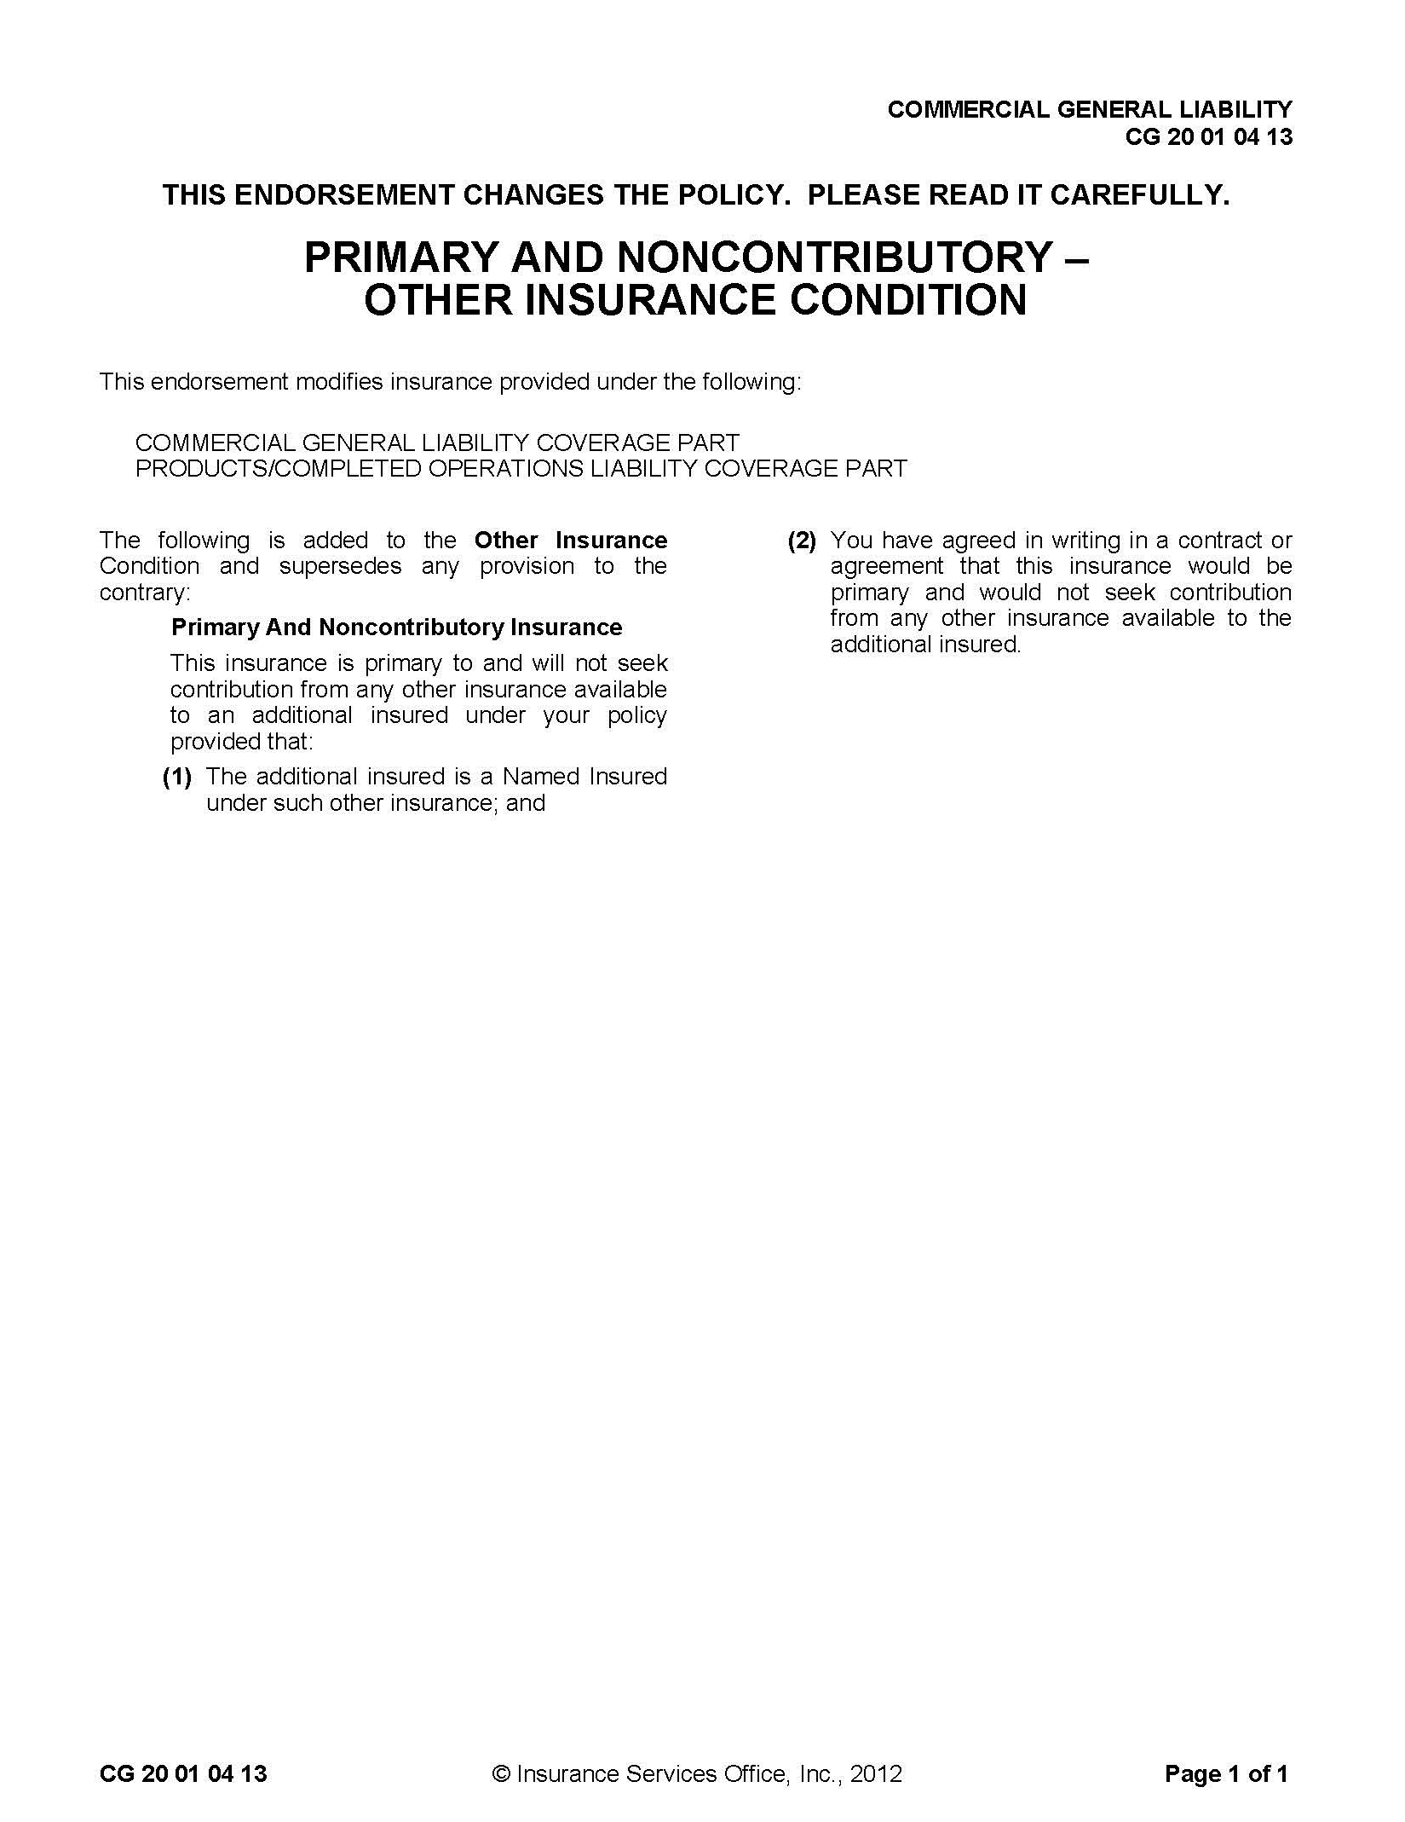
Reproduction of Insurance Services Office, Inc. Form
SAMPLE

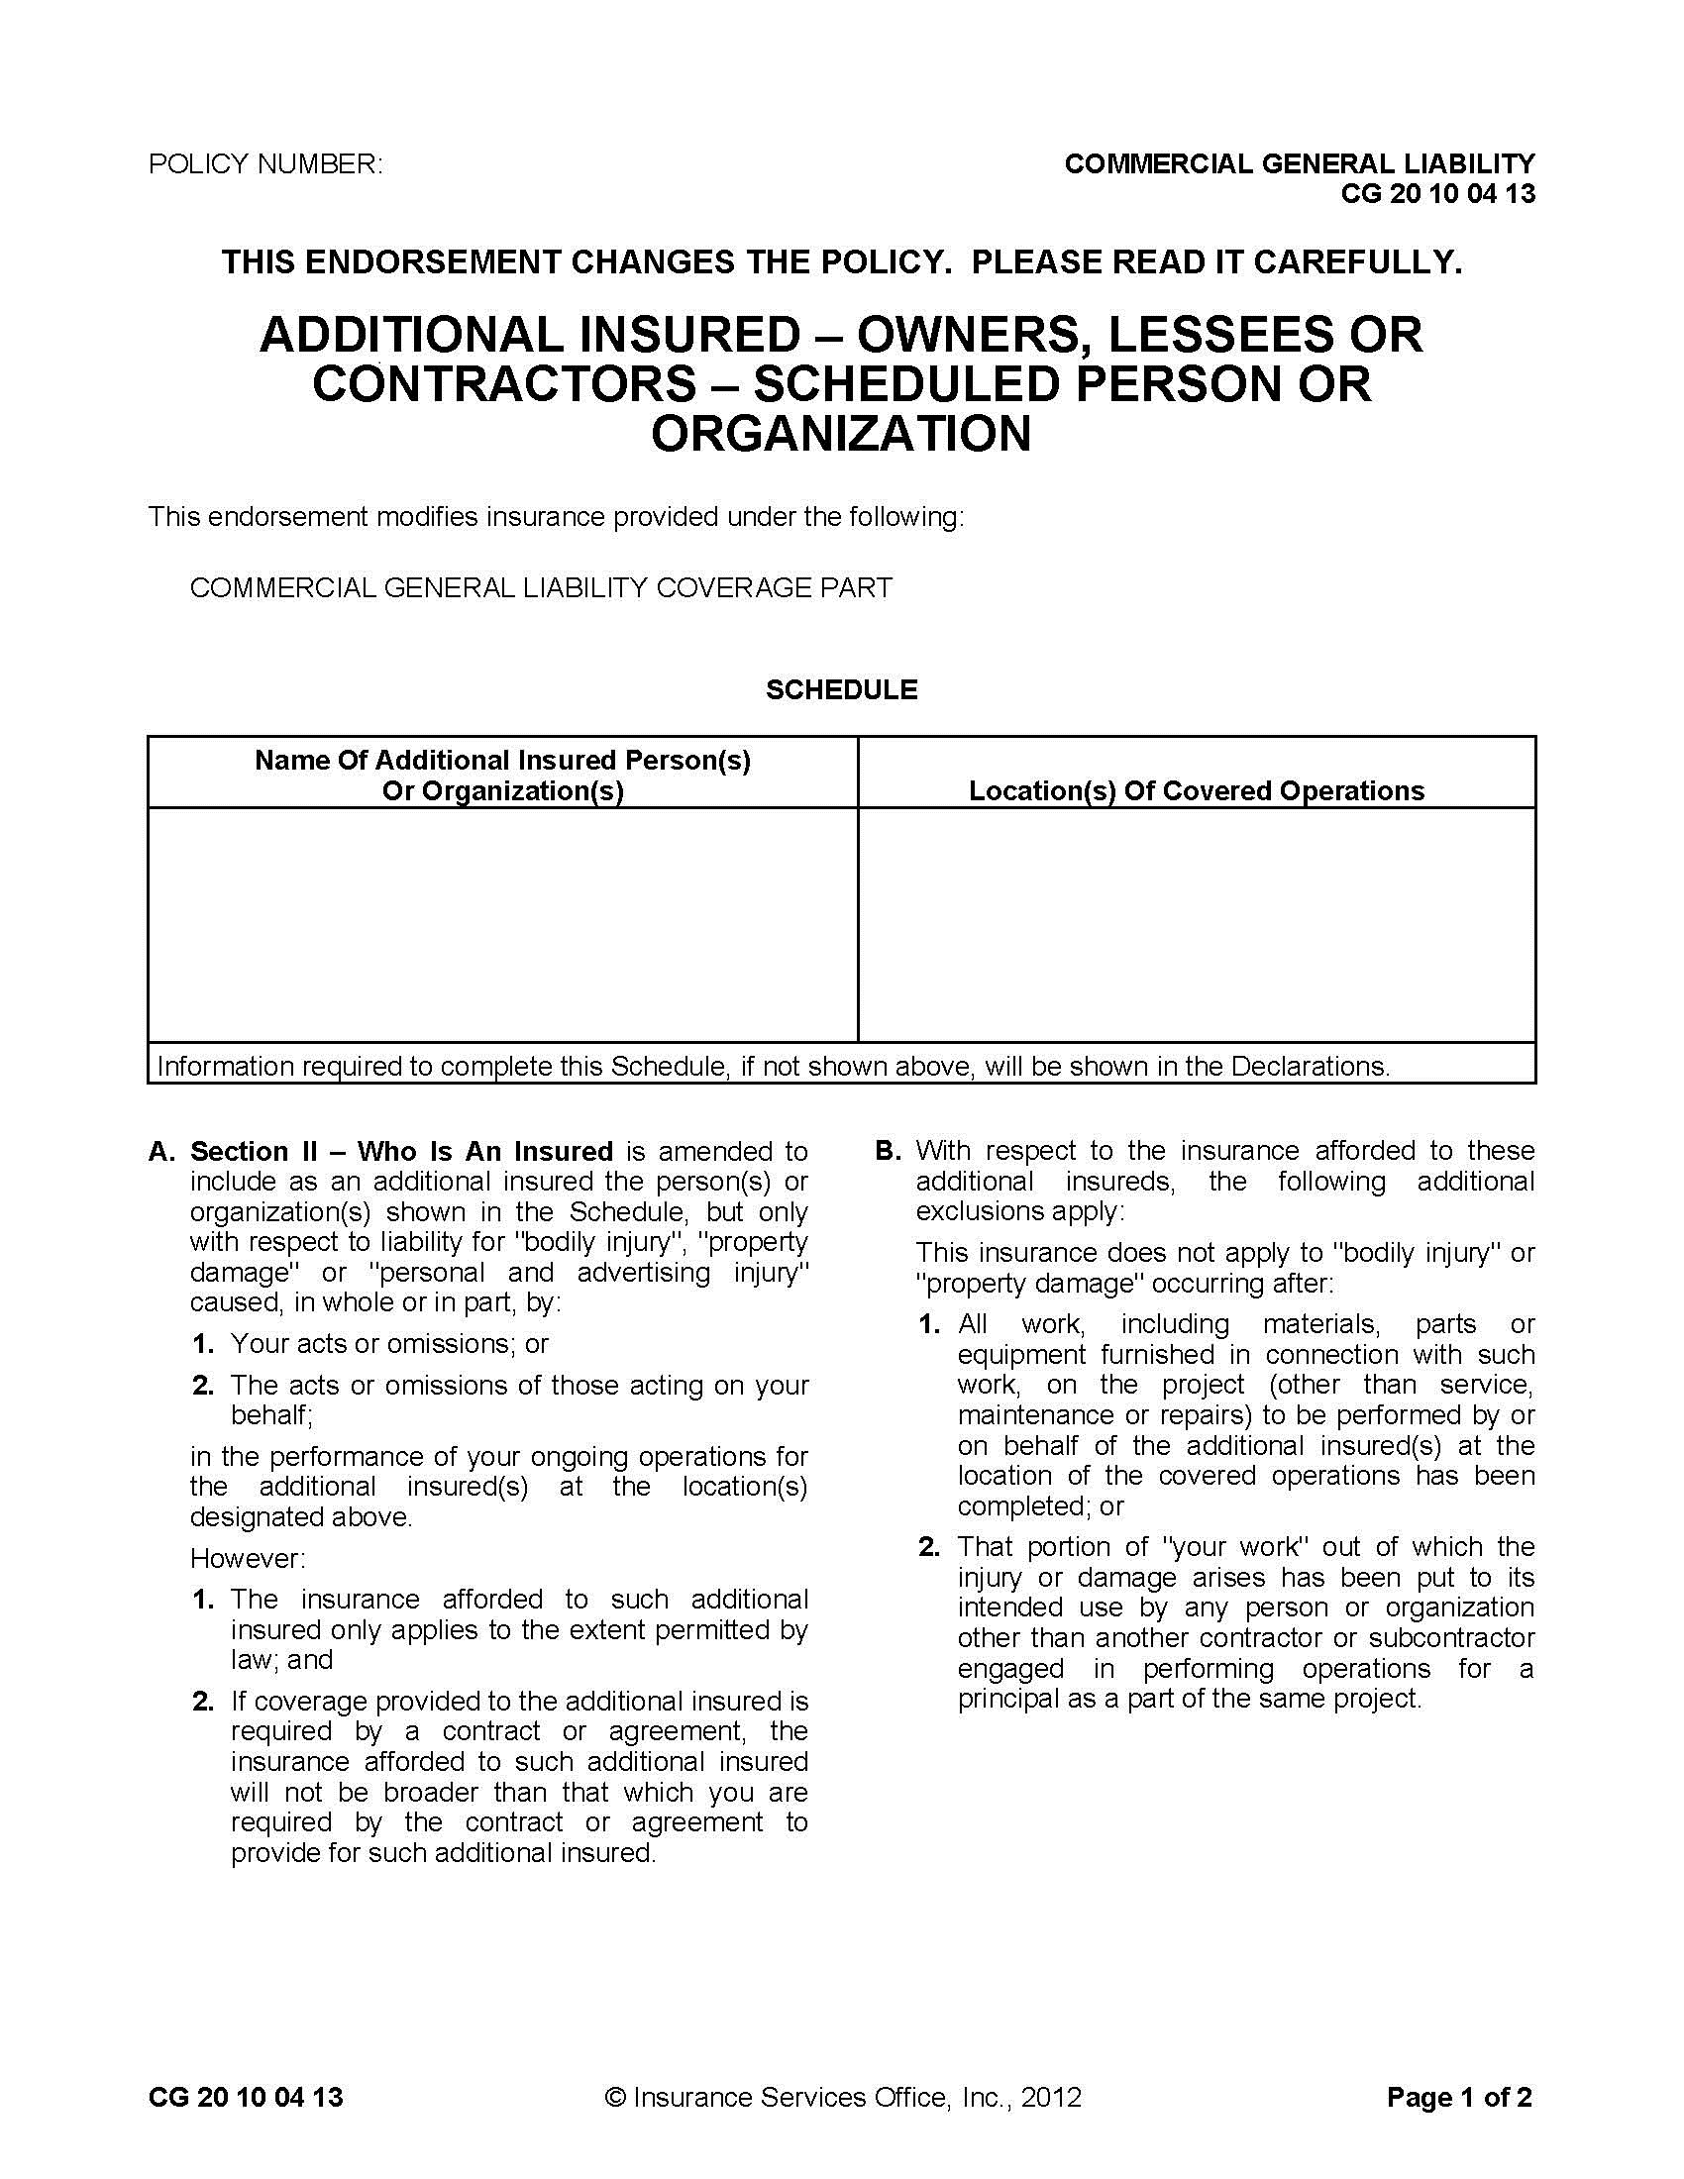
Reproduction of Insurance Services Office, Inc. Form
SAMPLE

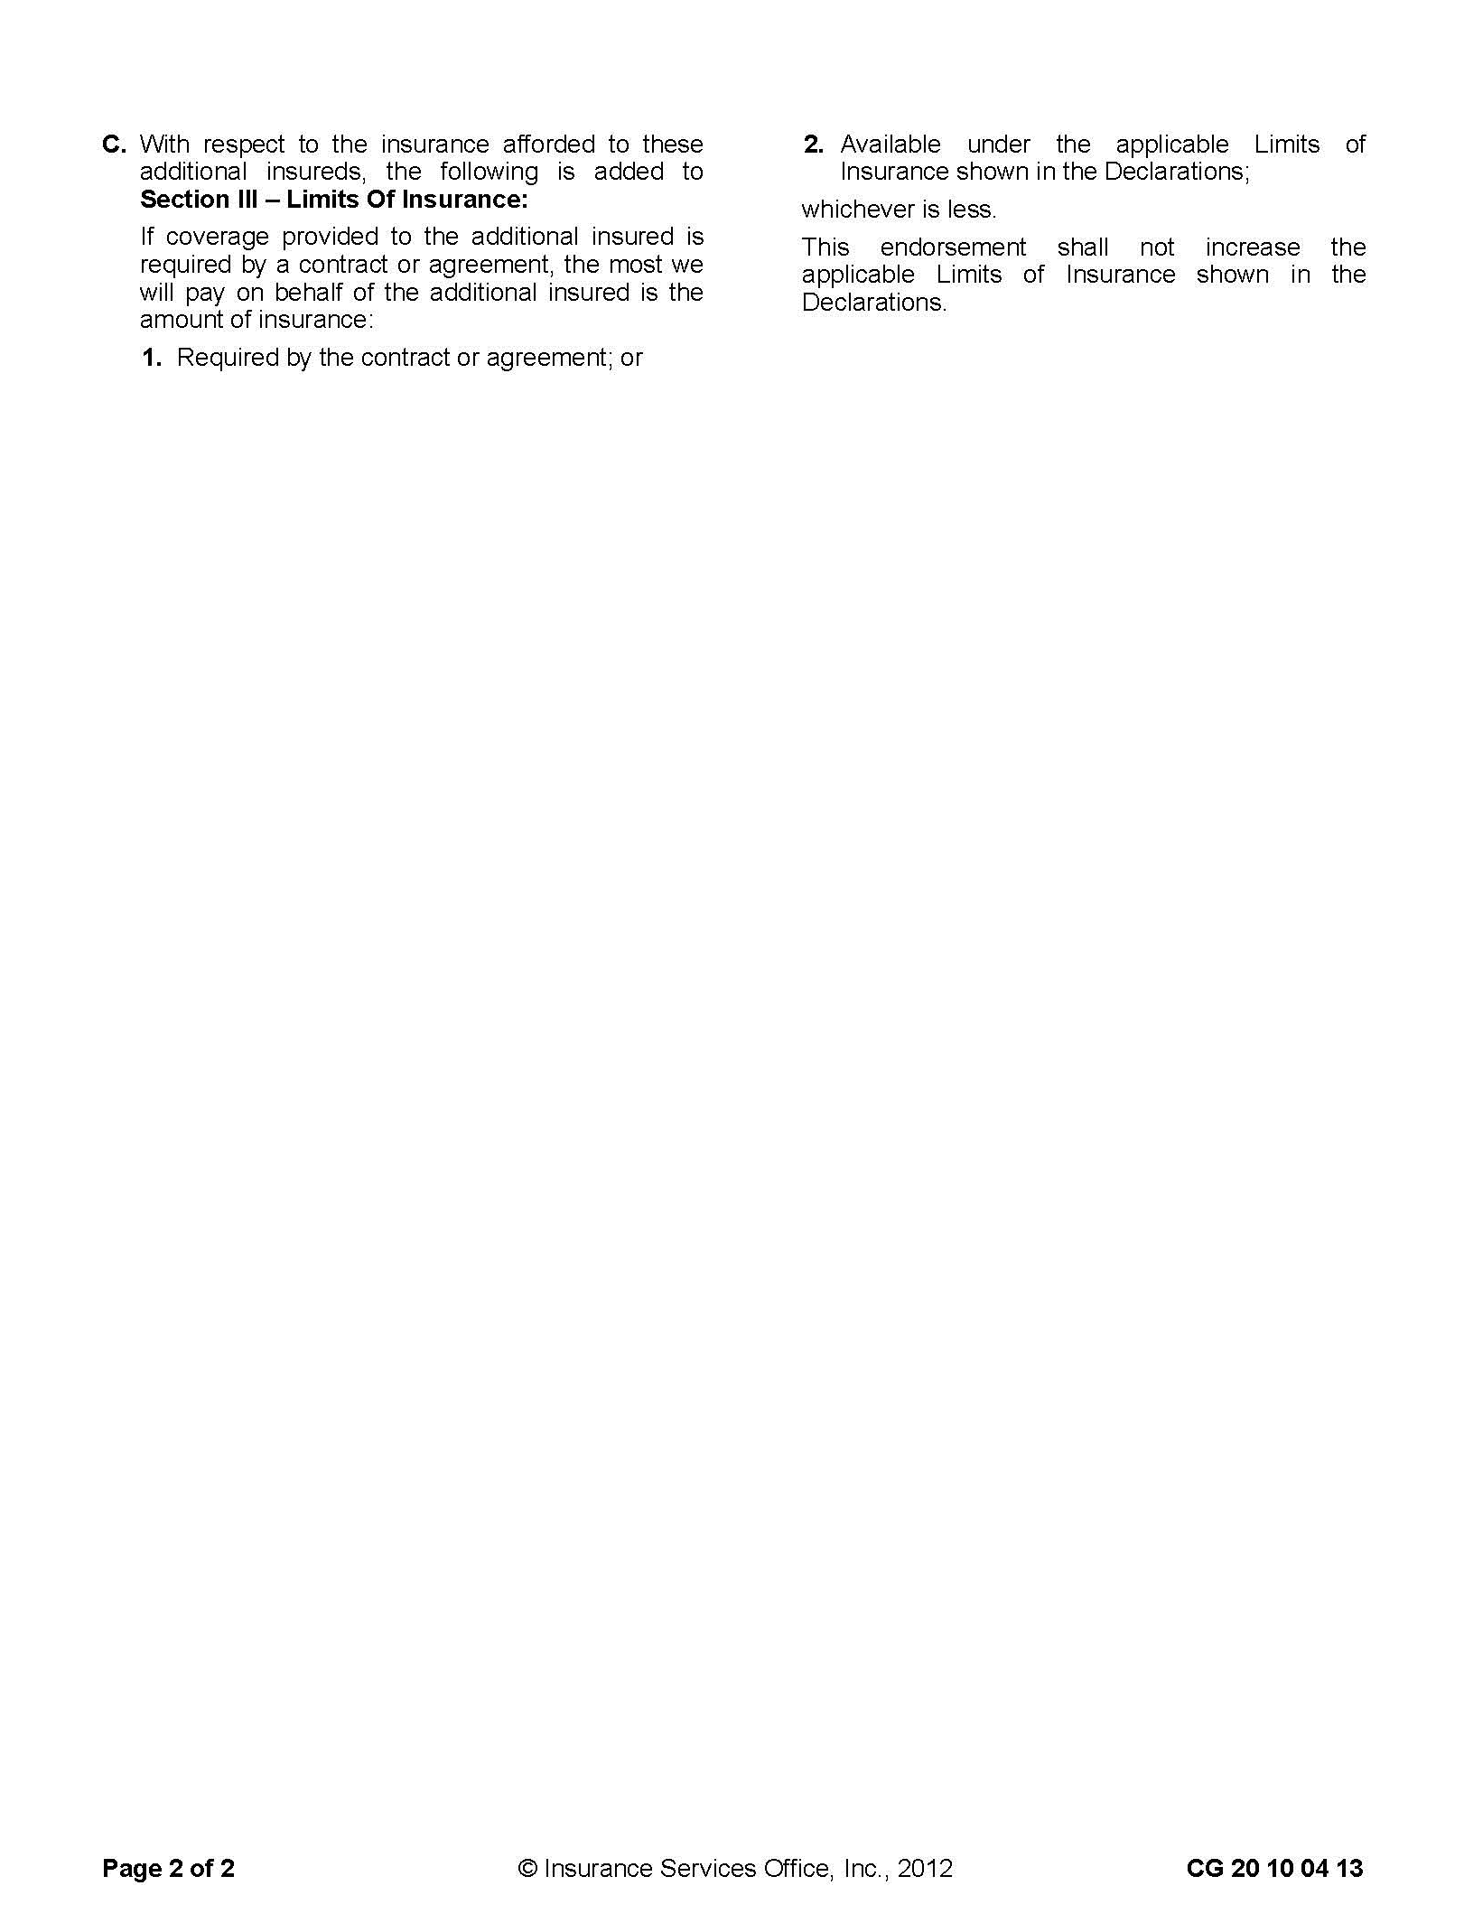
Reproduction of Insurance Services Office, Inc. Form
SAMPLE
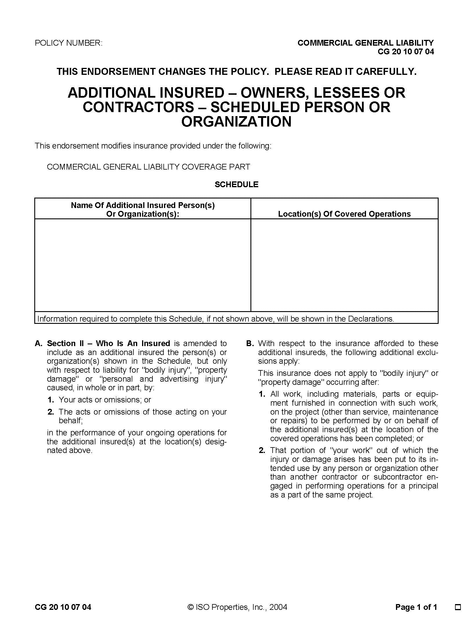
Reproduction of Insurance Services Office, Inc. Form
SAMPLE

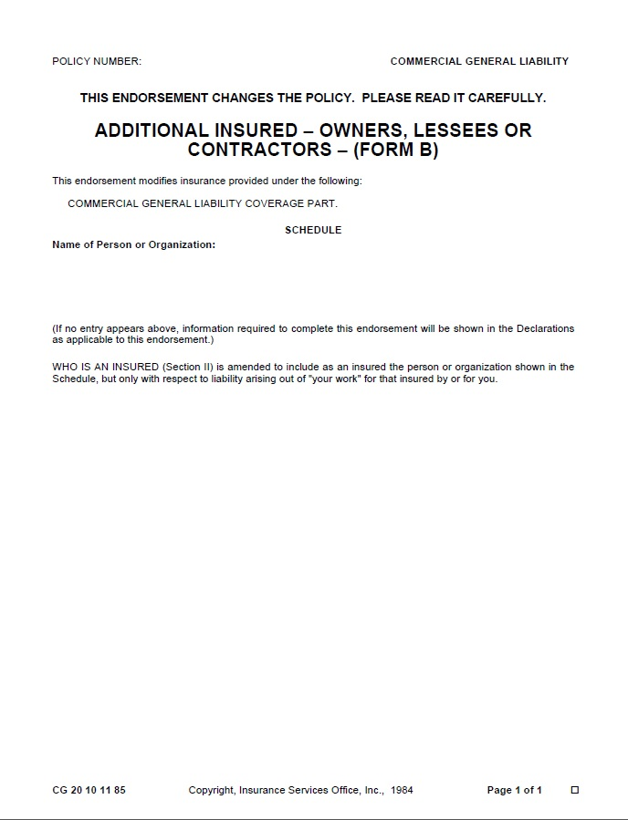
Modifications to ISO form CG 20 10 11 85:
    - The Insured scheduled above includes the Insured's officers, officials, employees and volunteers.
    - This insurance shall be primary as respects the Insured shown in the schedule above, or if excess, shall stand in an unbroken chain of coverage excess of the Named Insured's scheduled underlying primary coverage. In either event, any other insurance maintained by the Insured scheduled above shall be in excess of this insurance and shall not be called upon to contribute with it.
    - The insurance afforded by this policy shall not be canceled except after thirty days prior written notice by certified mail return receipt requested has been given to the Entity.
SAMPLE
Reproduction of Insurance Services Office, Inc. Form

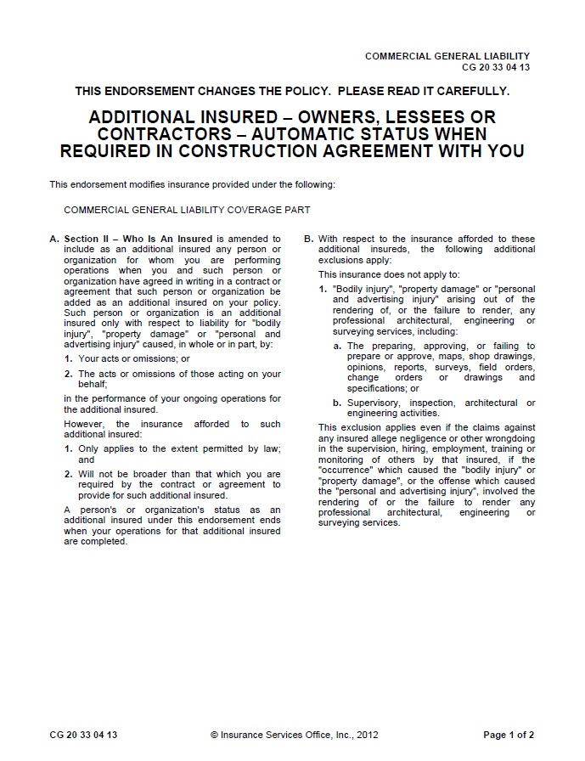
Reproduction of Insurance Services Office, Inc. Form
SAMPLE

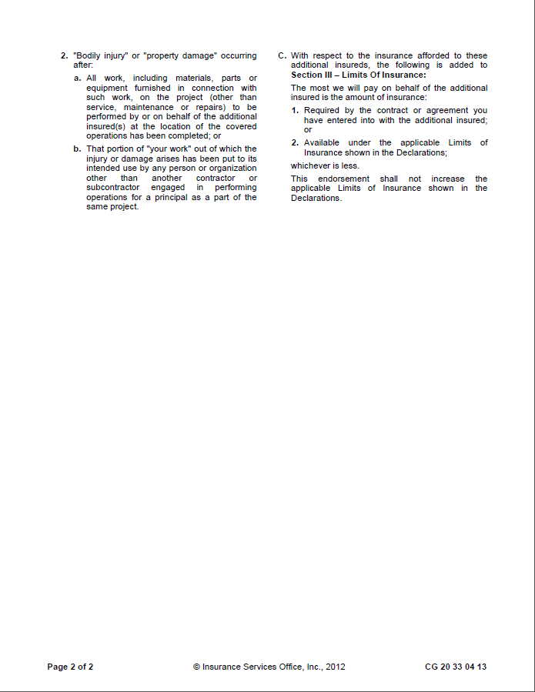
Reproduction of Insurance Services Office, Inc. Form
SAMPLE

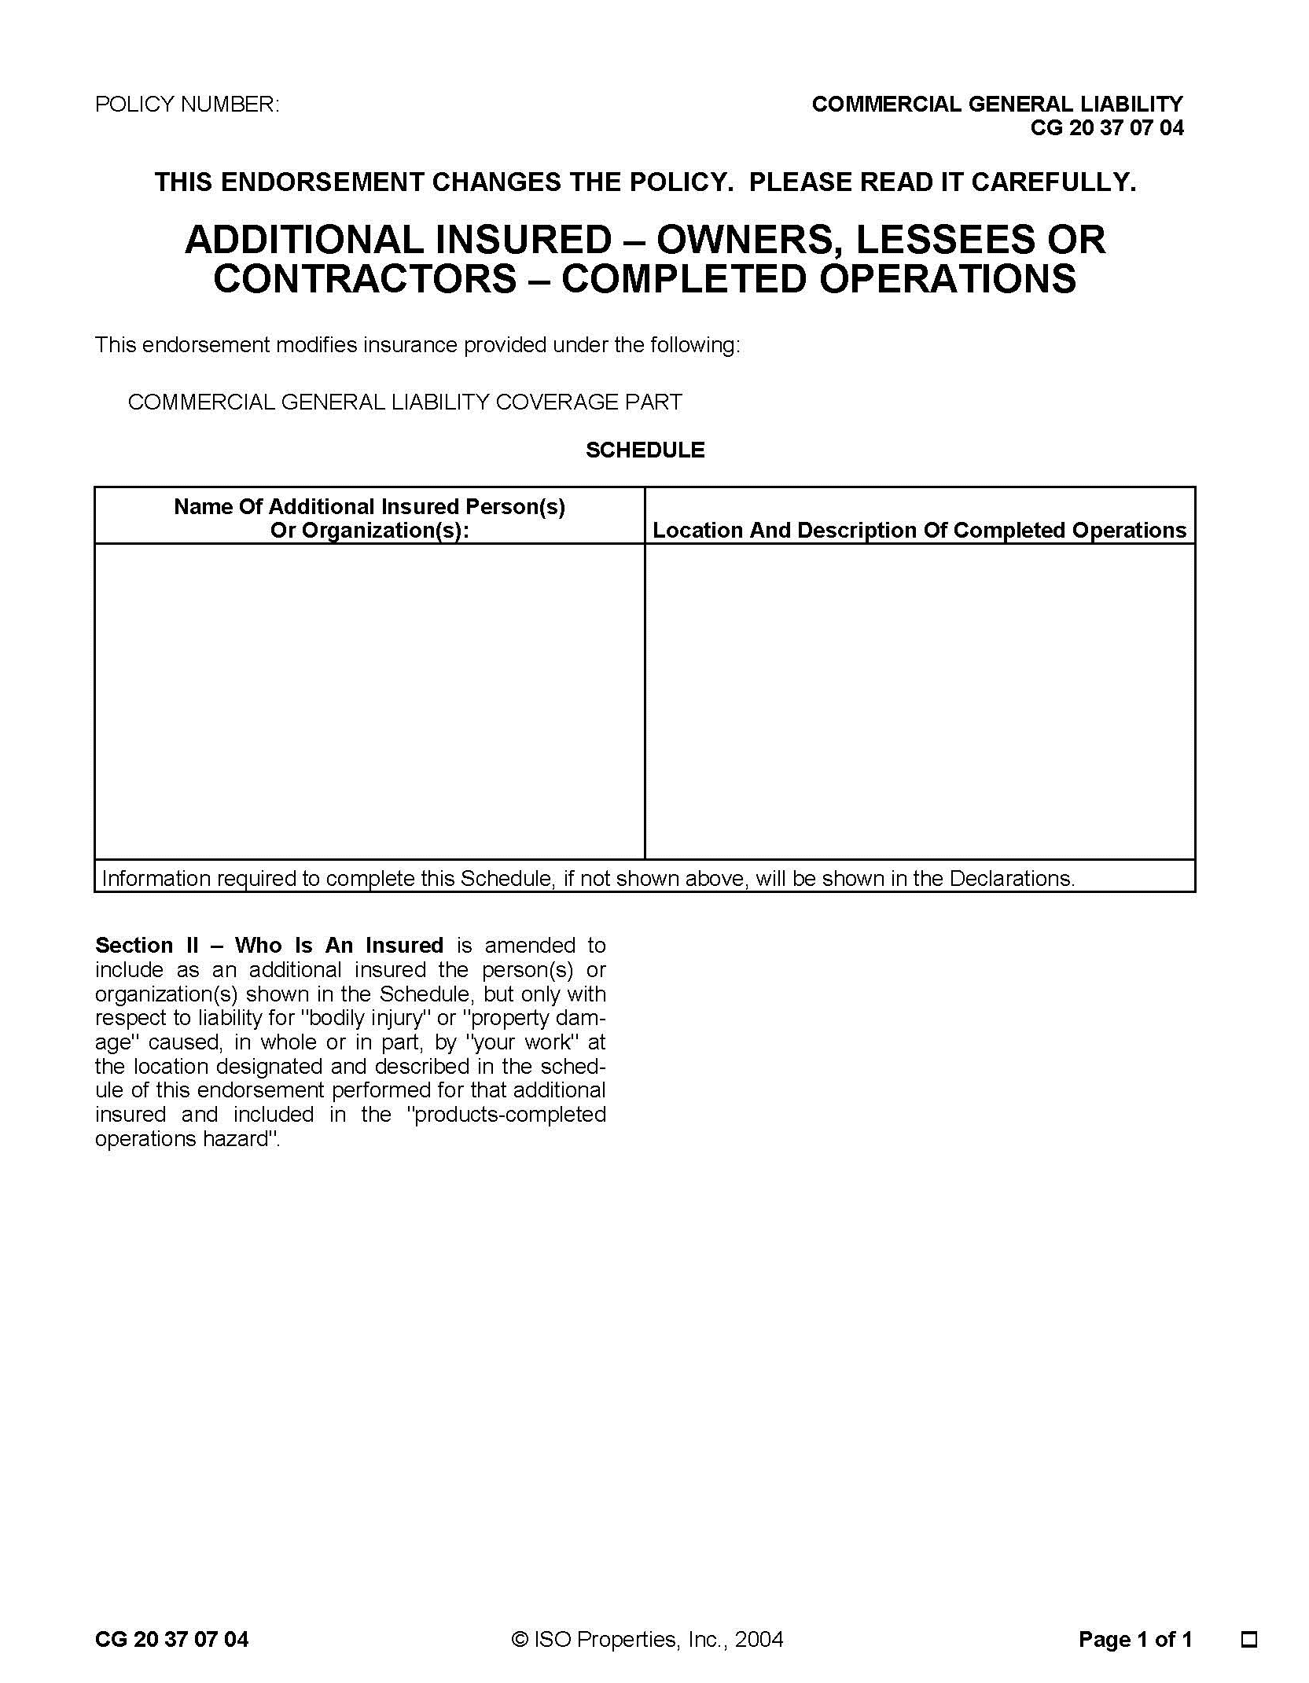
Reproduction of Insurance Services Office, Inc. Form
SAMPLE

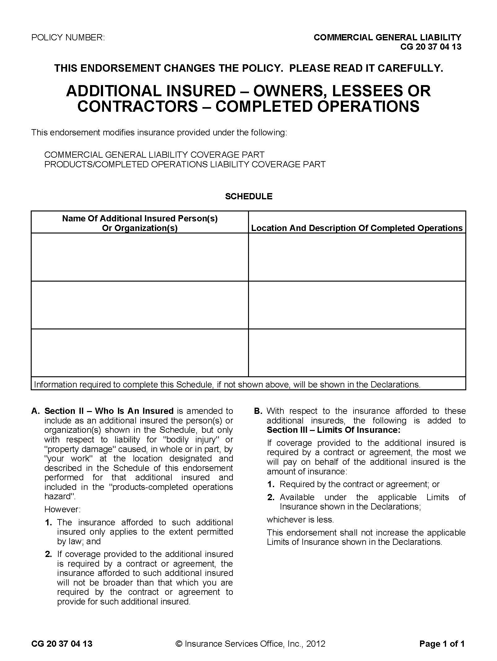
Reproduction of Insurance Services Office, Inc. Form
SAMPLE
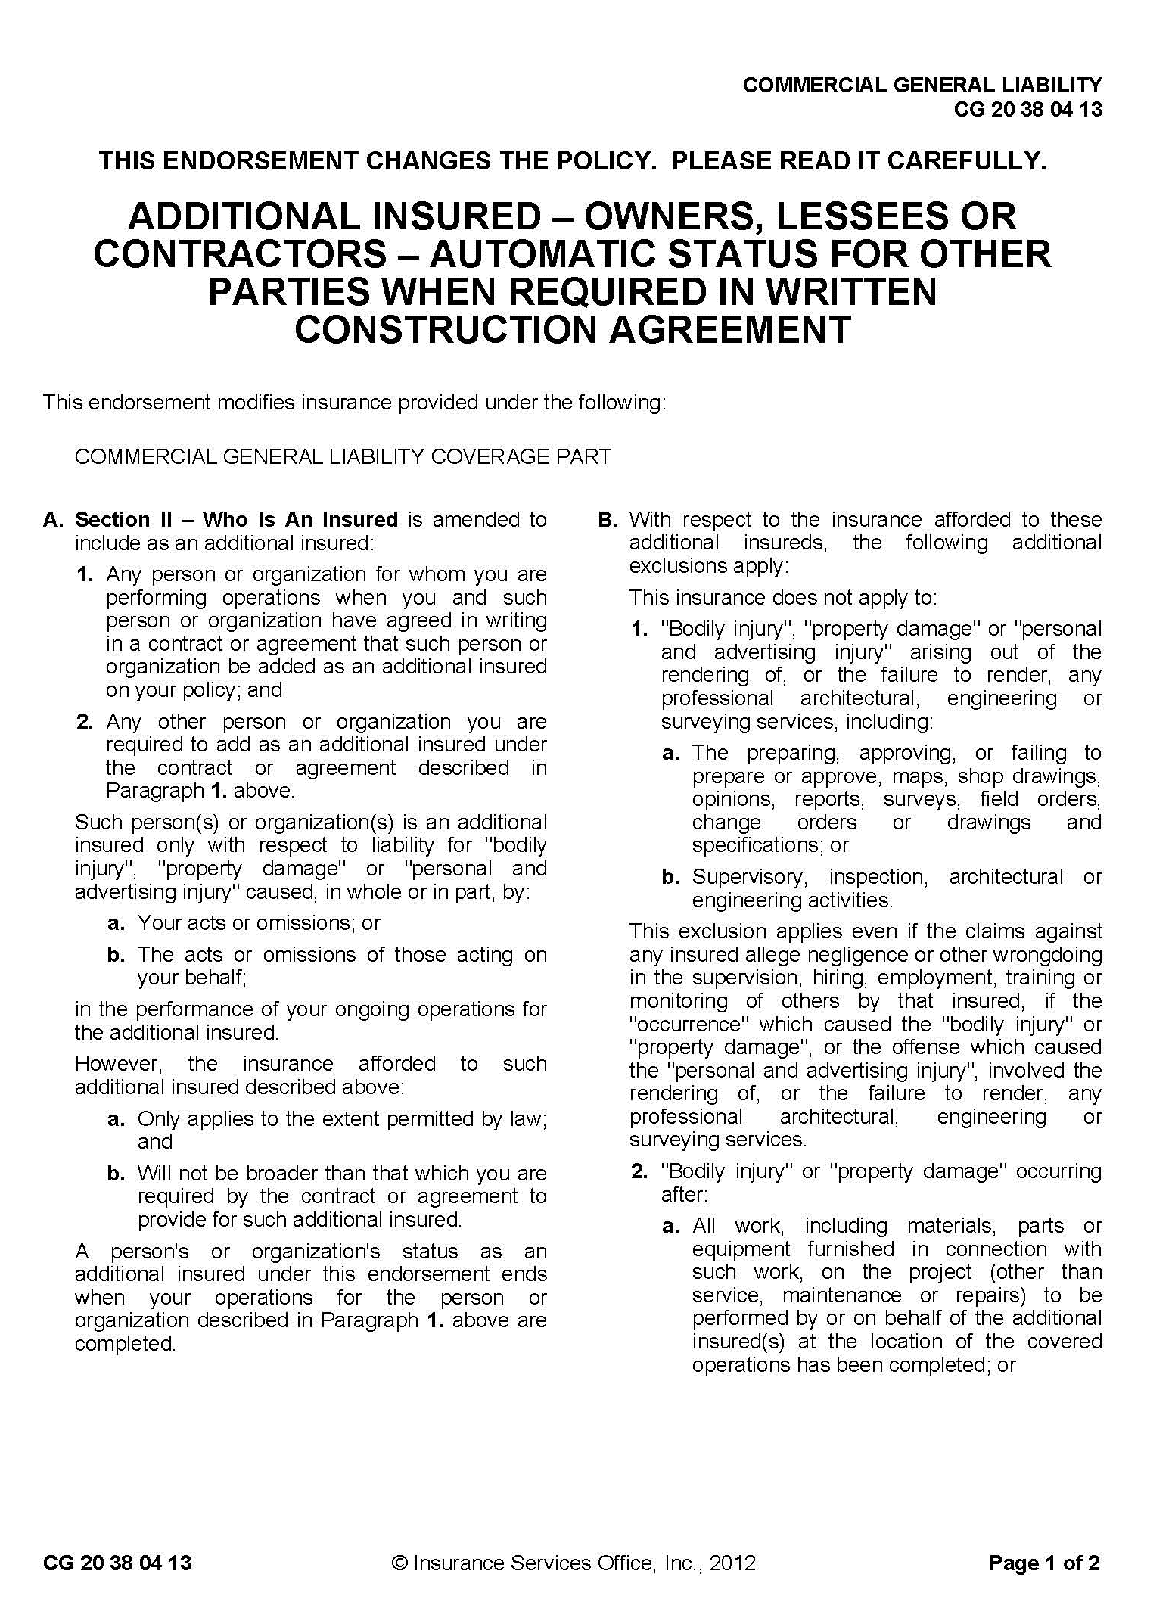
Reproduction of Insurance Services Office, Inc. Form
SAMPLE
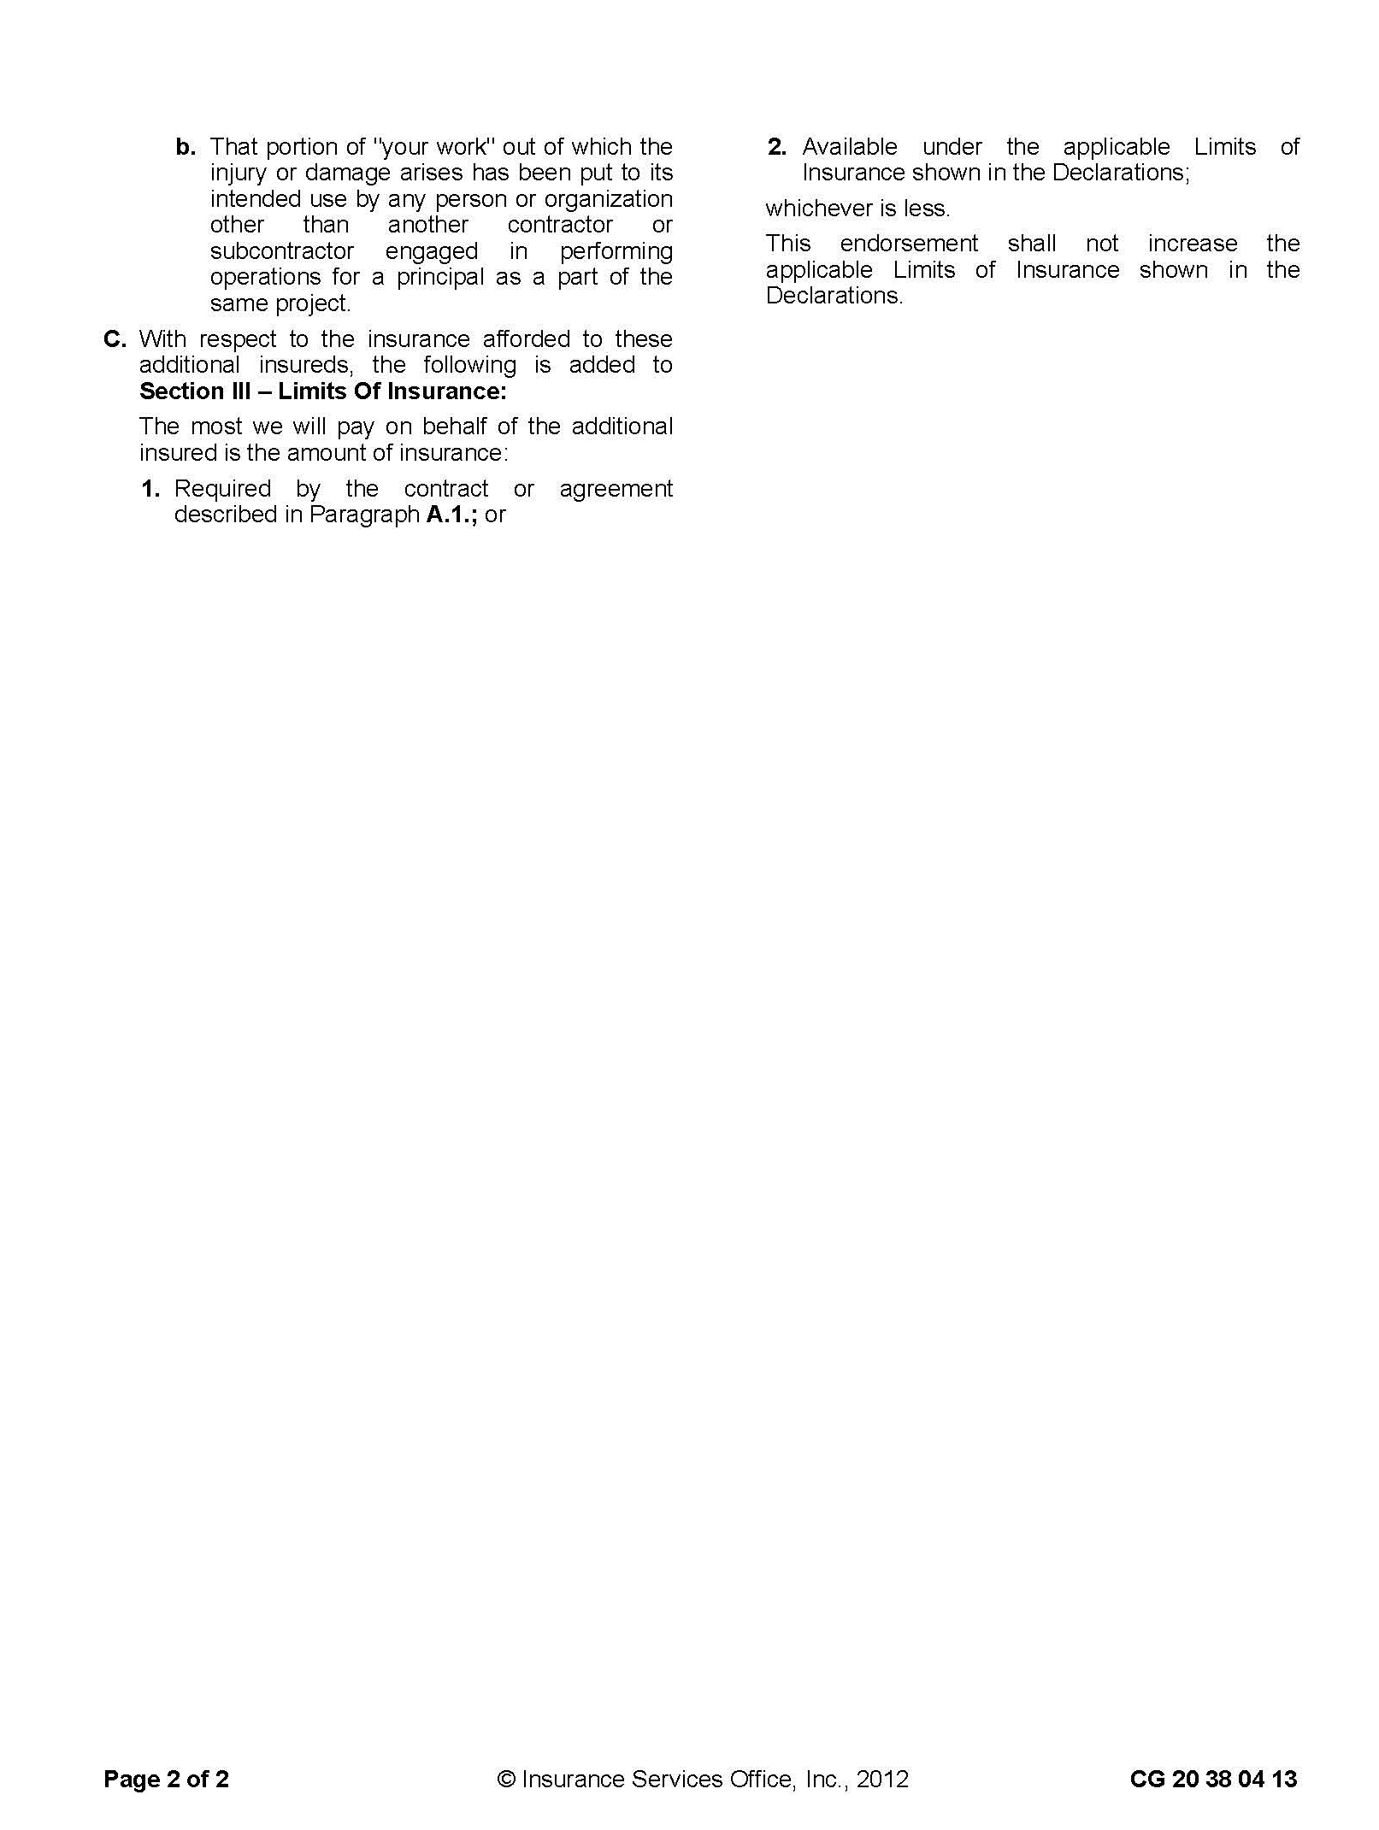

Reproduction of Insurance Services Office, Inc. Form
SAMPLE
Reproduction of Insurance Services Office, Inc. Form
SAMPLE
SAMPLE
Reproduction of Insurance Services Office, Inc. Form
SAMPLE
SAMPLE

Reproduction of Insurance Services Office, Inc. Form
SAMPLE

Reproduction of Insurance Services Office, Inc. Form

SAMPLE
Reproduction of Insurance Services Office, Inc. Form
SAMPLE
Reproduction of Insurance Services Office, Inc. Form
SAMPLE

Reproduction of Insurance Services Office, Inc. Form
SAMPLE
Reproduction of Insurance Services Office, Inc. Form
SAMPLE

Reproduction of Insurance Services Office, Inc. Form
SAMPLE

Reproduction of Insurance Services Office, Inc. Form
Reproduction of Insurance Services Office, Inc. Form
SAMPLE
SAMPLE

Reproduction of Insurance Services Office, Inc. Form

Reproduction of Insurance Services Office, Inc. Form
SAMPLE
SAMPLE

Reproduction of State Compensation Insurance Fund Form
Reproduction of State Compensation Insurance Fund Form
STATE  COMPENSATION  INSURANCE  FUND | P.O. BOX 807, SAN FRANCISCO, CALIFORNIA 94101  Certificate Of Workers’ Compensation Insurance
POLICY NUMBER:
CERTIFICATE EXPIRES:

This is to certify that we have issued a valid Workers’ Compensation insurance policy in a form approved by the California Insurance Commissioner to the employer named below for the policy period indicated.

This policy is not subject to cancellation by the Fund except upon 30 day’s written notice to the employer.

We will give you 30 day’s advance notice should this policy be canceled prior to its normal expiration.

This certificate of insurance is not an insurance policy and odes not amend, extend or alter the coverage afforded by the policies listed herein. Notwithstanding any requirement, term or condition of any contract or other document with respect to which this certificate may be issued or may pertain, the insurance afforded by the policies described herein is subject to all the terms, exclusions and conditions of such policies.

______________________________
PRESIDENT

(Note: following text is typewritten addition to printed form)

THE STATE COMPENSATION INSURANCE FUND WAIVES ANY RIGHT OF SUBROGATION ENDORSEMENT #2570. AGAINST (ENTITY) ___________________________, ITS OFFICIALS, EMPLOYEES AND VOLUNTEERS BY REASON OF ANY PAYMENT UNDER THIS POLICY.

ENDORSEMENT #0015 ENTITLED ADDITIONAL INSURED EMPLOYER EFFECTIVE 07-20-87 IS ATTACHED TO AND FORMS A PART OF THIS POLICY. ADDITIONAL INSURED EMPLOYER: ___________________________.

ENDORSEMENT #2065 ENTITLED 30 DAY CANCELLATION NOTICE EFFECTIVE 07-20-87 IS ATTACHED TO AND FORMS A PART OF THIS POLICY.

LIABILITY OF THE STATE COMPENSATION INSURANCE FUND IS LIMITED TO $3,000,000 FOR ALL DAMAGES FOR ONE OR MORE CLAIMS RESULTING FROM EACH ACCIDENT OF OCCURRENCE ARISING OUT OF ANY ONE EVENT.

______________________________
EMPLOYER

SAMPLE

STATE  COMPENSATION  INSURANCE  FUND | additional insured employer  endorsement agreement
Home Office  San Francisco | All Effective Dates are at 12:01 AM Pacific Standard Time  or the Time Indicated at Pacific Standard Time

ANYTHING IN THIS POLICY TO THE CONTRACT NOTWITHSTANDING, IT IS AGREED THAT

EMPLOYER: | NAMED OF ADDITIONAL INSURED  (ONE NAME PER ENDORSEMENT)

IS HEREBY NAMED AS AN ADDITIONAL INSURED EMPLOYER ON THIS POLICY BUT ONLY AS RESPECTS EMPLOYEES WHOSE NAMES APPEAR ON THE PAYROLL RECORDS OF

(POLICY NAME)

(HEREIN CALLED THE PRIMARY INSURED) WHILE THOSE EMPLOYEES ARE ENGAGED IN WORK UNDER THE SIMULTANEOUS DIRECTION AND CONTROL OF THE PRIMARY INSURED AND THE ADDITIONAL INSURED EMPLOYER.

IT IS FURTHER AGREED THAT THE PAYMENT OF THE FULL PREMIUM DUE AND PAYABLE UNDER THIS POLICY SHALL REMAIN THE SOLE RESPONSIBILITY OF THE PRIMARY INSURED.

NOTHING IN THIS ENDORSEMENT CONTAINED SHALL BE HALED TO VARY, ALTER, WAIVE OR EXTEND ANY OF THE TERMS, CONDITIONS, AGREEMENTS OR LIMITATIONS OF THIS POLICY OTHER THAN AS STATED. NOTHING ELSEWHERE IN THIS POLICY SHALL BE HELD TO VARY, ALTER, WAIVE OR LIMIT THE TERMS, CONDITIONS, AGREEMENTS OR LIMITATIONS OF THIS ENDORSEMENT.

COUNTERSIGNED AND ISSUED AT SAN FRANCISCO 0015
SAMPLE
Reproduction of State Compensation Insurance Fund Form
SAMPLE

STATE  COMPENSATION  INSURANCE  FUND | ADDITIONAL INSURED EMPLOYER  ENDORSEMENT AGREEMENT
Home Office  San Francisco | All Effective Dates are at 12:01 AM Pacific Standard Time  or the Time Indicated at Pacific Standard Time

ANYTHING IN THIS POLICY TO THE CONTRARY NOTWITHSTANDING, IT IS AGREED THAT THE STATE COMPENSATION INSURANCE FUND WAIVES ANY RIGHT OF SUBROGATION AGAINST:

(SPECIFY 3RD PARTY REQUESTING WAIVER: ONE NAME PER ENDORSEMENT)

WHICH MIGHT ARISE BY REASON OF ANY PAYMENT UNDER THIS POLICY IN CONNECTION WITH WORK PERFORMED BY:

(POLICY NAME)

IT IS FURTHER AGREED THAT THE INSURED SHALL MAINTAIN PAYROLL RECORDS ACCURATELY SEGREGATING THE REMUNERATION OF EMPLOYEES WHILE ENGAGED IN WORK FOR THE ABOVE EMPLOYER.

IT IS FURTHER AGREED THAT PREMIUM ON THE EARNINGS OF SUCH EMPLOYEES SHALL BE INCREASED BY _________%.

NOTHING IN THIS ENDORSEMENT CONTAINED SHALL BE HALED TO VARY, ALTER, WAIVE OR EXTEND ANY OF THE TERMS, CONDITIONS, AGREEMENTS OR LIMITATIONS OF THIS POLICY OTHER THAN AS STATED. NOTHING ELSEWHERE IN THIS POLICY SHALL BEHELD TO VARY, ALTER, WAIVE OR LIMIT THE TERMS, CONDITIONS, AGREEMENTS OR LIMITATIONS OF THIS ENDORSEMENT.

COUNTERSIGNED AND ISSUED AT SAN FRANCISCO 2570

Reproduction of State Compensation Insurance Fund Form
SAMPLE

STATE  COMPENSATION  INSURANCE  FUND | ADDITIONAL INSURED EMPLOYER  ENDORSEMENT AGREEMENT
Home Office  San Francisco | All Effective Dates are at 12:01 AM Pacific Standard Time  or the Time Indicated at Pacific Standard Time

ANYTHING IN THIS POLICY TO THE CONTRARY NOTWITHSTANDING, IT IS AGREED THAT THIS POLICY SHALL NOT BE CANCELED UNTIL:

(SPECIFY NUMBER) ______________________ DAYS

AFTER WRITTEN NOTICE OF SUCH CANCELLATION HAS BEEN PLACED IN THE MAIL BY STATE FUND TO CURRENT HOLDERS OF CERTIFICATE OF WORKERS’ COMPENSATION INSURANCE.

NOTHING IN THIS ENDORSEMENT CONTAINED SHALL BE HALED TO VARY, ALTER, WAIVE OR EXTEND ANY OF THE TERMS, CONDITIONS, AGREEMENTS OR LIMITATIONS OF THIS POLICY OTHER THAN AS STATED. NOTHING ELSEWHERE IN THIS POLICY SHALL BEHELD TO VARY, ALTER, WAIVE OR LIMIT THE TERMS, CONDITIONS, AGREEMENTS OR LIMITATIONS OF THIS ENDORSEMENT.

COUNTERSIGNED AND ISSUED AT SAN FRANCISCO 0015

Reproduction of Insurance Services Office, Inc. Form
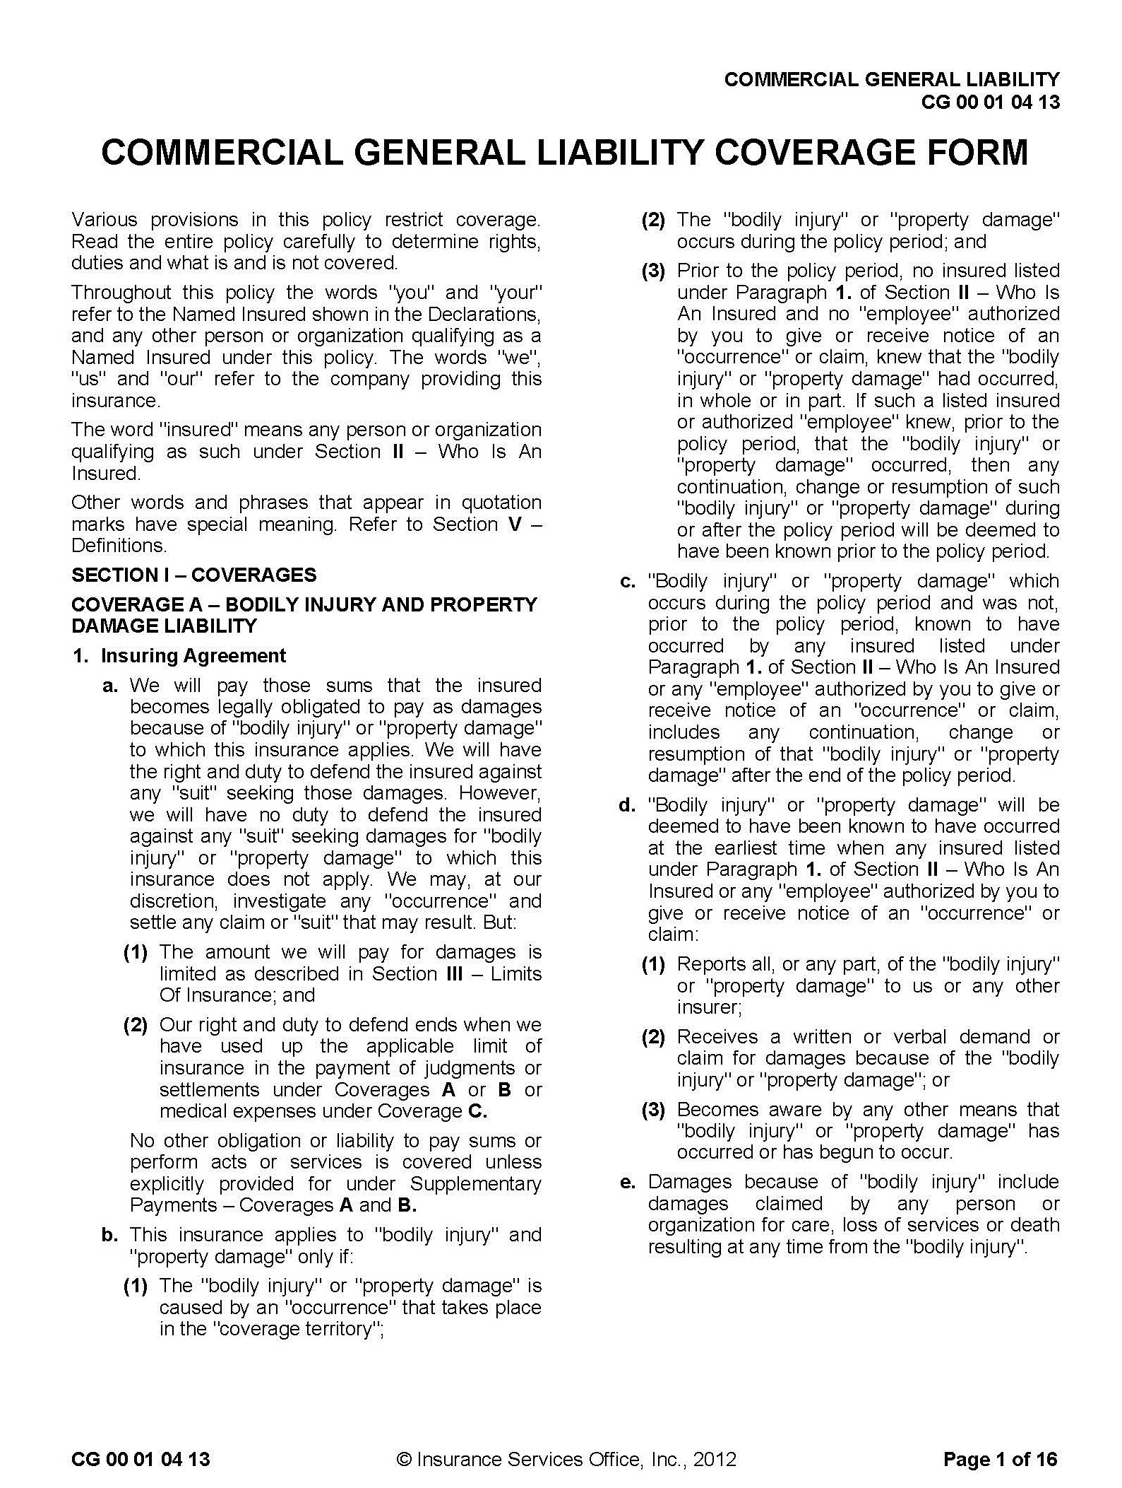
SAMPLE
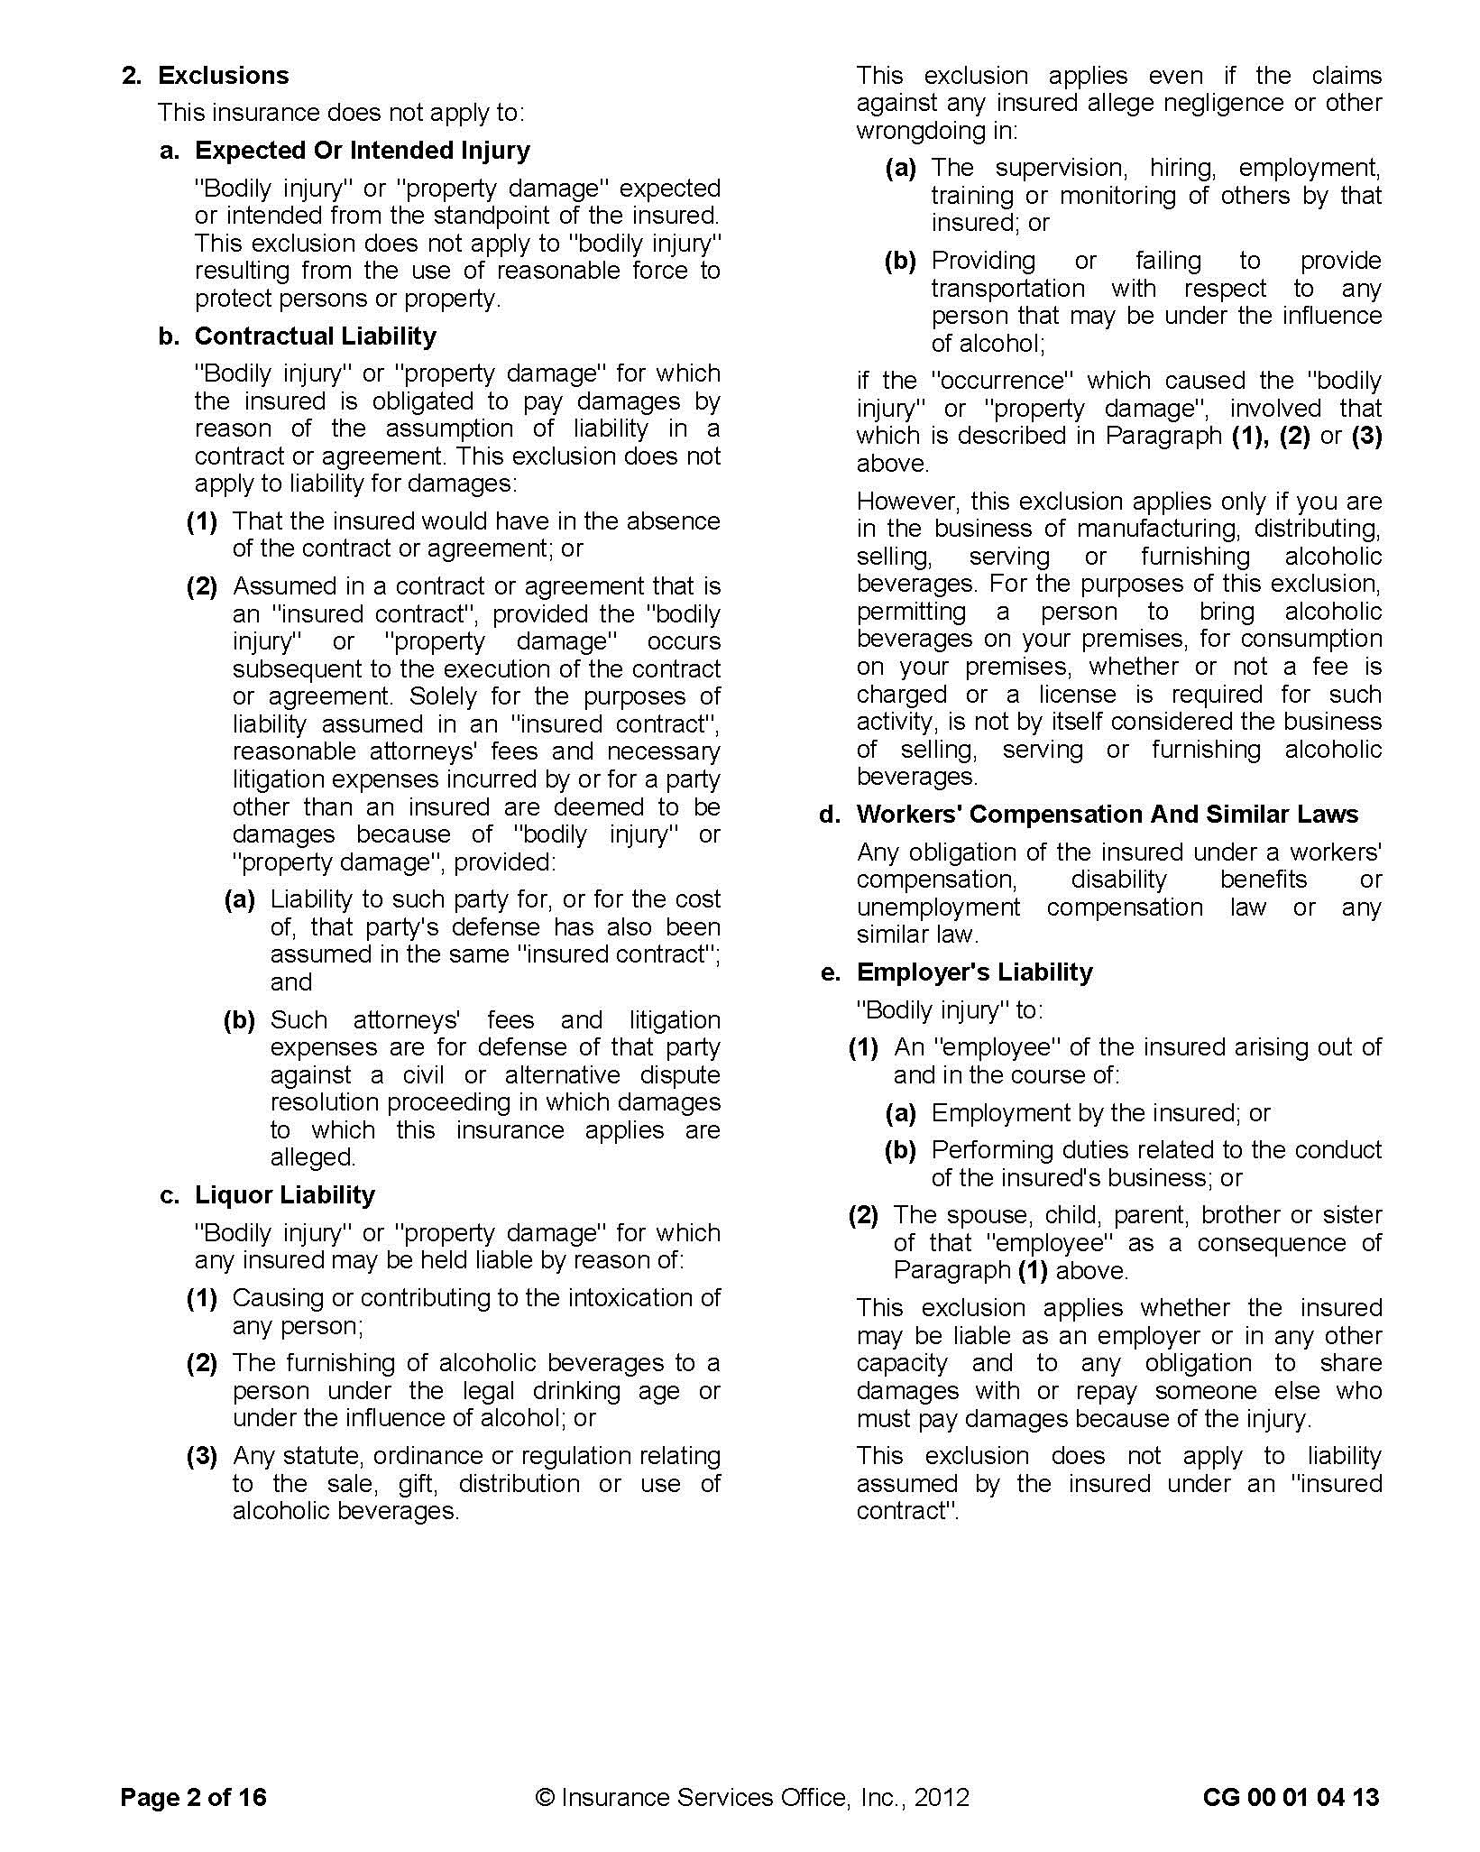
Reproduction of Insurance Services Office, Inc. Form
SAMPLE
Reproduction of Insurance Services Office, Inc. Form
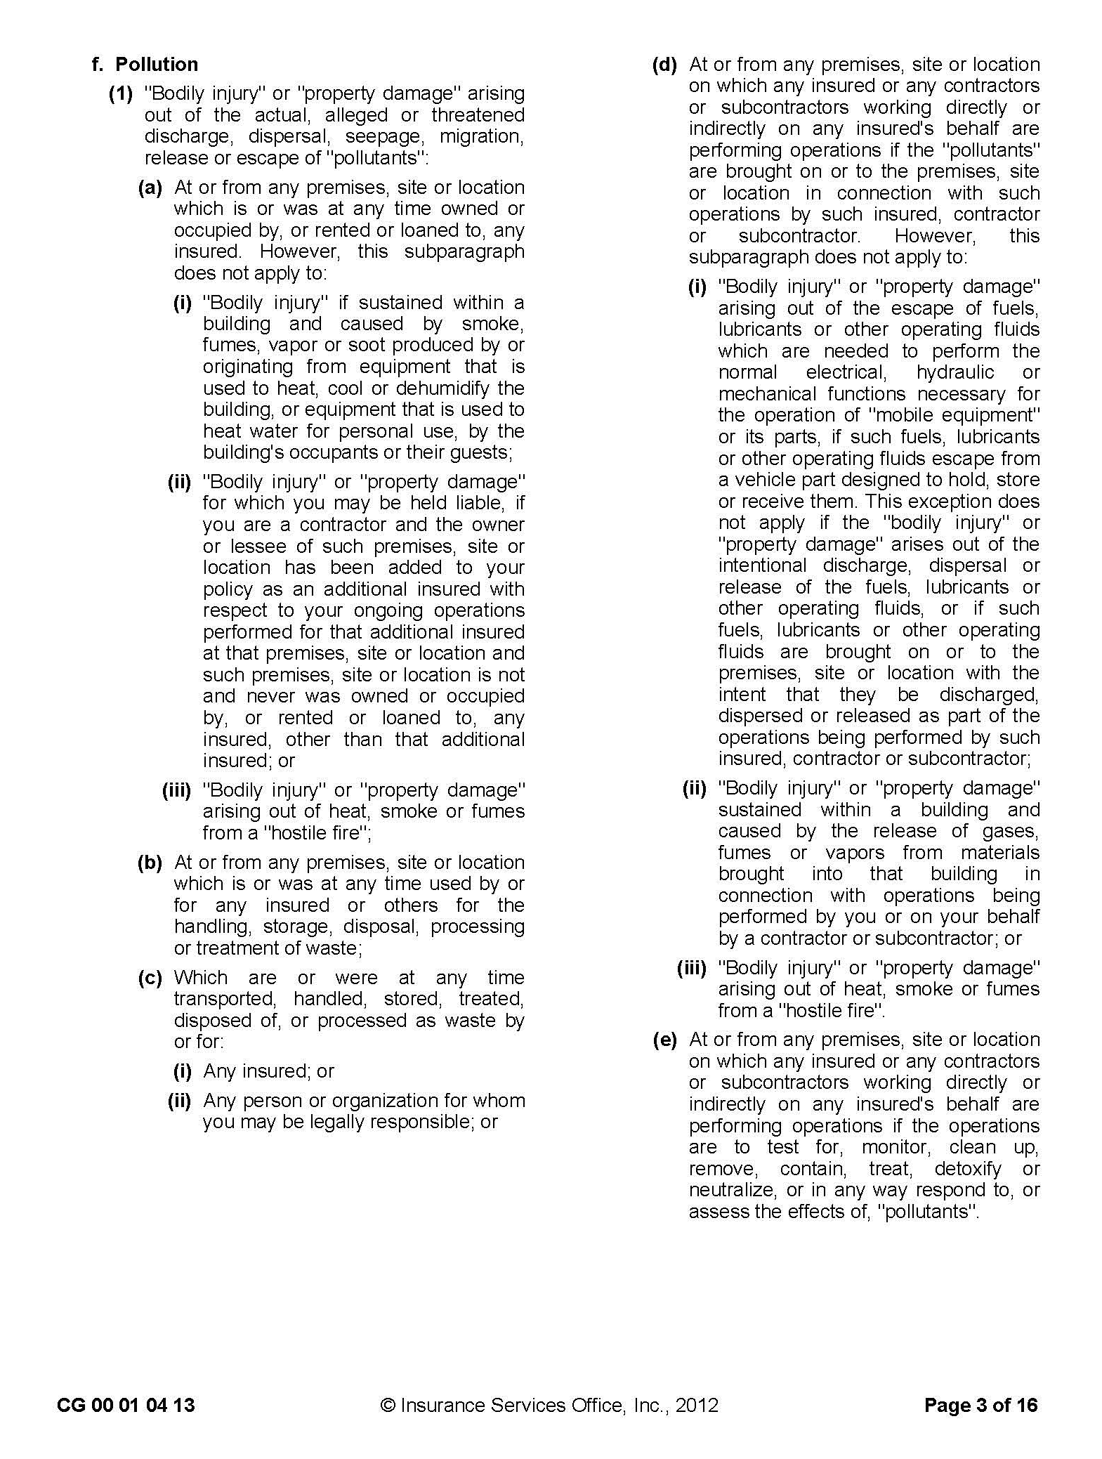
SAMPLE

Reproduction of Insurance Services Office, Inc. Form

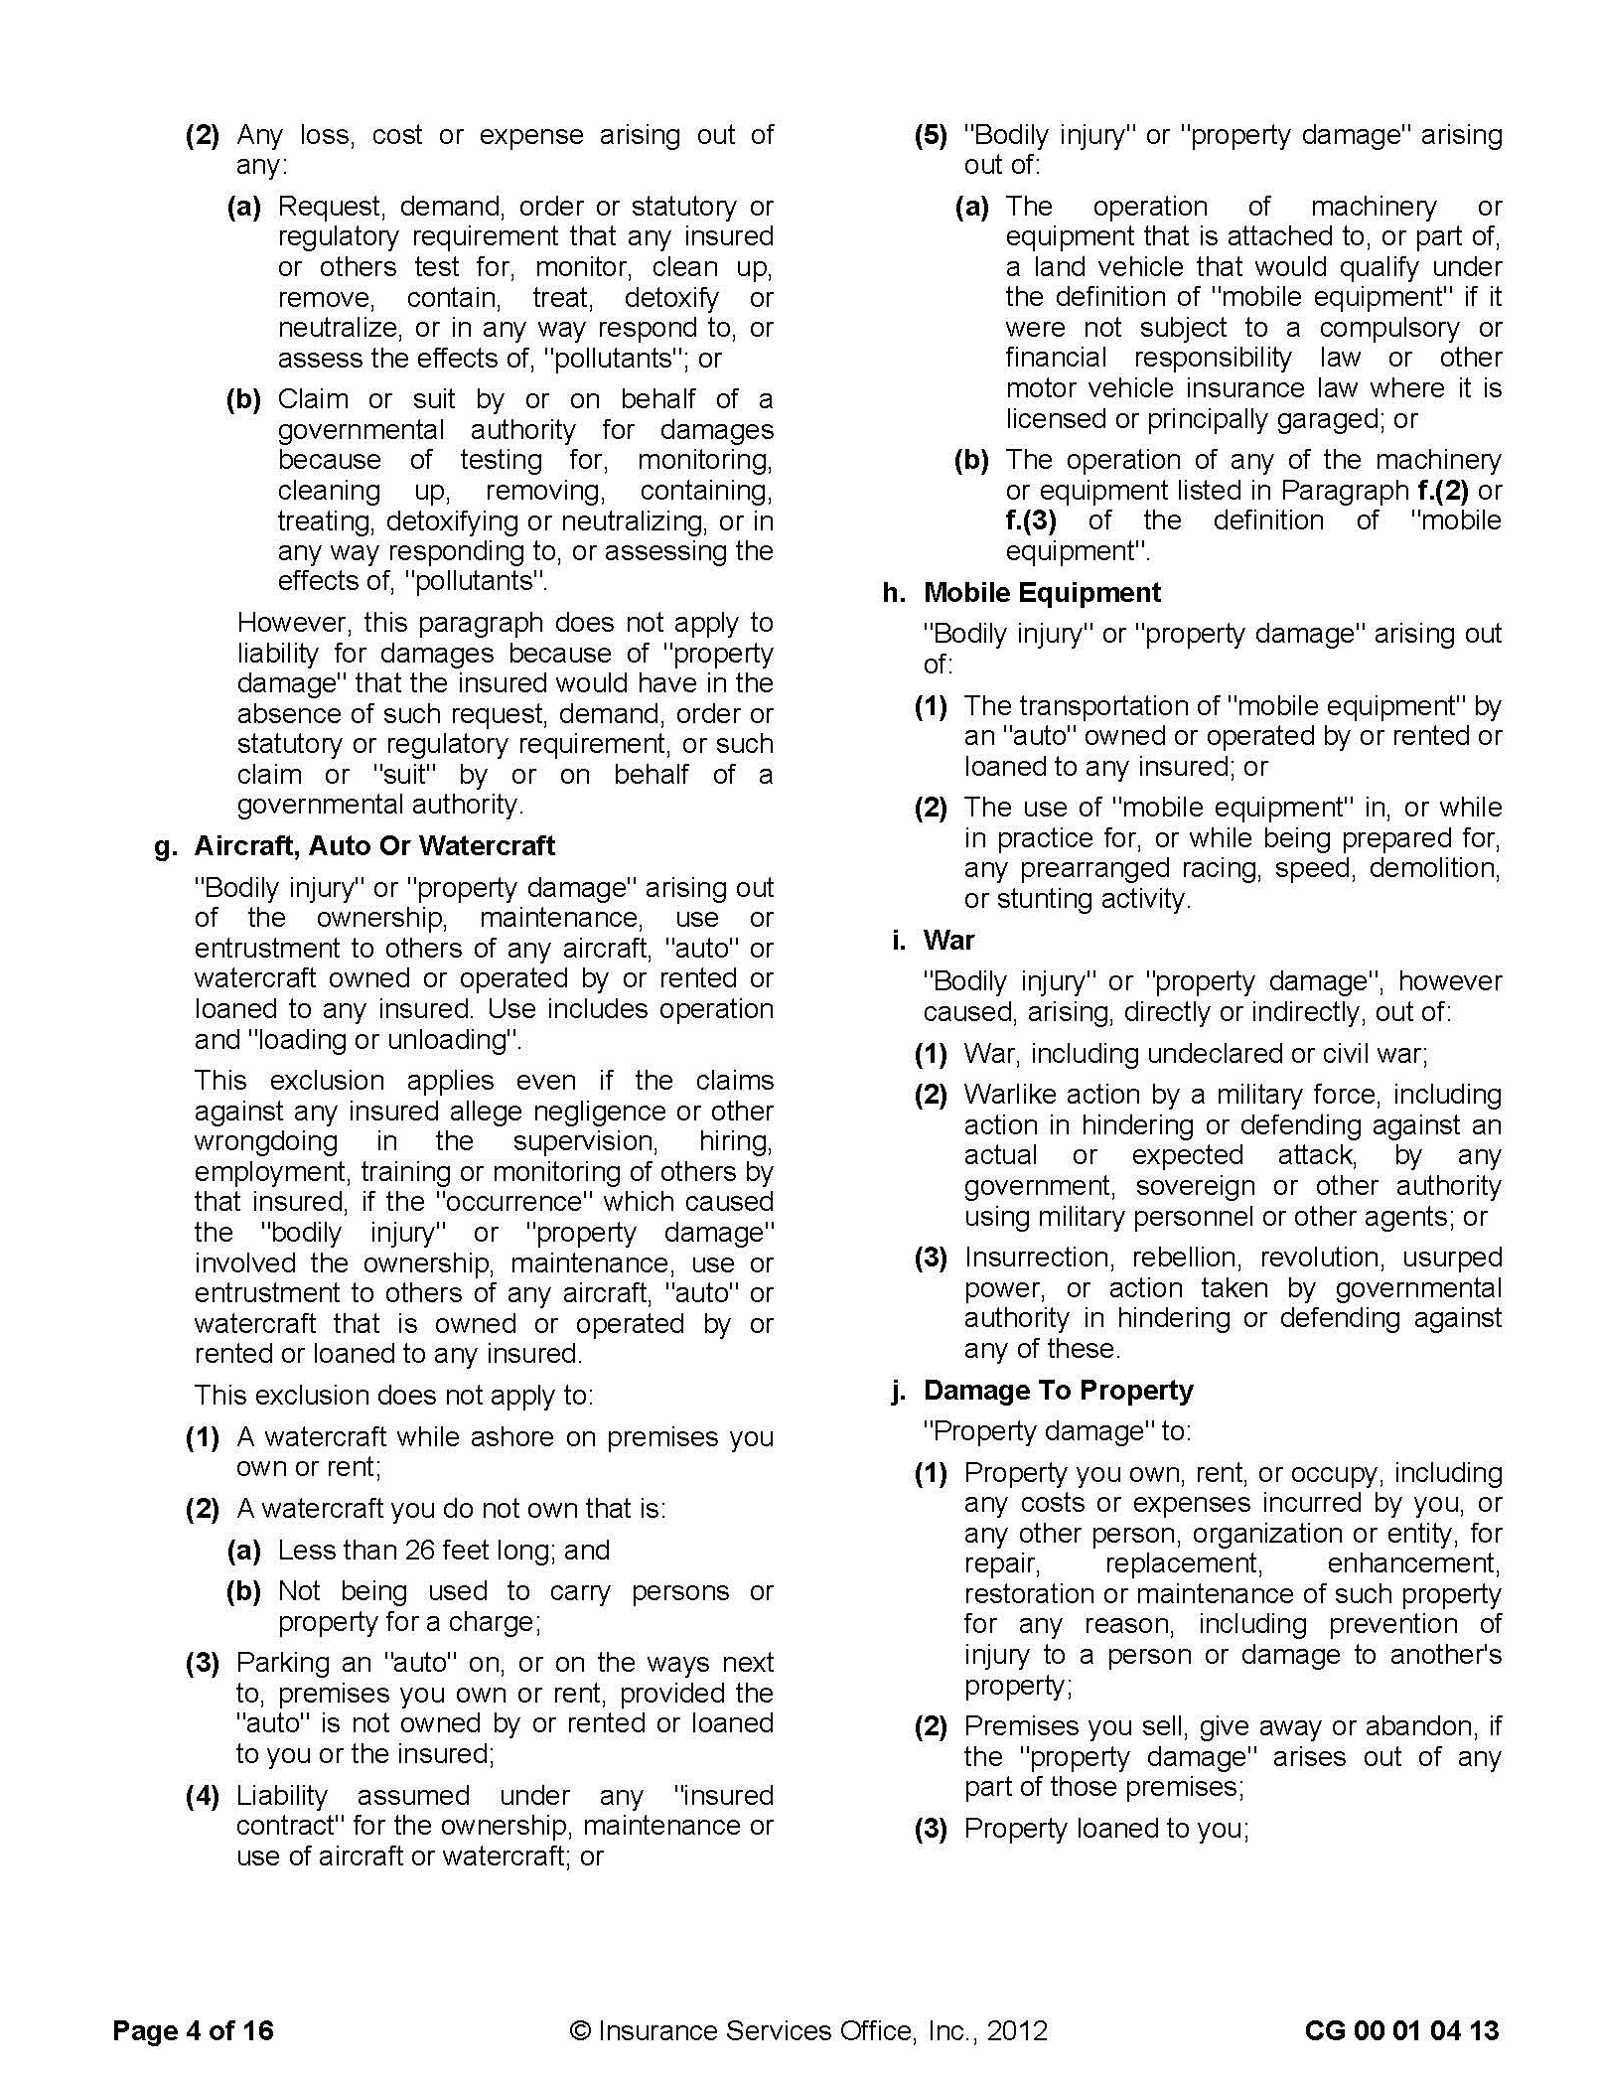
SAMPLE
Reproduction of Insurance Services Office, Inc. Form

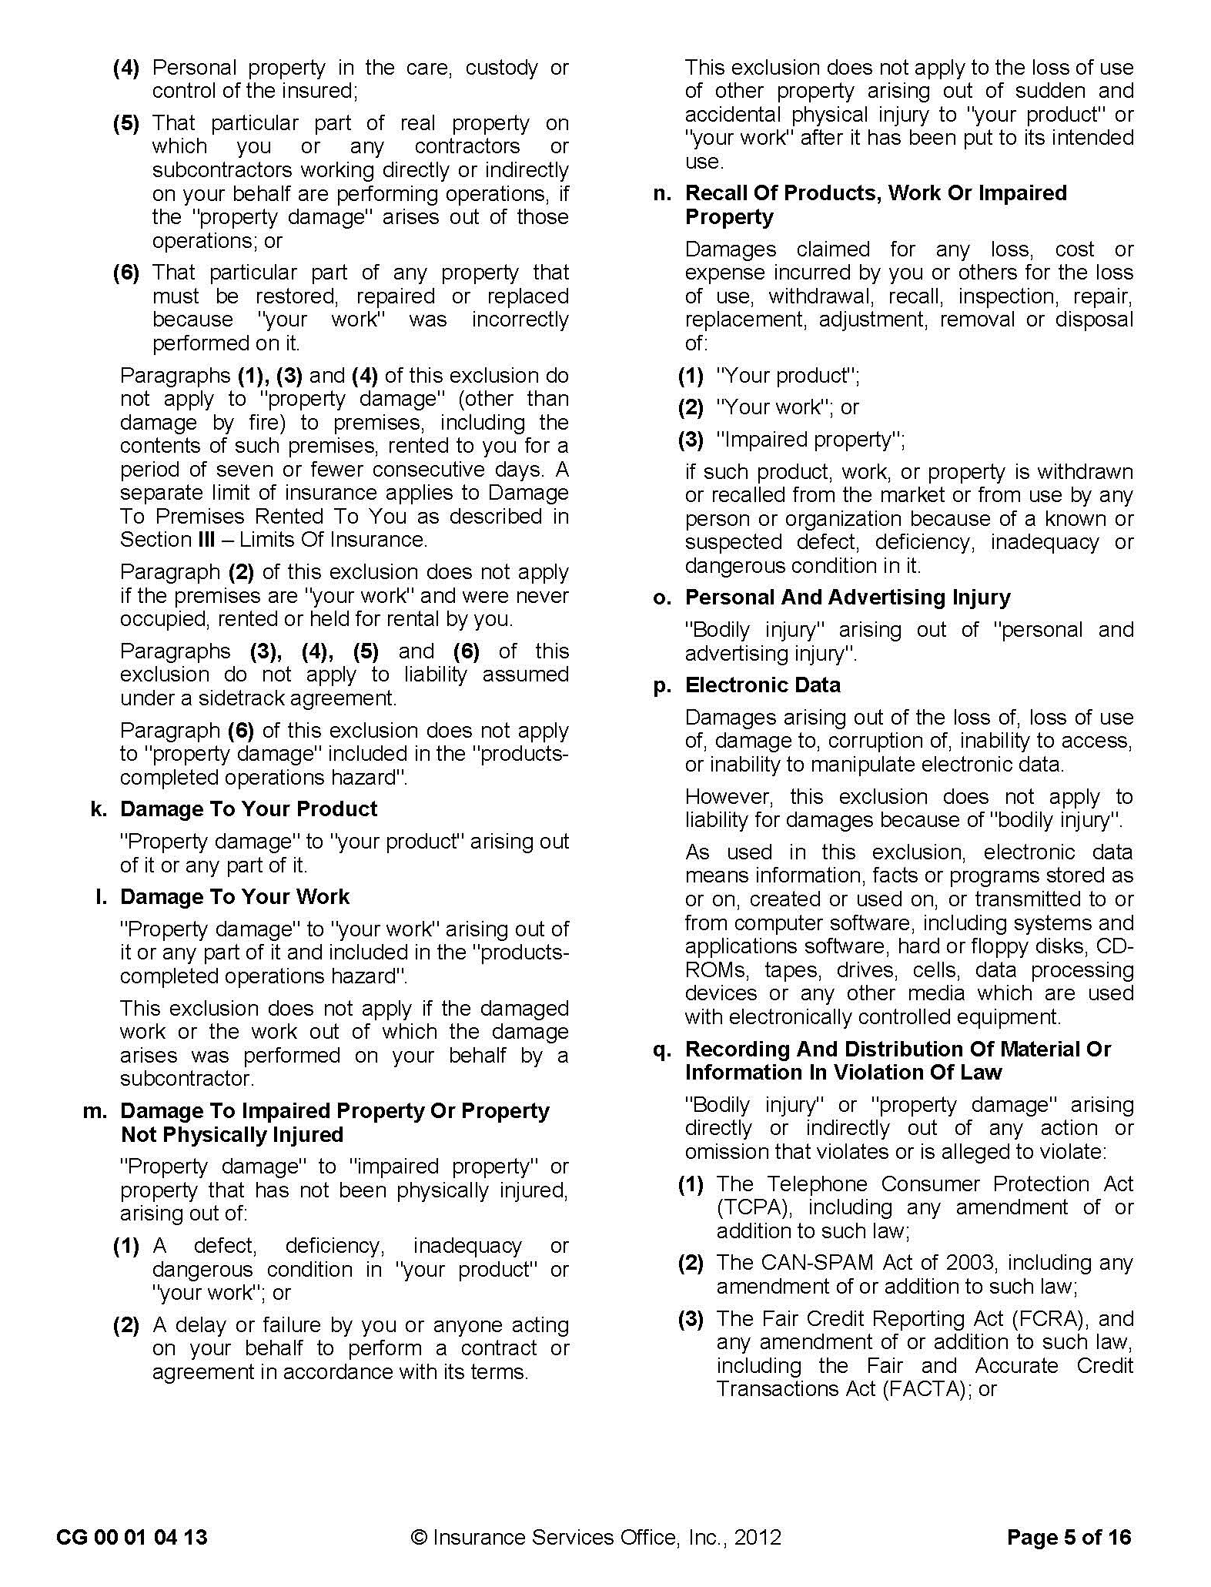
SAMPLE
Reproduction of Insurance Services Office, Inc. Form
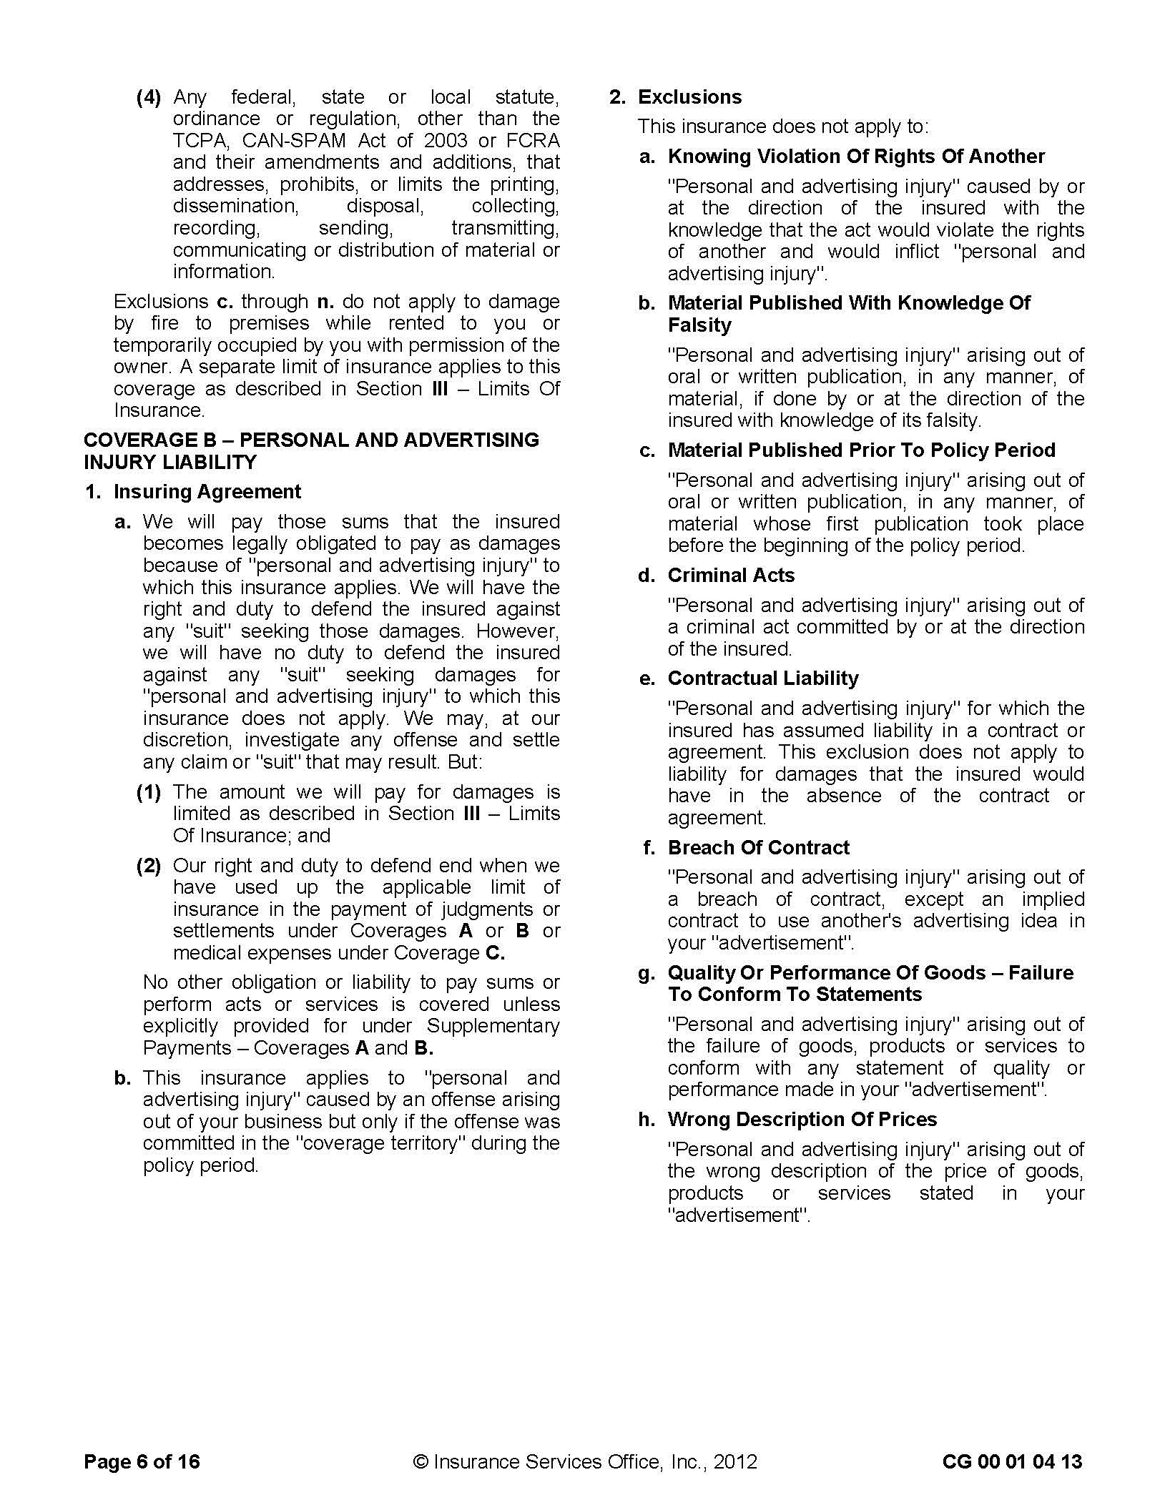
SAMPLE

Reproduction of Insurance Services Office, Inc. Form
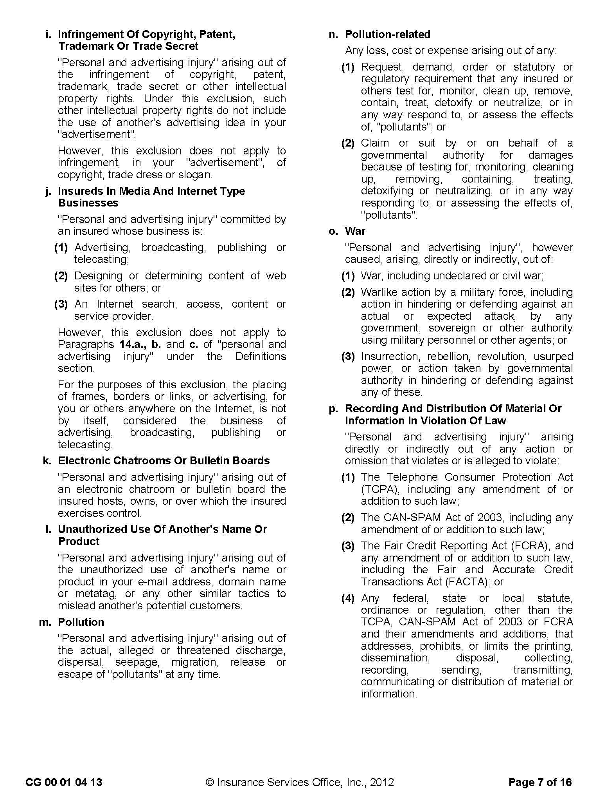
SAMPLE
Reproduction of Insurance Services Office, Inc. Form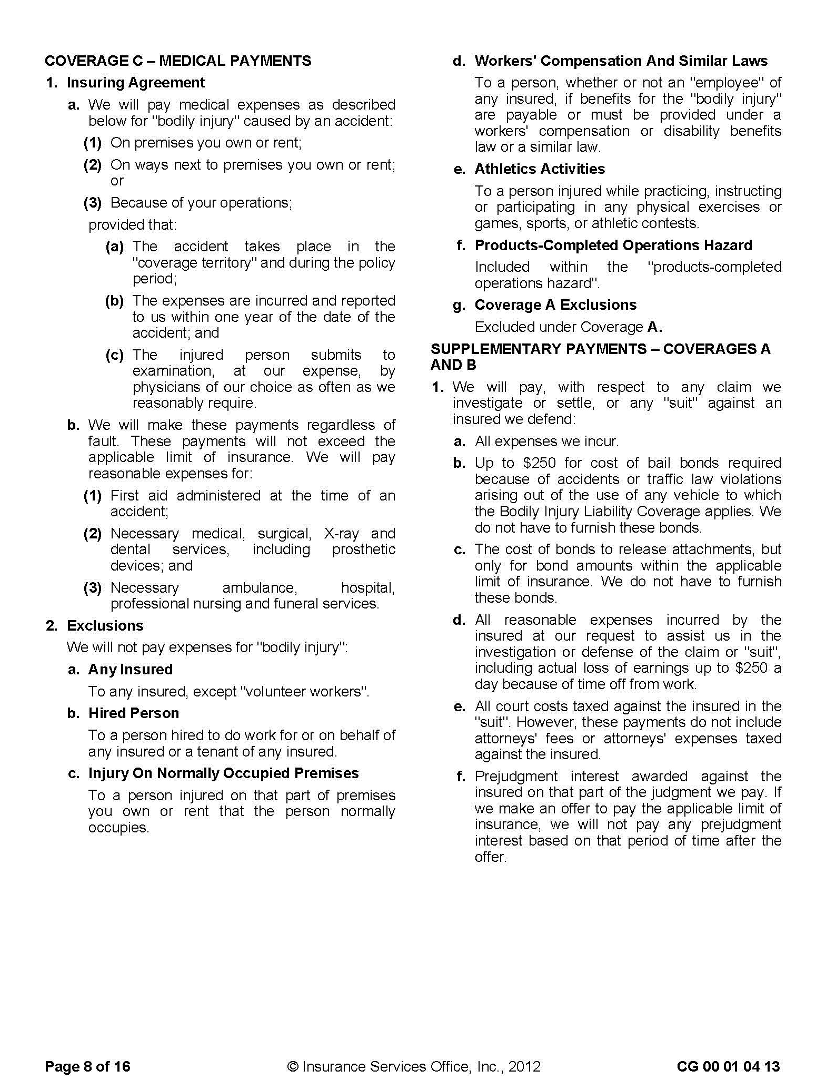
SAMPLE
Reproduction of Insurance Services Office, Inc. Form
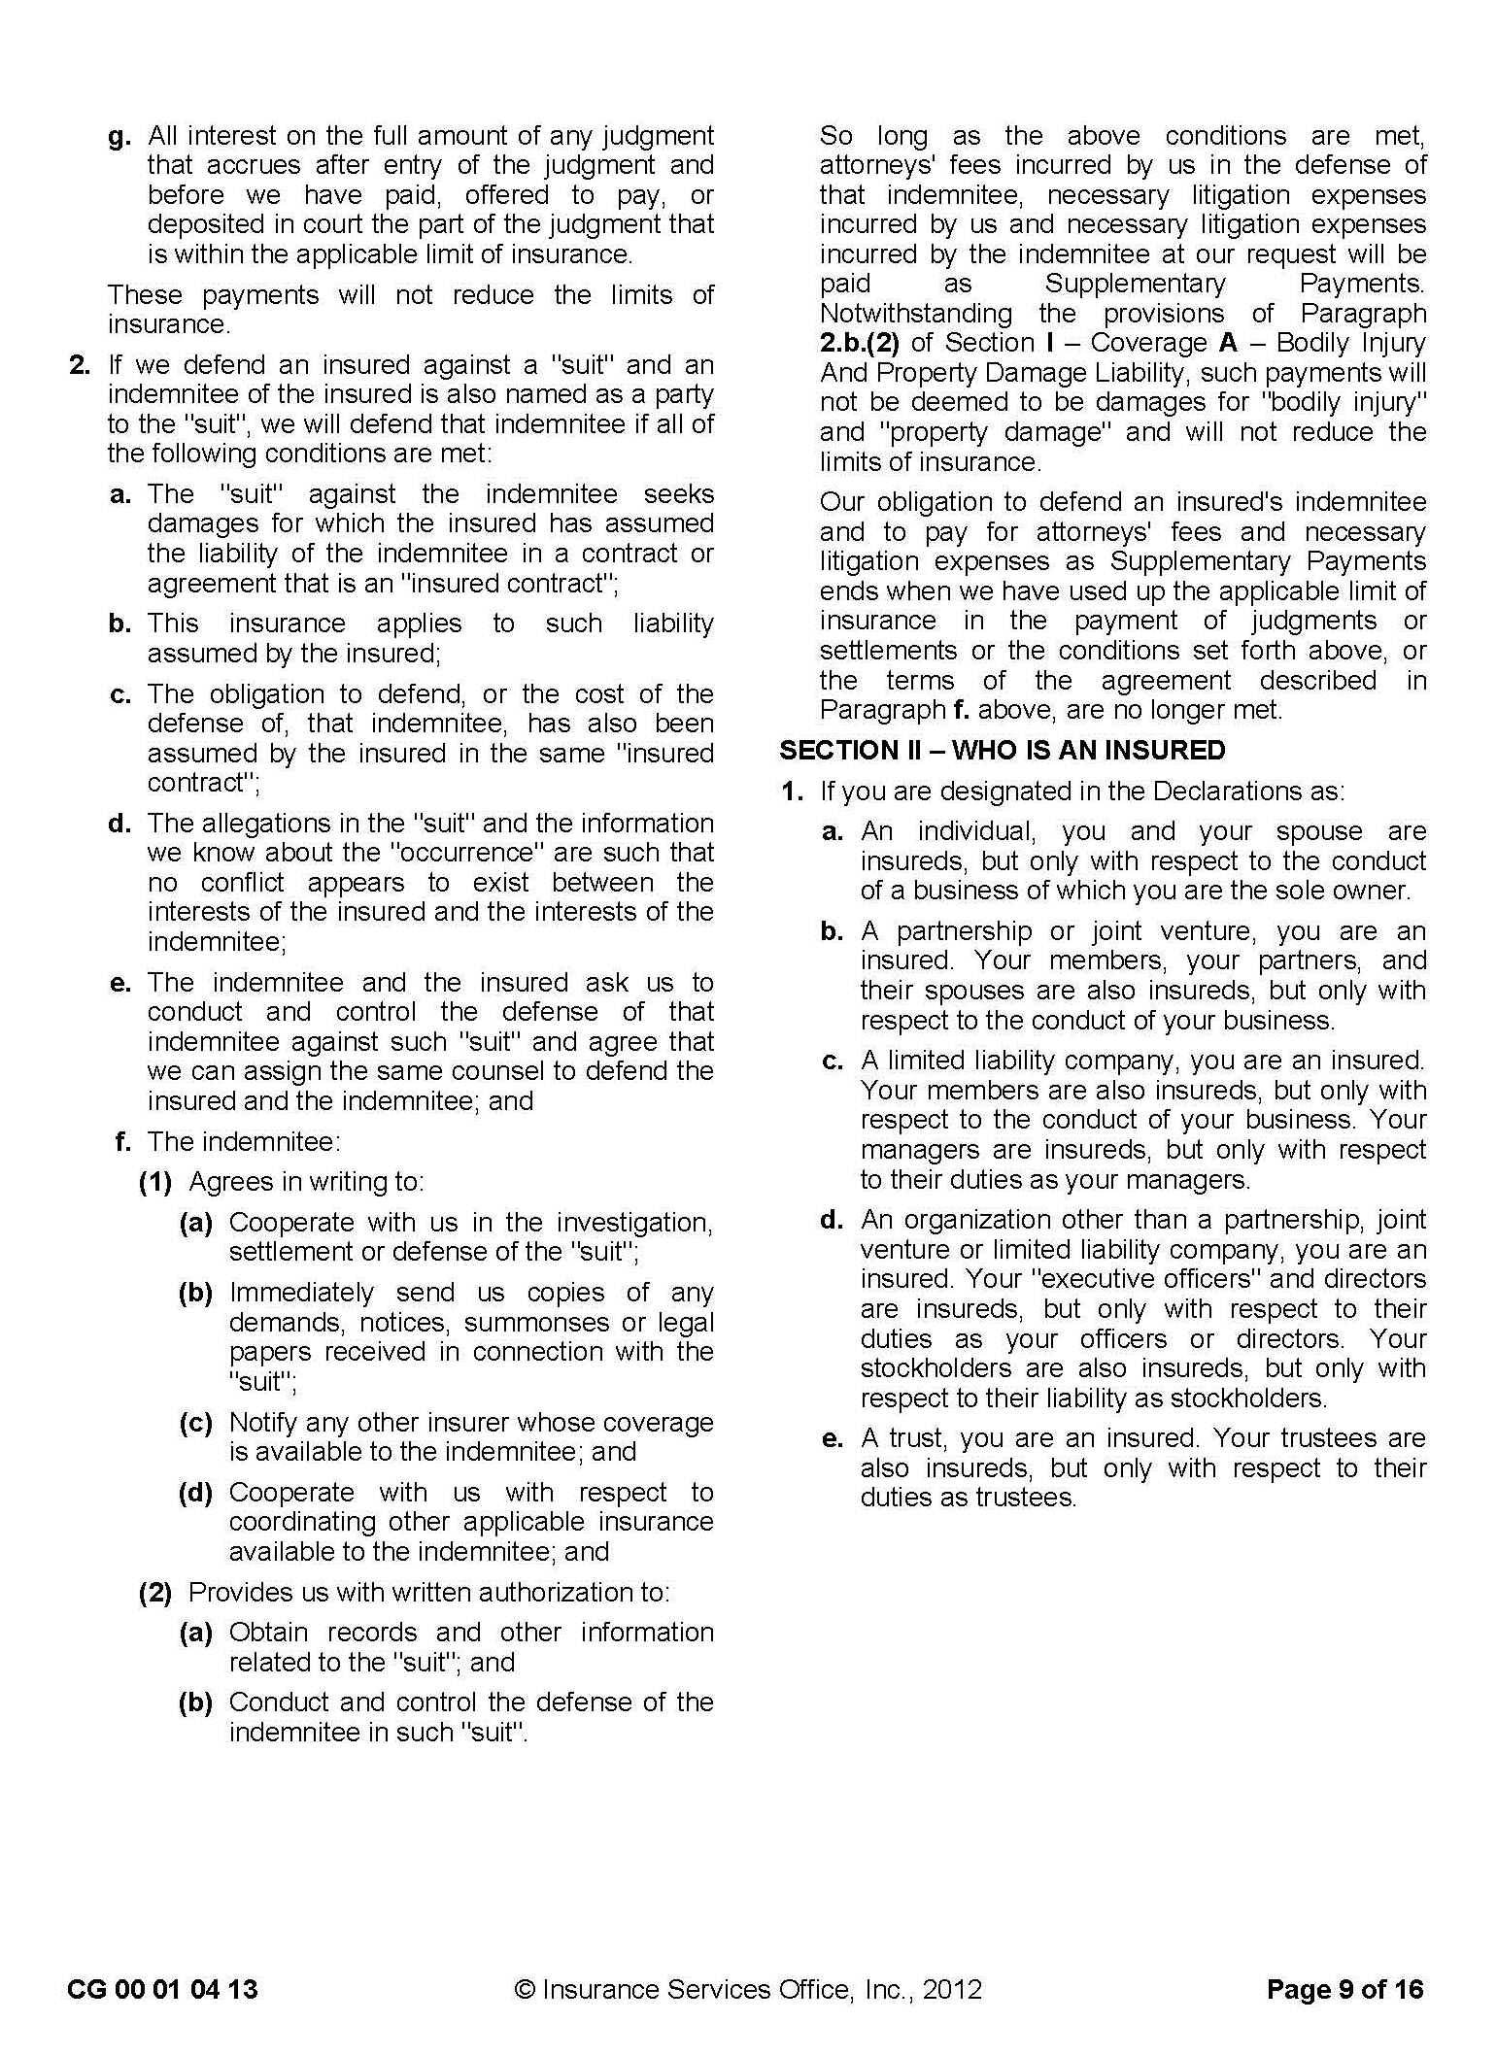
SAMPLE
Reproduction of Insurance Services Office, Inc. Form

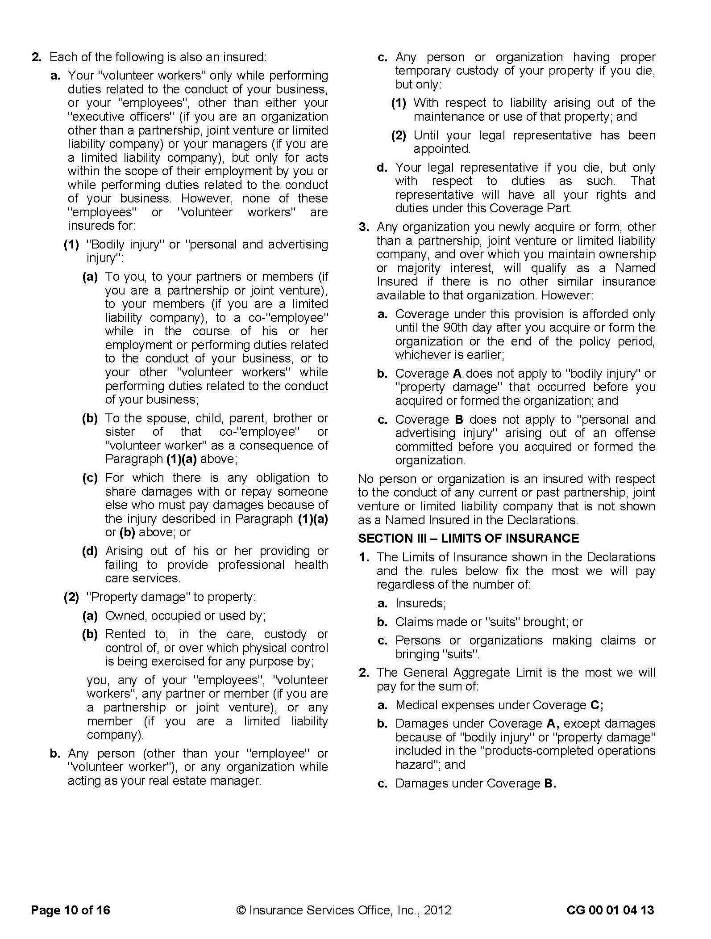
SAMPLE
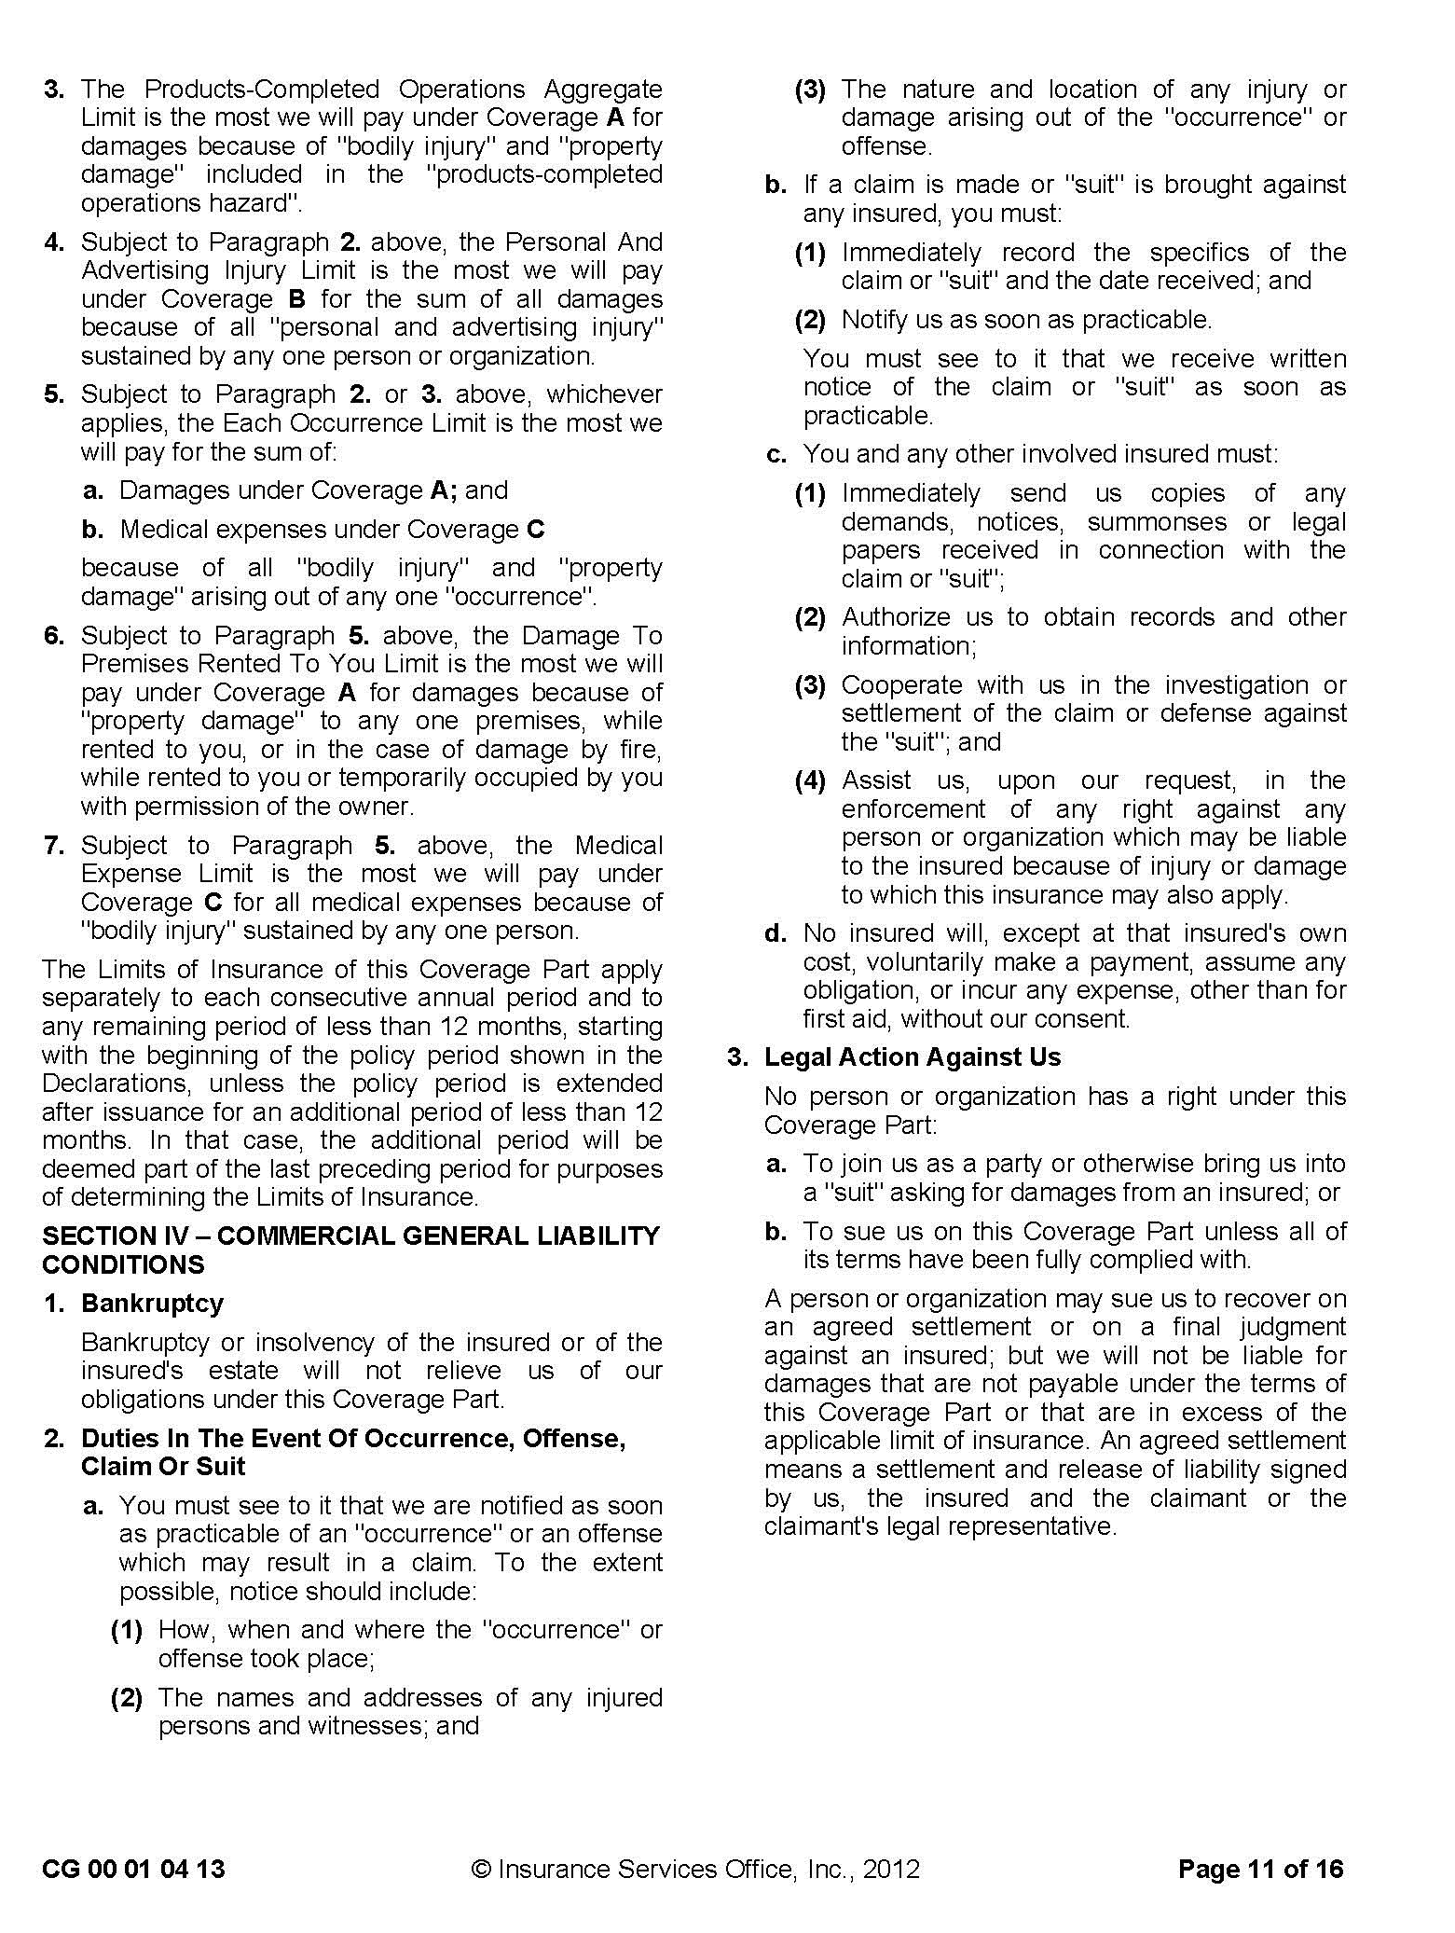
Reproduction of Insurance Services Office, Inc. Form
Reproduction of Insurance Services Office, Inc. Form
SAMPLE
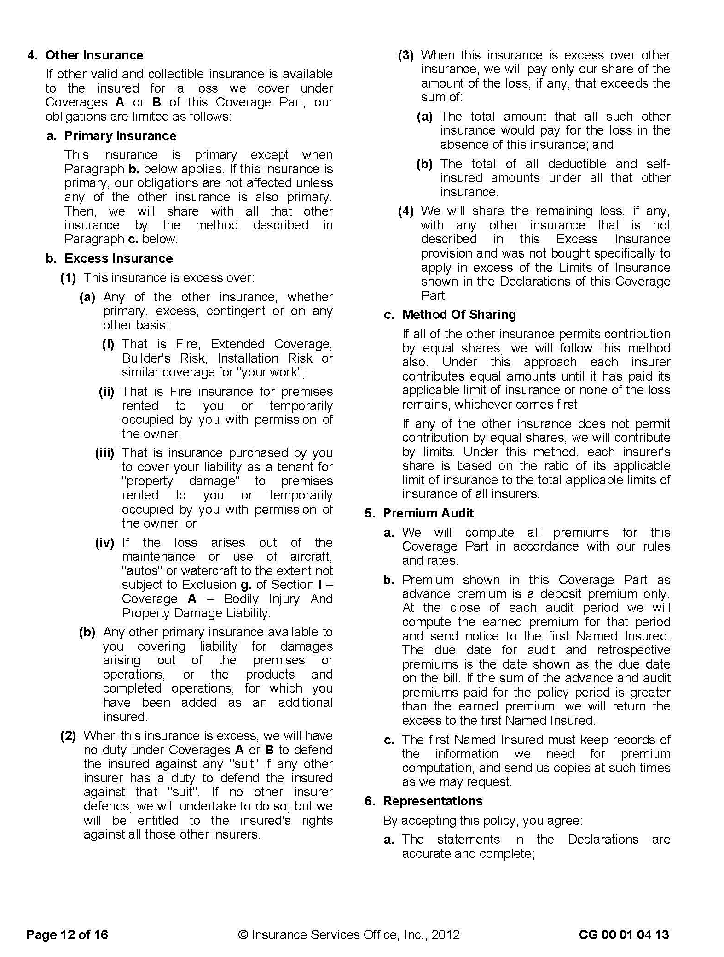
SAMPLE

Reproduction of Insurance Services Office, Inc. Form
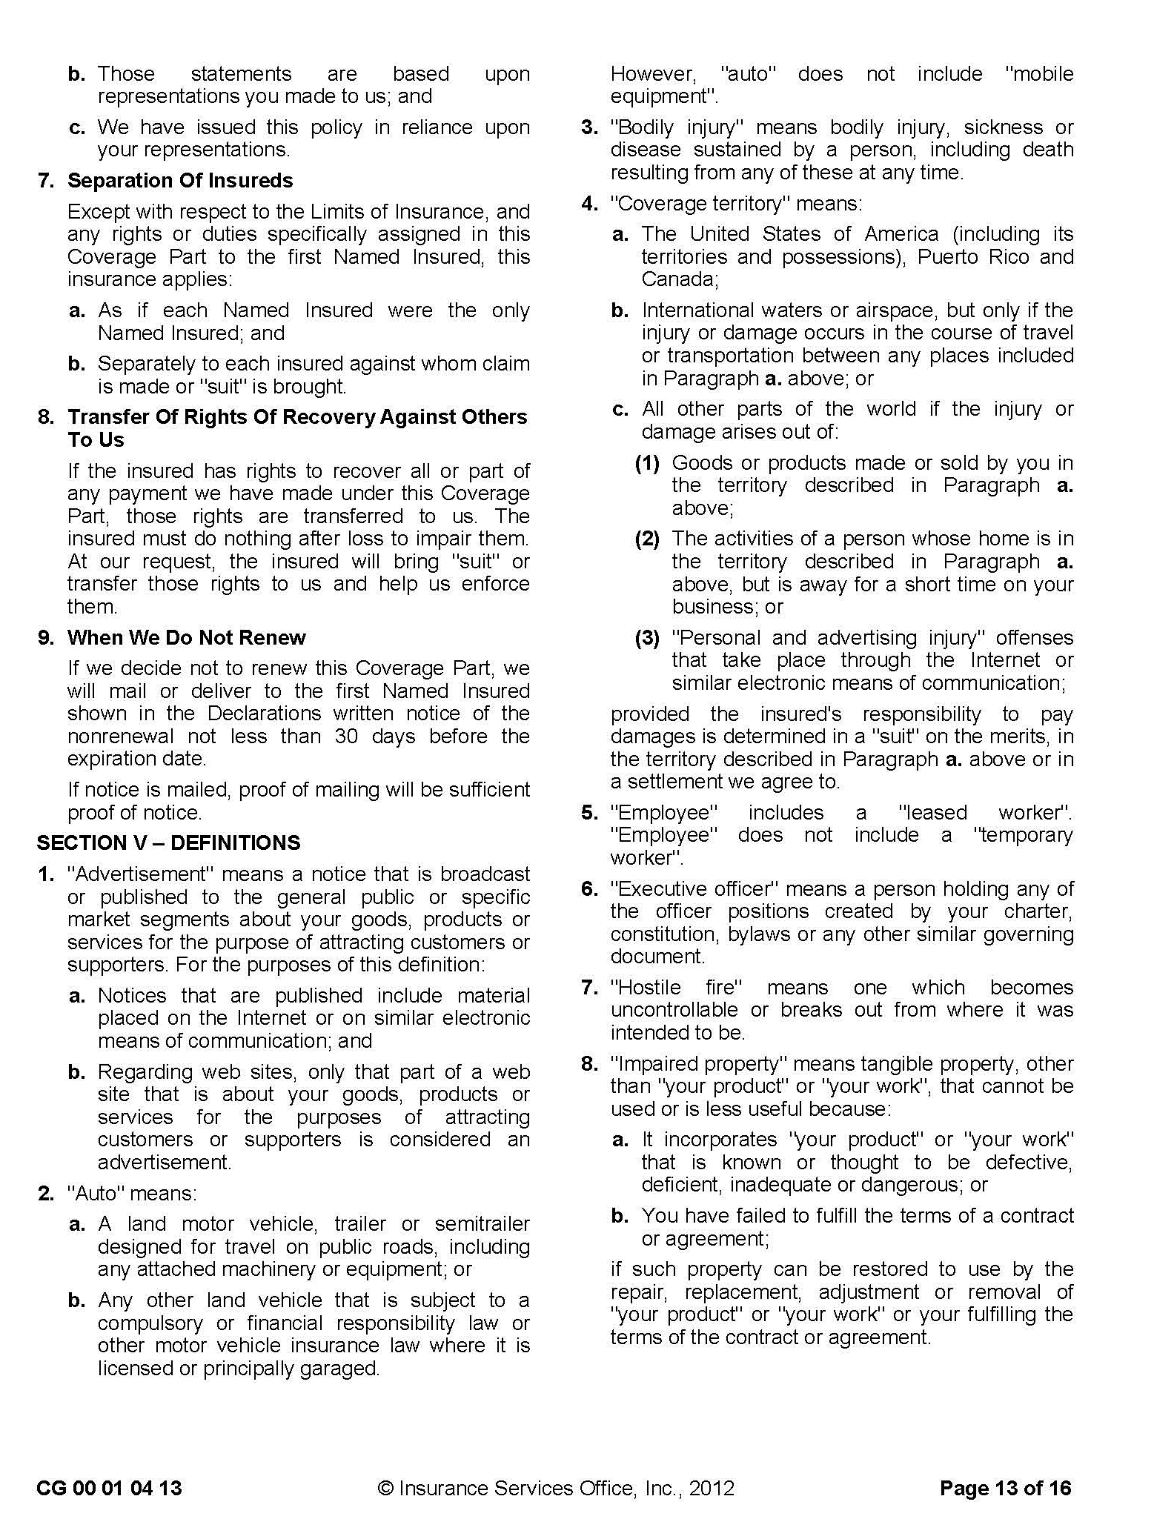
SAMPLE
Reproduction of Insurance Services Office, Inc. Form

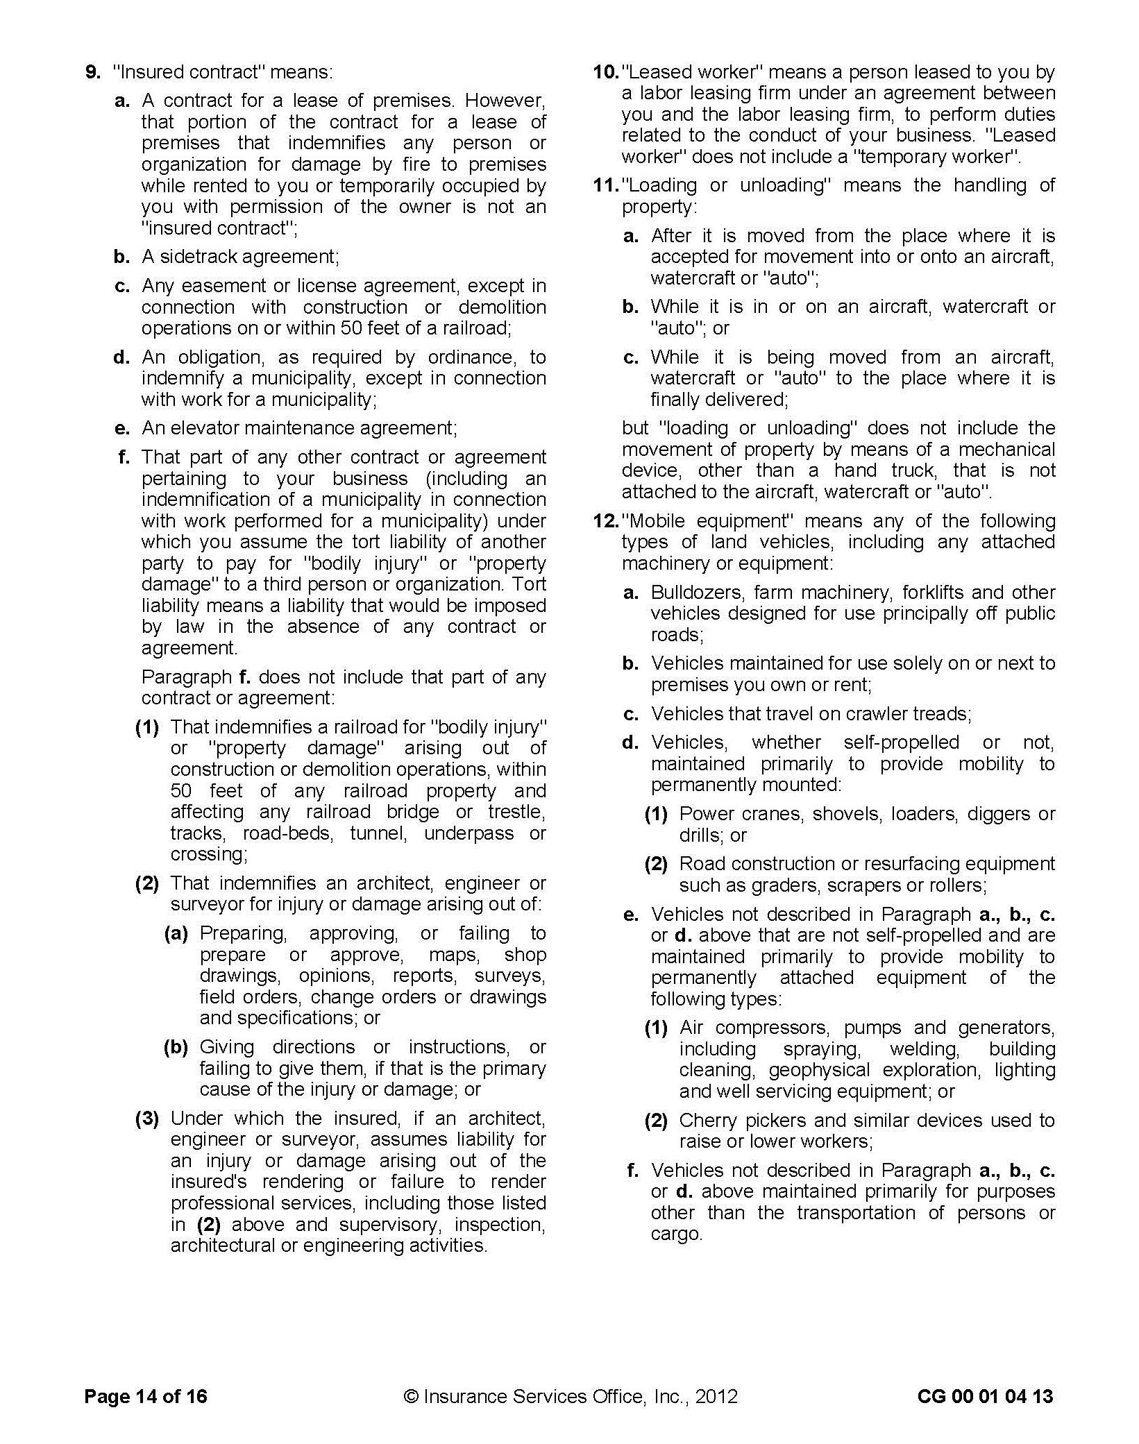
SAMPLE

Reproduction of Insurance Services Office, Inc. Form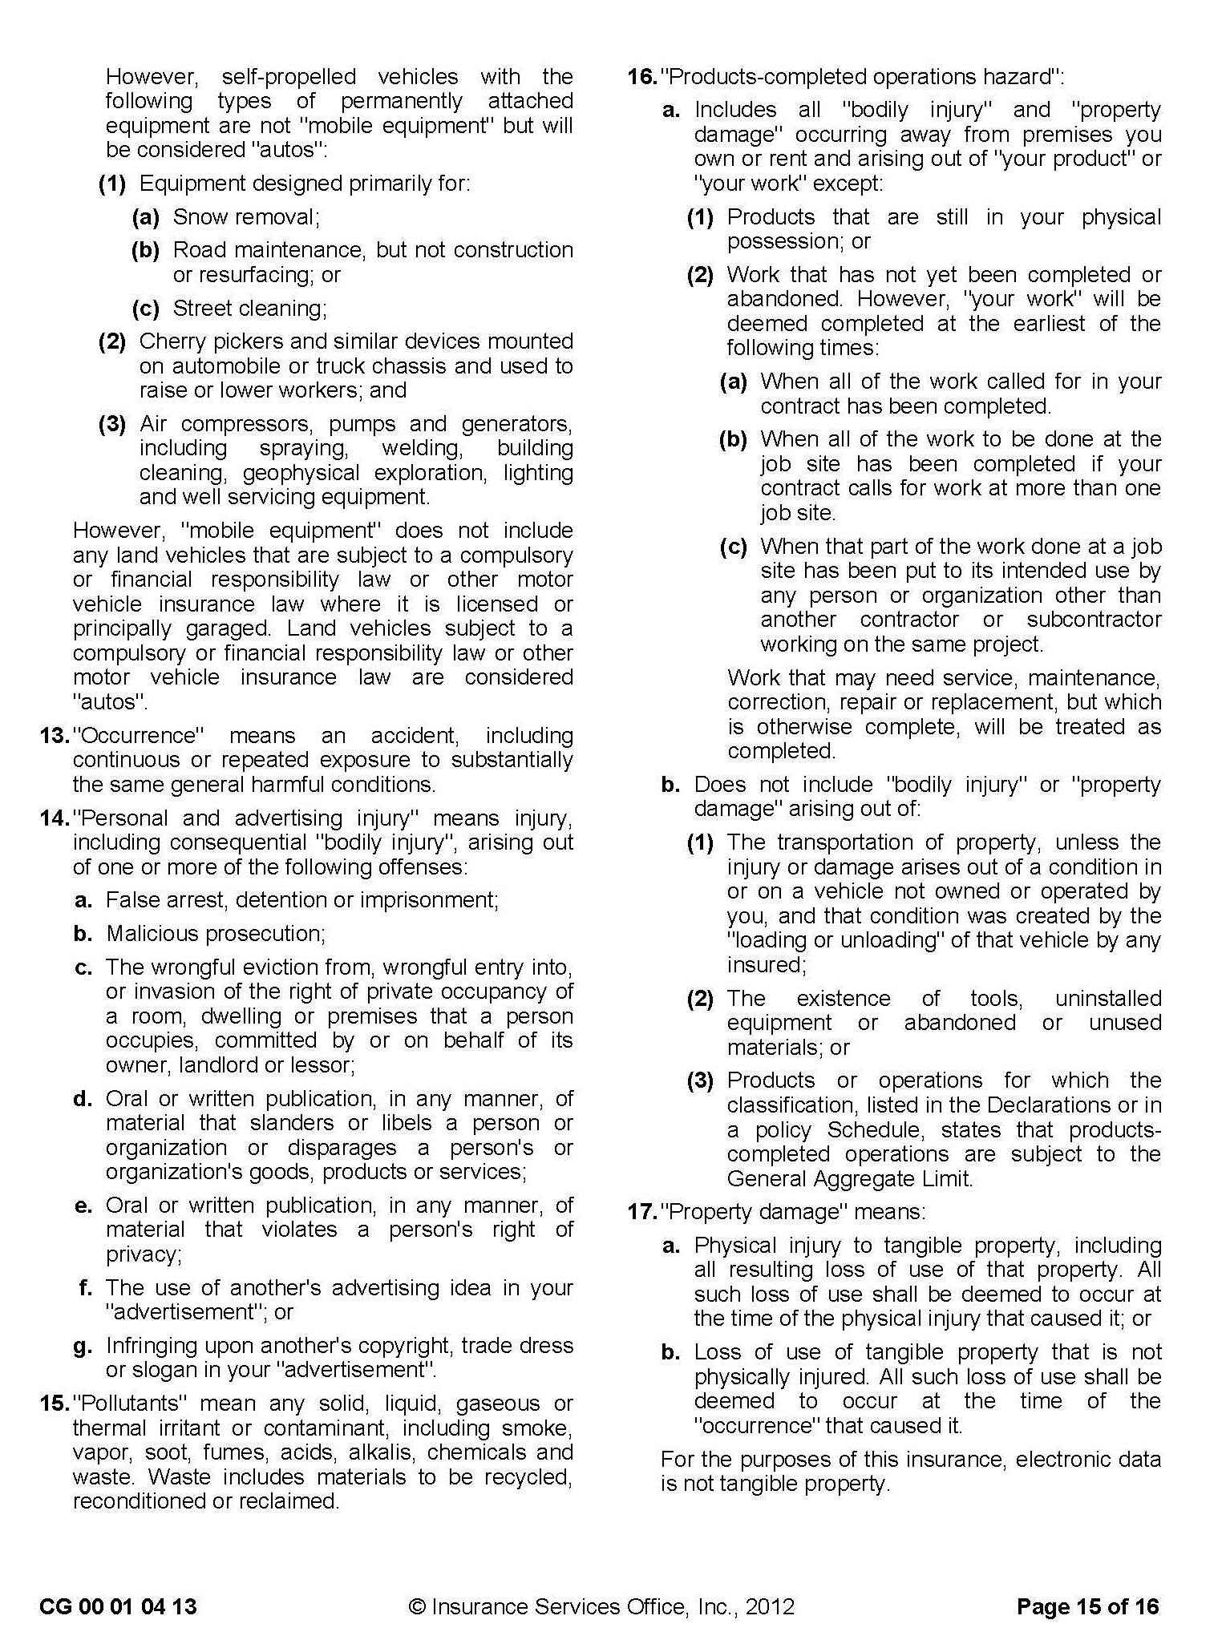
SAMPLE
Reproduction of Insurance Services Office, Inc. Form
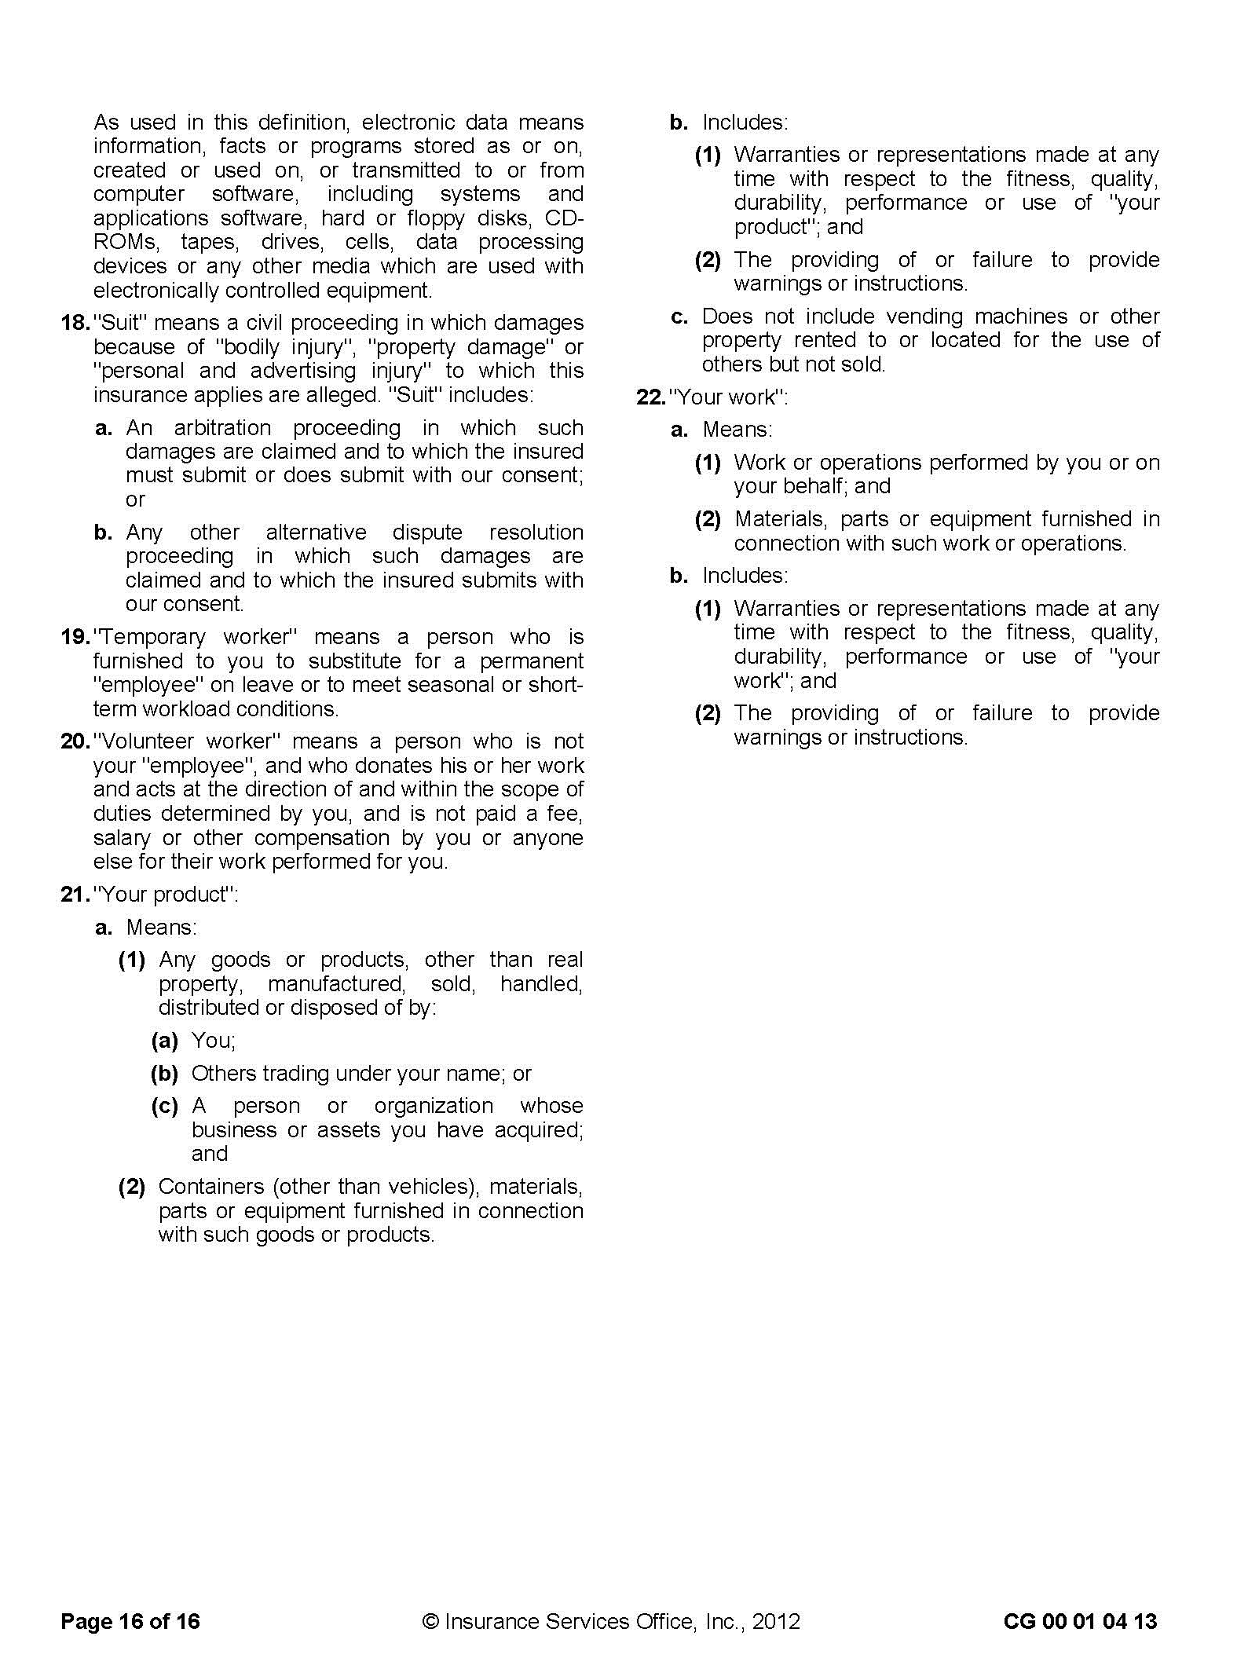
SAMPLE

MCS-90: Motor Carrier Public Liability
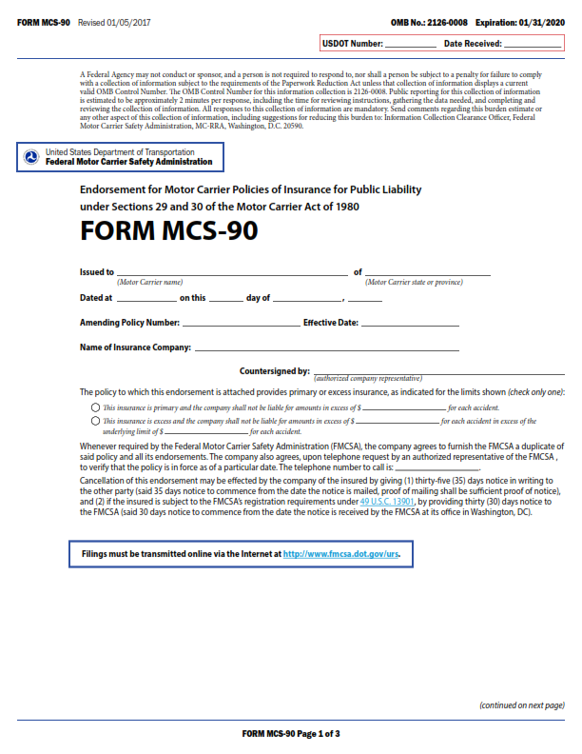

SAMPLE
MCS-90: Motor Carrier Public Liability (cont’d)

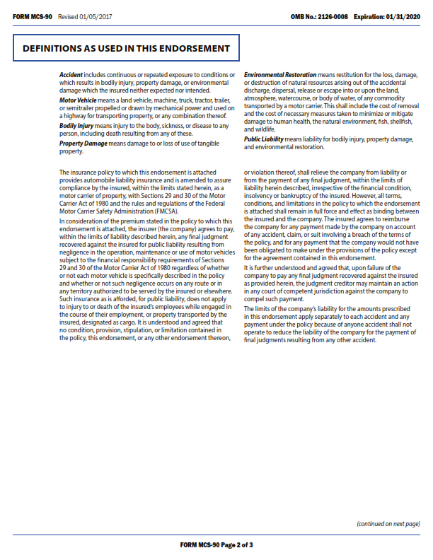
SAMPLE

MCS-90: Motor Carrier Public Liability (cont’d)
SAMPLE
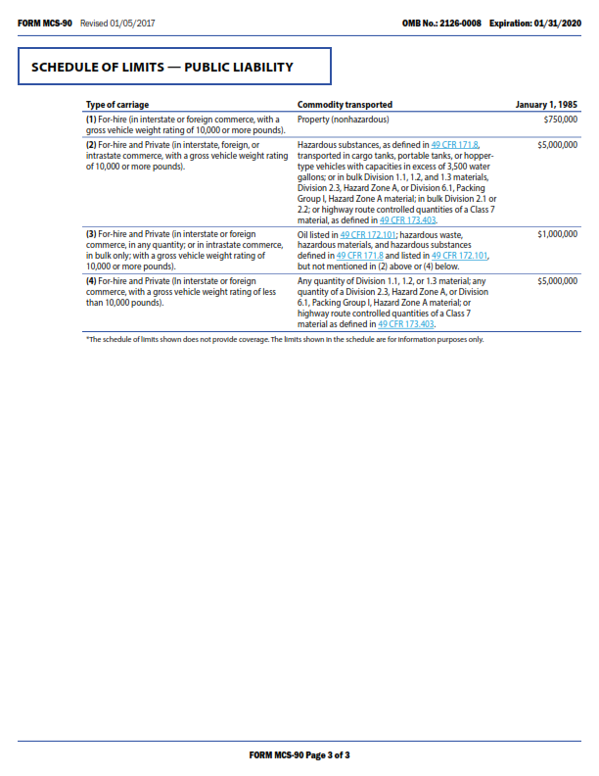
SAMPLE

SAMPLE

SAMPLE
SAMPLE
SAMPLE
SAMPLE
SAMPLE

Performance Bond
BOND NO. ____________
PREMIUM: _____________

WHEREAS, The ____________________________________, (hereinafter designated as “Obligee”) and ___________________________ (hereinafter designated as “Principal”) have entered into an agreement whereby principal agrees to install and complete certain designated public improvements, which said agreement, dated __________________________ , and identified as project _________________________ is hereby referred to and made a part hereof; and
WHEREAS, Said principal is required under the terms of said agreement to furnish a bond for the faithful performance of said agreement;
NOW, THEREFORE, We, the principal and ______________________ as surety, are held and firmly bound unto the hereinafter called “The Obligee,” in the penal sum of ______________________________ dollars ($ _________________) lawful money of the United States for the payment of which sum well and truly to be made, we bind ourselves, our heirs, successors, executors and administrators, jointly and severally firmly by these presents.
SAMPLE
The condition of this obligation is such that if the above bound principal, his or its heirs, executors, administrators, successors or assigns, shall in all things stand to and abide by, and well and truly keep and perform the covenants, conditions and provisions in the said agreement and any alteration thereof made as therein provided, on his or their part, to be kept and perform and at the time and in the manner therein specified, and in all respects according to their true intent and meaning, and shall indemnify and save harmless the Obligee, its officers, agents and employees, as therein stipulated, then this obligation shall become null and void; otherwise it shall be and remain in full force and effect.
As part of the obligation secured hereby and in addition to the face amount specified therefore, there shall be included costs and reasonable expenses and fees, including reasonable attorney’s fees, incurred by county in successfully enforcing such obligation, all to be taxed as costs and included in any judgment rendered.
The surety hereby stipulates and agrees that no change, extension of time, alteration or addition to the terms of the agreement or to the work to be performed thereunder or the specification accompanying the same shall in any wise affect its obligations on this bond, and it does hereby waive notice of any such change, extension of time, alteration or addition to the terms of the agreement or to the work or to the specifications.
IN WITNESS WHEREOF, this instrument has been duly executed by the principal and surety above named, on

By _____________________________________________
PRINCIPAL
By: _____________________________________________
PRINCIPAL
By: _____________________________________________
Attorney-In-Fact

Payment (Labor & Materials) Bond

BOND NO.__________________

KNOW ALL MEN/WOMEN BY THESE PRESENT that we,_______________________ as Principal (also referred to herein as “CONTRACTOR”), and __________________________ as Surety, are held and firmly bound unto ____________, hereinafter called "OWNER," in the sum of _______________________________________________Dollars ($___________), for the payment of which sum, well and truly to be made, we bind ourselves, our heirs, executors, administrators, successors, and assigns, jointly and severally, firmly by these present.
The condition of the above obligation is such that, whereas said Principal has been awarded and is about to enter into the annexed Contract for the __________________________ [NAME OF PROJECT], in accordance with OWNER’s Call for Bids documents and Principal’s Bid Dated _____________, and to which reference is hereby made for all particulars, and is required by said “OWNER” to give this bond in connection with the execution of said Contract;
NOW, THEREFORE, if said CONTRACTOR, its Subcontractors, its heirs, executors, administrators, successors, or assigns, shall fail to pay (a) for any materials, provisions, equipment, or other supplies used in, upon, for or about the performance of the WORK contracted to be done under the Contract, or (b) for any work or labor thereon of any kind contracted to be done under the Contract, or (c) for amounts due under the Unemployment Insurance Code with respect to work or labor performed pursuant to the Contract, or (d) for any amounts required to be deducted, withheld, and paid over to the Employment Development Department from the wages of employees of the CONTRACTOR and its Subcontractors under Section 13020 of the Unemployment Insurance Code with respect to such work and labor, in each case, as required by the provisions of Sections 9550-9566 inclusive, of the Civil Code of the State of California and acts amendatory thereof, and sections of other codes of the State of California referred to therein and acts amendatory thereof, and provided that the persons, companies, corporations or other entities so furnishing said materials, provisions, provender, equipment, or other supplies, appliances, or power used in, upon, for, or about performance of the Work contracted to be executed or performed, or any person, company, corporation or entity renting or hiring implements or machinery or power for or contributing to said Work to be done, or any person who performs work or labor upon the same, or any person, company, corporation or entity who supplies both work and materials therefor, shall have complied with the provisions of said laws, then said Surety will pay in full the same in an amount not exceeding the sum hereinabove set forth and also will pay, in case suit is brought upon this bond, a reasonable attorney's fee, as shall be fixed by the Court. This bond shall inure to the benefit of any and all persons named in Section 9100 of the Civil Code of the State of California so as to give a right of action to them or their assigns in any suit brought upon this bond.
SAMPLE
PROVIDED, that any alterations in the WORK to be done or the materials to be furnished, or changes in the time of completion, which may be made pursuant to the terms of said Contract Documents, shall not in any way release said CONTRACTOR or said Surety thereunder, nor shall any extensions of time granted under the provisions of said Contract Documents release either said CONTRACTOR or said Surety, and notice of such alterations or extensions of the Agreement is hereby waived by said Surety.

IN WITNESS WHEREOF, the Principal and the Surety have executed this instrument in duplicate this ________________ day of ________________, 20_____.

_________________________________ __________________________________
Surety Principal

By: ______________________________ By: _______________________________

SAMPLE
_________________________________ ___________________________________
Print Name/Title Print Name/Title

_________________________________ ___________________________________
Address Address

(______)__________________________ (_____)______________________________
Telephone Number Telephone Number

__________________________________ ____________________________________
Email Address Email Address
NOTARIAL CERTIFICATE OF ATTORNEY IN FACT AND SEAL OF SURETY MUST BE ATTACHED.

Appendix C:
Sample Hold Harmless Agreements
The second step in the process of contractual risk transfer outlined in this manual is to use good hold harmless language to provide your entity the broadest protection possible in the event of a claim or suit arising from the contractor’s services, work product, or activities. Hold harmless language should be included in all types of agreements, including permits, purchase orders, and leases. As used in this section “hold harmless” agreements typically include agreements to “hold harmless, defend and indemnify” with each of these three terms having a distinct legal meaning. Also, we have provided here some analysis of California statutes, and these may be similar to other jurisdictions but should be reviewed in the context of each state’s laws and regulations.
In contract, the language that transfers the risk from one organization to another is commonly referred to as the hold harmless clause. Note that a hold harmless clause may also be referred to as an indemnification clause. This clause should specifically spell out the responsibilities of your entity and the contractor. It will identify which types of losses the parties to the agreement will be responsible for.
Often times, the hold harmless language will be a “mutual hold harmless” clause which is a frequent practice when two or more public agencies are signatories to agreements. There is a genuine need for caution with this type of “mutual hold harmless” since they may cancel each other out and provide no protection for either Entity. If the scope of the hold harmless is not specified for each Entity and they cancel each other out, the attorneys for the carriers involved will regard the opposing party without the good will the original drafters had in mind when they adopted the “mutual hold harmless” language.
This practice is not recommended when you are contracting with private organizations and the agreements should require contractors to assume all of the liability imposed by the actions of the agreements to the extent possible. This type of liability transfer will generally be recognized and upheld in the legal system as long as the inherent risk transferred is commensurate with the compensation to the contractor. We strongly recommend that legal, risk management, and other disciplines within your organization collaborate to create hold harmless agreements that are acceptable to your entity.
The following hold-harmless agreement wordings are provided as examples only. Innumerable alternatives to these forms are possible, each alternative having a different purpose depending on the wishes of the parties. Drafting hold harmless language in contracts is a crucial part of the risk transfer process and should not be undertaken without the advice and assistance of legal counsel.
Indemnity and hold harmless provisions are regulated by the California Civil Code and case law interpreting the Code sections. Under CA Civil Code Section 1668,
All contracts which have for their object, directly or indirectly, to exempt anyone from responsibility for his own fraud, or willful injury to the person or property of another, or violation of law, whether willful or negligent, are against the policy of the law.
Under CA Civil Code Section 2773,
An agreement to indemnify a person against an act thereafter to be done, is void, if the act be known by such person at the time of doing it to be unlawful.
CA Civil Code Section 2782(b) provides that
Except as provided in Sections 2782.1, 2787.2, and 2782.5, provisions, clauses, covenants or agreements contained in, collateral to or affecting any construction contract with a public agency which purport to impose on the contractor, or relieve the public agency from, liability for the active negligence of the public agency shall be void and unenforceable.
Section 2782.1 makes an exception where the contract is not being performed for the public agency, but the public agency as an accommodation allows the contractor to enter upon its property or adjacent to its property. Section 2782.2 permits the owner of a project to indemnify a professional engineer if certain conditions are met. Section 2782.5 permits parties to a construction contract to negotiate and expressly agree with respect to the allocation, release, liquidation, exclusion, or limitation as between the parties of any liability (a) for design defects, or (b) of the promisee to the promisor arising out of or relating to the construction contract.
California case law has analyzed indemnity clauses as falling under these three classifications. (However, some cases indicate that the intent of the parties controls the case regardless of these classification cases). Section 2782.8 was amended as of January 1, 2018 and declares unenforceable all contracts under which a public agency seeks indemnity from specified professionals, unless the underlying claim arises out of negligence, recklessness or willful misconduct of the design professional. Effective January 1, 2009, California added 2782.9. Subsection (a) states
All contracts . . . or agreements . . . entered into after January 1, 2009, for a residential construction project on which a wrap-up insurance policy . . . is applicable, that require [a] . . . subcontractor or other participant to indemnify, hold harmless, or defend another for any claim or action covered by that program, arising out of that project are unenforceable.
A wrap-up insurance policy, as defined by the California Insurance Code §11751.82(b) is a policy “written to cover risks associated with a work of improvement” covering two or more contractors or subcontractors.

Example 1 - Type I Indemnity Language
This is the recommended type of indemnity for most contracts, with sample language:
Contractor shall hold harmless, defend and indemnify Entity and its officers, officials, employees and volunteers from and against any and all liability, loss, damage, expense, costs (including without limitation costs and fees of litigation) of every nature arising out of or in connection with Contractor’s performance of work hereunder or its failure to comply with any of its obligations contained in the agreement, except such loss or damage which was caused by the sole negligence or willful misconduct of the Entity.
The contractor promises your Entity to assume all risk of loss resulting from the project, including losses caused by the joint negligence of your Entity and the contractor or its subcontractors. The only exceptions are for your sole negligence or willful acts.
Caution regarding Type 1: While this type of agreement provides the broadest protection for the Entity, it is no longer allowed in a construction related contract (defined in CA Civil Code Section 2783), after January 1, 2013. Example 2 (below) should be used instead.

Example 2 – Intermediate Form – For Construction Contracts
For public entity construction related contracts, you must also have an exception for your active negligence. Sample language, with emphasis added:
Contractor shall hold harmless, defend, and indemnify Entity and its officers, officials, employees, and volunteers from and against all claims, damages, losses, and expenses including attorney fees arising out of the performance of the work described herein, caused in whole or in part by any negligent act or omission of the Contractor, any subcontractor, anyone directly or indirectly employed by any of them, or anyone for whose acts any of them may be liable, except where caused by the active negligence, sole negligence, or willful misconduct of the Entity.
In this second example, the Entity receives indemnification if it was not negligent or if its negligence was only passive. There is a great deal of case law on the active/passive distinction, but essentially active negligence is affirmative participation in causing the harm, or failure to prevent a known danger. Conversely, passive negligence is failure to detect a danger which the Entity is under a duty to detect, such as a dangerous condition on its property created by the contractor.
There is great variety of language used to arrive at this type of intermediate form because any indemnity contract which does not specifically refer to the indemnitee’s negligence will be construed as this type of general clause, not providing indemnity for active negligence. So, if the contract promises indemnity for losses, however caused, regardless of responsibility for negligence, arising from use of the premises, facilities or services, or caused by any person or persons, the wording will be interpreted as a general indemnity clause and would be void and unenforceable. At the end of this appendix, is a broader discussion of indemnity clauses found within construction agreements, titled “Construction Indemnification – Indemnification provisions in Construction Contracts”.

Example 3 - Limited Form
Contractor agrees to protect, indemnify, and save harmless Entity and its officers, officials, employees, and volunteers from and against all claims, demands, and causes of action by Contractor’s employees or third parties on account of personal injuries or death or on account of property damages arising out of the work to be performed by contractor hereunder and resulting from the negligent act or omissions of Contractor, Contractor’s agents, employees, or subcontractors.
This example is the most limited, Type 3, of indemnity agreement because it only provides indemnity for any passive negligence of the Entity cause in whole or in part by the negligent Contractor, but not from passive negligence of the Entity caused by other contractors (this would be Type 2).
Example 4 – Design Professional Contract Language
A significant restriction for public entity contracts with “Design Professionals” CA Civil Code §2782.8 became effective as of January 1, 2007, and limits the indemnity language a public agency may use by stating:
“design professional services contracts that purport to indemnify, including the cost to defend, the public agency by a design professional against liability for claims against the public agency are unenforceable, except claims that arise out of, pertain to, or relate to the negligence, recklessness or willful misconduct of the design professional.”

“Design professional” includes all of the following: licensed architects, landscape architects, professional engineers, and professional land surveyors. It does not include and therefore may not apply to construction management or inspection services.
The code, as previously referenced, was amended again in 2009, holding residential contracts with wrap-up insurance policies are unenforceable. The most recent amendment to §2782.8 applies to contracts and agreements entered into on or after January 1, 2018. Such design professional contracts are unenforceable,
“except to the extent that the claims against the indemnitee arise out of, pertain to, or relate to the negligence, recklessness, or willful misconduct of the design professional. In no event shall the cost to defend charged to the design professional exceed the design professional’s proportionate percentage of fault. However . . . [if] one or more defendant is unable to pay its share of defense costs due to bankruptcy or dissolution of the business, the design professional shall meet and confer with other parties regarding unpaid defense costs. The duty to indemnify, including the duty and the cost to defend, is limited as provided in this section. This section shall not be waived or modified by contractual agreement, act, or omission of the parties.”
The main concern raised by the amendment relates to the proportionate percentage of fault attributed to the design professional. Such determination is made by a combination of adjusters, attorneys, insurers, mediators and ultimately the courts. Further complications arise because this determination often doesn’t come until after trial, which of course requires all parties to incur legal fees, regardless of whether those will be repaid.
Another issue is whether payment of such legal fees occurs at the outset of litigation, or after litigation has been concluded. Because this section was amended as of January 1, 2018, it will likely be some time before courts reach conclusions on its interpretation. The lack of case law and corresponding unknowns regarding issues under this code make it nearly impossible to know who will be responsible for what defense costs and at what point(s) in litigation. Contractors may be required to pay defense costs at the outset and thus pay more than their proportionate share, to use statutory language, resulting in necessary reimbursement from the public entity. Conversely, the design professional likely accepts responsibility negating the public entity’s obligation to front defense costs and hope for reimbursement afterwards.
Because case law and statutory interpretation are understandably silent, initial negotiations regarding such payments and their timing are of the utmost importance. Though the statute clearly states design professionals have a duty to defend proportionate to their level of fault, the parties are left to determine the rest.
Some options for the parties to consider when deciding how to interpret this statute include:
1. The duty to defend is triggered when the claim arises, design professional pays costs when claim is tendered and design professional’s cost to defend is determined after claim is resolved. Design professional makes a payment for defense costs in proportion to their fault, or
2. The duty to defend exists, but the amount of defense costs are determined once the design professional’s proportional liability is established or agreed upon, or
3. Some pro-rata basis is agreed upon between the parties for paying defense costs, with final determination of the amount of the parties’ proportionate share when that has either been agreed upon or established through settlement, mediation, arbitration or trial.
To sum up, here are the options that an entity would use in its indemnity agreement.
1. Duty to defend is triggered when claim is tendered to the design professional. Any over-payment for defense costs are rebated to design professional at the conclusion of the case or is otherwise determined through settlement, mediation or arbitration or trial.
2. Duty to defend exists from beginning, but payment of defense costs are deferred until the conclusion of the case or when the design professional’s proportionate share is determined through settlement, mediation or arbitration.
3. The parties agree to share defense costs on some pro-rata basis or equally during the litigation and once each party’s proportionate share is determined, the party paying more than agreed share gets a refund.
Option 4. This should be included in any defense cost agreement per the statue, that when a bankruptcy occurs, the parties meet and confer over how the remaining defense costs are to be handled. (Likely on some pro-rata basis based on the proportion of fault of the remaining parties.)
Option 1 is best for public agency; option 2 is best for design professional; and option 3 may be a fair distribution of potential costs and rebate at conclusion of case to party that pays more than its proportionate share.
An appropriate hold harmless for public entity contracts with design professionals may read as follows:
Pursuant to the full language of California Civil Code §2782,design Professional agrees to indemnify, including the cost to defend, entity and its officers, officials, employees, and volunteers from and against any and all claims, demands, costs, or liability that arise out of, or pertain to, or relate to the negligence, recklessness, or willful misconduct of Design Professional and its employees or agents in the performance of services under this contract, but this indemnity does not apply to liability for damages arising from the sole negligence, active negligence, or willful acts of the Public Entity; and does not apply to any passive negligence of the Public Entity unless caused at least in part by the Design Professional. The Public Entity agrees that in no event shall the cost to defend charged to the Design Professional exceed that professional’s proportionate percentage of fault. This duty to indemnify shall not be waived or modified by contractual agreement or acts of the parties.
For design/build contracts or liability that may arise from activities of the design professional not related to professional services, you may want to use two separate hold harmless agreements. Example 4 should be followed for design professional liability, and example 2 should be your guide for all other liability in the contract. Also consider separate contracts, one for the design and one for the build, if appropriate.

Summary - Hold Harmless Language - Depends on Contract
- General Contracts – Example 1 - Type I Indemnity
  - All claims arising from all acts or omissions, except those arising from agency’s sole negligence or willful acts.
- Construction Contracts – Example 2 - Intermediate Form
  - All claims arising from all acts or omissions, except those arising from agency’s sole or active negligence or willful acts.
- Design Professional Contracts – Example 4 - Per Civil Code
All claims that arise out of, pertain to, or relate to, directly or indirectly, in whole or in part, the negligence, recklessness, or willful misconduct of Design Professional, any sub consultant, anyone directly or indirectly employed by them, or anyone that they control, except those arising from the sole negligence, active negligence, or willful acts of the Public Entity; and does not apply to any passive negligence of the Public Entity unless caused at least in part by the Design Professional.
- Limited Forms – Example 3 – Based on Bargaining Power
Contractors and professional service providers may balk at your entity’s preferred hold harmless language and suggest changes. Be aware of language that is not as broad as recommended above and involve legal counsel in any proposed changes. You should give up any protections grudgingly, but at times you may have to accept less than you would like.
Many contractors will attempt to limit their responsibility only to negligent acts, or only the portion of the damages they cause by inserting qualifiers such as “to the extent caused by” their actions, or to limit the types of damage to bodily injury or property damage, or otherwise try to limit their obligations to what their insurance will cover. Sample language, with emphasis added:
- All claims for property damage and bodily injury, including death, arising out of the work to be performed by contractor hereunder and resulting from the negligent acts or omissions of Contractor, Contractor’s agents, employees or subcontractors.
- Note on Use of Mutual Hold Harmless Agreements
- Most of the time you shouldn’t do it!
- If you are paying for a service, you should be indemnified by the other party.
- Can be more confusing than helpful.
- You WANT to be indemnified even if you are a percentage at fault. [Not possible on construction for active fault (Type 1; Type 2 & 3 are allowed); and Design Professional Contracts (only Type 3 allowed)]
- If you WANT to pay your share you can always agree to be “fair” later.
- Matter of bargaining power. Best you can get?
- OK for joint use/activity, use of other’s facilities, but make sure scope of work and responsibility for indemnity is clear!

Release Agreement
If you have a defined group of persons who might be exposed to the harm (for example, participants in an athletic event on Entity property), a release agreement can be prepared. Generally, a release agreement must be prominently displayed, no smaller than 8- to 10-point type. The language cannot be overly complex, nor can it be buried in other verbiage. A standard release might read as follows:
In consideration of the acceptance of my application for entry into the above event, I hereby waive, release, and discharge any and all claims for damages for death, personal injury, or property damage which I may have, or which hereafter accrue to me, against the Entity as a result of my participation in the event. This release is intended to discharge the Entity, its officers, officials, employees, and volunteers, any other involved municipalities or public agencies from and against any and all liability arising out of or connected in any way with my participation in the event, even though that liability may arise out of the negligence or carelessness on the part of persons or Entities mentioned above. I further understand that accidents and injuries can arise out of the event; knowing the risks, nevertheless, I hereby agree to assume those risks and to release and to hold harmless all of the persons or agencies mentioned above who (through negligence or carelessness) might otherwise be liable to me (or my heirs or assigns) for damages. It is further understood and agreed that this waiver, release, and assumption of risk is to be binding on my heirs and assigns.
The above language was adapted from a case which cited release language with approval. However, note that the release might still be avoided by a plaintiff if the injury occurs in an unforeseeable way, not typical or common to the activity.

Construction Indemnification

Appendix D:
Sample Checklists

These checklists are included in the manual as examples of how the user might wish to organize its contract and specifications review.
We would like to thank Robert Marshburn for his Additional Insured ISO Forms Matrix.
We would like to thank Joseph Risser for his self-designed checklist entitled “Project Name/Purchase.”

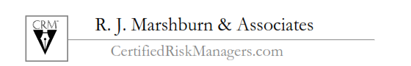

ISO COVERAGES for Parties Other than the Named Insured
CAUTION! Non-ISO Manuscript Policies or Modified Definitions or Endorsements differ from
the standard ISO coverages below! Be very careful!

Contractual Liability Insurance covering Named Insured (Indemnitor) for Entity Indemnification

BEWARE of endorsements amending, excluding, or changing Contractual Liability coverage or the “insured contract” definition (such as CG 21 39 deleting “f.”) that provides the liability coverage for the Named Insured for Indemnity obligations assumed by Contract (Contractual Liability).

ADDITIONAL INSURED Forms: Insured Relationship to AI Required to Trigger Coverage:

Insured Relationship to AI for Coverage | Doing Work For AI with a Contract requirement regardless of Privity |  | Doing Work For AI, with Privity, but no Subs | No Contract “With You” (No Privity) & No Work For Additional Insured
Type of Endorsement | Scheduled | Automatic* | Automatic** | Automatic* | Designated
Ongoing Ops Form # | 20 10 | 20 38 | 20 33 | 20 43 | 20 42 & 20 26
Completed Ops Form # | 20 37 | 20 40 | 20 39 | NONE | NONE

* ONLY if required in a written contract or agreement ** ONLY if required in a written contract “With You” (Privity)
For Automatic Status, Form Numbers 20 38 and 20 40 should be required rather than the 20 33 and 20 39

**Use form 20 33 and 20 39 ONLY when you are SURE there are NO Subs being used unless they have a Contract “With You”

ADDITIONAL INSURED ENDORSEMENT Forms: Edition Date Coverage Comparison:
(CG 20 01 adds Primary & Non-Contributory)

Ongoing Operations (During Construction) | Completed Operations (After Construction) | Covers “arising out of”; not just “caused by” Insured | Covers only “caused by” Named Insured coverage. ALL 07.04, 04.13 & 12.19
Named AI- CG 2010 & 2026#—All editions | CG 2010 & 2026#  11.85 Edition only | YES—all except  Editions after 07.04 | CG 2010 & 2026#  07.04, 04.13* & 12.19*
Automatic CG 2033 All & 2038 4.13* & 12.19* | CG 2033 & 2038 All editions = NO Coverage | YES—all except  Editions after 07.04 | CG 2033 07.04 &  CG 2038 04.13* & 12.19*
Named AI - CG 2037  & Automatic AI 2039 & 2040 = NO Coverage | CG2037, 2039 & 2040 ALL editions* | YES 2037 10.01 only; NO for 07.04 & 04.13* & 12.19* | CG 2037 07.04, 04.13* & 12.19*

1- EXAMINE CAREFULLY Non-ISO Additional Insured Endorsements to see how they differ from the above for coverage in each of the categories in the 4 columns and 3 rows (like Counterfeit Money).
2- #2026 (or 2011) covers “Designated” Additional Insured for rental of premises; 2012 = AI for Permits.
3- Automatic forms require a specific “written contract or agreement” to trigger policy coverage!
4- *ALL of the 04.13 & 12.19 Additional Insured Endorsements will NOT (1) provide broader coverage or (2) pay higher limits than required by the written Contract or Agreement! The Contract must explicitly require the limits and extent of coverage or there is NO coverage even if the policy would otherwise provide the coverage! No clear Contract requirement = NO COVERAGE!

Project Name/Purchase:
Check One: | Construction |  | Services (specify)
 | Purchase |  | Lease (specify)
Insurance Company Ratings, Coverage and Limit Guideline
BEST Secure Ratings |  |  |  | NOT RECOMMENDED
Superior | A++ | A+ | Excellent | A |  | A– | Very Good | B++ | B+
BEST Financial Size Categories |  |  |  |  | NOT RECOMMENDED
Class XI – XV |  |  | Class VII – X |  |  |  | Class I - VI
Coverage Minimum Limit Guidelines
Form | Basis | High Risk | Medium Risk | Low Risk | NOT RECOMMENDED |  | Approved Amount | N/A
CGL | Occurrence | $5 million | $2 million | $1 million | $500,000 | $250,000
 | Aggregate | $10 million | $5 million | $2 million | $1 million | $500,000
BAC | Occurrence |  | $2 million | $1 million | $500,000 | $250,000
WC  and EL |  | Statutory Limits
 |  | $1 million |  |  | $500,000 | $250,000
++++ Option for sole proprietors and excluded employees ++++
 | Health Ins | Employment related injuries not excluded
 | Disability | Comparable to Statutory limits
CC/BR |  | Completed Project Value
Property |  | Full Replacement-No Coinsurance
E&O/PL | Occurrence* | $10 million | $5 million | $1 million | $500,000 | $250,000
 | Aggregate | $10 million | $5 million | $1 million | $500,000 | $250,000
Pollution | Occurrence* | $10 million | $5 million | $1 million | $500,000 | $250,000
 | Aggregate | $10 million | $5 million | $1 million | $500,000 | $250,000
*Claims Made |  |  | 5 year tail | 3 year tail | 1 year tail | no tail

Indicate approved amount unless recommended coverage is not applicable
Recommendation |  |  | Date
 |  | Project Manager/Purchasing Agent
Approval |  |  | Date
 | Director Facilities Planning/Director Support Services

Sample Insurance Requirements Matrix For Public Entities
(Recommended Minimum Amounts)

Chap. | Description |  |  | Certificate of Insurance | Additional Insured
1 | Building Contractors
1 | General Liability | $5,000,000 |  | X | X
1 | Automobile Liability | $1,000,000 |  | X
1 | Workers’ Compensation | Statutory |  | X | *
1 | Employer’s Liability | $1,000,000 |  | Included
1 | Professional Liability | $1,000,000 |  | X
2 | Contractors: Painters, Plumbers, Landscapers, etc.
2 | General Liability | $2,000,000 |  | X | X
2 | Automobile Liability | $1,000,000 |  | X
2 | Workers’ Compensation | Statutory |  | X | *
2 | Employer’s Liability | $1,000,000 |  | Included
3 | Environmental Contractors or Consultants
3 | General Liability | $2,000,000 |  | X | X
3 | Automobile Liability | $1,000,000 |  | X
3 | Workers’ Compensation | Statutory |  | X | *
3 | Employer’s Liability | $1,000,000 |  | Included
3 | Pollution Liability and/or Asbestos Pollution Liability and/or Professional Liability | $1,000,000  (occurrence);  $2,000,000  (aggregate) |  | X | X
4 | Consultants/Professional Service Providers: auditor, engineer, insurance broker, specified medical practitioners, etc.
4 | General Liability | $2,000,000 |  | X | X
4 | Automobile Liability | $1,000,000 |  | X
4 | Professional Liability(other than physicians) | $1,000,000 |  | X
4 | Medical Malpractice(physicians, dentists, psychologists) | $1,000,000 |  | X
4 | Workers’ Compensation | Statutory |  | X | *
4 | Employer’s Liability | $1,000,000 |  | Included
4 | Sexual Abuse or Molestation | $1,000,000 |  | X | X
5 | Suppliers and/or Vendors
5 | General Liability | $2,000,000 |  | X | X
5 | Automobile Liability | $1,000,000 |  | X
5 | Workers’ Compensation | Statutory |  | X | *
5 | Property Insurance | Replacement Value |  | X
6 | Bus Transportation and/or Contractors
6 | General Liability | $2,000,000 |  | X | X
6 | Automobile Liability | $5,000,000 |  | X
6 | Workers’ Compensation | Statutory |  | X | *
6 | Employer’s Liability | $1,000,000 |  | Included
6 | Sexual Abuse or Molestation | $1,000,000 |  | X | X
7 | Use of Facilities: Private Citizens, Organizations or Non-business groups, etc.
7 | General Liability | $1,000,000 |  | X | X
* Waiver of Subrogation Required
Contract Review Checklist
HOLD HARMLESS / INDEMNIFICATION REVIEW
1. | Contract Date/Parties:
2. | Party(ies) Accepting Risk:
3. | Type of Risk Accepted | Negligence | Other
4. | Breadth of Risk Accepted | Own | Joint | Sole
5. | Nature of Damage/Injury Accepted: | Direct | Consequential
 | Property Damage: | Our property | Other party’s property | Property of third persons
 | Bodily injury/personal injury: | Our employees | Other party’s employees | Third party employees
INSURANCE REVIEW
No answer means either it is not mentioned in the contract or it is specifically rejected.
 |  |  |  |  |  |  |  |  |  | Required of you |  |  |  | Required of  Other Party
1. | Liability Insurance |  |  |  |  |  |  |  |  | YES |  | NO |  | YES |  | NO
 | a. | Is it required?
 | b. | Limits of Liability |  |  |  |  |  |  |  | $ |  | $ |  | $ |  | $
 | c. | Special coverages required
 | d. | Occurrence vs. claims made coverage
 | e. | Named as additional insured
 | f. | Cross liability
 | g. | Contractual limits required
 | h. | Cancellation notice |  |  |  | # of days:
 | i. | Certificate or other evidence
 | j. | Other:
2. | Workers’ Compensation |  |  |  |  |  |  |  |  | YES |  | NO |  | YES |  | NO
 | a. | Is it required?
 | b. | Contractor’s employee / borrowed servants
 | c. | Waiver of subrogation
 | d. | Federal acts
 | e. | All states and employer’s stop gap
 | f. | Cancellation notice |  |  |  | # of days:
 | g. | Certificate or other evidence
 | h. | Other:
3. | Property Insurance |  |  |  |  |  |  |  |  | YES |  | NO |  | YES |  | NO
 | a. | Is it required?
 | b. | Valuation method required |  |  |  |  |  |  |  | ACV |  | RV |  | ACV |  | RV
 | c. | Additional named insured / additional insured
 | d. | Waiver of subrogation
 | e. | Cancellation notice |  |  | # of days:
 | f. | Certificate or other evidence
 | g. | Other:
4. | Automobile Liability Insurance |  |  |  |  |  |  |  |  | YES |  | NO |  | YES |  | NO
 | a. | Is it required?
 | b. | Valuation method required
 | c. | Additional named insured / additional insured
 | d. | Waiver of subrogation
 | e. | Cancellation notice |  |  | # of days:
 | f. | Certificate or other evidence
 | g. | Other:

For additional details see www.AutomatedInsuranceVerification.com
Risk Analysis Worksheet

Activity Contemplated in Contract | General  Liability | Automobile  Liability |  | Workers’  Comp. | Errors &  Omissions | Builder’s  Risk | Aircraft  Liability | Special  Coverage
Advertising, publication | (1)
Aircraft; use, ownership or maintenance of |  |  |  | (Statutory) |  |  | (10)
Animals; care use of , maintenance of | (1) |  |  | (Statutory) |  |  |  | (?)
Caustics; use or handling of | (3) | (5) |  | (Statutory) |  |  |  | (3+)
Child care | (5) | (1) |  | (Statutory) |  |  |  | (5+)
Construction, remodeling | (5) | (5) |  | (Statutory) | (1+) | Value
Crowd (more than 10 persons) | (5+) | (1) |  | (Statutory)
Docks/wharves; use, ownership or maintenance of | (5) | (1) |  | (Statutory) |  |  |  | (5)
Electricity use of, electrical work, repair | (3) | (1) |  | (Statutory) |  | Value
Emission or discharge of potentially | (5) | (1) |  | (Statutory) |  |  |  | (5+)
Explosives; use of, storage, transportation or handling | (10) | (5) |  | (Statutory) |  | Value |  | (5)
Flammables, usage of | (5) | (1) |  | (Statutory)
Food; service, sales | (3) | (1) |  | (Statutory)
Medical services, skilled | (1) | (1) |  | (Statutory) | (3+) |  |  | (?)
Nuclear/radioactive material; use of | (1) |  |  |  |  |  |  | (5)
Plumbing/sewer; maintenance, construction, repair | (3+) |  |  |  |  | Value
Professional services, other than medical or design | (1) | (1) |  | (Statutory) | (1+)
Professional services; engineering, architectural | (1) | (1) |  | (Statutory) | (1+) | Value
Railroads; use, ownership or maint. of, operations near |  |  |  |  |  |  |  | (RR sets)
Security Guards | (3) | (1) |  | (Statutory) | (3+)
Toxics; use or handling of | (3) | (5) |  | (Statutory) |  |  |  | (5+)
Trucking, transportation, solid waste hauling | (1+) | (5+) |  | (Statutory)
Tunneling; excavation | (10) | (1+) |  | (Statutory) |  | Value
Watercraft; use, ownership, maintenance of | (1) |  |  | (Statutory) |  |  |  | (1+)
Weapons; use, ownership or maintenance of | (5+) | (1) |  | (Statutory) |  |  |  | (?)
Welding, cutting with torch | (5) | (1) |  | (Statutory) |  | Value
Key: = Required = Probably required = May be required |  |  | Courtesy of the California Joint Powers Risk Management Authority
Identify the types of risks involved in the contract you are analyzing.
For each required category of insurance, use the activity with the highest risk number to determine limits to require.

Appendix E:
Resources

The following is an overview of references and resources on the subject of insurance requirements in contracts, as well as resources on public entity and general risk management practices.

International Risk Management Institute, Inc. (IRMI), www.irmi.com. Excellent resource for glossary of insurance terms, reference manual for additional insured issues, construction risk management, and a wide variety of insurance and risk management topics.
Public Agency Risk Managers Association (PARMA), www.parma.com. California association dedicated to public agency risk management education. Annual conference and regional chapters provide opportunities for learning and networking.
Public Risk and Insurance Association (PRIMA), www.primacentral.org. National association dedicated to public agency risk management. Annual conference and other training opportunities, with many good resources on its website.
California Association of Joint Powers Authorities (CAJPA), www.cajpa.org. California association dedicated to public agency risk pool standards and education, with annual conference every September. Also tracks legislative issues of interest.
Association of Governmental Risk Pools, AGRiP, www.agrip.org. National association dedicated to public agency risk pooling standards and education. Holds conferences at various times throughout the year.
Risk and Insurance Management Society, RIMS, www.rims.org. National association of risk managers, good resource for continuing education, benchmarking data, and enterprise risk management.
Insurance Education Association (IEA), www.ieatraining.com. Excellent resource for a wide variety of training, especially workers’ compensation certification, ARM, CPCU and other designation courses, and workshops on current topics.
American Institute Chartered Property Casualty Underwriters (CPCU) and Insurance Institute of America, www.aicpcu.org. Resource for obtaining many professional designations in risk management and insurance, including the CPCU and ARM designations.
Public Agency Safety Management Association, www.pasmaonline.org. California association focused on occupational safety and workers’ compensation issues.
Insurance Journal, www.insurancejournal.com. National, multi-regional, and international insurance news stories happening throughout the country and the world.

